Docker Setup in Windows Server
==========================
System-Requirements
=================
- Hyper-V and Containers Windows features must be enabled in windows server.
- The following hardware prerequisites are required to successfully to run Client Hyper-V on Windows server:
- 4GB system RAM
- BIOS-level hardware virtualization support must be enabled in the BIOS settings.
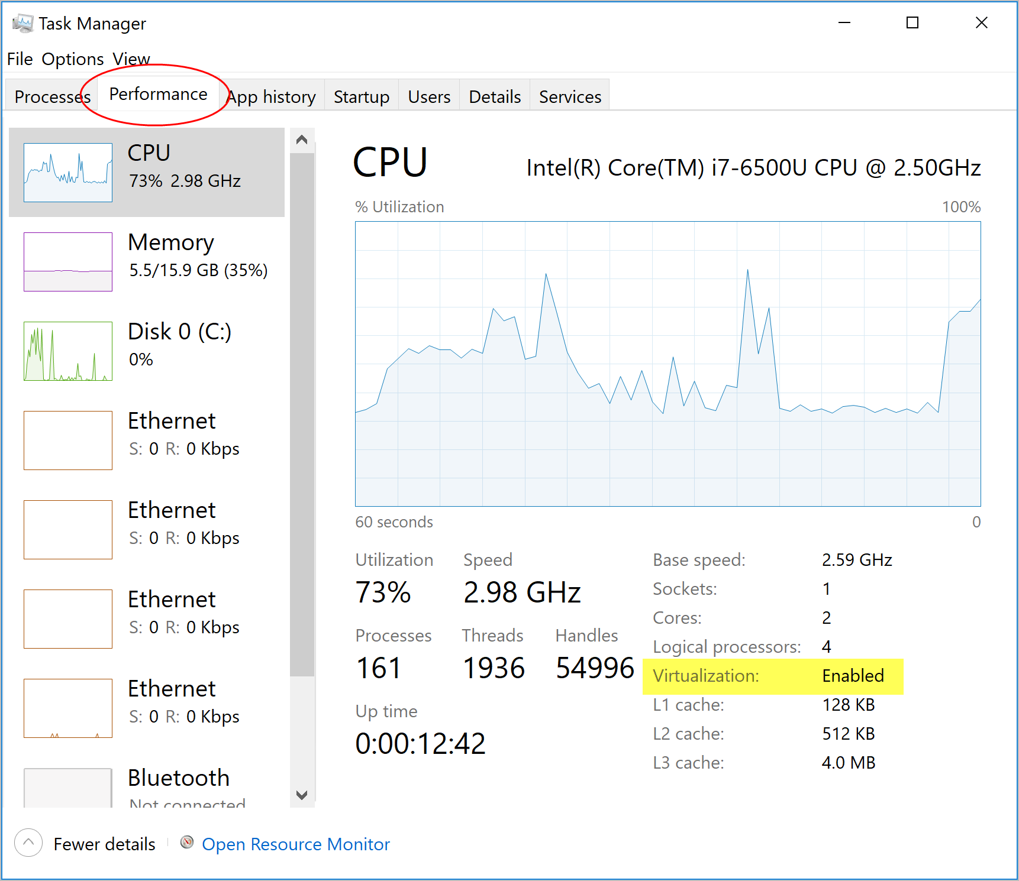

Install Docker Desktop on Windows-Server
- Download the docker desktop installer exe file from DockerHub.
- Double-click the DockerDesktopInstaller file and follow the instructions on the installation wizard to accept the license, authorize the installer, and proceed with the install.
- Authorize – Privileged access (system password) is needed to install networking tools, links to the Docker apps and manage the HYPER-V VMs.
- Click Finish
Start Docker Desktop
To start the DockerDesktop, search for Docker and select the DockerDesktop in the search results. when the whale icon in the status bar stays steady, Docker Desktop is up-and-running, and is accessible from any terminal window.
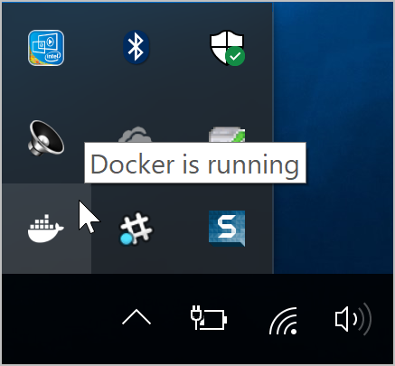

Now the installation of Docker Desktop is completed.

SETUP : Damico Release

NOTE: we are doing all the builds in our local Ubuntu system.

Release steps for Java sources :
=======================
STEP-1 :
First, we need to place a builded jar file or build a jar from the latest source. Then create Dockerfile for java service to build the docker image.

Dockerfile for java source as follows,

FROM java:8

EXPOSE 8099

ADD damicoService-1.0.0.jar damicoService-1.0.0.jar

ENTRYPOINT [ "java","-jar","damicoService-1.0.0.jar" ]

STEP-2
Hit the following command to build the docker image for java sources.

# sudo docker build -f Dockerfile -t damico_service . → Damico_Service
# sudo docker build -f Dockerfile -t damico_sync . → Damico_Sync

Release steps for frontend sources :
==========================
STEP-3:
We need to place the latest front-end dist files . Then create Dockerfile for Apache to build the docker image. Dockerfile for front-end source as follows.

FROM httpd:alpine

ADD httpd.conf /usr/local/apache2/conf/httpd.conf

#ADD proxy-html.conf conf/extra/proxy-html.conf

COPY . /usr/local/apache2/htdocs/

Here, In this Apache, we need to replace the default httpd.conf into customized httpd.conf file for enabling required dependency modules and port.

** I enclosed customized httpd.conf file in this documentation home directory.

STEP-4
Hit the following command to build the docker image for frontend sources.

# sudo docker build -f Dockerfile -t damico_dist . → Damico_frontend

STEP-5 : Docker Image Backup

You will need to save the Docker image as a tar file.

# sudo docker save IMAGE-NAME > Image_backup_name.tar
For Example,
# sudo docker save damico_service > damico_service_sep_18.tar

STEP-6 : Copy and Load Images : Windows-Server

Copy your images to a windows server through Team-viewer. After that we will have to load the image into docker. Go to the location on which we have a backup images and execute the following command in windows-power-shell.

> docker load -i <PATH_TO_IMAGE_FILE>

STEP-7 : Run the Images : Windows-Server

Now it’s time to run the images in windows-server. Execute the following command to run Damico – service,sync and front-end.

> docker run -d -v C:\SVM_Rules:/app/ -p 7700:7700 --restart unless-stopped damico_service
> docker run -d -v C:\SVM_Rules:/app/ -p 7700:7700 --restart unless-stopped damico_sync
> docker run -d -p 8089:8089 --restart unless-stopped damico_dist
> docker run -d -p 80:80 --restart unless-stopped damico_main_apache

Note: In above all run commands, we mapped RuleSheet from physical windows-server into inside the containers. i.e., SVM_Rules directory in windows-server is mapped into /app directory inside the docker containers.

