1. Register the user

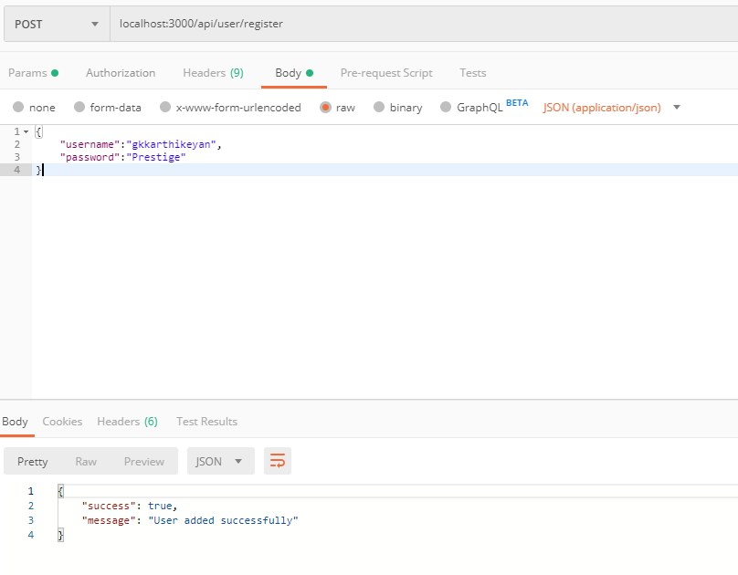

1. Login

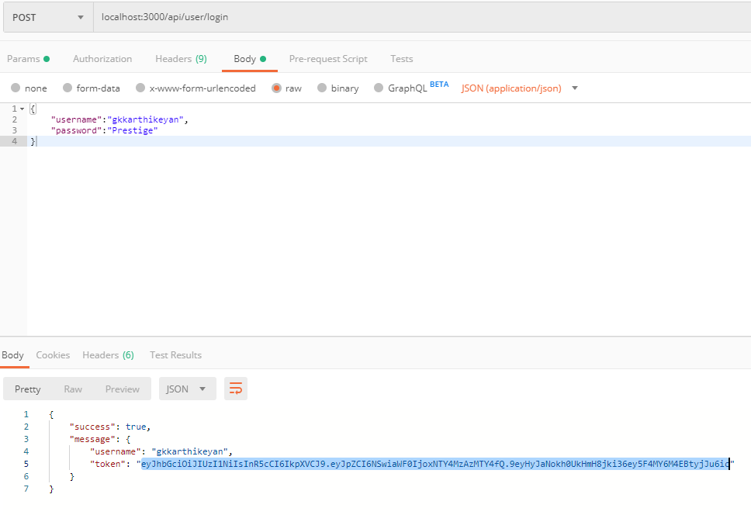

1. Story 1 - Retrieving a Store by ID

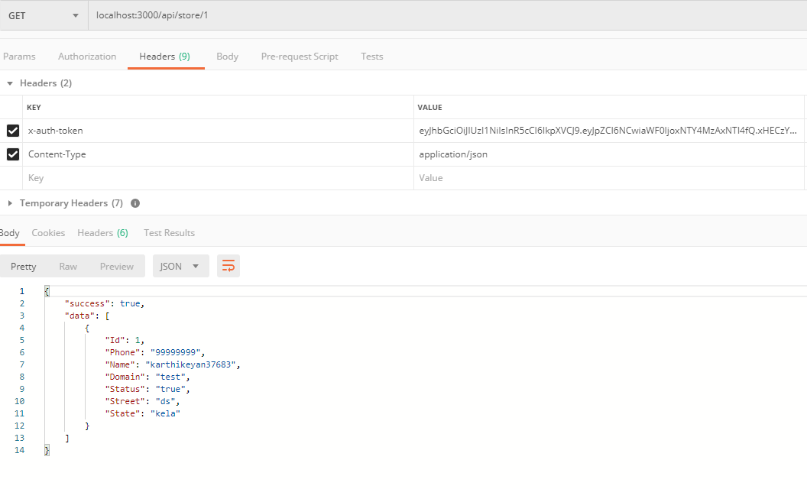

1. Story 2 - Retrieving list of Stores

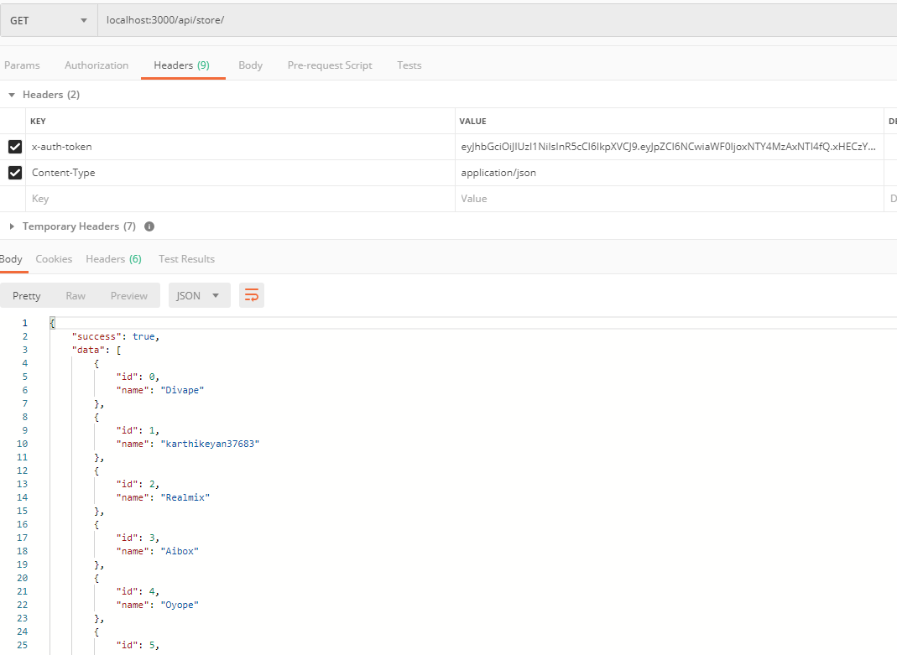

1. Story 3 - Update a Store

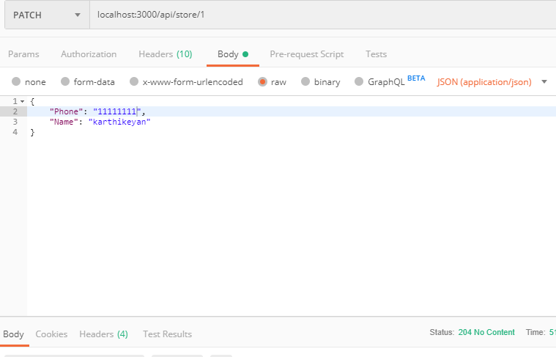



1. Story 4 - Retrieving list of Stores w/ total customers count

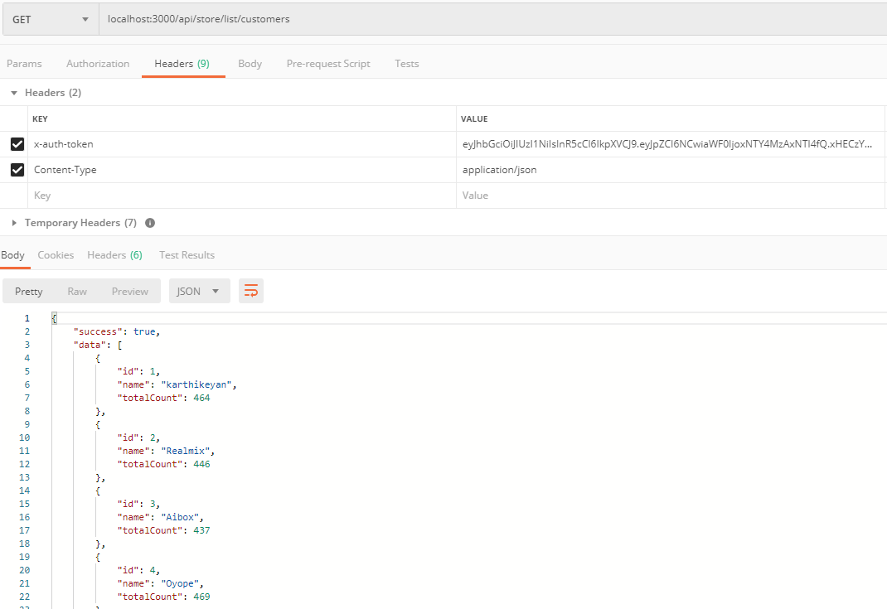

1. Story 5 - Retrieve a Stores Customers

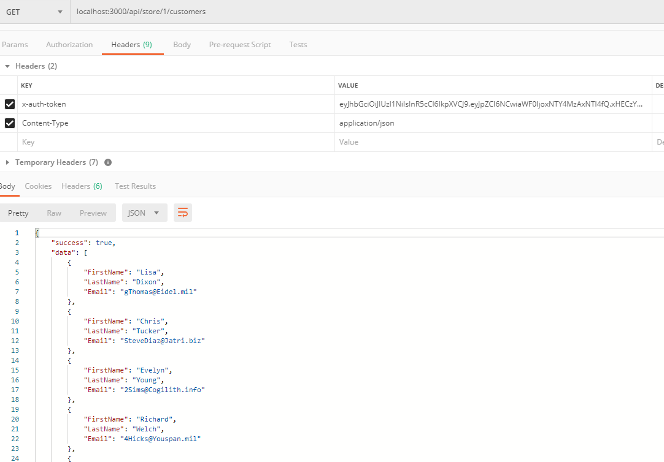

1. Story 6 - Create a Customer

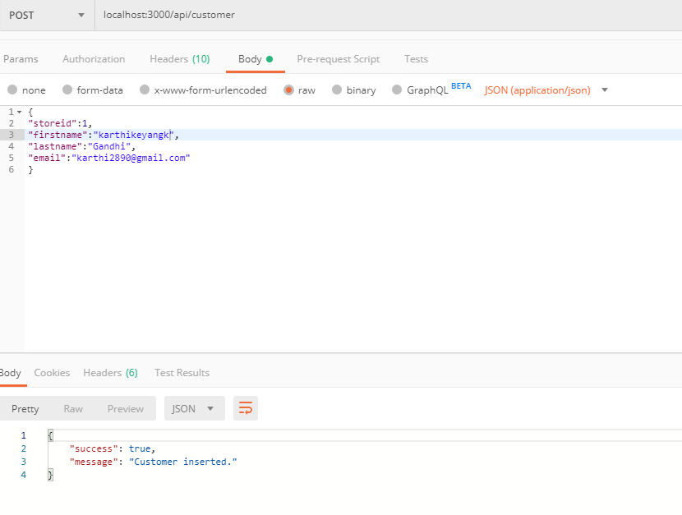

1. Story 7 - Search for Store

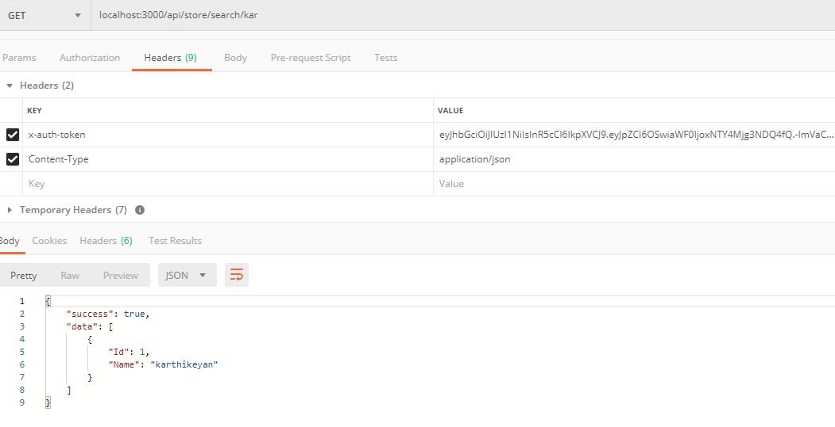

1. Story 8 – Authentication
   1. Refer 1.Register and 2.Login