Phase 2: Org Setup & Configuration
Purpose: Configure Salesforce org for FitTrack to ensure users, profiles, roles, and security settings are correct.
Steps:
Salesforce Edition: Developer Edition

Company Profile Setup: Name, Address, Timezone, Locale, Currency
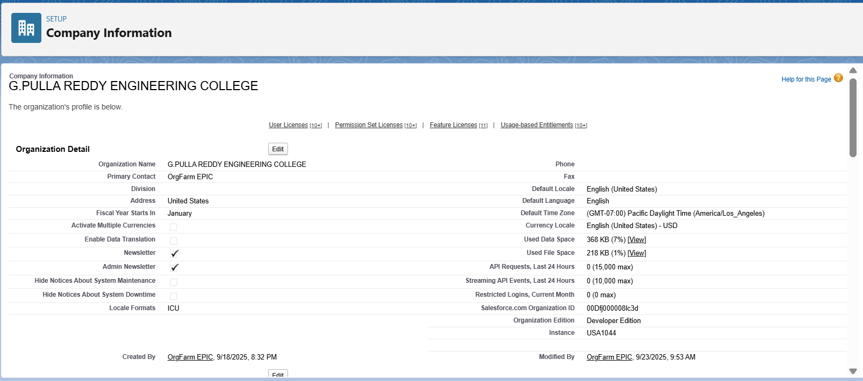

Business Hours & Holidays: Mon–Sun, 6 AM – 10 PM; add public holidays

Fiscal Year: Standard

User Setup & Licenses: Create sample users:

Admin (Full access)

Trainer (Manage Members & Workout Plans)

Receptionist (Member creation only)
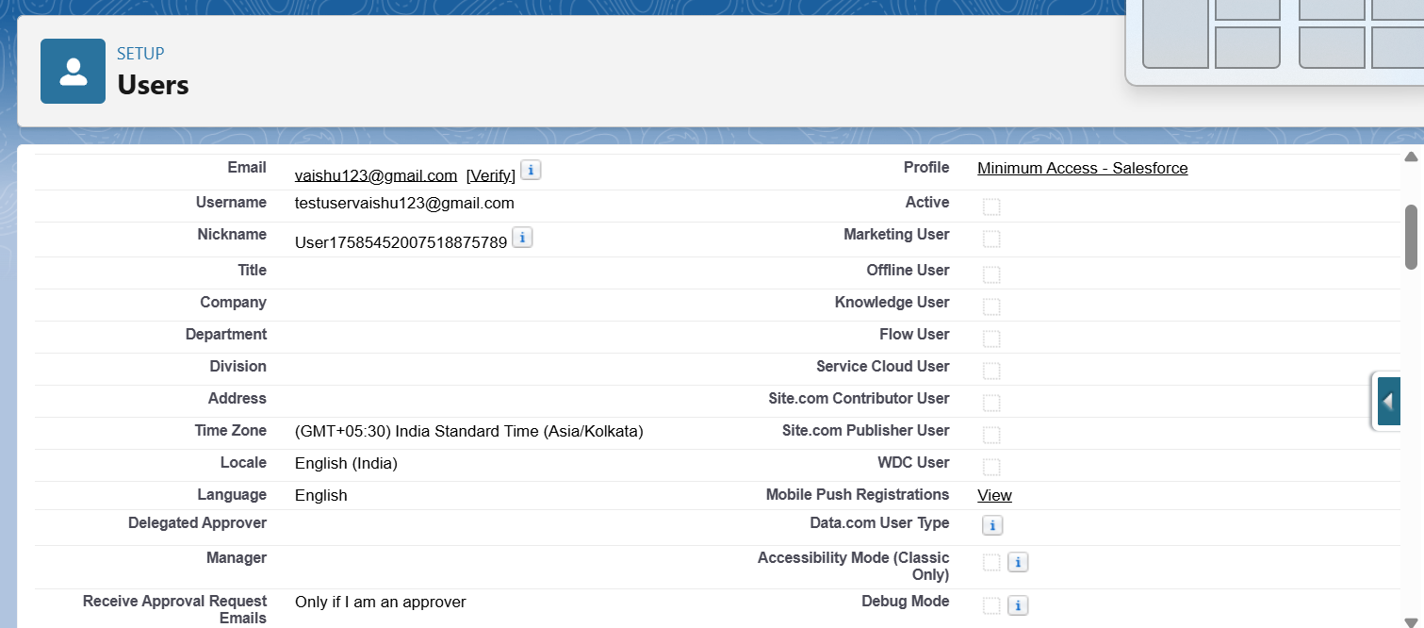

Profiles:

Admin → Full access

Trainer → Edit/View Members & Workout Plans

Receptionist → Create/View Members only

Roles: Admin > Trainer > Receptionist
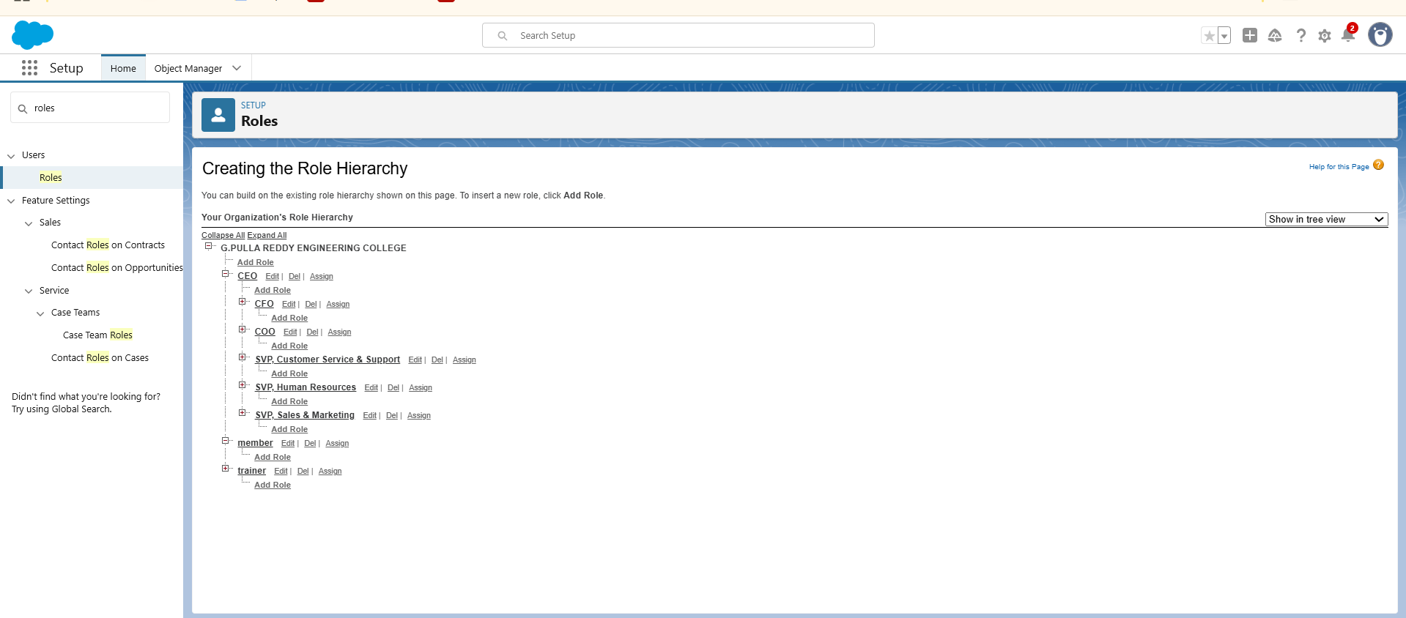
Permission Sets: Assign dashboard/report access for Trainers

OWD & Sharing Rules:

Members → Private

Trainers → Private

Workout Plans → Private

Sharing rules → Share members with their assigned trainers

Login Access Policies: Admin can login as any user

Sandbox Usage & Deployment Basics: Optional for larger org setup

