Phase 3: Data Modeling & Relationships
Purpose: Design objects and relationships for member, trainer, and workout data.
Custom Objects:
Member: Name, Email, Phone, Membership Start/End, Fitness Goal, Age, Gender

Trainer: Name, Email, Phone, Expertise

Workout Plan: Plan Name, Duration, Intensity, Assigned Member
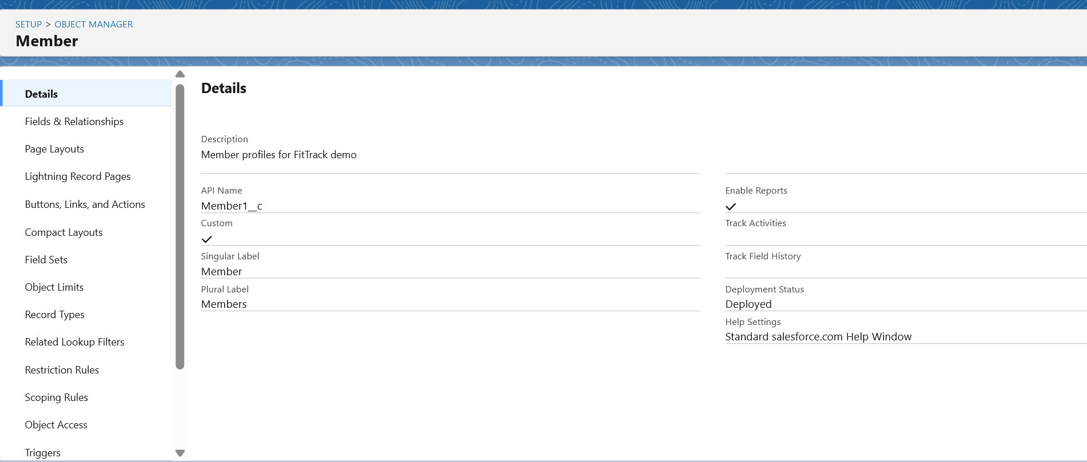

Relationships:
Member ↔ Trainer → Lookup relationship (each member has a trainer)

Member ↔ Workout Plan → Master-Detail (one member can have multiple plans)
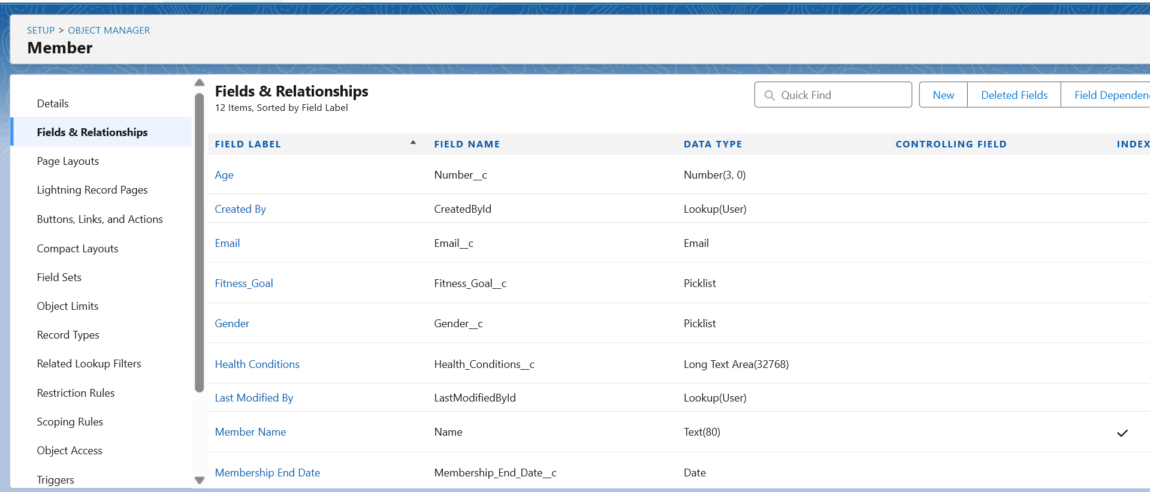

Additional Configuration:
Page Layouts: Display key fields on Member, Trainer, Workout Plan

Compact Layouts: Show Name, Membership Status, Fitness Goal

Schema Builder: Visual diagram of objects and relationships
