Phase 4: Process Automation (Admin)
Purpose: Automate repetitive tasks and notifications.
Automation Examples:
Validation Rules: Ensure Membership End Date > Start Date
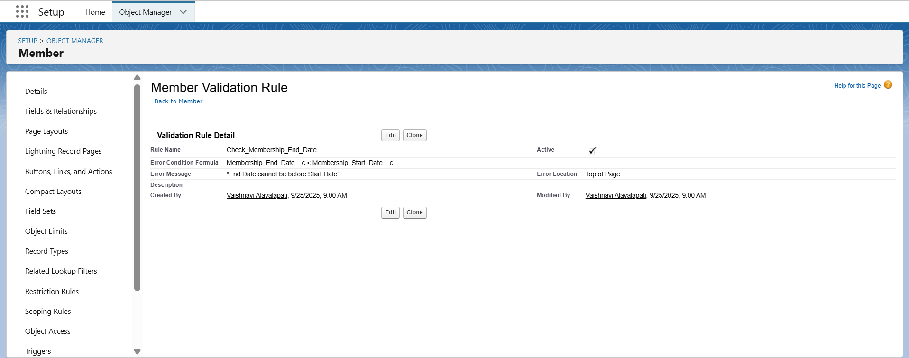

Workflow / Process Builder:

Notify Admin/Trainer when membership is near expiry

Auto-assign new members to default trainer if none chosen

Flow Builder:

Auto-create “Expired Members” report

Automate follow-up reminders

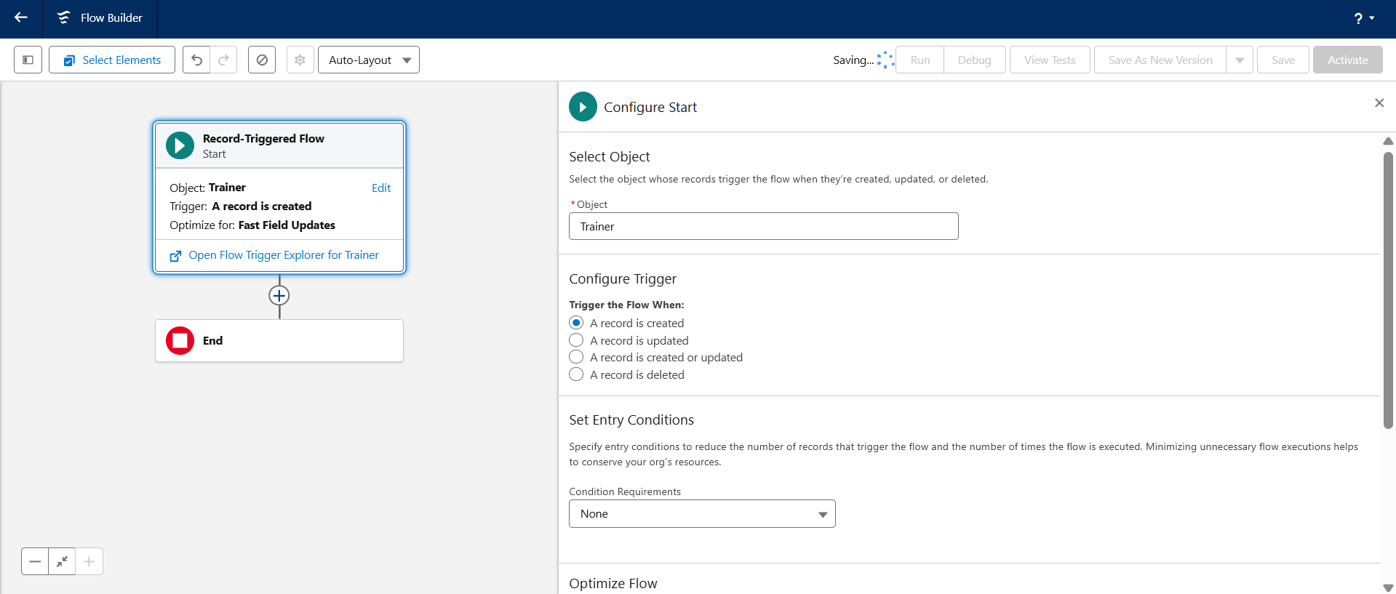
Email Alerts / Custom Notifications:

Notify members of upcoming expiry or trainer updates
