Phase 6: User Interface Development
Purpose: Create a user-friendly experience for different roles.
Steps:
Create FitTrack App in Lightning App Builder
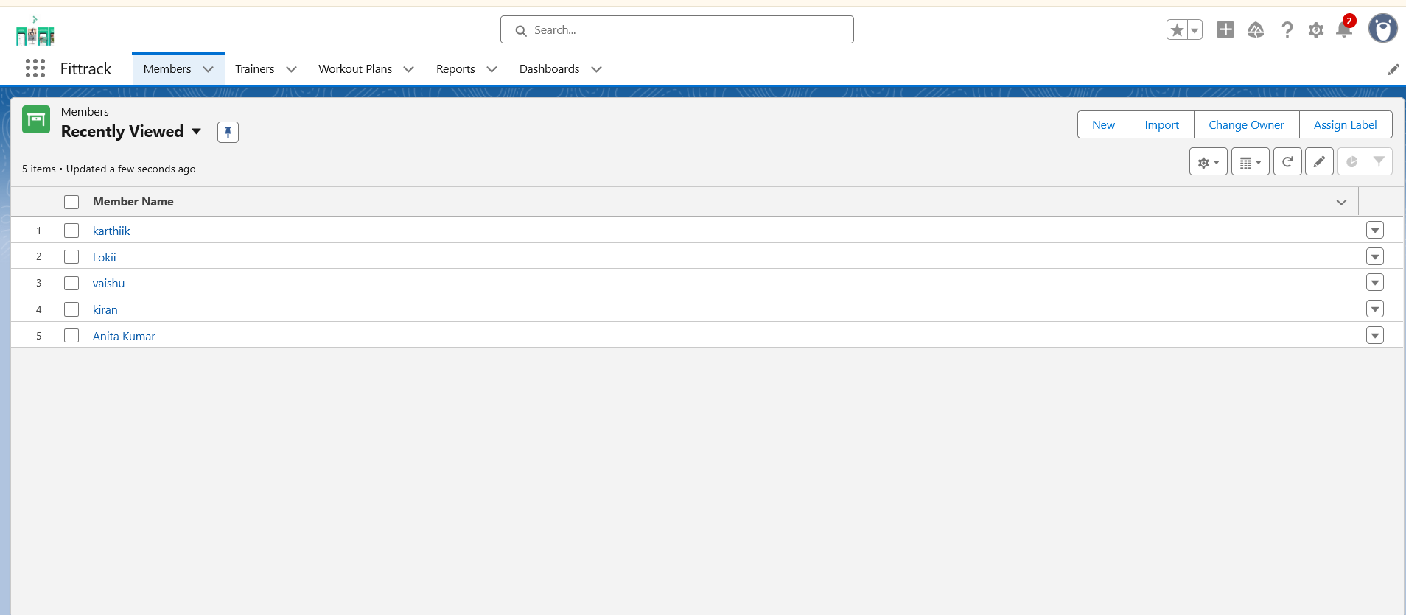

Add Tabs: Members, Trainers, Workout Plans, Reports, Dashboards

Customize Record Pages for Members and Workout Plans

Home Page Layouts: Dashboard showing Active vs Expired Members, Trainer workload

Optional: Lightning Web Component for member search or fitness progress chart
