Phase 7: Integration & External Access
Purpose: Connect Salesforce with external systems (optional).
Named Credentials: Connect with third-party APIs (fitness trackers, email, SMS)
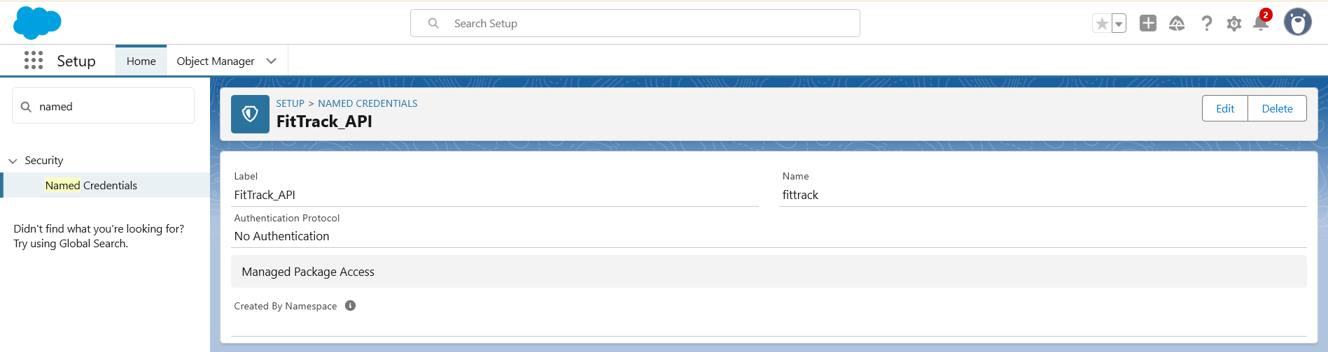

Platform Events: Notify trainer when workout plan updated

Remote Site Settings: Allow external API access
