Phase 9: Reporting, Dashboards & Security Review
Purpose: Track member activity and performance metrics.
Reports:
Active vs Expired Members (Matrix or Summary)

Members by Fitness Goal (Summary)

Trainer Workload (Tabular)
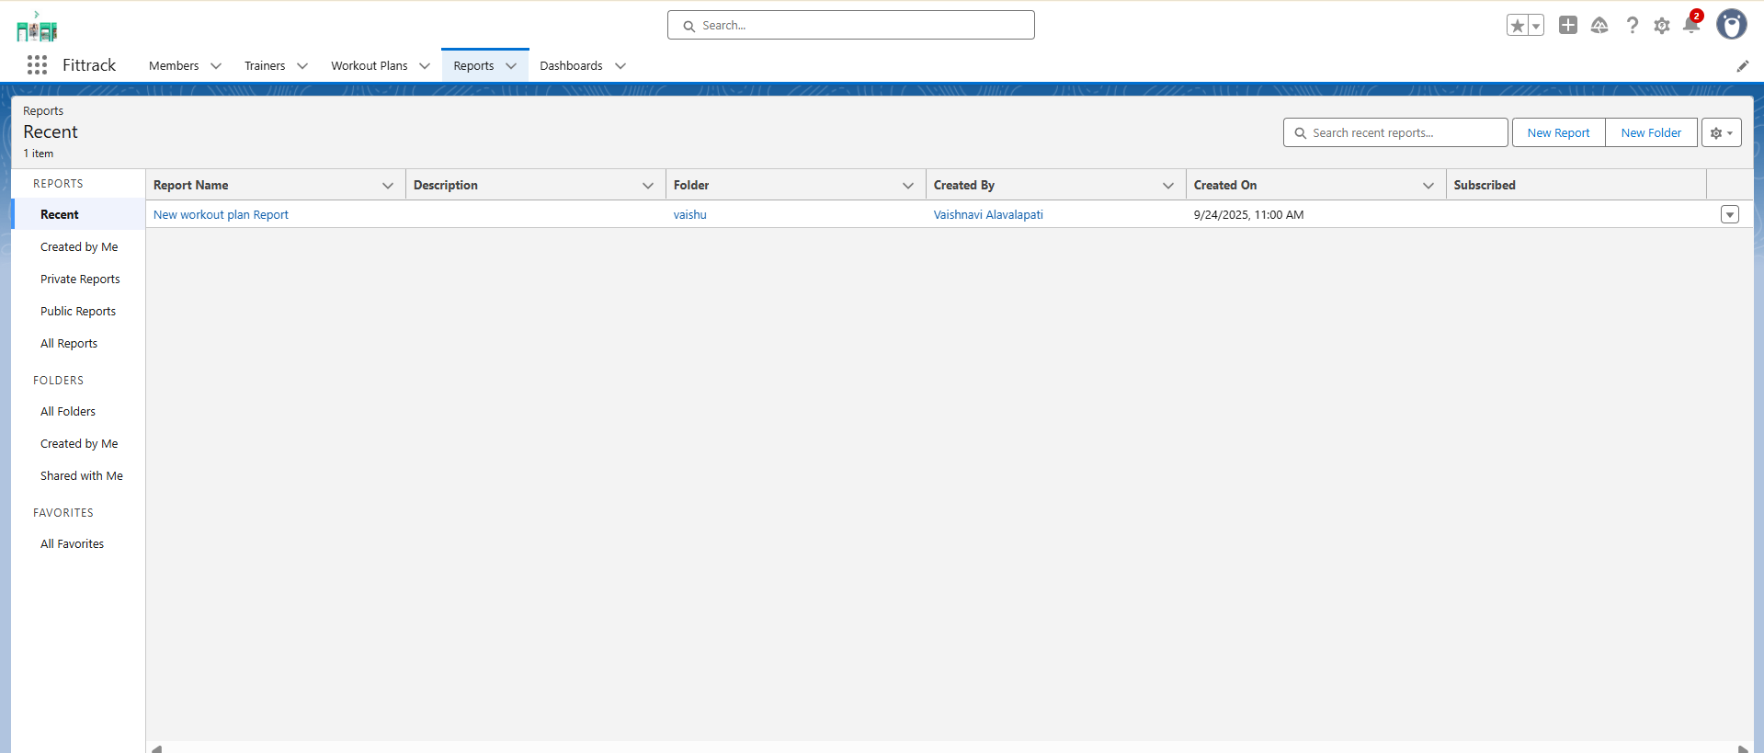
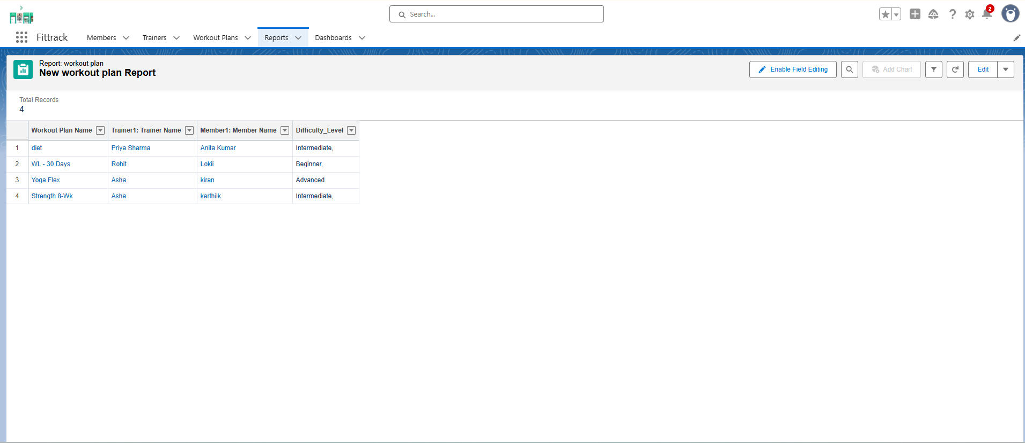

Dashboards:
Donut chart – Active vs Expired Members

Bar chart – Members per Trainer
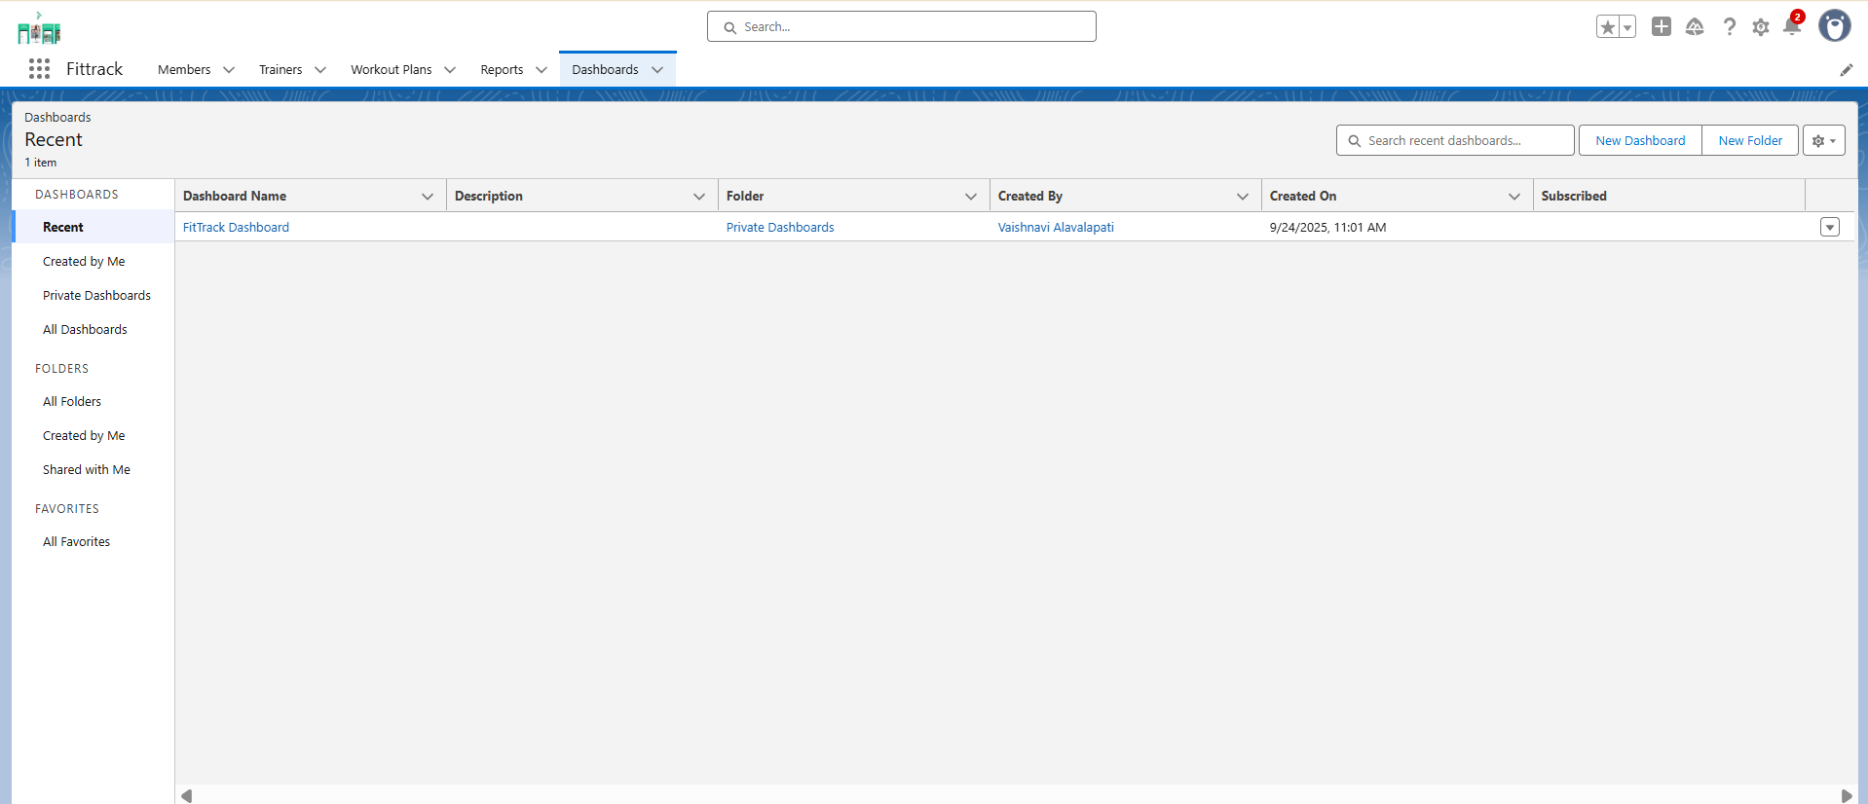

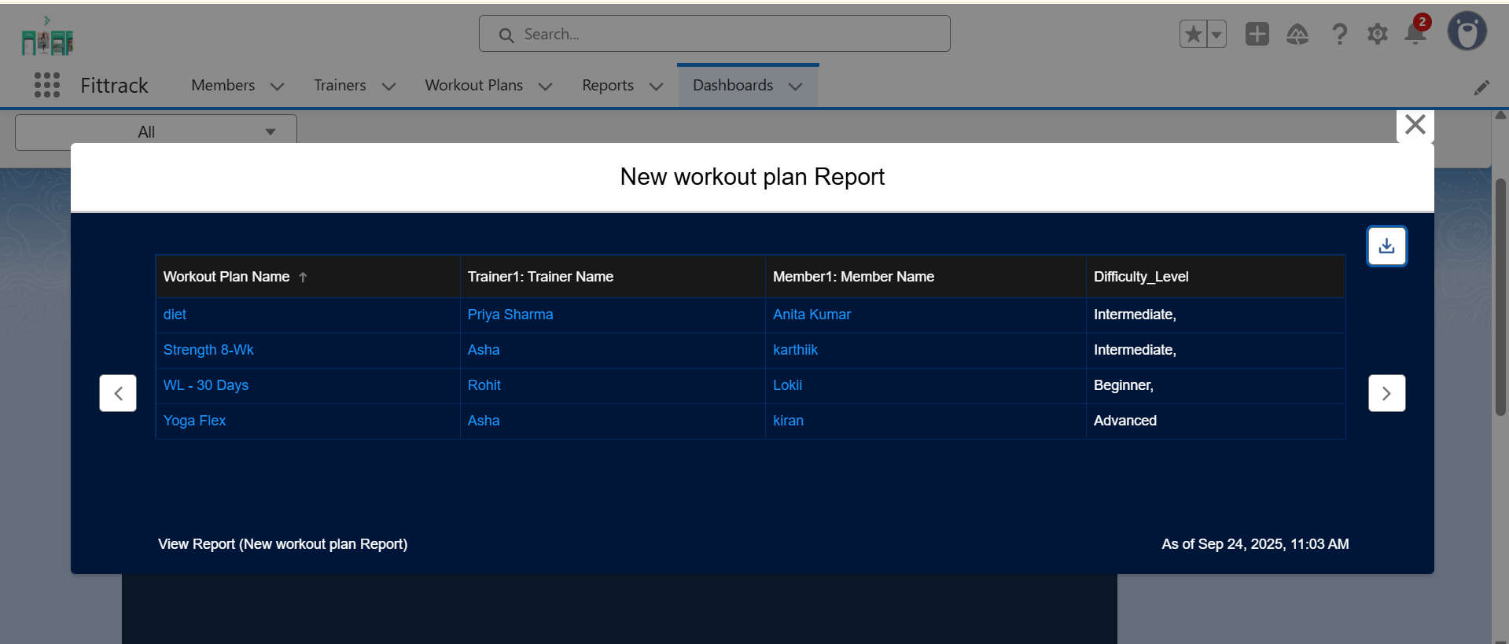

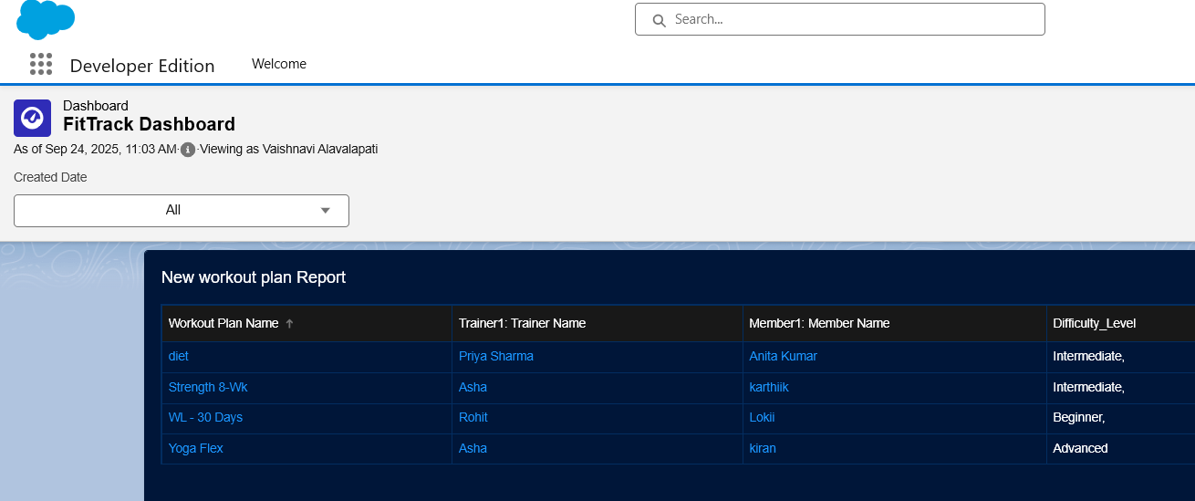

Security:
Field-Level Security for sensitive data (Email, Phone)

Sharing Rules applied

Audit Trail for changes

