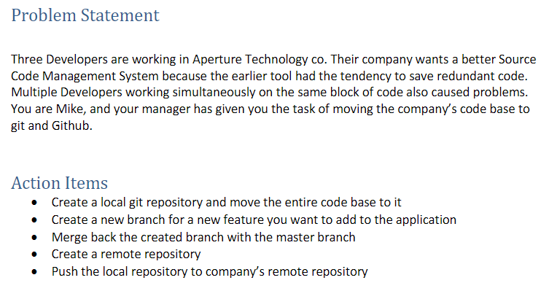

Git Init:

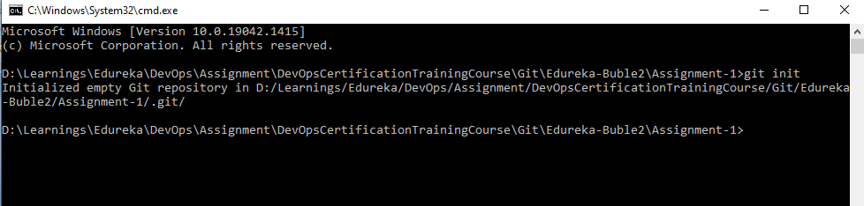

Git master branch created:

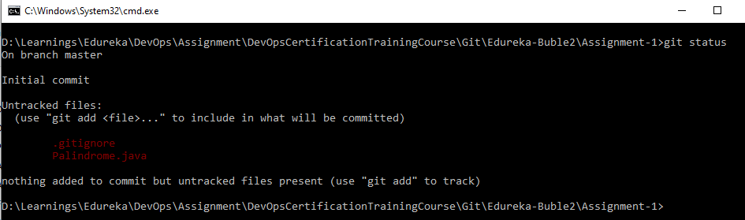

Git feature branch created:

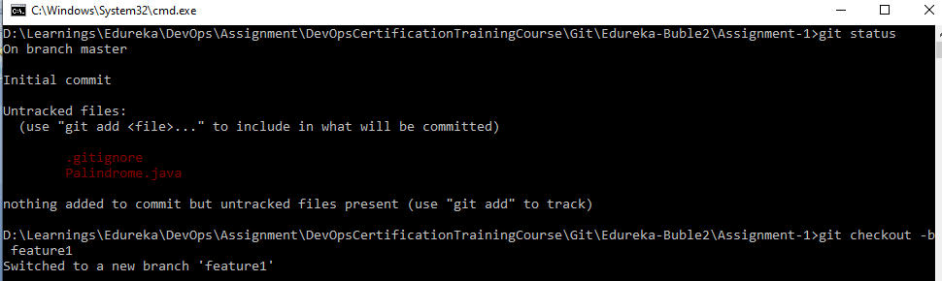

Git merge : Code merged back to master branch.

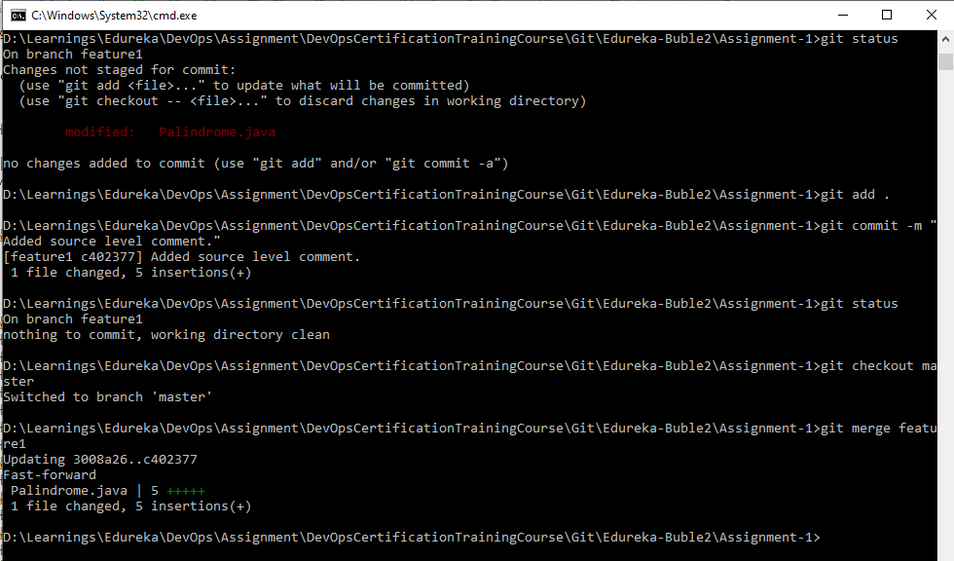

Adding Remote:

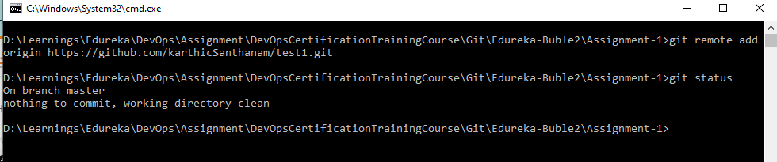

Changed the repo to <https://github.com/karthicSanthanam/devops_assignment.git>

using git remote set-url https://github.com/karthicSanthanam/devops_assignment.git

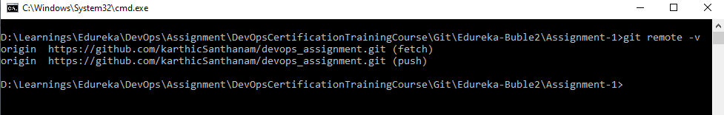

Git Push:

