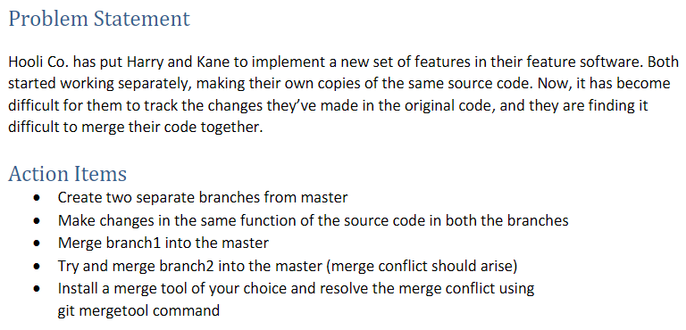

Git branches created:

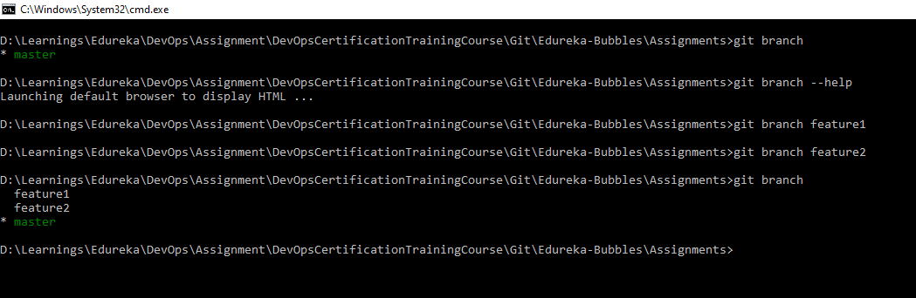

Switched to feature1 branch:



Feature1 branch code change:

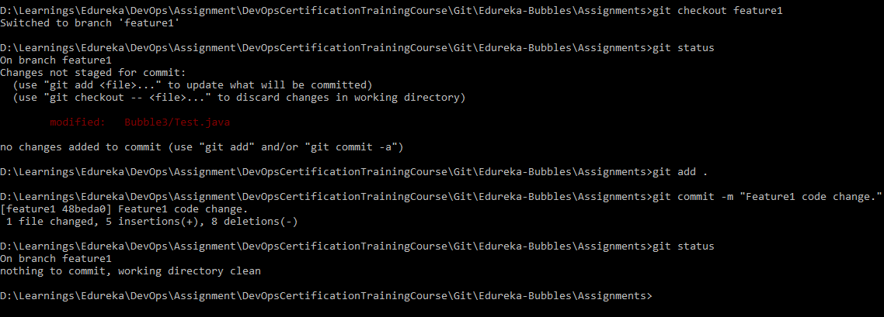

Feature1 branch merged to master:

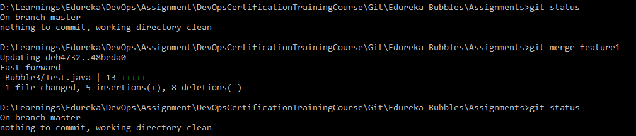

Feature2 branch code change:

In feature2 branch

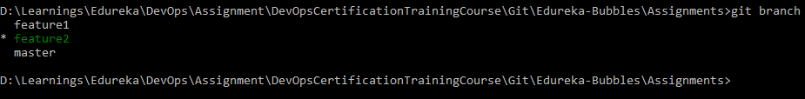

Code change in feature2

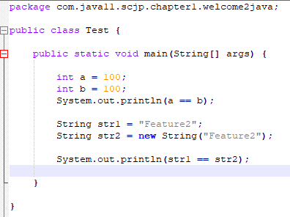

Feature2 code committed in the same branch.

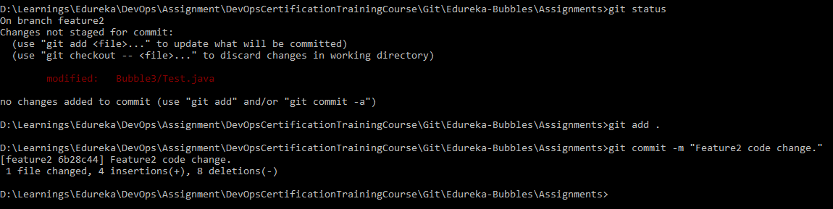

Git merge and conflict:

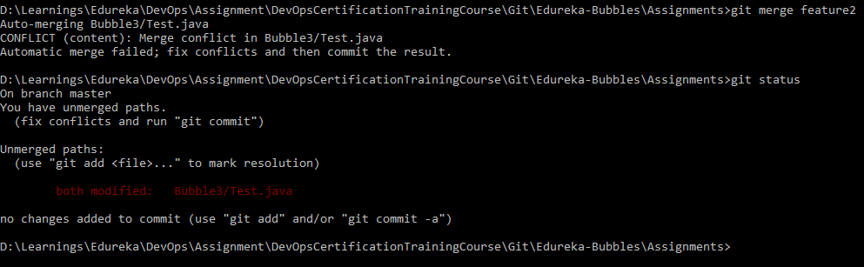

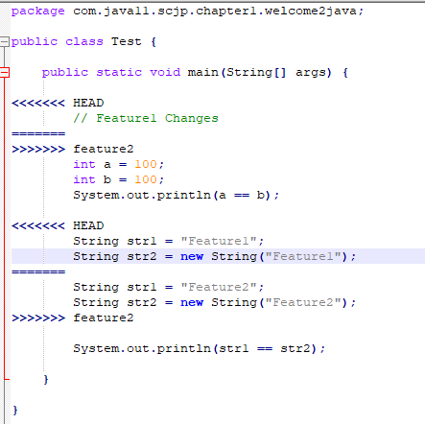

Conflict Resolved:



