MINI PROJECT REPORT

E-Salon Booking System

Web-application

By:

Karthick Kumar P

Hari Krishnan B

Jeevanantham

Guided by:

Dr . E . Kannamal

Abstract

The project E-salon Booking is a Website where user can reserve the time slot in a salon at available date

Introduction

Online salon Booking is a Website where user can reserve the time slot in a salon at available date

* User can book their services as per convenient date and time. So that they don't need to wait for the service in a salon at Queue.
* User can easily identify where he can Get the required Service
* User Friendly Application
* Only an Registered user can Reserve a slot , a new user should signup to proceed with booking.
* User Selects the Shop then redirects to a page where Available slots , Dates , services are Displayed.
* User has to choose the date and available slot along with the required Service.
* User can not choose a slot which is already Reserved.
* User needs to Confirm the booking by clicking confirm
* User can checkout his Bookings at My Bookings Module

Existing Systems

The existing systems are salonbooking websites like:

* Salon Booking System
* Saloniris

Proposed Systems

With Esalon Booking System made easy for the customer to book their slots by a single Click.

The web-application is user friendly for the customers and admin can maintain all those things at one place.

Screenshots

Login:

The Login Page has username and password field on successful Login takes to salons page

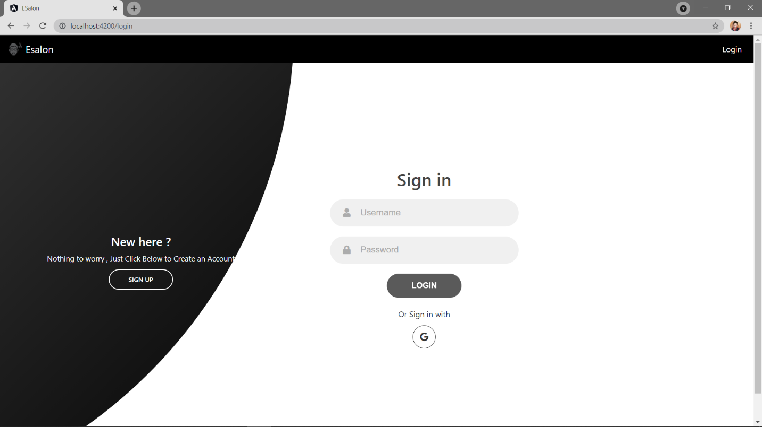

Register :

The new user can register at this page.

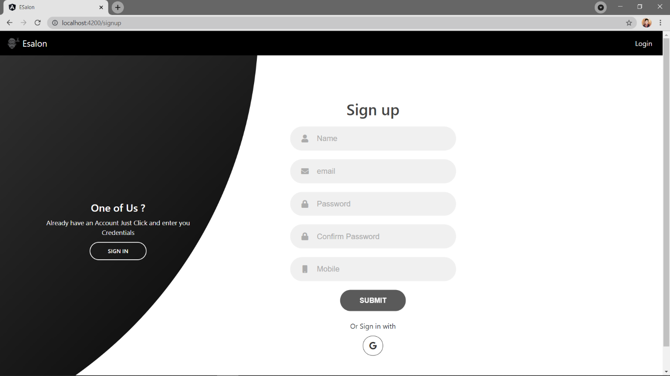

Home page:

The home page welcomes the user and has some links to Login , Booking , Register

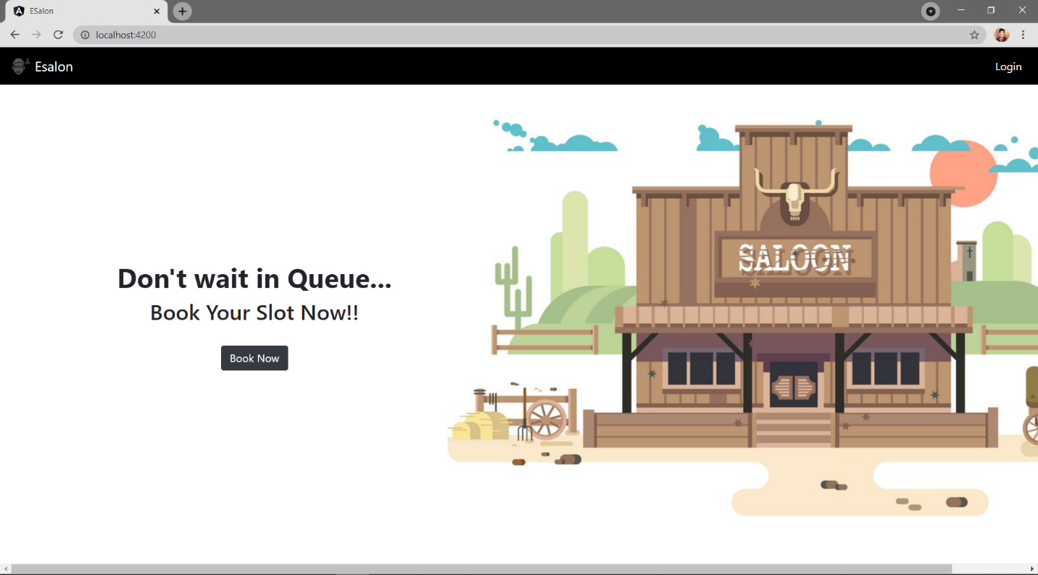

Salons Page:

This Page Displays Number of Shops User can Select the Required One

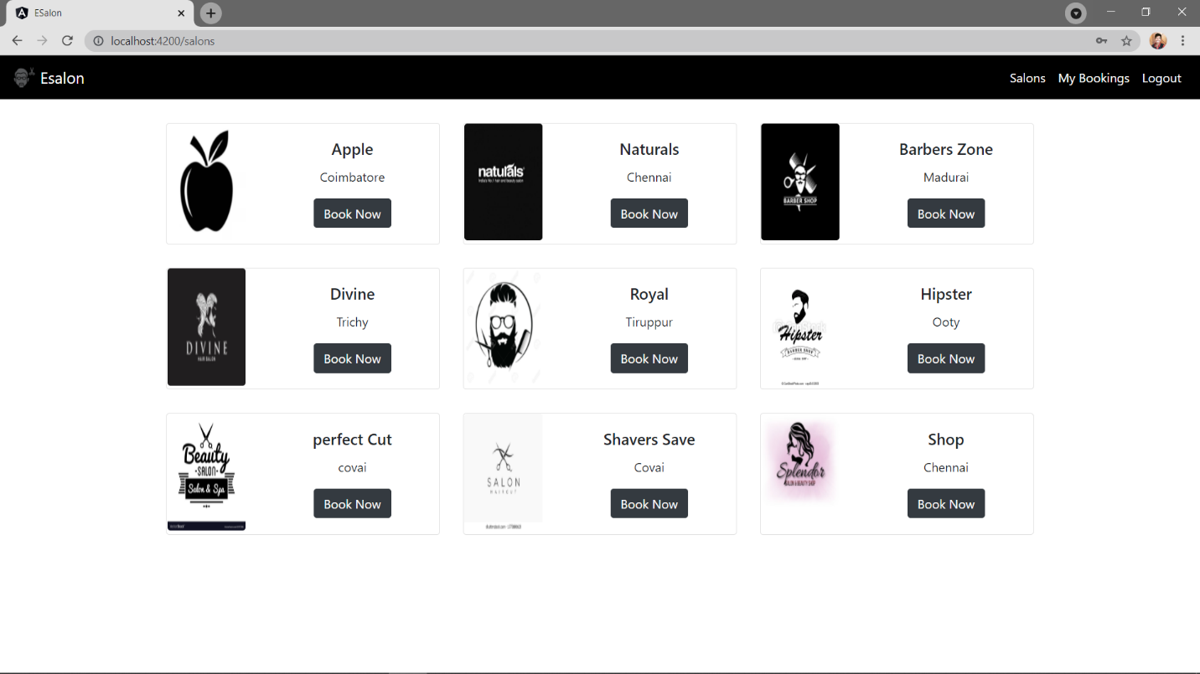

Booking Page:

In this page the user selects the date , time and service

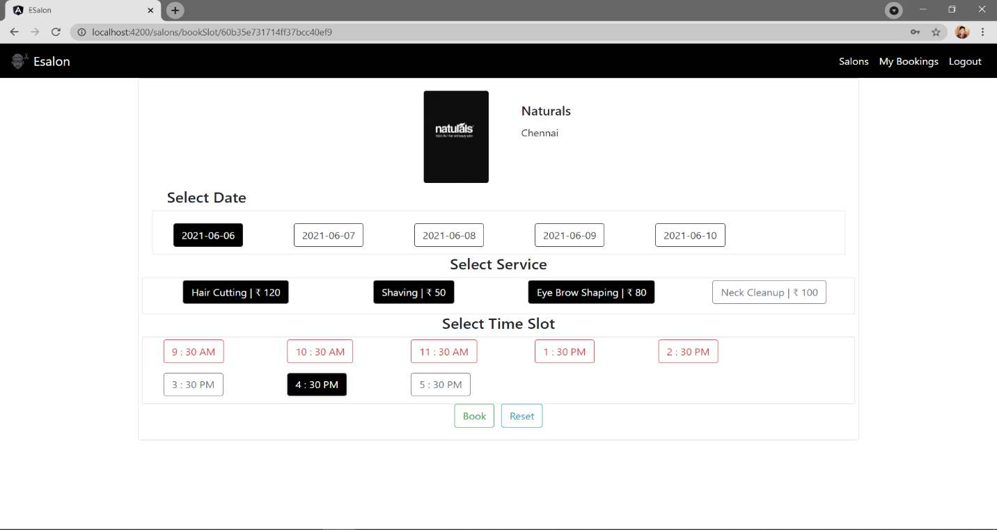

Confirmation Page:

Here the User can Confirm His Booking

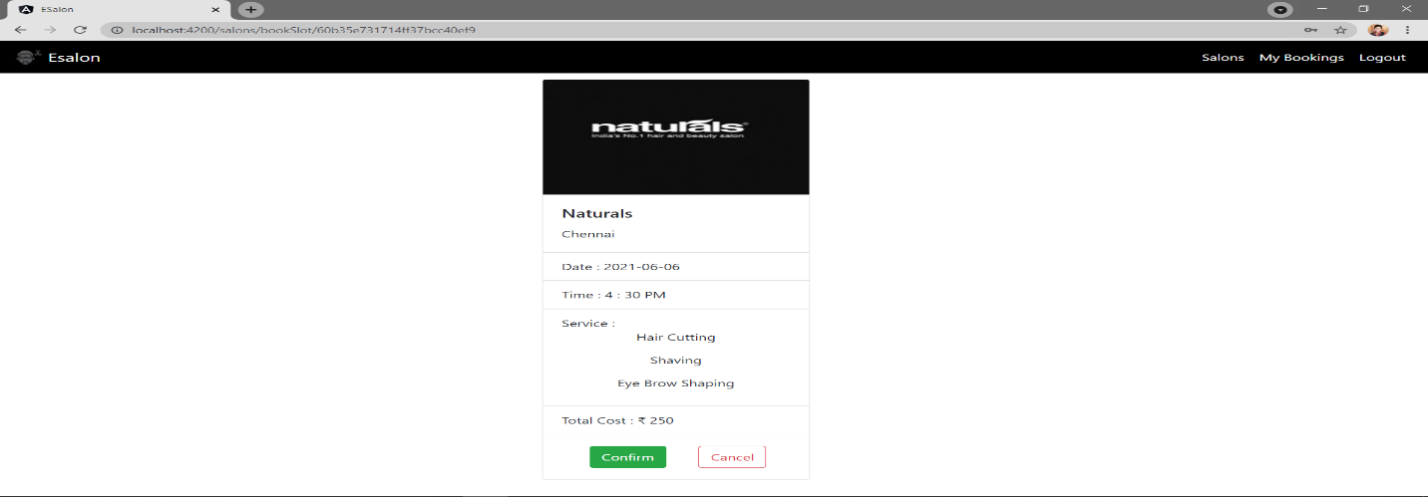

Bookings Page:

Here The User Can See His Booking History

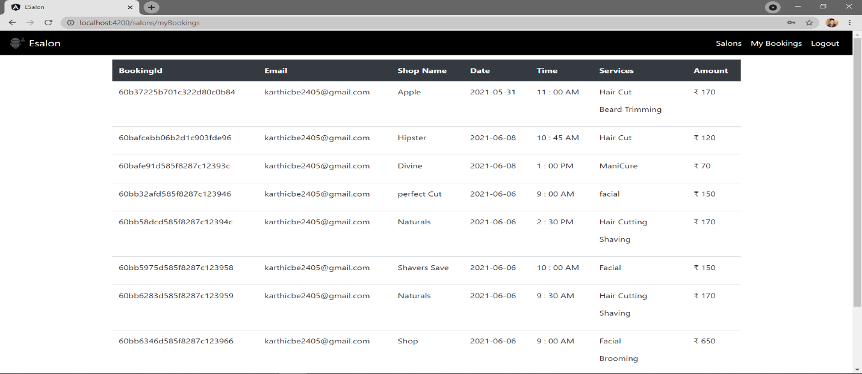

Admin :

Here the Admin can Add Shop , Add Service , Generate Slot

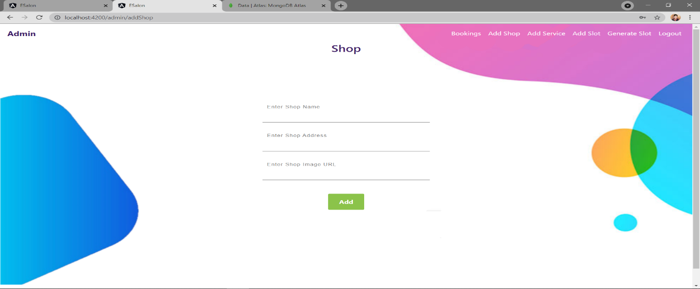

Adminlogin :

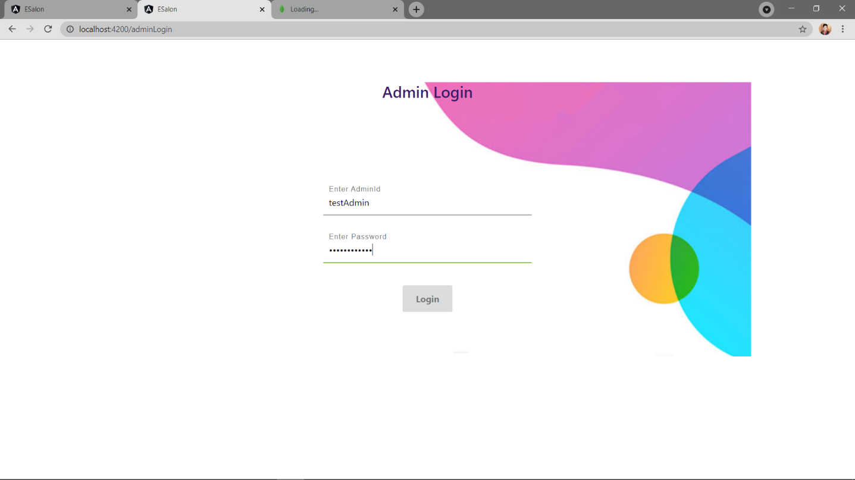

Email :

Once the Booking Confirmation is done a Confirmation Mail is Send to the User Registered Mail ID

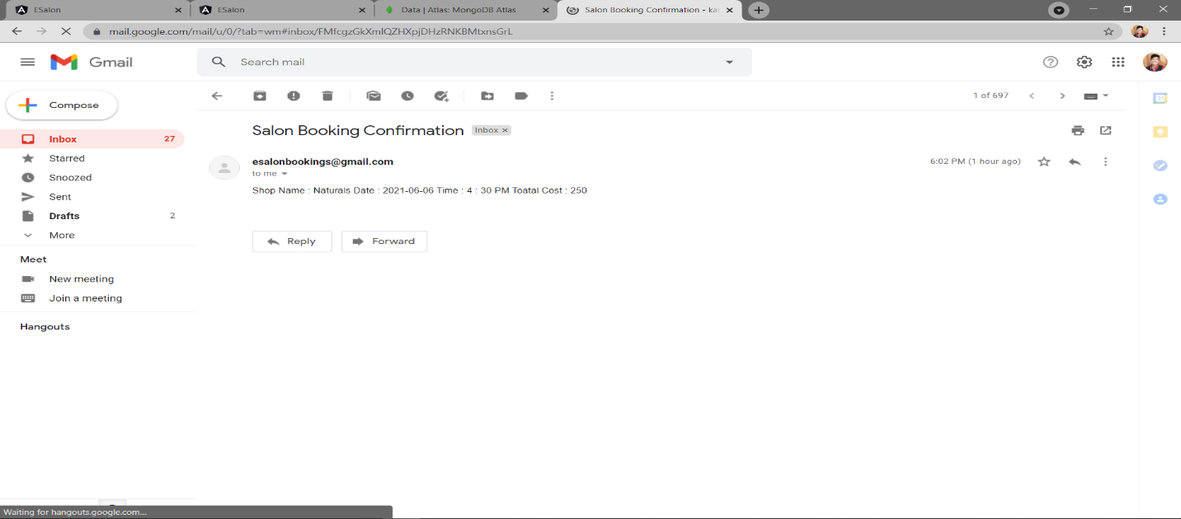

Conclusion

Thus Online Salon Booking Website Was Developed Successfully Using MEAN Stack

Future Enhancements

* Payment Integeration
* Separate Admin Login For Individual Shops
* Integrating Some Automation

Project Link

<https://github.com/karthicbe2405/Esalon>