A reliability-constrained, multi-objective framework for minimum-mass design of steel frame structures under material and loading uncertainty
[Author name] ([Affiliation], [Country])
Abstract
Minimum-mass design of steel frames against deterministic code checks leaves the reliability of the optimised frame unquantified. This paper presents an open, reproducible framework for reliability-constrained optimisation of planar steel moment frames, built on PyNite, with discrete W-shapes checked to AISC 360-16 under the ASCE 7-05 load combinations, a fixed code basis used as a benchmark. The ultimate limit state is component-based: the first attainment of a member limit state in a second-order elastic analysis ($B_{1}$–$B_{2}$ amplification of superposed linear responses), not collapse. It is combined with 50-year drift and deflection serviceability. A sample average approximation makes the reliability constraints deterministic for a genetic algorithm. The targets are imposed on point estimates or on 95% lower confidence bounds, always in addition to all code checks. Optima are re-verified with ${10}^{6}$ independent samples and exact binomial intervals. The paper distinguishes a point estimate that reaches a target, an interval that contains it, and a lower bound that exceeds it. The surrogate is validated against OpenSeesPy and against full second-order re-analysis in the failure tail of ten designs.
For seven frames, deterministic optima had ultimate reliability indices of 2.88–3.66 and drift indices of 0.89–2.54. With point-estimate constraints (targets 3.0 and 1.5), six of seven reliability-based optima met both targets with 95% confidence in the baseline surrogate model, at 1.1–10.1% more steel. With confidence-bounded constraints, all seven did so, at 1.1–11.7% more steel. These bounds cover sampling uncertainty only, and drift results near the target remain sensitive to the 1% error of the $B_{1}$–$B_{2}$ drifts. For a three-storey frame the surrogate was unconservative. A design with 2.7% more steel than the point-estimate design (5.2% more than the deterministic optimum) met the target on the re-analysed tail samples; for the complete full model this rests on an assumed heavy-tailed residual model, and its interval is model-conditional, not a distribution-free bound. Uncertainty-aware optimisation did not reduce steel mass; its benefit is the lightest design found, within the tested search budget, that meets a stated reliability, conditional on the probabilistic and structural models.
Keywords: Reliability-based design optimisation ; Steel moment frames ; Monte Carlo simulation ; Direct Analysis Method ; NSGA-II ; Serviceability ; Model uncertainty ; PyNite

Introduction
Minimum-weight design of steel moment frames with discrete catalogue sections is a mature topic in structural optimisation. Genetic algorithms (Camp, Pezeshk, and Cao 1998; Pezeshk, Camp, and Chen 2000), harmony search (Degertekin 2008) and a large family of other metaheuristics (Saka and Geem 2013) have been used to select hot-rolled sections that satisfy code strength and serviceability checks at least weight. Almost all of this work is deterministic: the optimiser drives the governing load-and-resistance-factor design (LRFD) checks to unity and treats the partial factors of the code as a sufficient representation of uncertainty. The partial factors, however, were calibrated for members and typical load ratios (Ellingwood et al. 1980; Galambos et al. 1982); they do not guarantee a uniform reliability for an optimised system, whose members are all deliberately pushed to their limits and whose governing constraints may be strength in one member group and drift in another.
Reliability-based design optimisation (RBDO) replaces or supplements the deterministic checks by explicit constraints on failure probabilities (Frangopol 1985; Enevoldsen and Sørensen 1994; Valdebenito and Schuëller 2010; Aoues and Chateauneuf 2010). Table 1 summarises the studies closest to the present one. Reliability-based optimisation of steel frames with discrete sections and Monte Carlo simulation was pioneered by Papadrakakis, Lagaros and co-workers (Papadrakakis and Lagaros 2002; Papadrakakis et al. 2004; Lagaros and Papadrakakis 2007). Papadrakakis et al. (2004) optimised a seismically loaded 3-storey planar moment frame with evolution strategies. They imposed the Eurocode 3 and 8 checks in both the deterministic and the reliability-based problem, and added a Monte Carlo constraint on the probability that the interstorey drift exceeds 4% of the storey height. The reliability-based optimum was heavier than the deterministic one (their text gives approximately 26%; the volumes in their Table 6 differ by 34%). The deterministic optimum had a failure probability of $9.3×{10}^{−2}$. Their failure probabilities were estimated from 5000 (MCS) or 1000 (LHS) samples, without confidence intervals. Truong and Kim (2017) embedded plastic-hinge advanced analysis in the RBDO of steel space frames under gravity and wind with harmony search. Their RBDO also kept the deterministic strength and $H/400$ drift constraints, and used a sampling estimator verified against crude Monte Carlo on benchmark problems. Drift was not a probabilistic constraint, and the failure probabilities of the final frame designs were not re-estimated independently. Multi-objective genetic algorithms have been used for probabilistic performance-based design of steel moment frames (Foley, Pezeshk, and Alimoradi 2007) and for weight–reliability fronts of transmission towers (Mathakari et al. 2007). The system reliability of frames designed by advanced analysis has been quantified without optimisation (Buonopane and Schafer 2006; Zhang et al. 2016).
Imposing code checks in addition to a reliability constraint is therefore not new (Papadrakakis et al. 2004; Truong and Kim 2017), and neither is the finding that a reliability constraint can increase the weight (Papadrakakis et al. 2004). In the two closest studies, which we read in full, we did not find (i) a comparison of reliability-based optima under a code-calibrated gravity–wind model with deterministic optima of the same frames, including deterministic designs with tightened drift limits and RBDO with and without the code checks; (ii) a probabilistic serviceability (drift) constraint next to the ULS constraint; (iii) confidence intervals for the failure probabilities of the final designs, or a re-estimate of them with independent samples; (iv) a validation of the reliability surrogate against full second-order re-analysis in the failure tail of several optimised designs; or (v) a release of the code and raw results. For the other studies in Table 1, which we could assess only from their abstracts and records, we make no such claim.
This paper addresses the research question: can uncertainty-aware optimisation produce lighter steel frame designs than code-based optimisation while satisfying explicit reliability and serviceability constraints? Steel mass is the objective; it is used as a proxy for material cost, and its relation to a broader cost is examined with an illustrative cost model. The contribution is not a new optimisation algorithm, but a computational workflow, with demonstrated accuracy, that makes probabilistic constraints practical in discrete steel-section optimisation and allows an honest comparison with code-based design. Specifically:
- a superposition surrogate that turns five linear analyses per design (PyNite (Brinck 2026)) and the AISC 360-16 $B_{1}$–$B_{2}$ amplification into a vectorised Monte Carlo evaluation of a series-system ultimate limit state (ULS) and two serviceability limit states (SLS) for $5×{10}^{4}$–${10}^{6}$ samples per design (the superposition of the linear unit-case responses is exact within the linear analysis, whereas the $B_{1}$–$B_{2}$ amplification approximates the full second-order response; Section 3.3), combined with a sample average approximation (SAA) (Kleywegt, Shapiro, and Homem-de-Mello 2002) that makes the reliability constraints deterministic functions of the design;
- four formulations solved with the same optimiser on the same frames: deterministic design optimisation (DDO) with several drift limits, RBDO with reliability constraints only, a code-compliant RBDO (RBDO-C) that also enforces every LRFD (AISC 360-16, ASCE 7-05) and serviceability check, and a bi-objective mass–reliability formulation;
- a statistical treatment of the reliability estimates (exact binomial confidence intervals, failure counts, an explicit acceptance rule, and a confidence-bounded variant of the reliability constraint), and an assessment of optimiser robustness by repeated runs, SAA variants and exhaustive enumeration of a reduced design space;
- a verification chain from closed-form solutions and an independent solver (OpenSeesPy (McKenna, Scott, and Fenves 2010; Zhu, McKenna, and Scott 2018)) to full P-$Δ$ re-analysis Monte Carlo of ten designs from six frame configurations, including the failure tail, the failure classification and a model-based treatment of the unanalysed part of the tail; and
- an open release of the code, input data, seeds and raw results with a one-command reproduction.
What is demonstrated is restricted to the seven regular planar steel moment frame configurations studied (three to nine storeys under gravity and wind), with a second-order elastic, component-based ULS and the stated probabilistic model. Generality to three-dimensional frames, seismic actions, inelastic collapse reliability and full cost models is not demonstrated here.
Section 2 presents the frame family, the design checks, the probabilistic model, the reliability estimation and the optimisation formulations. Section 3 verifies the structural and reliability models. Section 4 reports the optimiser robustness, the comparison of deterministic and reliability-based designs, the cost–reliability trade-off and the parametric, economic and sensitivity studies. Section 5 discusses the interpretation and limitations and Section 6 concludes.
Table 1. Closely related studies. Entries for Papadrakakis et al. (2004) and Truong and Kim (2017) were taken from the full texts. Entries marked $​^{†}$ were taken from the abstracts and bibliographic records only, because the full texts were not available to the authors; n.r. = not reported there; – = not applicable. MRF: moment-resisting frame; MCS: Monte Carlo simulation; LHS: Latin hypercube sampling; ES: evolution strategies; FR/PR: fully/partially restrained connections.
Study | Structure and analysis | Design variables | Reliability formulation | Optimiser | Independent verification | Public code/data
Papadrakakis and Lagaros (2002)$​^{†}$ | Large-scale structures; elastoplastic analysis to collapse | n.r. | MCS with importance sampling; plastic collapse | ES; neural-network surrogate of constraints or analysis | n.r. | n.r.
Papadrakakis et al. (2004) | 3-storey, 4-bay planar steel MRF, seismic; multi-modal response-spectrum analysis | Discrete W-shapes, 5 groups | MCS ($5000$) or LHS ($1000$); failure = interstorey drift $>4\%$ of storey height; $P_{f}≤{10}^{−3}$; EC3/EC8 checks also imposed; compared with deterministic optimum | $\left(μ+λ\right)$-ES | MCS vs. LHS estimate; no CI | none stated
Lagaros and Papadrakakis (2007)$​^{†}$ | Steel buildings, seismic | n.r. | MCS; robust (two-objective) and reliability-based formulations | Modified NSGA-II | n.r. | n.r.
Foley, Pezeshk, and Alimoradi (2007)$​^{†}$ | Single- and multi-storey planar steel MRFs with FR/PR connections, seismic | n.r. | Probabilistic performance-based (life safety, damage) | Multi-objective GA | n.r. | n.r.
Mathakari et al. (2007)$​^{†}$ | 3D trusses (transmission towers); FE | Topology, geometry, member sizes | FE reliability, importance sampling; deformation and stress thresholds under wind | MOGA (weight vs. $β$) | n.r. | n.r.
Buonopane and Schafer (2006)$​^{†}$ | Planar steel frames; advanced (inelastic) analysis | – (assessment) | System reliability of frames designed by advanced analysis | – | – | n.r.
Zhang et al. (2016)$​^{†}$ | Planar steel frames; advanced analysis | – (assessment) | System-reliability framework for system-based design | – | – | n.r.
Truong and Kim (2017) | 2- and 6-storey steel space frames, gravity and wind; plastic-hinge advanced analysis | Discrete W-shapes | Improved LHS with importance sampling; failure = load-carrying capacity $<$ applied load; $P_{f}≤{10}^{−3}$; deterministic strength, drift ($H/400$) and constructability constraints also imposed; drift not probabilistic | Harmony search | Estimator vs. crude MCS on benchmarks; final frame designs not re-checked; no CI | none stated
This study | Planar steel MRFs; second-order elastic (DAM, $B_{1}$–$B_{2}$ surrogate of five linear analyses) | Discrete AISC W-shapes, 9 variables | Crude MCS with SAA; series-system first-member ULS (two Turkstra scenarios), drift and deflection SLS; with and without the LRFD checks; exact binomial CIs | GA + local search; NSGA-II; exhaustive enumeration of a reduced space | Closed form; OpenSeesPy; full P-$Δ$ MC of 10 designs (8 principal + 2 three-storey variants) incl. tail strata | Yes: code, inputs, raw results, seeds

Framework

Parameterised frame family
The framework generates regular planar moment frames with $n_{s}$ storeys and $n_{b}$ bays of width $b$ (Fig. 1). All beam–column connections are rigid and column bases are fixed. The ground storey is 4.5 m high and the upper storeys 3.8 m. Frames are spaced at 7.5 m, which defines the tributary width of floor loads and wind pressure. Nominal floor loads are $q_{D}=4.0$ kPa (slab, finishes and services) and $q_{L}=2.4$ kPa (office occupancy); the roof carries 3.0 kPa dead and 1.0 kPa live load. Member self-weight is added to the dead load. The nominal 50-year wind is represented by a net (windward plus leeward) pressure $p_{w}$, converted to storey forces from the tributary storey heights and distributed equally to the floor nodes, which mimics a rigid floor diaphragm.
Members are grouped by storey groups of two storeys (three for the nine-storey frame); every group has three discrete design variables: the exterior column, the interior column and the beam section. Columns are selected from 20 W14 shapes (W14$×$48 to W14$×$311) and beams from 28 W16–W30 shapes. All sections are ASTM A992 ($F_{y}=345$ MPa, $E=200$ GPa). Section properties were taken from the AISC Shapes Database (American Institute of Steel Construction 2017); as a guard against transcription errors, each entry was checked against the fillet-free three-plate idealisation of the section, giving ratios of tabulated to plate values of 0.99–1.03 for $A$, $I_{x}$, $Z_{x}$ and $I_{y}$ in all cases. The catalogues are sorted by area so that an index step is a monotonic change in mass. A constructability constraint requires column areas not to increase with height.
The base frame has six storeys, three 8-m bays and $p_{w}=1.2$ kPa. The parametric family varies one parameter at a time (Table 2): $n_{s}∈\{3,6,9\}$, $b∈\{6,8,10\}$ m and $p_{w}∈\{0.8,1.2,1.6\}$ kPa. A reduced problem, the base frame with one section group over all six storeys (three variables, $20×20×28=11 200$ designs), is used to check the optimiser against exhaustive enumeration.
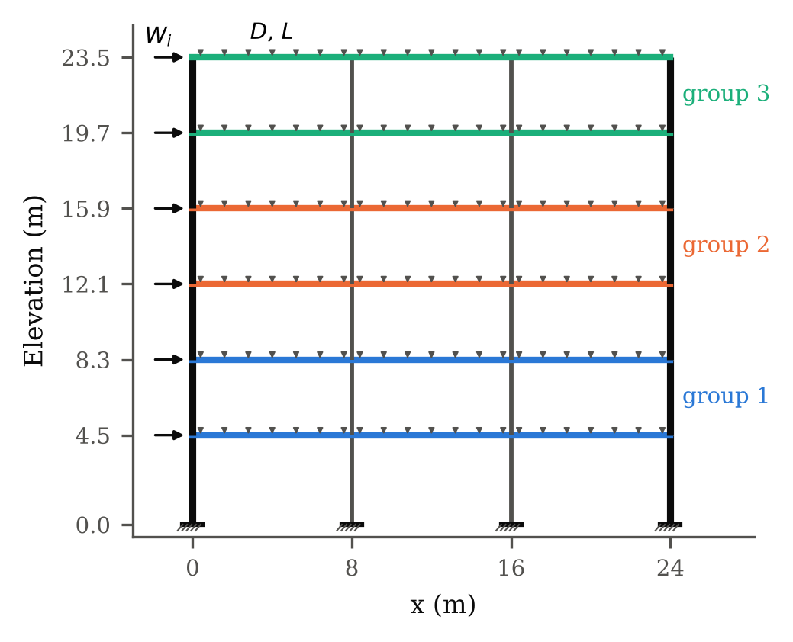
Figure 1. Base frame (six storeys, three 8-m bays). Thick lines: exterior columns; colours indicate the three storey groups, each with an exterior-column, interior-column and beam design variable. Gravity loads act on the beams; wind storey forces $W_{i}$ are applied at the floor levels.
Table 2. Frames of the parametric study (one parameter varied at a time from the base frame).
Frame | Storeys | Bays | Bay (m) | $p_{w}$ (kPa) | Groups | Variables
3 storeys | 3 | 3 | 8 | 1.2 | 2 | 6
Base | 6 | 3 | 8 | 1.2 | 3 | 9
9 storeys | 9 | 3 | 8 | 1.2 | 3 | 9
Bay 6 m | 6 | 3 | 6 | 1.2 | 3 | 9
Bay 10 m | 6 | 3 | 10 | 1.2 | 3 | 9
$p_{w}$ = 0.8 kPa | 6 | 3 | 8 | 0.8 | 3 | 9
$p_{w}$ = 1.6 kPa | 6 | 3 | 8 | 1.6 | 3 | 9

Structural analysis by superposition of PyNite unit cases
For each candidate design $x$, PyNite (Brinck 2026) solves five first-order linear elastic load cases with nominal stiffness: dead load $D$ (including self-weight), live load $L$, wind $W$, and two lateral cases $N_{D}$ and $N_{L}$ whose floor forces equal the dead and live gravity load of each floor. Any realisation of the loading, with intensities $\left(d,ℓ,w\right)$ (multiples of the nominal $D$, $L$, $W$) and a global out-of-plumbness angle $θ$, then produces the first-order response
$$r=\underset{r_{nt}}{\underset{⏟}{d r_{D}+ℓ r_{L}}}+\underset{r_{lt}}{\underset{⏟}{w r_{W}+θ \left(d r_{N_{D}}+ℓ r_{N_{L}}\right)}}, \text{(1)}$$
split into the no-translation part $r_{nt}$ and the lateral-translation part $r_{lt}$ required by the approximate second-order analysis of AISC 360 Appendix 8. Because member forces of a frame with uniformly scaled modulus $eE$ are independent of $e$ and displacements scale with $1/e$, a global random modulus factor is also represented exactly. Responses extracted per unit case are column end moments, axial and shear forces; beam moments at 11 stations along the span, axial and end shear forces; mid-span beam deflections relative to the chord; and floor-average inter-storey drifts.
Equation (1) is exact for the first-order linear analysis: it reproduces the linear response of any realisation without approximation. This exactness does not extend to the second-order response. The $B_{1}$–$B_{2}$ amplification below is an approximation of the full P-$Δ$ analysis, and its error is quantified in Section 3.3.
Second-order effects are introduced with the $B_{1}$–$B_{2}$ method. For storey $i$,
$$B_{2,i}={\left(1−\frac{P_{story,i}}{P_{e,story,i}}\right)}^{−1}, P_{e,story,i}=R_{M} τ e \frac{H_{i}h_{i}}{Δ_{H,i}}, \text{(2)}$$
where $P_{story,i}$ is the total gravity load carried by the storey, $H_{i}/Δ_{H,i}$ the first-order lateral stiffness obtained from the $W$ case, $h_{i}$ the storey height and $R_{M}=0.85$. For columns, $B_{1}=C_{m}/\left(1−P_{r}/P_{e1}\right)≥1$ with $C_{m}=0.6−0.4M_{1}/M_{2}$ computed from the no-translation end moments and $P_{e1}=π^{2}τeEI/L^{2}$. Required strengths are $M_{r}=B_{1}M_{nt}+B_{2}M_{lt}$ and $P_{r}=P_{nt}+B_{2}P_{lt}$; beams use the larger $B_{2}$ of the two storeys they connect. A storey with $P_{story}≥P_{e,story}$ is unstable and is treated as failure.
The amplifiers are recomputed for every sample: $P_{story}$, $P_{r}$ and $C_{m}$ follow the sampled gravity loads, and $P_{e,story}$ and $P_{e1}$ follow the sampled modulus factor $e$. The assumptions behind this use of the method are that (a) the lateral stiffness of a storey scales with the frame-wide modulus factor and is otherwise that of the nominal sections, (b) the gravity load is distributed over the columns as in the first-order analysis, (c) member stiffness is not reduced by yielding before the first member limit state is reached, and (d) the storey amplification is the same for all columns of a storey (rigid floor). Assumptions (a) and (b) are removed in the full re-analysis of Section 3.3, where every member has its own modulus and property factor and the P-$Δ$ (and, through the element geometric stiffness, P-$δ$) effects are computed directly; assumption (c) is inherent in the elastic ULS definition below. In deterministic design, the Direct Analysis Method (DAM) (American Institute of Steel Construction 2016; Surovek-Maleck and White 2004) is followed: stiffness is reduced by $τ=0.8$, notional loads of $0.002Y_{i}$ are applied in gravity-only combinations and an additional $0.001Y_{i}$ in all combinations so that $τ_{b}=1$ may be used; effective length factors are then $K=1$. In the reliability analysis the best-estimate stiffness ($τ=1$) is used and the notional loads are replaced by the random out-of-plumbness $θ$.

Member resistances and limit states
Nominal resistances follow AISC 360-16: compression from Chapter E3 with $K=1$, strong-axis buckling over the storey height and weak-axis buckling between floors (columns) or between secondary beams at third points (beams); flexure from F2 (lateral–torsional buckling, $C_{b}=1$) and F3 (flange local buckling); shear from G2.1; and combined forces from the H1-1 interaction equations. Beam axial forces are small (largest beam $P_{r}/P_{c}$ of the optimised designs below 0.07), so the slender-web reduction of beam compression capacity is not modelled. For the deterministic checks the LRFD resistance factors $ϕ_{c}=ϕ_{b}=ϕ_{t}=0.9$ and $ϕ_{v}=1.0$ or $0.9$ (G2.1) are applied to the ASCE 7-05 (American Society of Civil Engineers 2006) strength combinations $1.4D$, $1.2D+1.6L$, $1.2D+0.5L±1.6W$ and $0.9D±1.6W$ (roof live load is treated as part of $L$). Serviceability requires inter-storey drift $≤h/400$ under $D+0.5L+W$ and beam live-load deflection $≤$ span/360.
Code basis. AISC 360-16 and ASCE 7-05 are used as a fixed, internally consistent benchmark, not as the current provisions. Both have since been superseded (AISC 360-22 (American Institute of Steel Construction 2022) and ASCE/SEI 7-22 (American Society of Civil Engineers 2022)). From ASCE 7-10 onwards, wind loads are based on strength-level wind speeds with a load factor of 1.0, so moving to a later edition would change the definition of the nominal wind load $W$ together with the wind-load statistics of Table 3, not only a load factor. Throughout this paper, “code-compliant” and “code checks” mean compliance with the AISC 360-16 checks listed above under the ASCE 7-05 combinations. The designs have not been checked against AISC 360-22 or ASCE/SEI 7-22.
For each realisation the member utilisation $U_{k}$ is the larger of the H1-1 interaction ratio and the shear ratio, both evaluated with nominal (unfactored) resistances that depend on the random yield stress, modulus and fabrication factor of the member. Three limit-state functions are defined:
$$\begin{matrix}g_{ULS} & =1−\max_{s∈\{S_{1},S_{2}\}}\max_{k}U_{k}^{\left(s\right)}, \text{(3)} \\ g_{drift} & =1−\max_{i}\frac{δ_{i}^{\left(S_{2}\right)}/h_{i}}{1/400}, \text{(4)} \\ g_{defl} & =1−\max_{j}\frac{δ_{L,j}}{ℓ_{j}/360}. \text{(5)}\end{matrix}$$
The load scenarios are constructed with Turkstra’s rule (Turkstra and Madsen 1980): $S_{1}=D+L_{50}$ (50-year maximum live load) and $S_{2}=D+L_{apt}+W_{50}$ (arbitrary-point-in-time live load with the 50-year maximum wind); the out-of-plumbness acts in both. The ULS event is the union of the member events over all members and both scenarios. It is constructed sample by sample, so the dependence between members (common loads, common modulus, partly correlated yield stress) and between the scenarios (common $D$, $E$, $F_{y}$, fabrication factor and $θ$) is represented exactly by the joint sampling; no bounds or independence assumptions of series-system theory are needed. Turkstra’s rule itself neglects the probability that the 50-year live load and the 50-year wind coincide, which is small for the statistics used. The drift SLS is evaluated in $S_{2}$ and the deflection SLS under $L_{50}$.
$g_{ULS}$ is a first-member-failure, second-order elastic, component-based limit state: the frame is deemed to fail when the first member reaches a code-format resistance, evaluated with the AISC interaction equations and nominal (unfactored) resistances. It is not a collapse analysis. It does not credit inelastic redistribution, and residual stresses and member out-of-straightness enter only through the column-curve and LTB equations of AISC 360, not through an explicit imperfect model. Connections are rigid and do not fail. Throughout this paper $β_{ULS}$ denotes the reliability index of this event. It is consistent with the member-based calibration of current codes (Ellingwood et al. 1980), but it is a lower bound-type measure of the collapse reliability, which inelastic system analyses report to be higher (Buonopane and Schafer 2006; Zhang et al. 2016).

Probabilistic model
Table 3 lists the basic random variables, their sources, and which parameters are assumptions of this study. The load statistics are those of the probability-based load criterion of Ellingwood et al. (1980) for dead load, 50-year live load and 50-year wind, together with the arbitrary-point-in-time live load (gamma, mean $0.24L_{n}$, c.o.v. 0.60) and the fabrication (geometric) factor (c.o.v. 0.05). These statistics were used to calibrate the LRFD load factors, so using them makes the comparison between code-based and reliability-based designs internally consistent. The c.o.v. of yield stress (0.07) and modulus (0.03) and the lognormal model are those of the JCSS Probabilistic Model Code (Joint Committee on Structural Safety 2001). The mean-to-nominal ratio of $F_{y}$ (1.10) and the inter-member equicorrelation of $lnF_{y}$ ($ρ=0.5$) are assumptions; both are varied in the sensitivity study. The initial out-of-plumbness is normal with zero mean and standard deviation 1/1000, so that the erection tolerance of 1/500 corresponds to two standard deviations.
Dependence. The load intensities are fully correlated over the frame, i.e. one realisation of $D$, $L$ and $W$ scales the nominal load pattern. For dead load and wind this is the usual assumption; for live load it neglects the spatial variability between floors and bays and is conservative for the frame-level effects that govern here. The modulus factor is frame-wide in the surrogate (members from one mill order) and member-specific in the full re-analysis; the yield stress and fabrication factor are member-specific, the former with partial correlation to represent a common heat or producer. $θ$ is a single frame-wide sway imperfection.
Aleatory versus epistemic uncertainty. The variables of Table 3 describe physical (aleatory) variability, with their parameters fixed at the cited values. Model-form (epistemic) uncertainty of the structural and resistance models, i.e. the error of the H1-1 interaction equations and of the second-order elastic analysis, is not part of the baseline model, so that the baseline indices are conditional on the structural model, as in the code calibration that is the reference of the comparison. Its effect is quantified separately by frame-wide lognormal model factors with unit mean on resistance ($θ_{R}$), load effect ($θ_{E}$) and drift ($θ_{δ}$), with c.o.v. of 0.05 and 0.10 chosen to bracket plausible values (Section 4.8). Because H1-1 and the shear check are homogeneous of degree one in the demands and of degree minus one in the resistances, the factors act on the utilisation exactly as $Uθ_{E}/θ_{R}$. Parameter uncertainty of the load statistics is addressed by the sensitivity study. The model-factor analysis has two uses in this paper. First, it is a sensitivity study of the final designs (Table 19). Second, for the base frame and the three-storey frame, the factors with c.o.v. 0.05 are included in the reliability constraints themselves (RBDO-C-MU, Section 2.6) to quantify the extra steel needed to keep the targets when this uncertainty is counted. Because the baseline indices exclude model-form uncertainty, they should not be read as estimates of real-world failure rates.
Dependence and spatial variability. The loads are fully correlated over the frame (one dead-load, one live-load and one wind factor per realisation), and the out-of-plumbness is a single frame-wide variable. These assumptions suit the small regular frames studied here. They should not be extrapolated to buildings in which the spatial variability of loads or imperfections is substantial.
Table 3. Basic random variables (50-year reference period), source of each model, and which parameters are assumptions of this study.
Variable | Distribution | Mean/nominal | c.o.v. | Basis | Status
Dead load $D$ | Normal | 1.05 | 0.10 | Ellingwood et al. (1980) | sourced
50-yr max. live load $L_{50}$ | Gumbel | 1.00 | 0.25 | Ellingwood et al. (1980) | sourced
Arbitrary-point-in-time live load $L_{apt}$ | Gamma | 0.24 | 0.60 | Ellingwood et al. (1980) | sourced
50-yr max. wind load $W_{50}$ | Gumbel | 0.78 | 0.37 | Ellingwood et al. (1980) | sourced
Elastic modulus $E$ | Lognormal | 1.00 | 0.03 | JCSS (2001): c.o.v., lognormal | sourced
Yield stress $F_{y}$ (per member) | Lognormal | 1.10 | 0.07 | JCSS (2001): c.o.v., lognormal; mean ratio and $ρ$ | assumed (mean, $ρ$)
Fabrication factor $F$ (per member) | Normal | 1.00 | 0.05 | Ellingwood et al. (1980) | sourced
Out-of-plumbness $θ$ (rad) | Normal | 0 | s.d. 1/1000 | 1/500 tolerance taken as 2 s.d. | assumed
Model factors $θ_{R},θ_{E},θ_{δ}$ (frame-wide) | Lognormal | 1.00 | 0 (0.05, 0.10) | baseline: 0; sensitivity study: 0.05, 0.10; RBDO-C-MU (2 frames): 0.05 | assumed

Reliability estimation, confidence intervals and acceptance
Failure probabilities are estimated by crude Monte Carlo simulation. With $k$ failures in $N$ independent samples, the point estimate is ${\hat{P}}_{f}=k/N$, its c.o.v. is $\sqrt{\left(1−P_{f}\right)/\left(NP_{f}\right)}$, and the reported index is $\hat{β}=−Φ^{−1}\left({\hat{P}}_{f}\right)$. Because $k$ is binomial, an exact (Clopper–Pearson) two-sided $95\%$ confidence interval $\left[P_{f}^{lo},P_{f}^{hi}\right]$ is computed from the beta distribution,
$$P_{f}^{lo}=B^{−1}​\left(0.025; k, N−k+1\right), P_{f}^{hi}=B^{−1}​\left(0.975; k+1, N−k\right), \text{(6)}$$
and mapped to the interval $\left[−Φ^{−1}\left(P_{f}^{hi}\right), −Φ^{−1}\left(P_{f}^{lo}\right)\right]$ of $β$. The one-sided $95\%$ lower confidence bound of $β$ follows from the one-sided upper bound $B^{−1}\left(0.95; k+1, N−k\right)$ of $P_{f}$. When no failure is observed, the point estimate is undefined and only the lower confidence bound is reported (for $N={10}^{6}$, $P_{f}≤3.0×{10}^{−6}$ and $β≥4.53$ with $95\%$ confidence). Every final design is reported with $N$, $k$, the point estimate and the interval.
The limit states are evaluated by the superposition (1) and closed-form resistances, so a sample costs a few vectorised arithmetic operations per member; a design is evaluated with $5×{10}^{4}$ samples in about one second on one CPU core, about four times the cost of the five PyNite analyses.
Sample average approximation. Inside the optimiser the samples are drawn once and reused for every design (common random numbers). This SAA (Kleywegt, Shapiro, and Homem-de-Mello 2002) makes $\hat{β}\left(x\right)$ a deterministic function of the design, so the comparison of two designs is not corrupted by independent sampling noise (their estimates are positively correlated) and the discrete search is well posed. The price is a finite-sample misclassification risk: a design whose true index is just below the target may be accepted because the particular sample is favourable, and the optimiser, which seeks the lightest accepted design, preferentially finds such designs (the optimisation bias of SAA). We control this risk in three ways: (i) every final design is re-verified with $N={10}^{6}$ independent samples; (ii) the SAA problem is re-solved with other sample streams and sizes ($N=2×{10}^{4}$, $5×{10}^{4}$, ${10}^{5}$) to measure the spread of the optima; and (iii) a confidence-bounded variant imposes the targets on the one-sided $95\%$ lower confidence bound of $β$ in the SAA sample instead of the point estimate. To save time, a design is first evaluated on the first ${10}^{4}$ samples and the remainder is computed only if the screening estimate is not clearly infeasible (more than 0.4 below a target index).
Three claims about a target. For a target $β_{T}$ and an estimate from $N$ samples, three statements of different strength are distinguished throughout the paper:
- the point estimate reaches the target, $\hat{β}≥β_{T}$;
- the $95\%$ confidence interval contains the target; the evidence is then inconclusive, because the true index may lie on either side of $β_{T}$;
- the one-sided $95\%$ lower confidence bound exceeds the target, $β^{lcb}≥β_{T}$. Only this statement establishes that the target is met with $95\%$ confidence.
In the independent verification, each design and target is classified as “above” when the lower end of the two-sided interval exceeds the target, so that (L) holds; “within” when the interval contains the target, i.e. case (I); and “below” when the upper end is smaller than the target. A “within” result is not reported as meeting the target. We say that such a design is consistent with the target at the stated sampling resolution, and give the interval.
Two reliability constraints. The optimiser imposes the targets in one of two ways. In the point-estimate formulations (RBDO, RBDO-C) the SAA point estimates must reach the targets, which corresponds to (P) on the SAA sample. In the confidence-bounded formulation (RBDO-C95, Section 2.6) the one-sided $95\%$ lower confidence bounds of the SAA estimates must reach the targets, which corresponds to (L) on the SAA sample. The second formulation is the one to use when the purpose is to demonstrate a prescribed minimum reliability with $95\%$ confidence. Its designs are again verified with ${10}^{6}$ independent samples. Both formulations control only the Monte Carlo sampling uncertainty of the estimates. Neither removes systematic errors of the surrogate or of the models (Sections 3.3 and 4.6), and a lower confidence bound is conditional on the model under which it is computed.
All reliability indices in this paper are conditional on the probabilistic model of Table 3 and on the structural and resistance models. They do not include model-form uncertainty unless this is stated explicitly (Sections 2.4 and 4.8).

Optimisation formulations
The objective is the steel mass mx=ρsk​Akxℓk, used as a proxy for material cost (connection, fabrication and erection costs are considered only in the illustrative cost model of Section 2.7). The formulations are
DDO-h/n: minx m s.t. maxc,kUc,kLRFD≤1, δh≤1n, δL≤ℓ360, (7)RBDO: minx m s.t. βULS≥βT, βdrift≥βSLS, βdefl≥βSLS, (8)RBDO-C: minx m s.t. the constraints of DDO-h/400 and of RBDO, (9)RBDO-C95: minx m s.t. the constraints of DDO-h/400,minx m s.t. βULSlcb≥βT, βdriftlcb, βdefllcb≥βSLS, (10)MO: minx m, −βULS s.t. βdrift,βdefl≥βSLS, βULS≥1, (11)
all subject to column areas that do not increase with height. DDO with $n=400$ (“DDO”) is the code-based design; $n=450$, 500 and 600 represent the range of tighter drift limits used in practice. RBDO-C is the formulation that a designer bound by the code could adopt: the reliability constraints are added to, not substituted for, the mandatory checks, so that every RBDO-C design is code-compliant and its mass is directly comparable with DDO. RBDO without the code checks is retained to show what the reliability constraints alone would select; a design accepted by RBDO but failing an LRFD check would have no regulatory standing under a prescriptive code, although it could be admissible under a reliability-based (performance-based) route of the kind allowed by EN 1990 (CEN 2002). RBDO-C95 replaces the SAA point estimates of RBDO-C by their one-sided $95\%$ lower confidence bounds (Section 2.5). It is the formulation to use when the target is to be demonstrated with $95\%$ confidence. The point-estimate formulation RBDO-C is used for the like-for-like comparisons with DDO, because DDO, too, is judged on nominal values. Two further variants are used for the three-storey frame and the base frame: RBDO-C with an increased ULS target that absorbs the surrogate discrepancy found in the validation (Section 3.3), and RBDO-C with the model factors of Section 2.4 included in the reliability constraints (“RBDO-C-MU”).
The baseline targets are $β_{T}=3.0$ for the ULS, the value adopted by Ellingwood et al. (1980) for gravity load combinations in the calibration of the LRFD load factors (a lower value was accepted for combinations with wind), and $β_{SLS}=1.5$ (50 years), the value given by EN 1990 (CEN 2002) for irreversible serviceability states. Because both targets are choices of the owner or code writer, results are also given for other targets.
DDO and RBDO(-C) are solved with the same elitist genetic algorithm (population 40, binary tournament with Deb’s feasibility rules (Deb 2000), uniform crossover with probability 0.9, per-gene mutation probability $1.5/n_{v}$ of which 70% are steps of $±1$–3 catalogue positions and 30% random resets, and $\left(μ+λ\right)$ replacement). A run stops after 15 generations without improvement of the best design or after 60 generations. The best GA design is then polished by a discrete local search that accepts the first feasible lighter neighbour among single down-sizing moves and down/up-sizing swaps of two variables, repeated until no improvement is found, so every reported optimum is locally optimal with respect to these moves. The GA is a heuristic: convergence of repeated runs indicates robust convergence within the search budget, not a guarantee of global optimality, which is checked only for the reduced problem by enumeration. Accordingly, “optimum”, “optimal design” and “minimum-mass design” denote in this paper the best feasible design found within the tested optimisation budget, not a proven global minimum; “minimum mass” in the title names the objective of the optimisation problem. The bi-objective problem is solved with NSGA-II (Deb et al. 2002) with constrained domination (population 48, 60 generations); all feasible designs visited are archived and the non-dominated archive is re-verified. The SAA samples, the GA operators and the verification samples are all seeded, so every number in this paper is reproducible from the released code.

Illustrative cost model
To test whether conclusions drawn from steel mass carry over to cost, a simple cost index in tonnes of steel equivalent is used,
$$C=m+τ n_{sec}+κ m_{beam}, \text{(12)}$$
where $n_{sec}$ is the number of distinct section designations (procurement, detailing and handling), $m_{beam}$ the beam mass (a proxy for the size of moment connections and their welding, which scale with the beam flange force), and $τ$ and $κ$ are cost ratios. The number of members, connections and pieces is identical for all designs of a frame and therefore does not change the comparison. Equation (12) is not a calibrated cost model. The values of $τ$ (0.25–1 t per section designation) and $κ$ (0–0.25) are hypothetical sensitivity parameters, not estimates of actual fabrication or connection costs, and the ranking obtained with them has not been checked against project costs. The index is used only to show how large the non-mass terms would have to be to change the ranking of the designs. All statements on economy in this paper therefore refer to steel mass or to this illustrative index.

Verification of the structural and reliability models
The conclusions of an optimisation study are only as credible as the models it optimises. Four verification levels were therefore applied before any design comparison was made.

Closed-form benchmarks
Table 4 compares PyNite with closed-form solutions for a cantilever, a fixed–fixed beam under uniform load, and a fixed-base portal frame under lateral load. The portal solution follows from the slope-deflection method for inextensible members, with $k=\left(I_{b}/L\right)/\left(I_{c}/h\right)$,
$$Δ=\frac{Hh^{3}\left(2+3k\right)}{12EI_{c}\left(1+6k\right)}, M_{base}=\frac{Hh\left(1+3k\right)}{2\left(1+6k\right)}, M_{top}=\frac{3kHh}{2\left(1+6k\right)}. \text{(13)}$$
Agreement is at round-off level for the statically simple cases and within ${10}^{−5}$ for the portal, the residual being the axial flexibility that PyNite includes. The second-order response of a cantilever beam-column with axial load $P$ and tip load $H$ has the exact tip sway $Δ=\frac{H}{Pk}\left(tankL−kL\right)$, $k=\sqrt{P/EI}$. PyNite’s P-$Δ$ solver with a single element is within 0.6% of the exact value even at $P=0.6P_{cr}$, and converges to $<2×{10}^{−6}$ with eight elements (Table 4), showing that its geometric stiffness also captures the member (P-$δ$) effect.
Table 4. PyNite versus closed-form solutions ($E=200$ GPa).
Quantity | Closed form | PyNite | Rel. error
Cantilever tip deflection (m) | 0.053333 | 0.053333 | 0.0e+00
Cantilever fixed-end moment (kN m) | 200 | 200 | 0.0e+00
Fixed beam end moment (kN m) | 213.33 | 213.33 | 4.0e-16
Fixed beam mid-span moment (kN m) | 106.67 | 106.67 | 1.1e-15
Fixed beam mid-span deflection (m) | 0.010667 | 0.010667 | 3.3e-16
Portal sway (m) | 0.012698 | 0.012699 | 9.3e-06
Portal column base moment (kN m) | 114.29 | 114.29 | 7.2e-06
Portal column top moment (kN m) | 85.714 | 85.715 | 3.6e-06
Second-order cantilever, tip sway (mm): exact vs PyNite P-$Δ$ with $n$ elements
$P/P_{cr}$ | exact | $n=1$ / $n=2$ / $n=8$ | err. ($n=1$, $n=8$)
0.2 | 25.972 | 25.964 / 25.972 / 25.972 | 3.3e-04, 1.0e-07
0.4 | 34.534 | 34.471 / 34.529 / 34.534 | 1.8e-03, 5.5e-07
0.6 | 51.650 | 51.326 / 51.627 / 51.650 | 6.3e-03, 1.8e-06

Independent solver
The optimised designs were rebuilt in OpenSeesPy (McKenna, Scott, and Fenves 2010; Zhu, McKenna, and Scott 2018) with elastic beam-column elements, element loads for the distributed gravity and self-weight and nodal storey forces, independently of the PyNite model. Table 5 lists the largest relative difference of each response quantity, normalised by the largest absolute value of that quantity in the frame. For all five unit cases the two solvers agree to ${10}^{−13}$–${10}^{−16}$, i.e. to machine precision. (Gravity-load drifts of these symmetric frames are themselves of the order of round-off and are not compared.) For the P-$Δ$ analysis of the combination $1.2D+0.5L+1.6W$, OpenSees used the PDelta coordinate transformation and a load-controlled Newton solution. PyNite’s second-order drifts differ from OpenSees by at most 0.8%, and the $B_{1}$–$B_{2}$ amplified first-order drifts used by the surrogate by at most 1.8% (Fig. 2). The largest differences occur in the upper storeys, where the drifts and hence the governing drift checks are small; in the lower storeys, which govern the drift limit state, the surrogate exceeds the P-$Δ$ solution by up to 1.8%, and it underestimates it by at most 1.0% in any storey. Column base moments behave similarly (at most 1.6%). These differences are an order of magnitude smaller than the sampling resolution of the reliability constraints at the SAA sample size (Section 3.4).
Table 5. Maximum relative differences between PyNite and OpenSeesPy for the optimised base designs and two other frames: linear unit cases and P-$Δ$ analysis of $1.2D+0.5L+1.6W$.
Design | Case | Drift | Column $M$ | Column $N$ | Beam end $M$
Base DDO | D | – | 8.3e-16 | 2.0e-15 | 8.0e-16
 | L | – | 4.7e-16 | 1.6e-15 | 9.6e-16
 | W | 1.8e-14 | 1.1e-14 | 9.8e-15 | 1.4e-14
 | ND | 1.8e-14 | 1.3e-14 | 8.2e-15 | 1.4e-14
 | NL | 1.5e-14 | 1.0e-14 | 8.7e-15 | 1.3e-14
 | P-$Δ$: PyNite | 7.3e-03 | 7.4e-03
 | P-$Δ$: $B_{1}$–$B_{2}$ | 1.8e-02 | 1.6e-02
Base RBDO-C | D | – | 6.7e-16 | 1.4e-15 | 4.7e-16
 | L | – | 6.7e-16 | 1.3e-15 | 6.7e-16
 | W | 4.2e-14 | 4.3e-14 | 3.0e-14 | 4.2e-14
 | ND | 4.2e-14 | 4.2e-14 | 2.9e-14 | 4.1e-14
 | NL | 4.2e-14 | 4.3e-14 | 3.0e-14 | 4.2e-14
 | P-$Δ$: PyNite | 7.1e-03 | 6.2e-03
 | P-$Δ$: $B_{1}$–$B_{2}$ | 1.5e-02 | 1.5e-02
3-storey DDO | D | – | 3.1e-16 | 1.1e-15 | 4.9e-16
 | L | – | 7.7e-16 | 8.8e-16 | 5.5e-16
 | W | 6.0e-15 | 6.9e-15 | 2.8e-15 | 4.0e-15
 | ND | 6.0e-15 | 6.8e-15 | 2.9e-15 | 4.4e-15
 | NL | 6.8e-15 | 7.4e-15 | 3.5e-15 | 4.4e-15
 | P-$Δ$: PyNite | 5.7e-03 | 6.2e-03
 | P-$Δ$: $B_{1}$–$B_{2}$ | 9.4e-03 | 1.5e-02
9-storey DDO | D | – | 9.5e-16 | 2.0e-15 | 1.1e-15
 | L | – | 1.4e-15 | 2.8e-15 | 2.0e-15
 | W | 1.7e-13 | 1.1e-13 | 1.3e-13 | 1.4e-13
 | ND | 1.7e-13 | 1.2e-13 | 1.3e-13 | 1.4e-13
 | NL | 1.7e-13 | 1.2e-13 | 1.3e-13 | 1.4e-13
 | P-$Δ$: PyNite | 8.1e-03 | 7.5e-03
 | P-$Δ$: $B_{1}$–$B_{2}$ | 1.8e-02 | 1.5e-02
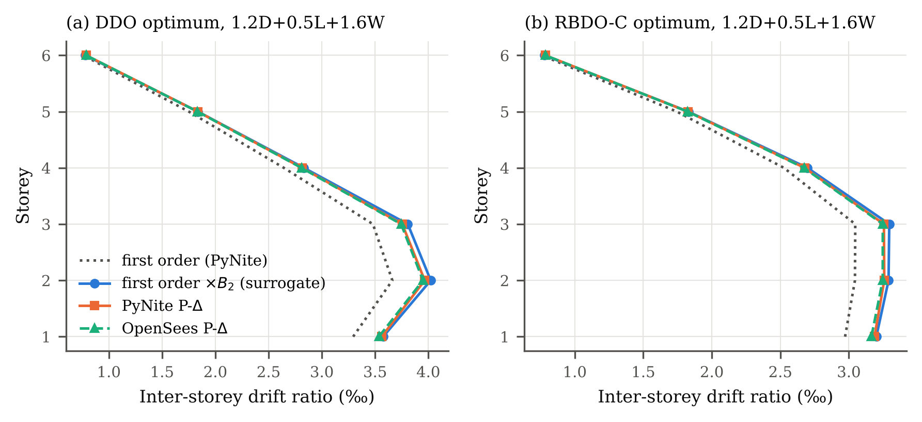
Figure 2. Inter-storey drift profiles of the base designs under $1.2D+0.5L+1.6W$: first-order PyNite, the $B_{2}$-amplified surrogate, PyNite P-$Δ$ and OpenSees P-$Δ$. PyNite and OpenSees P-$Δ$ differ by at most 0.8%. The surrogate differs from them by at most 1.8%, with the largest relative differences in the upper storeys; it underestimates the drift by at most 1.0%.

Reliability surrogate versus full second-order re-analysis
The surrogate rests on three simplifications: second-order effects through $B_{1}$–$B_{2}$, a modulus that is uniform over the frame, and nominal section stiffness (the fabrication factor enters the resistance only). In the full model, every sample is analysed with a PyNite P-$Δ$ analysis in which every member receives its own modulus factor (c.o.v. 0.03) and its fabrication factor is applied to $A$ and $I$; the surrogate is evaluated on the same samples with the mean of the member modulus factors. Because agreement of mean responses does not guarantee agreement of small failure probabilities, the comparison was designed around the failure classification and the tail, for eight final designs from six frame configurations (the base DDO design and the RBDO-C designs of all seven frames, including nine storeys, 10-m bays and high wind):
- a random set of 600 samples of scenario $S_{2}$, which compares utilisation and drift and, because $β_{drift}≈1.5$ for these designs, the drift classification at the actual SLS constraint level;
- a tail-stratified set drawn from a pool of $2×{10}^{5}$ samples: stratum A contains all samples the surrogate classifies as ULS failures ($U_{s}≥1$; up to 250 analysed), and stratum B the near misses $0.85≤U_{s}<1$ (250 analysed at random). Both scenarios are re-analysed when their surrogate utilisation is in the tail. With the stratum probabilities known from the pool, the full-model failure probability is estimated as ${\hat{P}}_{f}^{full}=P\left(A\right){\hat{f}}_{A}+P\left(B\right){\hat{f}}_{B}$, where $\hat{f}$ is the fraction of full-model failures in a stratum. A $95\%$ interval of ${\hat{P}}_{f}^{full}$, of the ratio ${\hat{P}}_{f}^{full}/{\hat{P}}_{f}^{sur}$ and of the difference in $β$ is obtained by propagating Jeffreys posteriors of the stratum fractions and of the pool counts by simulation;
- an excluded-stratum check. The estimator above assumes that samples with $U_{s}<0.85$ do not fail in the full model. This is an assumption, not a bound: a sample with $U_{s}<0.85$ fails only if $U_{full}/U_{s}≥1/0.85=1.18$, and no finite sample can exclude that. It is therefore tested in two ways. First, 300 samples of the stratum $C=\{0.70≤U_{s}<0.85\}$ of the same pool are re-analysed, which gives the stratified estimate with the threshold lowered to 0.70. Second, a residual-risk estimate is computed for all unanalysed samples with $U_{s}<0.85$. For this, $ln\left(U_{full}/U_{s}\right)$ is fitted to the re-analysed samples of strata B and C by a normal distribution and, as a deliberately heavy-tailed alternative, by a Student $t$ distribution with three degrees of freedom and the same scale. The probability $P\left(U_{full}/U_{s}≥1/U_{s}\right)$ is then summed over the pool’s histogram of $U_{s}$. The uncertainty of the fitted location and scale is propagated by a nonparametric bootstrap of the log-ratios (4000 resamples). Each bootstrap residual is added to a draw from the posterior of the sampled strata, which gives a $95\%$ interval and a one-sided lower bound for the combined estimate. These quantities are conditional on the $t_{3}$ model of the tail and are therefore called model-conditional confidence intervals and lower bounds. A $t$ distribution with two degrees of freedom is used as a further, more extreme case, for which only point estimates are reported.
The base RBDO-C design was in addition analysed under doubled wind (1000 samples) as a stress test that produces failure fractions large enough to be compared directly.
Table 7 and Fig. 3 summarise the results. Over all designs the surrogate overestimates the system utilisation by 0.4–1.1% on average (standard deviation of the difference 1.0–1.6%) and is unbiased for drift ($−1.0$ to $+1.4\%$, standard deviation 1.9–3.1%). In the random sets, 0 to 7 of 600 drift classifications differ (at most 1.2%), and the numbers of drift exceedances agree within their sampling scatter. In the tail, 79–91% of the surrogate failures are also failures of the full model and at most 4 of 250 near misses fail in the full model. The resulting full-model failure probabilities differ from the surrogate ones by $Δβ_{ULS}$ between $−0.07$ and $+0.05$; for seven of the eight designs the $95\%$ interval of $Δβ$ contains zero. The exception is the three-storey frame, for which the full model gives ${\hat{P}}_{f}^{full}=1.64×{10}^{−3}$ against $1.31×{10}^{−3}$ ($Δβ=−0.07$, $95\%$ interval $\left[−0.17,−0.01\right]$): in this strength-governed, low-rise frame, four near misses fail in the full model, so the surrogate is slightly unconservative. Under doubled wind (base design), the failure fractions are 2.1% (surrogate) and 1.7% (full analysis), and the drift exceedance fractions 68.1% and 67.8%.
Tables 7 and 6, and Fig. 3, also contain the two heavier three-storey designs of Section 4.6, so they list ten designs. The statements in this section refer to the eight designs above unless the three-storey designs are named. The excluded-stratum check is summarised in Table 6. None of the $10×300$ re-analysed samples of stratum C fails in the full model, and the largest ratio $U_{full}/U_{s}$ among them is 1.060. Over all $13 042$ re-analysed samples the largest observed ratio is 1.061. This is an observed maximum, not a guarantee. Lowering the threshold to 0.70 therefore leaves the point estimates unchanged. It does, however, widen the $95\%$ intervals considerably (lower ends 0.35–0.53 below the point estimates), because stratum C carries 6–37% of the pool probability and 300 failure-free samples cannot bound a probability of order ${10}^{−3}$ in it. A distribution-free bound of the required tightness would need tens of thousands of full analyses per design. The residual-risk estimate is negligible under the normal model of the ratio ($<{10}^{−23}$).
Why $t_{3}$, and what it is not. The $t_{3}$ model is used as a stress test, not as a validated distribution of the extreme tail of $U_{full}/U_{s}$. It has the same centre and scale as the data but a power-law tail: it assigns probabilities many orders of magnitude larger than the normal model to deviations of 10 or more standard deviations, which are the deviations needed for a sample with $U_{s}<0.85$ to fail. Within the observed range, the $t_{3}$ model is markedly more pessimistic than the data. Over the 5 500 standardised log-ratios of strata B and C of the ten designs, 78 exceed 2, 10 exceed 3 and none exceeds 4 standard deviations (largest 3.84). The normal model predicts 125, 7.4 and 0.2, and the $t_{3}$ model 383, 159 and 77. The data are therefore close to normal up to about four standard deviations and much lighter-tailed than $t_{3}$. Nothing is known about the tail beyond the observed range, and the residual estimates below are conditional on the assumed model.
Under the $t_{3}$ model the residual is $2.7×{10}^{−5}$–$1.8×{10}^{−4}$ (Table 6), i.e. 4–8% of ${\hat{P}}_{f}$ for six of the eight main designs, 23% for nine storeys and 80% for the 6-m bay design, whose $P_{f}$ is small ($8.5×{10}^{−5}$). Adding it lowers ${\hat{β}}_{ULS}^{full}$ by 0.01–0.02 for six designs, by 0.06 for nine storeys and by 0.15 for 6-m bays. Including the bootstrap uncertainty of the fit, the model-conditional intervals are 0.07–0.12 wide on the lower side. Under the more extreme $t_{2}$ model the point estimates fall by a further 0.1–0.5. The target classification of the main designs does not change under $t_{3}$, except for the three-storey design, which is already below the target in the full model. Table 6 keeps the sampled-strata intervals, which are statistical statements about the full model on the analysed strata, separate from the model-conditional estimates, which also depend on the residual model.
In summary, the surrogate reproduces the full second-order reliability within $−0.07$ to $+0.05$ in $β_{ULS}$ on the sampled strata of the eight designs ($−0.09$ for the heavier three-storey design of Section 4.6), and the drift reliability without detectable bias. Where it errs, it errs on the conservative side in six of eight designs. The validation is statistical: it rests on the observed distribution of $U_{full}/U_{s}$, whose tail beyond the observed maximum of 1.06 is modelled, not observed. The three-storey result shows that agreement is not guaranteed. There, the surrogate design with ${\hat{β}}_{ULS}=2.995$ has a full-model index of 2.94 [2.84, 3.01] on the sampled strata (2.92 with the $t_{3}$ residual), so it does not meet the target in the full model. The consequences for the design are examined in Section 4.6. A validation of this kind should accompany any application of the surrogate to frame types outside the tested range.
Table 6. Check of the samples excluded by the tail-stratified estimator (pool $2×{10}^{5}$). Stratum $C$: probability, full-model failures in 300 re-analysed samples, largest observed ratio. Sampled strata only: ${\hat{β}}_{ULS}^{full}$ with threshold 0.85 (strata A, B) and 0.70 (A, B, C), with Jeffreys $95\%$ intervals. These are statistical statements about the analysed strata. Sampled strata + residual: $R_{t_{3}}$ is the model-based failure probability of all unanalysed samples with $U_{s}<0.85$ under a $t_{3}$ model of $ln\left(U_{full}/U_{s}\right)$; the model-conditional interval and one-sided lower bound $β^{lcb}$ also propagate the bootstrap uncertainty of the fit, and are conditional on the $t_{3}$ model (a stress-test assumption, not a validated tail). Last column: point estimate with a $t_{2}$ model.
 | Stratum $C$: $0.70≤U_{s}<0.85$ |  |  | Sampled strata only (Jeffreys 95% CI) |  | Sampled strata + $t$-model residual of $U_{s}<0.85$
Design | $P\left(C\right)$ | $k_{C}/n_{C}$ | max $U_{f}/U_{s}$ | $A,B$ | $A,B,C$ | $R_{t_{3}}$ | $\hat{β}$ [model-cond. 95% CI] ($β^{lcb}$), $t_{3}$ | $\hat{β}$ (point est.), $t_{2}$
Base DDO | 0.299 | 0/300 | 1.032 | 3.060 [2.97, 3.11] | 3.060 [2.68, 3.09] | $8.2×{10}^{−5}$ | 3.038 [2.96, 3.08] (2.97) | 2.894
Base RBDO-C | 0.293 | 0/300 | 1.027 | 3.071 [2.99, 3.12] | 3.071 [2.69, 3.10] | $4.9×{10}^{−5}$ | 3.057 [2.98, 3.10] (2.99) | 2.941
3 storeys RBDO-C | 0.368 | 0/300 | 1.052 | 2.940 [2.84, 3.01] | 2.940 [2.59, 2.99] | $9.0×{10}^{−5}$ | 2.923 [2.83, 2.99] (2.85) | 2.808
9 storeys RBDO-C | 0.173 | 0/300 | 1.060 | 3.426 [3.32, 3.50] | 3.426 [2.92, 3.46] | $7.0×{10}^{−5}$ | 3.369 [3.28, 3.43] (3.29) | 3.082
Bay 6 m RBDO-C | 0.065 | 0/300 | 1.039 | 3.760 [3.64, 3.88] | 3.760 [3.22, 3.82] | $6.8×{10}^{−5}$ | 3.609 [3.53, 3.67] (3.54) | 3.152
Bay 10 m RBDO-C | 0.281 | 0/300 | 1.028 | 3.161 [3.07, 3.21] | 3.161 [2.73, 3.19] | $5.8×{10}^{−5}$ | 3.140 [3.05, 3.19] (3.06) | 2.984
$p_{w}$ = 0.8 kPa RBDO-C | 0.342 | 0/300 | 1.035 | 3.036 [2.93, 3.10] | 3.036 [2.64, 3.07] | $5.9×{10}^{−5}$ | 3.021 [2.92, 3.08] (2.94) | 2.905
$p_{w}$ = 1.6 kPa RBDO-C | 0.214 | 0/300 | 1.027 | 3.227 [3.15, 3.27] | 3.227 [2.82, 3.25] | $2.7×{10}^{−5}$ | 3.215 [3.14, 3.26] (3.15) | 3.089
3 storeys RBDO-C95 | 0.370 | 0/300 | 1.050 | 3.006 [2.89, 3.10] | 3.006 [2.61, 3.07] | $1.8×{10}^{−4}$ | 2.966 [2.86, 3.05] (2.87) | 2.781
3 storeys RBDO-C95, $β_{T}=3.21$ | 0.195 | 0/300 | 1.055 | 3.606 [3.45, 3.73] | 3.606 [2.91, 3.66] | $5.7×{10}^{−5}$ | 3.524 [3.41, 3.61] (3.43) | 3.160

Table 7. Surrogate versus full P-$Δ$ re-analysis with member-by-member random stiffness and section properties. Random set: 600 samples of $S_{2}$ (bias = mean $±$ standard deviation of surrogate/full $−1$; $k_{drift}$ = drift exceedances; discordant = samples classified differently). Tail strata (pool $2×{10}^{5}$): full-model failures / samples analysed. ${\hat{P}}_{f}$ from the pool (surrogate) and the stratified estimator (full model); intervals from Jeffreys posteriors.
 | Random set, scenario $S_{2}$ |  |  |  | Tail strata: full failures
Design | $U$ bias (%) | drift bias (%) | $k_{drift}$ full/sur. | discordant | A: $U_{s}≥1$ | B: $0.85≤U_{s}<1$ | ${\hat{P}}_{f}^{sur}$ | ${\hat{P}}_{f}^{full}$ [95% CI] | $Δβ_{ULS}$ [95% CI]
Base DDO | +1.1 $±$ 1.2 | +1.0 $±$ 2.2 | 96/103 | 7 | 203/233 | 1/250 | 1.17e-03 | 1.11e-03 [9.46e-04, 1.47e-03] | +0.02 [-0.07, +0.04]
Base RBDO-C | +0.8 $±$ 1.1 | -0.6 $±$ 2.2 | 43/37 | 6 | 196/220 | 1/250 | 1.10e-03 | 1.07e-03 [9.12e-04, 1.42e-03] | +0.01 [-0.07, +0.04]
3 storeys RBDO-C | +0.4 $±$ 1.6 | -0.1 $±$ 3.1 | 2/2 | 0 | 227/250 | 4/250 | 1.31e-03 | 1.64e-03 [1.31e-03, 2.27e-03] | -0.07 [-0.17, -0.01]
9 storeys RBDO-C | +0.8 $±$ 1.1 | -1.0 $±$ 1.9 | 38/38 | 4 | 54/68 | 1/250 | 3.40e-04 | 3.07e-04 [2.31e-04, 4.58e-04] | +0.03 [-0.07, +0.08]
Bay 6 m RBDO-C | +1.0 $±$ 1.3 | -0.5 $±$ 2.2 | 36/35 | 1 | 17/21 | 0/250 | 1.05e-04 | 8.50e-05 [5.30e-05, 1.38e-04] | +0.05 [-0.02, +0.11]
Bay 10 m RBDO-C | +1.1 $±$ 1.0 | -0.4 $±$ 2.5 | 27/28 | 1 | 142/171 | 1/250 | 8.55e-04 | 7.87e-04 [6.53e-04, 1.09e-03] | +0.02 [-0.07, +0.06]
$p_{w}$ = 0.8 kPa RBDO-C | +0.8 $±$ 1.1 | +1.4 $±$ 2.5 | 29/31 | 4 | 197/221 | 2/250 | 1.11e-03 | 1.20e-03 [9.79e-04, 1.69e-03] | -0.02 [-0.13, +0.02]
$p_{w}$ = 1.6 kPa RBDO-C | +0.7 $±$ 1.3 | -0.5 $±$ 2.1 | 39/36 | 5 | 125/138 | 0/250 | 6.90e-04 | 6.25e-04 [5.35e-04, 8.05e-04] | +0.03 [-0.03, +0.04]
3 storeys RBDO-C95 | +0.4 $±$ 1.6 | -0.1 $±$ 3.3 | 5/4 | 1 | 161/195 | 5/250 | 9.75e-04 | 1.33e-03 [9.79e-04, 1.94e-03] | -0.09 [-0.21, -0.01]
3 storeys RBDO-C95, $β_{T}=3.21$ | +0.3 $±$ 1.4 | -0.1 $±$ 3.3 | 2/2 | 0 | 21/25 | 2/250 | 1.25e-04 | 1.56e-04 [9.70e-05, 2.76e-04] | -0.06 [-0.21, +0.04]
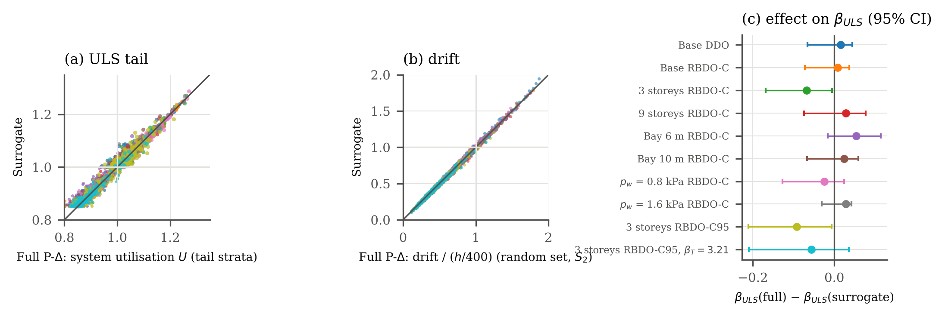
Figure 3. Surrogate versus full P-$Δ$ re-analysis for ten designs (the eight principal designs and the two heavier three-storey designs of Section 4.6): (a) system utilisation of the tail-stratified samples (large dots: stratum A, small dots: stratum B); (b) drift of the random sets; (c) difference of the ULS reliability index with $95\%$ interval. Colours identify the designs as labelled in (c).
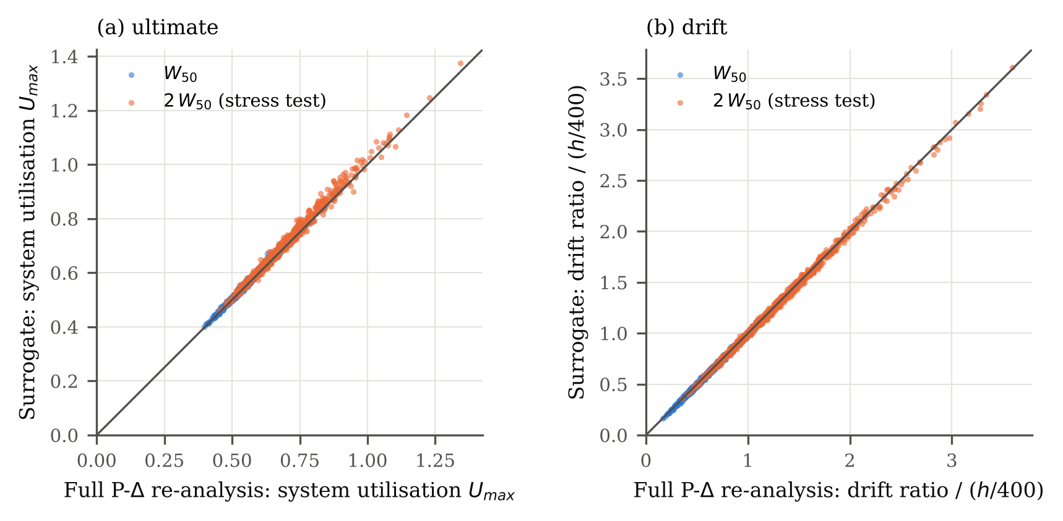
Figure 4. Surrogate versus full P-$Δ$ re-analysis for the base RBDO-C design under the 50-year wind and under doubled wind (1000 samples each).

Monte Carlo convergence and sampling resolution
Fig. 5 shows the reliability indices of the base DDO and RBDO-C designs as functions of the sample size for five independent random streams. At the SAA sample size ($N=5×{10}^{4}$) the five streams give ${\hat{β}}_{ULS}$ between 2.97 and 3.16, i.e. a resolution of about $±0.1$ with which the optimiser can enforce $β_{T}=3$; at $N={10}^{6}$ they agree within 3.02–3.05 (c.o.v. of ${\hat{P}}_{f}$ about 3%). The drift index converges much faster because its failure probability is larger. The SAA estimate therefore guides the search, and the independent ${10}^{6}$-sample estimate with its confidence interval is the one reported.
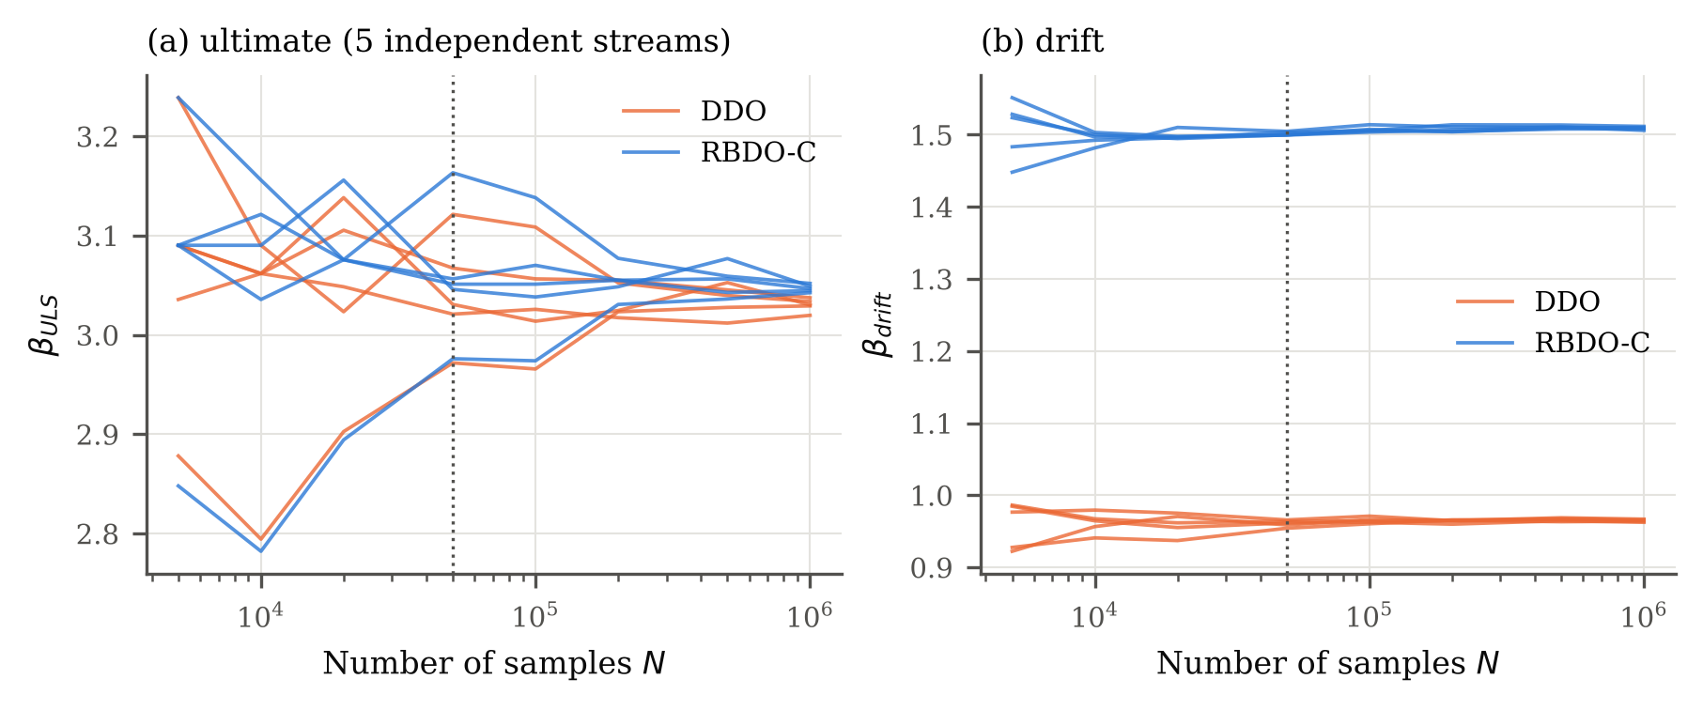
Figure 5. Convergence of the Monte Carlo reliability indices of the base designs (five independent streams each). The dotted line marks the SAA sample size used in the optimiser.

Results

Optimiser robustness and global-search credibility
Table 8 reports repeated runs. For the base frame, ten DDO runs gave the best mass of 18 261 kg in eight runs and 18 321 kg (+0.3%) in two, and five RBDO-C runs with different GA seeds all returned the same design (18 787 kg). For the other frames, two independent RBDO-C runs gave the same design in four of six frames; in the 6-m bay frame they differed by 0.1% and in the high-wind frame a third run was made because the first two differed: the three runs gave 21 738, 21 774 and 22 078 kg (spread 1.6%), the lightest coinciding with the design found by RBDO without code constraints. The GA with local search is thus robust within the tested budget for most frames, but not infallible; the reported optimum is always the lightest design found over all runs, and it is a local optimum with respect to the moves of the local search.
For the reduced problem (one section group, three variables, 11 200 designs), the exact optimum was obtained by evaluating the designs in order of increasing mass until the first feasible one (Table 9). All ten GA runs of each formulation found the exact optimum, already before the local search, using about 700 of the 11 200 designs. The DDO optimum (21 289 kg) is preceded by 739 lighter, infeasible designs and the RBDO and RBDO-C optima (both 22 383 kg, +5.1%) by 960. Grouping all storeys into one section group also shows the value of the design grouping: the six-storey frame with three groups is 14% (DDO) and 16% (RBDO-C) lighter.
The SAA settings were varied for the base frame (Table 10). With $N=2×{10}^{4}$, $5×{10}^{4}$ (three independent sample streams) and ${10}^{5}$, RBDO-C returned the same design, whose SAA estimates of $β_{ULS}$ ranged from 3.01 to 3.13 with the stream and size, while the independent verification gives $3.049$ $\left[3.03,3.07\right]$. Imposing the targets on the one-sided $95\%$ lower confidence bounds in the SAA sample selected a heavier design (19 079 kg, +1.6%) with ${\hat{β}}_{ULS}=3.125$ $\left[3.11,3.14\right]$ and ${\hat{β}}_{drift}=1.551$; this is the price of statistical conservatism at $N=5×{10}^{4}$ for this frame.
A DDO run took 2–12 min and an RBDO-C run 10–56 min (median 32 min) on one CPU core, the reliability evaluation accounting for a median of 83% of the RBDO-C time.
Table 8. Repeated optimisation runs (masses in kg). Distinct finals = number of different final designs; runs at best = runs that returned the lightest design. Designs eval. = mean number of distinct designs evaluated per run.
Problem | Formulation | Runs | Best (kg) | Median (kg) | Worst (kg) | Distinct finals | Runs at best | Designs eval.
3 storeys (9 var.) | DDO | 2 | 7995 | 7995 | 7995 | 1 | 2 | 1556
3 storeys (9 var.) | RBDO-C | 2 | 8188 | 8188 | 8188 | 1 | 2 | 1346
Base (9 var.) | DDO | 10 | 18261 | 18261 | 18321 | 2 | 8 | 2130
Base (9 var.) | RBDO | 2 | 18787 | 18787 | 18787 | 1 | 2 | 2074
Base (9 var.) | RBDO-C | 5 | 18787 | 18787 | 18787 | 1 | 5 | 2109
9 storeys (9 var.) | DDO | 2 | 32987 | 32987 | 32987 | 1 | 2 | 2247
9 storeys (9 var.) | RBDO-C | 2 | 35450 | 35450 | 35450 | 1 | 2 | 1950
Bay 6 m (9 var.) | DDO | 2 | 13707 | 13707 | 13707 | 1 | 2 | 1937
Bay 6 m (9 var.) | RBDO-C | 2 | 14668 | 14674 | 14680 | 2 | 1 | 2220
Bay 10 m (9 var.) | DDO | 2 | 25639 | 25639 | 25639 | 1 | 2 | 1938
Bay 10 m (9 var.) | RBDO-C | 2 | 26065 | 26065 | 26065 | 1 | 2 | 2080
$p_{w}$ = 0.8 kPa (9 var.) | DDO | 2 | 17788 | 17788 | 17788 | 1 | 2 | 1999
$p_{w}$ = 0.8 kPa (9 var.) | RBDO-C | 2 | 17989 | 17989 | 17989 | 2 | 2 | 1979
$p_{w}$ = 1.6 kPa (9 var.) | DDO | 2 | 19743 | 19803 | 19862 | 2 | 1 | 2153
$p_{w}$ = 1.6 kPa (9 var.) | RBDO-C | 3 | 21738 | 21774 | 22078 | 3 | 1 | 2103
Reduced (3 var.) | DDO | 10 | 21289 | 21289 | 21289 | 1 | 10 | 670
Reduced (3 var.) | RBDO | 10 | 22383 | 22383 | 22383 | 1 | 10 | 673
Reduced (3 var.) | RBDO-C | 10 | 22383 | 22383 | 22383 | 1 | 10 | 717

Table 9. Reduced problem (base frame with one section group): exact optimum by mass-ordered enumeration and success of ten GA runs per formulation (with and without the final local search).
Formulation | Designs | Exact optimum (kg) | Lighter designs (infeasible) | GA runs reaching it | GA without local search
DDO | 11200 | 21289 | 739 | 10/10 | 10/10
RBDO | 11200 | 22383 | 960 | 10/10 | 10/10
RBDO-C | 11200 | 22383 | 960 | 10/10 | 10/10

Table 10. Base frame RBDO-C: effect of the SAA sample size, the SAA sample stream and the acceptance rule (point estimate or one-sided $95\%$ lower confidence bound, LCB). Verified indices from ${10}^{6}$ independent samples; vs. targets: a = above, w = within, b = below the target ($95\%$ interval), for ULS/drift.
SAA setting | Mass (kg) | SAA ${\hat{β}}_{ULS}$, ${\hat{β}}_{drift}$ | $k_{ULS}$ | Verified ${\hat{β}}_{ULS}$ [95% CI] | $k_{drift}$ | Verified ${\hat{β}}_{drift}$ [95% CI] | vs. targets
$N=20 000$, stream A | 18787 | 3.01, 1.51 | 1148 | 3.049 [3.03, 3.07] | 65968 | 1.507 [1.50, 1.51] | a/a
$N=50 000$, stream A | 18787 | 3.07, 1.50 | 1148 | 3.049 [3.03, 3.07] | 65968 | 1.507 [1.50, 1.51] | a/a
$N=50 000$, stream A | 19039 | 3.07, 1.51 | 1154 | 3.047 [3.03, 3.06] | 65695 | 1.509 [1.50, 1.51] | a/a
$N=50 000$, stream C | 18787 | 3.13, 1.51 | 1148 | 3.049 [3.03, 3.07] | 65968 | 1.507 [1.50, 1.51] | a/a
$N=50 000$, stream B | 18787 | 3.08, 1.51 | 1148 | 3.049 [3.03, 3.07] | 65968 | 1.507 [1.50, 1.51] | a/a
$N=100 000$, stream A | 18787 | 3.04, 1.50 | 1148 | 3.049 [3.03, 3.07] | 65968 | 1.507 [1.50, 1.51] | a/a
$N=50 000$, stream A, 95% LCB | 19079 | 3.13, 1.54 | 888 | 3.125 [3.11, 3.14] | 60506 | 1.551 [1.55, 1.55] | a/a
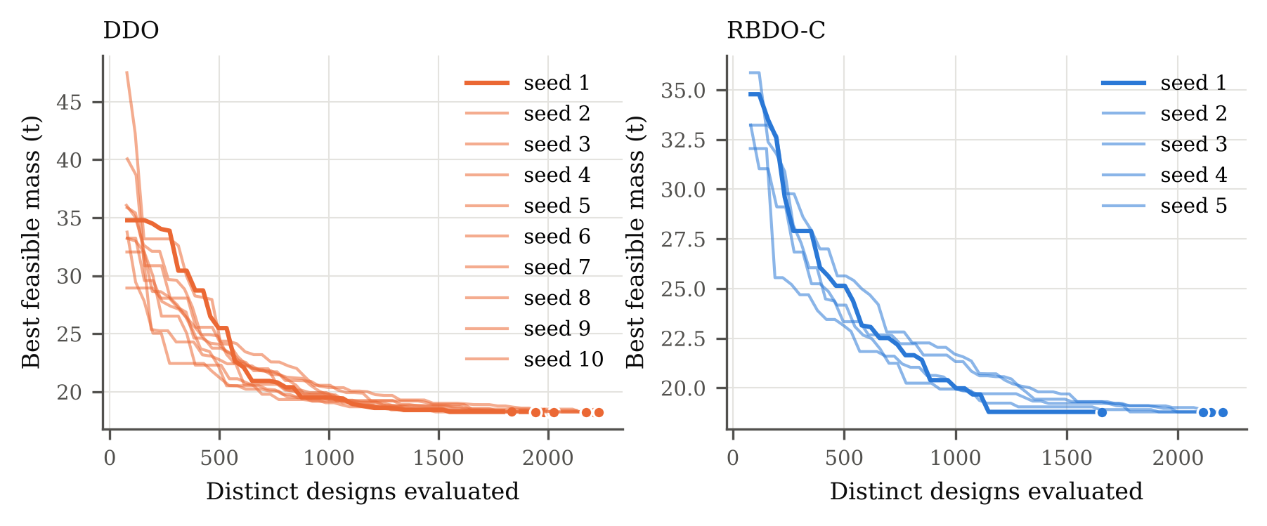
Figure 6. Convergence of the GA for the base frame (best feasible mass; ten DDO and five RBDO-C runs); dots mark the final designs after local search.

Deterministic versus code-compliant reliability-based design of the base frame
Table 11 compares the DDO and RBDO-C optima of the base frame. The DDO design weighs 18 261 kg; its governing LRFD ratio is 0.993 and its drift is 0.97 of the $h/400$ limit, so both strength and drift are active. Verified with ${10}^{6}$ independent samples, it has $k=1242$ ULS failures, ${\hat{β}}_{ULS}=3.025$ $\left[3.01,3.04\right]$, statistically above the target, but its 50-year drift reliability is only ${\hat{β}}_{drift}=0.962$ (${\hat{P}}_{f}=0.17$): a drift check at the nominal 50-year wind leaves about a one-in-six chance that the drift limit is exceeded during the reference period. The reason is that the 50-year maximum wind has a mean-to-nominal ratio of 0.78 but a c.o.v. of 0.37, so the nominal wind is exceeded with a probability of about 0.19, and serviceability checks carry no load factor.
The RBDO-C design ($β_{T}=3.0$, $β_{SLS}=1.5$) weighs 18 787 kg (+2.88%), satisfies all LRFD checks (strength ratio 0.977) and has ${\hat{β}}_{ULS}=3.049$ $\left[3.03,3.07\right]$ ($k=1148$) and ${\hat{β}}_{drift}=1.507$ $\left[1.50,1.51\right]$; both reliability constraints are active and both targets are met with $95\%$ confidence in the baseline surrogate model. The drift index is only 0.007 above its target, so a 1% underestimate of the drift by the $B_{1}$–$B_{2}$ surrogate would put it below (Section 4.6). It is the same design as found by RBDO without code constraints, so for the base frame the code checks are not binding once the reliability targets are imposed. The additional steel is placed where it buys stiffness most cheaply: the lower-storey beams are deepened (W21$×$50 to W24$×$55) and the interior columns of storeys 3–4 increased; its deterministic drift ratio is 0.80 of $h/400$, i.e. $h/500$. The exceedance curves of Fig. 7 show that the two designs have virtually identical distributions of the system utilisation, whereas the drift distribution of the RBDO-C design is shifted to the left over its whole range.
Table 11. Optimum designs of the base frame and their deterministic and probabilistic performance (${10}^{6}$ independent samples; exact $95\%$ confidence intervals; for zero failures the one-sided $95\%$ lower confidence bound of $β$ is given).
 | DDO |  |  | RBDO-C
Storeys | Ext. col. | Int. col. | Beam | Ext. col. | Int. col. | Beam
1-2 | W14X61 | W14X90 | W21X50 | W14X61 | W14X90 | W24X55
3-4 | W14X48 | W14X61 | W21X44 | W14X48 | W14X68 | W21X44
5-6 | W14X48 | W14X48 | W21X44 | W14X48 | W14X48 | W21X44
Steel mass (kg) | 18261 |  |  | 18787
Distinct sections | 5 |  |  | 6
LRFD strength ratio | 0.993 |  |  | 0.977
Drift ratio / limit (D+0.5L+W) | 0.972 |  |  | 0.798
Deflection / limit (L) | 0.156 |  |  | 0.156
Max. $B_{2}$ (DAM) | 1.186 |  |  | 1.151
ULS failures $k$ in $N={10}^{6}$ | 1242 |  |  | 1148
${\hat{P}}_{f,ULS}$ [95% CI] | 1.242e-03 [1.174e-03, 1.313e-03] |  |  | 1.148e-03 [1.083e-03, 1.216e-03]
${\hat{β}}_{ULS}$ [95% CI] | 3.025 [3.01, 3.04] |  |  | 3.049 [3.03, 3.07]
Drift failures $k$ | 167961 |  |  | 65968
${\hat{β}}_{drift}$ [95% CI] | 0.962 [0.96, 0.97] |  |  | 1.507 [1.50, 1.51]
Deflection failures $k$; $β_{defl}$ | 0; $≥$4.53 |  |  | 0; $≥$4.53
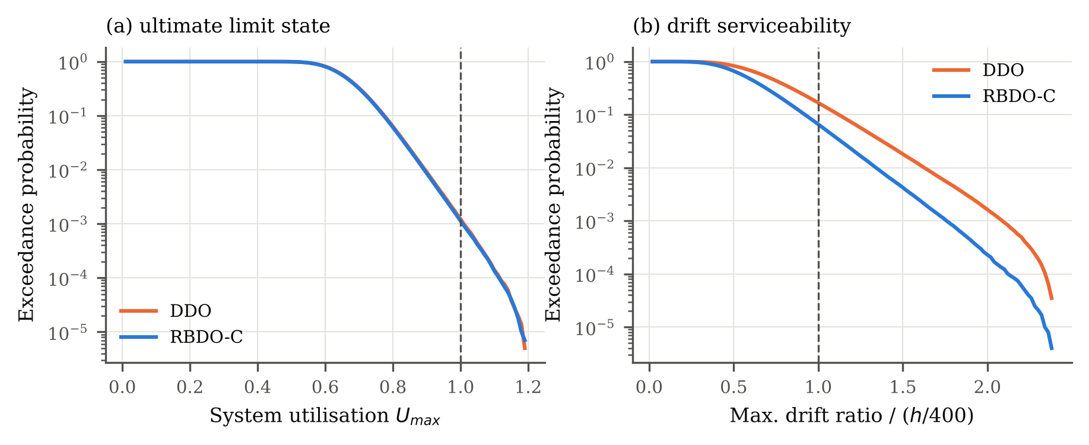
Figure 7. Exceedance probabilities of the system utilisation (ULS) and of the maximum inter-storey drift (normalised by $h/400$) of the base DDO and RBDO-C designs over 50 years (${10}^{6}$ samples).
Fig. 8 relates the member utilisations of the deterministic check to their probabilistic counterparts. The 99.9% quantile of the member utilisation lies 5–15% below the LRFD ratio for most members, which reflects the margin built into the partial factors. In 96% of the failed samples of both designs the governing member is a beam (Table 15), mostly the W21$×$44 beams at floor levels 3–5. The gravity scenario $S_{1}$ alone causes 79% (DDO) and 95% (RBDO-C) of the failures; stiffening the frame against drift removes most wind-scenario failures without changing the gravity-governed ULS reliability.
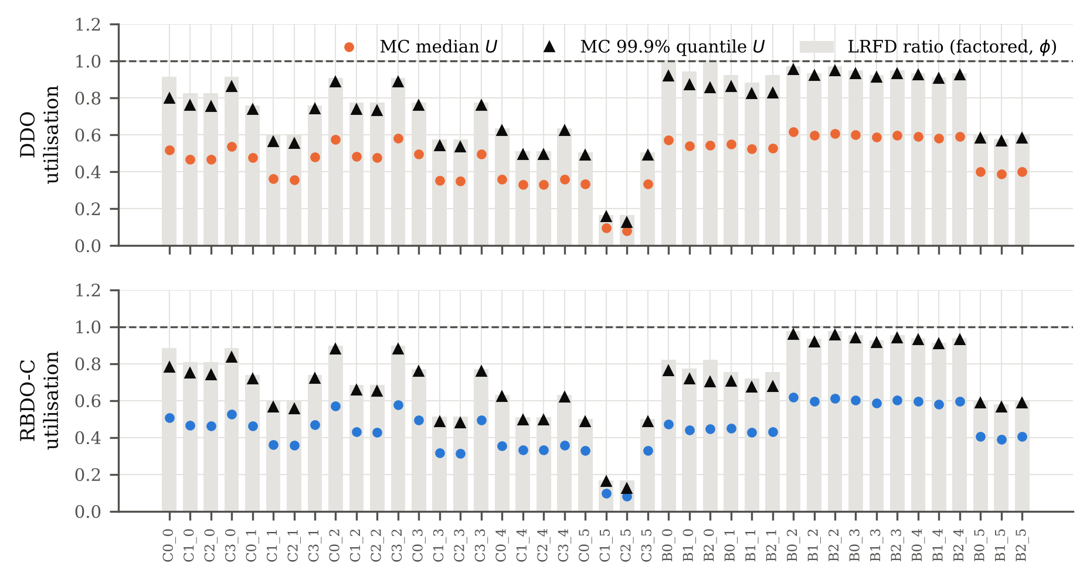
Figure 8. Member utilisations of the base designs: governing LRFD ratio (bars) and median and 99.9% quantile of the probabilistic utilisation. Member labels: C$i_s$ is the column on line $i$ in storey $s$, B$i_s$ the beam in bay $i$ at floor $s$ (counted from 0).

Cost–reliability trade-off
Fig. 9 shows the non-dominated designs of the bi-objective problem (mass versus $β_{ULS}$, subject to $β_{drift},β_{defl}≥1.5$), re-verified with $4×{10}^{5}$ independent samples and shown with their $95\%$ intervals, together with all feasible designs visited by NSGA-II (SAA estimates). The lightest front design (18 747 kg) fails the LRFD strength check (ratio 1.10) and has ${\hat{β}}_{ULS}=2.36$; all other front designs are code-compliant. Because drift governs the mass once $β_{SLS}=1.5$ is imposed, the code-compliant front is steep: raising ${\hat{β}}_{ULS}$ from 3.06 to 3.36, 3.64 and 3.83 costs +1.3%, +3.5% and +4.2% of steel (19 039, 19 452 and 19 568 kg against 18 787 kg). All front designs have ${\hat{β}}_{drift}$ between 1.51 and 1.57. The verified indices of the high-reliability front designs are lower than their SAA estimates (3.83 against 4.26 for the heaviest), which illustrates the SAA optimisation bias at small failure counts: the SAA sample contains only a few failures there, and the optimiser selects designs for which the particular sample is favourable. The front passes through the RBDO-C optimum, which is an independent check of both optimisers. The DDO optimum lies to the left of the front but is infeasible for it because ${\hat{β}}_{drift}=0.96$.
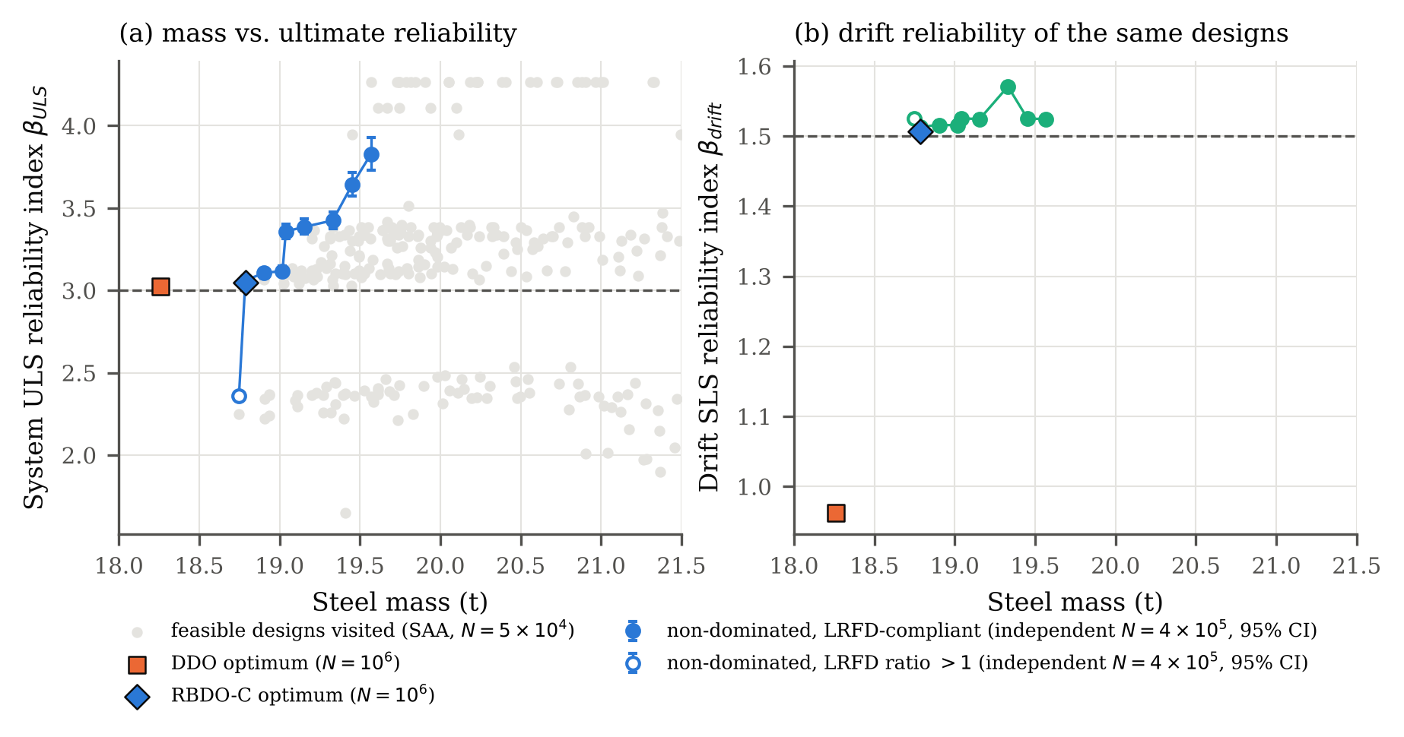
Figure 9. Cost–reliability trade-off of the base frame. (a) Non-dominated designs of the bi-objective problem, re-verified with $4×{10}^{5}$ independent samples ($95\%$ intervals; open marker: fails the LRFD strength check), and all feasible designs visited by NSGA-II (SAA estimates, $N=5×{10}^{4}$; values at the top are capped by the sample size); (b) drift reliability of the same non-dominated designs. The DDO and RBDO-C optima (${10}^{6}$ samples) are shown for reference.

Effect of the reliability targets and of the deterministic drift limit
Table 12 isolates the role of the targets for the base frame. With $β_{T}=3.0$ and $β_{SLS}=0.5$, RBDO returns exactly the DDO design: the best code-based design found is also the best reliability-based design found when the reliability levels it implicitly provides are required. Raising $β_{SLS}$ to 1.0 and 1.5 costs +0.97% and +2.88% of steel, and raising $β_{T}$ to 3.5 at $β_{SLS}=1.5$ costs +6.52% (${\hat{β}}_{ULS}=3.67$, above the target because of the discreteness of the catalogue).
Table 13 and Fig. 10 compare RBDO-C with deterministic optima for drift limits of $h/400$, $h/450$, $h/500$ and $h/600$, all with the same strength and deflection checks. Tightening the drift limit raises $β_{drift}$ of the drift-governed frames in a similar way (about 1.2–1.4 at $h/450$, 1.5 at $h/500$ and 2.0 at $h/600$), but it has no effect on frames governed by strength (three storeys, low wind) and cannot raise their $β_{ULS}$. Two comparisons are made, one for each strength of claim (Section 2.5).
- Weaker claim. Among the deterministic designs whose intervals are not below either target (claims P or I), the lightest is $h/500$ for the base, nine-storey, 6-m bay and high-wind frames and $h/600$ for the 10-m bay and low-wind frames. For the three-storey frame no drift limit reaches $β_{T}$. Compared with that design, RBDO-C is equal (base), lighter by 0.10% (nine storeys), 0.34% (low wind), 1.14% (high wind) and 4.99% (10-m bays), and heavier by 0.58% for the 6-m bays. The 6-m bay $h/500$ design has ${\hat{β}}_{drift}=1.499$ $\left[1.495,1.503\right]$, so its interval contains the target, but its SAA estimate (1.494) was below the target and the point-estimate SAA constraint rejected it.
- Claim L. Among the deterministic designs that meet both targets with $95\%$ confidence, RBDO-C95 is lighter in three frames (by 0.10% to 8.34%) and heavier in two: base ($+1.55\%$, against $h/500$, whose drift lower bound happens to reach 1.5) and high wind ($+0.27\%$). In the three-storey and low-wind frames no deterministic design in this range reaches claim L.
Near-threshold classification can thus change the comparison by up to about 1.5% of mass in either direction. No single drift limit delivers the target reliabilities in all frames, which is what the explicit reliability constraints achieve by construction.
Table 12. Base frame: optimum mass for different reliability targets and drift limits (${10}^{6}$ independent samples; $Δm$ from unrounded masses relative to DDO with $h/400$).
Formulation | $β_{T}$ | $β_{SLS}$ | Mass (kg) | $Δm$ | $k_{ULS}$ | ${\hat{β}}_{ULS}$ [95% CI] | ${\hat{β}}_{drift}$ | LRFD
DDO, drift $h/400$ | – | – | 18261 | +0.00% | 1242 | 3.025 [3.01, 3.04] | 0.962 | 0.993
DDO, drift $h/450$ | – | – | 18626 | +2.00% | 1039 | 3.079 [3.06, 3.10] | 1.410 | 0.973
DDO, drift $h/500$ | – | – | 18787 | +2.88% | 1148 | 3.049 [3.03, 3.07] | 1.507 | 0.977
DDO, drift $h/600$ | – | – | 20664 | +13.16% | 810 | 3.152 [3.13, 3.17] | 2.009 | 0.949
RBDO | 3.0 | 1.5 | 18787 | +2.88% | 1148 | 3.049 [3.03, 3.07] | 1.507 | 0.977
RBDO-C | 3.0 | 1.5 | 18787 | +2.88% | 1148 | 3.049 [3.03, 3.07] | 1.507 | 0.977
RBDO | 3.0 | 0.5 | 18261 | +0.00% | 1242 | 3.025 [3.01, 3.04] | 0.962 | 0.993
RBDO | 3.0 | 1.0 | 18438 | +0.97% | 1113 | 3.058 [3.04, 3.08] | 1.005 | 0.982
RBDO | 3.5 | 1.5 | 19452 | +6.52% | 120 | 3.673 [3.63, 3.72] | 1.518 | 0.894

Table 13. Optimum mass (kg) and verified ${\hat{β}}_{ULS}/{\hat{β}}_{drift}$ of deterministic designs with four drift limits, of RBDO-C and of RBDO-C95 (${10}^{6}$ samples). Bold: both targets met with $95\%$ confidence (claim L). Italic: neither interval below its target, but at least one target not met with $95\%$ confidence. $Δm_{1}$: RBDO-C relative to the lightest bold or italic design; $Δm_{2}$: RBDO-C95 relative to the lightest bold design.
Frame | DDO $h/400$ | DDO $h/450$ | DDO $h/500$ | DDO $h/600$ | RBDO-C | RBDO-C95 | $Δm_{1}$ | $Δm_{2}$
3 storeys | 7995 (2.93/2.54) | 7995 (2.93/2.54) | 7995 (2.93/2.54) | 7995 (2.93/2.54) | 8188 (3.00/2.71) | 8282 (3.07/2.55) | – | –
Base | 18261 (3.03/0.96) | 18626 (3.08/1.41) | 18787 (3.05/1.51) | 20664 (3.15/2.01) | 18787 (3.05/1.51) | 19079 (3.13/1.55) | +0.00% | +1.55%
9 storeys | 32987 (3.27/0.90) | 34665 (3.29/1.28) | 35484 (3.18/1.53) | 38784 (3.16/2.05) | 35450 (3.35/1.53) | 35450 (3.35/1.53) | -0.10% | -0.10%
Bay 6 m | 13707 (3.66/0.95) | 14140 (3.44/1.31) | 14583 (3.76/1.50) | 15960 (4.12/2.03) | 14668 (3.73/1.55) | 14630 (3.75/1.55) | +0.58% | -8.34%
Bay 10 m | 25639 (2.88/1.15) | 26035 (2.93/1.22) | 26035 (2.92/1.66) | 27435 (3.15/2.02) | 26065 (3.12/1.66) | 26065 (3.12/1.66) | -4.99% | -4.99%
$p_{w}$ = 0.8 kPa | 17788 (2.92/1.78) | 17788 (2.92/1.78) | 17788 (2.92/1.78) | 18050 (3.01/2.02) | 17989 (3.02/1.61) | 17989 (3.02/1.61) | -0.34% | –
$p_{w}$ = 1.6 kPa | 19743 (3.11/0.89) | 20679 (3.37/1.21) | 21989 (3.13/1.53) | 23385 (3.36/2.02) | 21738 (3.19/1.51) | 22047 (3.17/1.53) | -1.14% | +0.27%
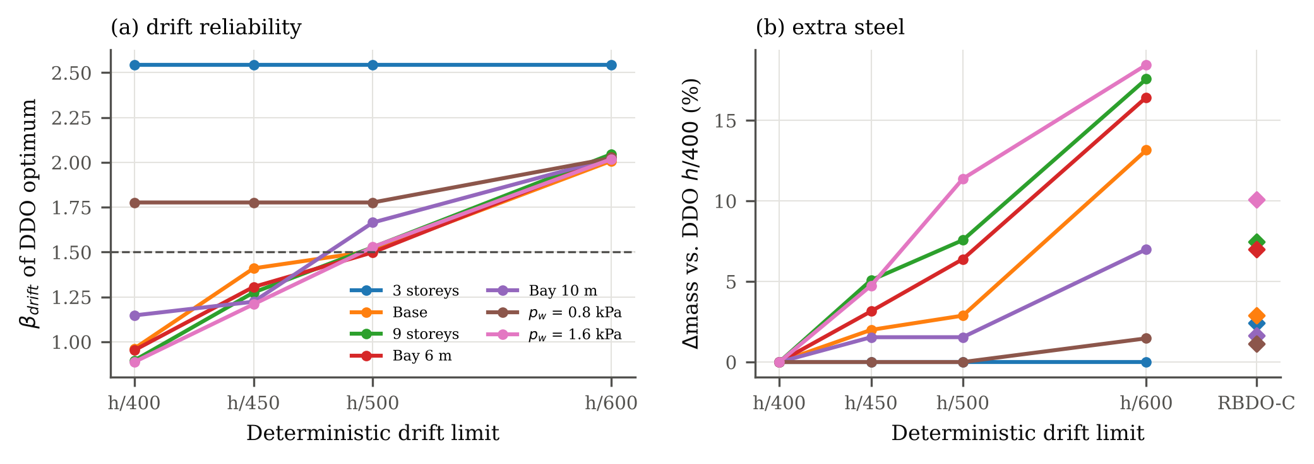
Figure 10. Deterministic optima with tightened drift limits: (a) verified drift reliability index; (b) mass increase relative to DDO with $h/400$, with the RBDO-C designs (diamonds) for comparison.

Parametric study and statistical verification of all final designs
Table 14 reports, for every frame, the DDO, RBDO and RBDO-C optima with their masses, LRFD ratios, failure counts and $95\%$ intervals, and Fig. 11 shows the same results graphically. Four observations stand out.
First, the reliability of deterministic optima is far from uniform. Although every DDO design has a governing strength or drift check within 7% of its limit, the verified system indices range from ${\hat{β}}_{ULS}=2.880$ $\left[2.87,2.89\right]$ (10-m bays) to 3.656 $\left[3.61,3.70\right]$ (6-m bays), and the drift indices from 0.887 (high wind) to 2.544 (three storeys). Three DDO designs fall significantly below $β_{T}=3.0$ (three storeys, 10-m bays, low wind) and five have ${\hat{β}}_{drift}<1.5$, four of them below 1.0.
Second, RBDO-C equalises the reliability. All seven RBDO-C designs satisfy every LRFD check, and their point estimates reach both targets in the SAA sample. In the independent verification, six of them meet both targets with $95\%$ confidence (claim L of Section 2.5). The three-storey design has ${\hat{β}}_{ULS}=2.995$ $\left[2.98,3.01\right]$: its interval contains the target, so the evidence is inconclusive (claim I), and it is not counted as meeting the target. Section 4.6 shows that this design also falls below the target in the full second-order model and gives the designs that remove both shortcomings. The mass premium relative to DDO, computed from unrounded masses, ranges from +1.13% (low wind) to +10.11% (high wind). The premium is essentially the cost of raising $β_{drift}$ to 1.5 in the drift-governed frames and of raising $β_{ULS}$ to 3.0 in the strength-governed ones.
Third, the code checks matter in two of seven frames. Without them, RBDO selects a 6-m bay design with an LRFD strength ratio of 1.011 and a low-wind design with 1.002, i.e. designs that meet the reliability targets but would marginally fail the mandatory strength check; in the 6-m bay frame RBDO trades the surplus ULS reliability of the DDO design (${\hat{β}}_{ULS}=3.66$) for stiffness (${\hat{β}}_{ULS}=3.22$). Adding the code checks (RBDO-C) raises the mass by 0.32% (6-m bays) and 0.64% (low wind) relative to RBDO. In the other five frames the RBDO optimum already satisfies the code checks and RBDO-C returns the same design. The conclusions on mass are therefore unchanged when all RBDO candidates must satisfy the deterministic LRFD checks; the premiums over DDO change from +6.67% to +7.01% (6-m bays) and from +0.48% to +1.13% (low wind).
Fourth, the location of the extra steel explains the premiums (Tables 15 and 18). In the drift-governed frames (base, nine storeys, high wind) RBDO-C adds steel to the beams of the lower storey groups and to the interior columns, which stiffens the frame; in the high-wind frame this adds 755 kg to columns and 1 240 kg to beams. In the 10-m bay frame, where DDO falls below $β_{T}$ because the long beams are governed by the 50-year live load (95% of failures in $S_{1}$, 95% in beams), RBDO-C deepens the beams (+577 kg) and lightens the columns ($−151$ kg), after which the remaining failures are shared between beams (57%) and columns (43%). In the 6-m bay frame, governed by drift but with short, lightly loaded beams, failures occur mostly in interior columns (77–79%) in the wind scenario.
Table 14. Statistical verification of all final designs ($N={10}^{6}$ independent samples). $Δm$: mass relative to DDO (unrounded); LRFD: governing strength ratio; $k$: number of failures; vs. targets: a = above, w = within, b = below the target, by the exact $95\%$ interval, for ULS/drift. No deflection failure occurred in any design ($β_{defl}≥4.53$ with $95\%$ confidence).
Frame | Formulation | Mass (kg) | $Δm$ | LRFD | $k_{ULS}$ | ${\hat{β}}_{ULS}$ [95% CI] | $k_{drift}$ | ${\hat{β}}_{drift}$ [95% CI] | vs. targets
3 storeys | DDO | 7995 | – | 0.991 | 1707 | 2.928 [2.91, 2.94] | 5481 | 2.544 [2.53, 2.55] | b/a
 | RBDO | 8188 | +2.42% | 0.978 | 1370 | 2.995 [2.98, 3.01] | 3357 | 2.711 [2.70, 2.72] | w/a
 | RBDO-C | 8188 | +2.42% | 0.978 | 1370 | 2.995 [2.98, 3.01] | 3357 | 2.711 [2.70, 2.72] | w/a
Base | DDO | 18261 | – | 0.993 | 1242 | 3.025 [3.01, 3.04] | 167961 | 0.962 [0.96, 0.97] | a/b
 | RBDO | 18787 | +2.88% | 0.977 | 1148 | 3.049 [3.03, 3.07] | 65968 | 1.507 [1.50, 1.51] | a/a
 | RBDO-C | 18787 | +2.88% | 0.977 | 1148 | 3.049 [3.03, 3.07] | 65968 | 1.507 [1.50, 1.51] | a/a
9 storeys | DDO | 32987 | – | 0.987 | 535 | 3.271 [3.25, 3.30] | 185169 | 0.896 [0.89, 0.90] | a/b
 | RBDO | 35450 | +7.47% | 0.965 | 403 | 3.351 [3.32, 3.38] | 62958 | 1.530 [1.53, 1.53] | a/a
 | RBDO-C | 35450 | +7.47% | 0.965 | 403 | 3.351 [3.32, 3.38] | 62958 | 1.530 [1.53, 1.53] | a/a
Bay 6 m | DDO | 13707 | – | 0.936 | 128 | 3.656 [3.61, 3.70] | 170283 | 0.953 [0.95, 0.96] | a/b
 | RBDO | 14621 | +6.67% | 1.011 | 642 | 3.220 [3.20, 3.24] | 60925 | 1.547 [1.54, 1.55] | a/a
 | RBDO-C | 14668 | +7.01% | 0.914 | 95 | 3.732 [3.68, 3.78] | 60850 | 1.548 [1.54, 1.55] | a/a
Bay 10 m | DDO | 25639 | – | 0.993 | 1986 | 2.880 [2.87, 2.89] | 125645 | 1.147 [1.14, 1.15] | b/b
 | RBDO | 26065 | +1.66% | 0.953 | 906 | 3.119 [3.10, 3.14] | 47974 | 1.665 [1.66, 1.67] | a/a
 | RBDO-C | 26065 | +1.66% | 0.953 | 906 | 3.119 [3.10, 3.14] | 47974 | 1.665 [1.66, 1.67] | a/a
$p_{w}$ = 0.8 kPa | DDO | 17788 | – | 0.999 | 1760 | 2.918 [2.90, 2.93] | 37801 | 1.777 [1.77, 1.78] | b/a
 | RBDO | 17874 | +0.48% | 1.002 | 1415 | 2.986 [2.97, 3.00] | 23753 | 1.982 [1.98, 1.99] | w/a
 | RBDO-C | 17989 | +1.13% | 0.998 | 1267 | 3.019 [3.00, 3.04] | 53870 | 1.608 [1.60, 1.61] | a/a
$p_{w}$ = 1.6 kPa | DDO | 19743 | – | 0.995 | 940 | 3.109 [3.09, 3.13] | 187435 | 0.887 [0.88, 0.89] | a/b
 | RBDO | 21738 | +10.11% | 0.963 | 714 | 3.189 [3.17, 3.21] | 65403 | 1.511 [1.51, 1.51] | a/a
 | RBDO-C | 21738 | +10.11% | 0.963 | 714 | 3.189 [3.17, 3.21] | 65403 | 1.511 [1.51, 1.51] | a/a
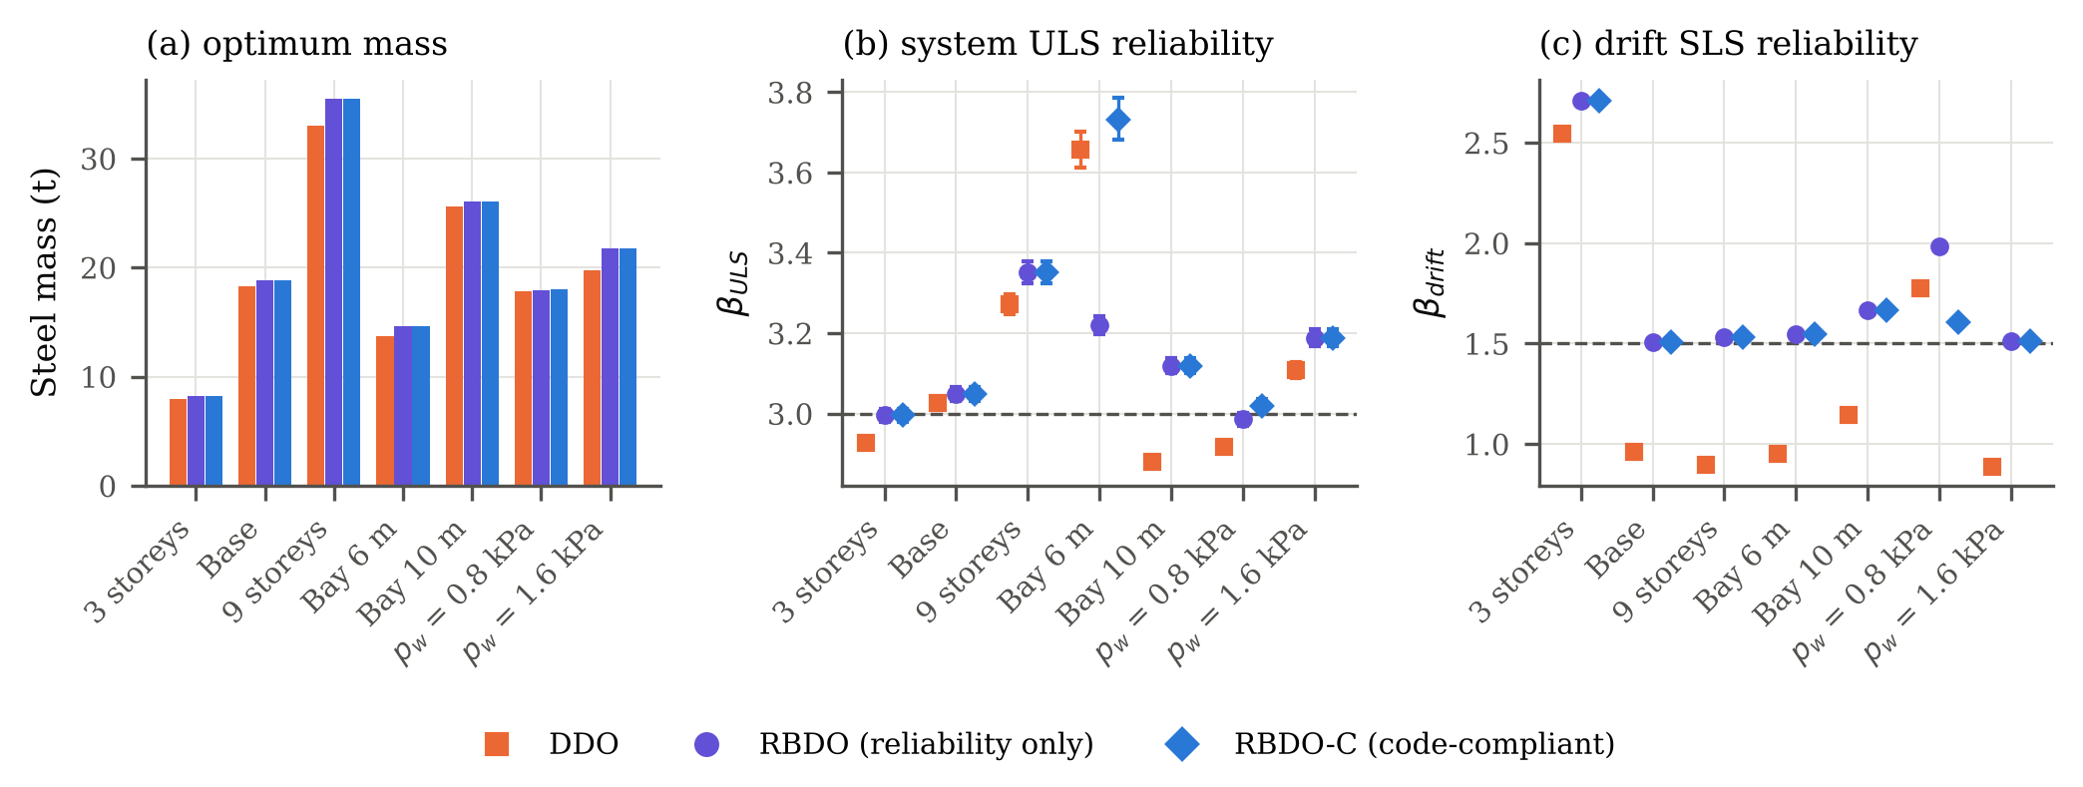
Figure 11. Parametric study: (a) optimum steel mass, (b) system ULS and (c) drift reliability indices with exact $95\%$ intervals of the DDO, RBDO and RBDO-C designs (${10}^{6}$ independent samples); dashed lines mark the targets.
Table 15. Where ULS failures occur (${10}^{6}$ samples): share of failures by governing member type and by scenario ($S_{1}$: gravity with $L_{50}$; $S_{2}$: wind).
Frame | Design | $k_{ULS}$ | Beams (%) | Ext. col. (%) | Int. col. (%) | $S_{1}$ only / $S_{2}$ only / both (%)
3 storeys | DDO | 1707 | 67 | 0 | 33 | 94 / 6 / 0
 | RBDO-C | 1370 | 67 | 0 | 33 | 97 / 3 / 0
Base | DDO | 1242 | 96 | 4 | 0 | 79 / 21 / 0
 | RBDO-C | 1148 | 96 | 4 | 0 | 95 / 5 / 0
9 storeys | DDO | 535 | 35 | 1 | 63 | 60 / 40 / 0
 | RBDO-C | 403 | 65 | 1 | 34 | 70 / 30 / 0
Bay 6 m | DDO | 128 | 15 | 8 | 77 | 14 / 86 / 0
 | RBDO-C | 95 | 16 | 5 | 79 | 25 / 75 / 0
Bay 10 m | DDO | 1986 | 95 | 1 | 4 | 95 / 5 / 0
 | RBDO-C | 906 | 57 | 29 | 14 | 93 / 7 / 0
$p_{w}$ = 0.8 kPa | DDO | 1760 | 60 | 2 | 38 | 94 / 6 / 0
 | RBDO-C | 1267 | 32 | 0 | 68 | 98 / 2 / 0
$p_{w}$ = 1.6 kPa | DDO | 940 | 89 | 8 | 2 | 64 / 36 / 0
 | RBDO-C | 714 | 97 | 3 | 0 | 97 / 3 / 0

Confidence-bounded designs, the three-storey frame and model uncertainty
Confidence-bounded designs. Table 16 compares the point-estimate designs (RBDO-C) with the confidence-bounded designs (RBDO-C95) of all frames. Each design is classified by the strongest of the three claims of Section 2.5. In the independent verification, the RBDO-C designs of six frames already meet both targets with $95\%$ confidence (L), because the discrete catalogue leaves a margin above the target. RBDO-C95 returns the same design in three of these frames (nine storeys, 10-m bays, low wind) and heavier designs for the base frame ($+1.55\%$) and the high-wind frame ($+1.42\%$). For 6-m bays it finds a design that is 0.26% lighter than the best of the two RBDO-C runs. That design is also feasible for RBDO-C, so this result is a further indication of the limited search budget (Section 4.1). In the three-storey frame, RBDO-C95 costs $+1.15\%$ and turns the inconclusive result (I) into claim L: ${\hat{β}}_{ULS}=3.068$ with a lower bound of 3.053. All RBDO-C95 designs therefore meet both targets with $95\%$ confidence in the baseline surrogate model, at 0 to 1.6% more steel than RBDO-C and 1.1 to 11.7% more than DDO. The confidence bound controls Monte Carlo sampling uncertainty only. It does not remove systematic errors of the surrogate, which are examined next.
Drift bias of the surrogate. The $B_{1}$–$B_{2}$ drifts are up to 1.0% lower than the second-order drifts in some storeys (Section 3.2), and the random validation sets show mean drift differences of $−1.0$ to $+1.4\%$. Near the drift target this matters. Increasing all surrogate drifts by 1% lowers $β_{drift}$ by 0.026–0.028 (Table 16, last columns). The base and high-wind RBDO-C designs, whose drift indices are 1.507 and 1.511, would then fall below 1.5, and the nine-storey design would become inconclusive. The RBDO-C95 designs keep claim L for $β_{drift}$ under this bias, except the nine-storey design, which is the same as its RBDO-C design. The drift targets of designs that are within about 0.03 of $β_{SLS}$ should therefore be regarded as met only to the accuracy of the $B_{1}$–$B_{2}$ approximation.
The three-storey frame in the full model. The validation of Section 3.3 found that the surrogate overestimates $β_{ULS}$ of the three-storey design. The same check was repeated for the two heavier designs (Table 7):
- RBDO-C (8188 kg): ${\hat{β}}_{ULS}^{full}=2.94$ [2.84, 3.01], i.e. point estimate below the target.
- RBDO-C95 (8282 kg): ${\hat{β}}_{ULS}^{full}=3.01$ [2.89, 3.10] with $Δβ=−0.09$ [$−0.21$, $−0.01$]. The point estimate reaches the target, but the interval contains it (P, I), and with the $t_{3}$ residual of the excluded samples the estimate is 2.97.
- RBDO-C95 with a margin (8408 kg): the ULS target is raised to $β_{T}=3.21$, i.e. by the upper end of the observed discrepancy, so that the target is still met in the full model if the surrogate error is as large as the validation allows. Because the catalogue is discrete, the optimum jumps to a design with ${\hat{β}}_{ULS}=3.621$ [3.58, 3.66] in the surrogate. In the full model it has two estimates of different standing:
  - on the sampled strata, ${\hat{β}}_{ULS}^{full}=3.61$ [3.45, 3.73], a statistical result for the analysed strata;
  - with the $t_{3}$ residual of the unanalysed samples, a model-based engineering estimate of 3.52, with a model-conditional $95\%$ confidence interval [3.41, 3.61] and lower bound 3.43, including the bootstrap uncertainty of the fit.
- Both lie above the target. With the more extreme $t_{2}$ residual model, the point estimate is 3.16; no confidence interval or lower bound was computed for the $t_{2}$ model.
For this margin design, the ULS target is therefore met with $95\%$ confidence on the sampled strata. For the complete full model, the model-conditional lower bound (3.43) also exceeds the target, but this holds only under the assumed $t_{3}$ residual model and not under every tail model (the $t_{2}$ point estimate is 3.16). It is not a distribution-free bound, because the tail of $U_{full}/U_{s}$ beyond the observed range is assumed, not observed (Section 3.3). On this basis, meeting the ULS target for the three-storey frame in the full second-order model costs $+2.69\%$ of steel relative to RBDO-C ($+5.17\%$ relative to DDO). Controlling only the sampling uncertainty of the surrogate costs $+1.15\%$. The surrogate discrepancy is systematic for this frame ($Δβ=−0.07$ and $−0.09$ for two different designs). Its cause has not been isolated. The surrogate uses one frame-wide modulus factor and nominal section stiffness, whereas the full model gives every member its own modulus and fabrication factor; in a low-rise, strength-governed frame the resulting redistribution of member forces may matter more than in the drift-governed frames, but this has not been verified. The three-storey result is therefore retained as evidence of a limitation of the surrogate, and the RBDO-C design of this frame is not described as meeting the target.
Model-uncertainty-aware designs. Table 17 gives the designs obtained when the model factors with c.o.v. 0.05 are included in the reliability constraints (RBDO-C-MU). With these factors, the RBDO-C designs have ${\hat{β}}_{ULS}=2.70$ (three storeys) and 2.77 (base), i.e. they do not meet the target. Keeping $β_{T}=3.0$ including model uncertainty costs $+1.34\%$ of steel for the base frame and $+2.69\%$ for the three-storey frame, whose discrete optimum is the same design as the margin design above. Model uncertainty with c.o.v. 0.10 would lower the indices by another 0.6, so the corresponding designs would be heavier still. They were not computed.
Table 16. Point-estimate (RBDO-C) and confidence-bounded (RBDO-C95) designs (${10}^{6}$ independent samples). $β^{lcb}$: one-sided $95\%$ lower confidence bound. Claim: L = lower bound $≥$ target ($95\%$ confidence); P, I = point estimate $≥$ target, interval contains it; I = point estimate $<$ target, interval contains it; below = interval below the target. Last columns: drift index if all surrogate drifts are increased by 1%; a claim other than L there (base and high-wind RBDO-C: below; nine storeys, both formulations: P, I) marks a result that is sensitive to the $B_{1}$–$B_{2}$ drift approximation. The lower bounds address Monte Carlo sampling uncertainty only.
Frame | Formulation | Mass (kg) | $Δm$ vs. RBDO-C | ${\hat{β}}_{ULS}$ ($β^{lcb}$) | claim | ${\hat{β}}_{drift}$ ($β^{lcb}$) | claim | ${\hat{β}}_{drift}$, drift $+1\%$ ($β^{lcb}$) | claim
3 storeys | RBDO-C | 8188 | – | 2.995 (2.982) | I | 2.711 (2.701) | L | 2.683 (2.674) | L
 | RBDO-C95 | 8282 | +1.15% | 3.068 (3.053) | L | 2.550 (2.542) | L | 2.524 (2.516) | L
 | RBDO-C, $β_{T}=3.07$ | 8282 | +1.15% | 3.068 (3.053) | L | 2.550 (2.542) | L | 2.524 (2.516) | L
Base | RBDO-C | 18787 | – | 3.049 (3.034) | L | 1.507 (1.503) | L | 1.479 (1.476) | below
 | RBDO-C95 | 19079 | +1.55% | 3.125 (3.109) | L | 1.551 (1.547) | L | 1.522 (1.519) | L
9 storeys | RBDO-C | 35450 | – | 3.351 (3.328) | L | 1.530 (1.527) | L | 1.502 (1.499) | P, I
 | RBDO-C95 | 35450 | +0.00% | 3.351 (3.328) | L | 1.530 (1.527) | L | 1.502 (1.499) | P, I
Bay 6 m | RBDO-C | 14668 | – | 3.732 (3.689) | L | 1.548 (1.544) | L | 1.520 (1.517) | L
 | RBDO-C95 | 14630 | -0.26% | 3.754 (3.709) | L | 1.546 (1.542) | L | 1.518 (1.515) | L
Bay 10 m | RBDO-C | 26065 | – | 3.119 (3.103) | L | 1.665 (1.661) | L | 1.637 (1.633) | L
 | RBDO-C95 | 26065 | +0.00% | 3.119 (3.103) | L | 1.665 (1.661) | L | 1.637 (1.633) | L
$p_{w}$ = 0.8 kPa | RBDO-C | 17989 | – | 3.019 (3.005) | L | 1.608 (1.605) | L | 1.581 (1.577) | L
 | RBDO-C95 | 17989 | +0.00% | 3.019 (3.005) | L | 1.608 (1.605) | L | 1.581 (1.577) | L
$p_{w}$ = 1.6 kPa | RBDO-C | 21738 | – | 3.189 (3.171) | L | 1.511 (1.508) | L | 1.483 (1.480) | below
 | RBDO-C95 | 22047 | +1.42% | 3.172 (3.154) | L | 1.533 (1.530) | L | 1.506 (1.502) | L

Table 17. Model-uncertainty-aware designs (RBDO-C-MU), optimised for two frames only (three storeys and base): the reliability constraints include the model factors $θ_{R},θ_{E},θ_{δ}$ with c.o.v. 0.05 (${10}^{6}$ independent samples). Designs for c.o.v. 0.10 were not optimised. Last column: indices of the same designs without model factors.
Frame | Formulation | Mass (kg) | $Δm$ vs. RBDO-C | ${\hat{β}}_{ULS}$, c.o.v. 0.05 ($β^{lcb}$) | ${\hat{β}}_{drift}$, c.o.v. 0.05 ($β^{lcb}$) | ${\hat{β}}_{ULS}$ / ${\hat{β}}_{drift}$ without model factors
3 storeys | RBDO-C | 8188 | – | 2.700 (2.691) | 2.688 (2.679) | 2.995 / 2.711
 | RBDO-C-MU | 8408 | +2.69% | 3.253 (3.233) | 2.673 (2.664) | 3.621 / 2.695
Base | RBDO-C | 18787 | – | 2.773 (2.763) | 1.496 (1.493) | 3.049 / 1.507
 | RBDO-C-MU | 19039 | +1.34% | 3.047 (3.033) | 1.509 (1.505) | 3.328 / 1.518

Sections and an illustrative cost model
Table 18 lists the number of distinct sections of the DDO and RBDO-C designs, the change of column and beam mass, and the cost premium of RBDO-C under the cost index (12) for $τ$ between 0.25 and 1 t of steel per distinct section and $κ$ of 0 or 0.25. RBDO-C uses one section more than DDO in three frames, one fewer in two and the same number in two. Accordingly, the non-mass terms increase the premium for the base, low- and high-wind frames (base: from 2.9% to 4.9% for $τ=0.5$ t) and reduce it for the nine-storey and 6-m bay frames; only for the 6-m bays with $τ=1$ t and $κ=0$ does RBDO-C become marginally cheaper ($−0.2\%$). Within this range of cost ratios, the ranking of DDO and RBDO-C does not change in any other case, so the conclusions drawn from steel mass carry over to this broader cost measure. The index is an uncalibrated sensitivity model; it has not been validated against actual project costs.
Table 18. Distinct sections, change of column and beam mass, and cost premium of RBDO-C over DDO under the illustrative cost index $C=m+τn_{sec}+κm_{beam}$ ($τ$ in tonnes of steel per distinct section).
 | Distinct sections |  | $Δm$ RBDO-C vs. DDO (kg) |  |  | Cost premium of RBDO-C over DDO
Frame | DDO | RBDO-C | Columns | Beams | Mass | $τ=0.25$, $κ=0.0$ | $τ=0.5$, $κ=0.0$ | $τ=1.0$, $κ=0.0$ | $τ=0.5$, $κ=0.25$ | $τ=1.0$, $κ=0.25$
3 storeys | 4 | 4 | +193 | +0 | +2.42% | +2.15% | +1.93% | +1.61% | +1.74% | +1.48%
Base | 5 | 6 | +162 | +365 | +2.88% | +3.98% | +4.94% | +6.56% | +4.81% | +6.29%
9 storeys | 8 | 7 | +785 | +1677 | +7.47% | +6.32% | +5.31% | +3.57% | +5.74% | +4.14%
Bay 6 m | 7 | 6 | -115 | +1076 | +7.01% | +4.59% | +2.67% | -0.19% | +3.90% | +1.03%
Bay 10 m | 6 | 6 | -151 | +577 | +1.66% | +1.57% | +1.49% | +1.35% | +1.74% | +1.59%
$p_{w}$ = 0.8 kPa | 5 | 6 | -212 | +413 | +1.13% | +2.37% | +3.45% | +5.27% | +3.55% | +5.18%
$p_{w}$ = 1.6 kPa | 6 | 7 | +755 | +1240 | +10.11% | +10.57% | +10.97% | +11.63% | +11.03% | +11.63%

Sensitivity to the probabilistic model and to model uncertainty
Fig. 12 shows how the verified reliability indices of the base designs change when one assumption of Table 3 is altered ($4×{10}^{5}$ samples each). Among the physical variables, the system ULS index is most sensitive to the live-load model (c.o.v. 0.35 instead of 0.25: $Δβ≈−0.5$), the fabrication factor (removing it: $+0.3$) and the yield-stress model (mean-to-nominal 1.05 instead of 1.10, or c.o.v. 0.10 instead of 0.07: $−0.2$). Inter-member correlation of $F_{y}$ changes $β_{ULS}$ by $±0.05$, and the out-of-plumbness and modulus variability are negligible. The drift index depends almost exclusively on the wind model: a mean-to-nominal ratio of 0.90 instead of 0.78 lowers it by 0.4, and the c.o.v. changes it by about $±0.2$. The DDO and RBDO-C designs react in the same way, so the comparison between them is robust to these assumptions.
Model uncertainty has a larger effect on the absolute ULS indices (Table 19). Frame-wide model factors on resistance, load effect and drift with c.o.v. 0.05 lower $β_{ULS}$ by 0.23–0.30 and with c.o.v. 0.10 by 0.82–0.90 in all frames, for DDO and RBDO-C alike, whereas $β_{drift}$ changes by at most 0.05 because the drift uncertainty is dominated by the wind. The baseline indices of this paper are therefore conditional on the structural and resistance models. With a model uncertainty of 0.10, a design that meets $β_{T}=3.0$ in the baseline model would have an index of only about 2.1–2.3, so the baseline designs do not meet the target once this uncertainty is counted. Because the shift is almost uniform across frames and formulations, the relative comparison of DDO and RBDO-C is not affected. The steel needed to keep the target when model uncertainty with c.o.v. 0.05 is included in the constraints is given in Section 4.6 (Table 17).
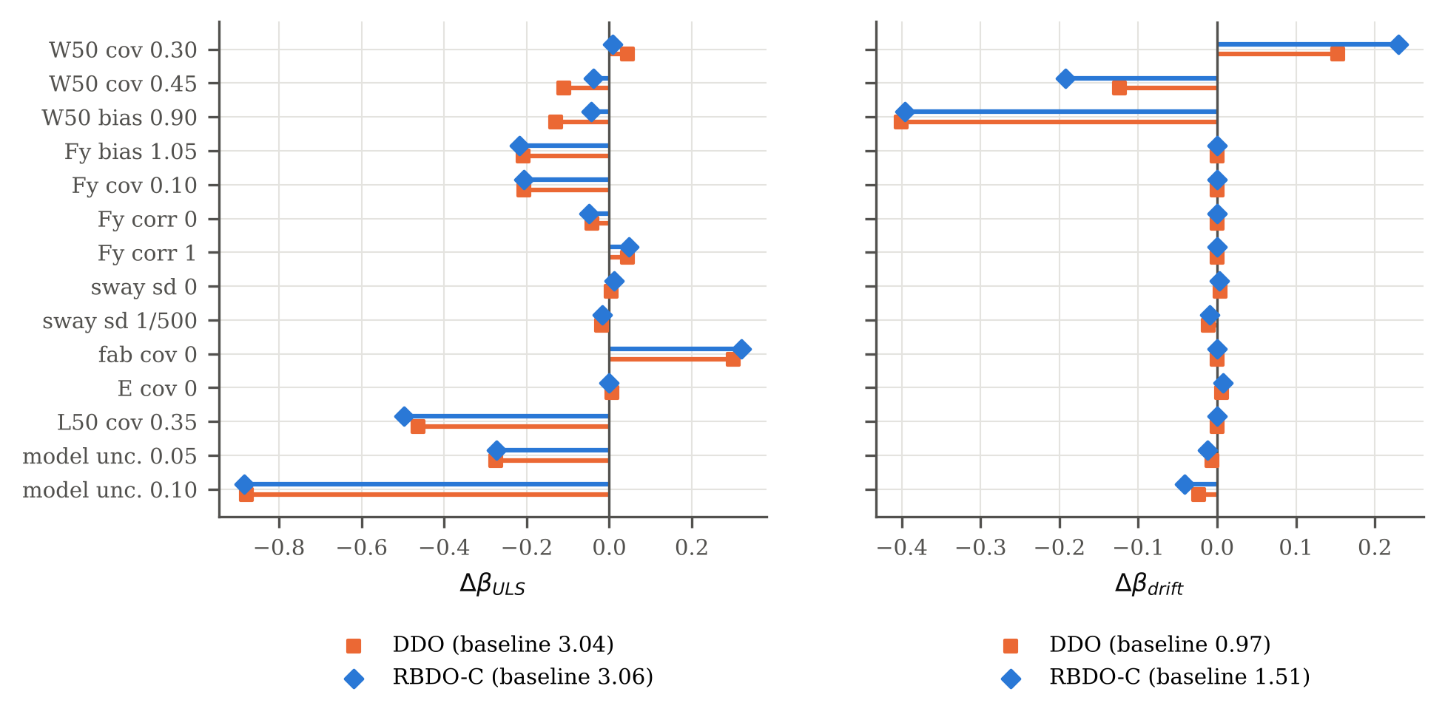
Figure 12. Change of the reliability indices of the base designs when one assumption of the probabilistic model is changed, including frame-wide model uncertainty factors (baseline indices in the legend).
Table 19. Verified reliability indices of the final designs without and with frame-wide model uncertainty factors $θ_{R}$, $θ_{E}$ and $θ_{δ}$ (lognormal, unit mean, common c.o.v. 0.05 or 0.10; ${10}^{6}$ samples).
 |  | ${\hat{β}}_{ULS}$ |  |  | ${\hat{β}}_{drift}$
Frame | Design | none | 0.05 | 0.10 | none | 0.05 | 0.10
3 storeys | DDO | 2.93 | 2.64 | 2.04 | 2.54 | 2.53 | 2.47
 | RBDO-C | 3.00 | 2.70 | 2.09 | 2.71 | 2.69 | 2.62
Base | DDO | 3.03 | 2.76 | 2.17 | 0.96 | 0.96 | 0.94
 | RBDO-C | 3.05 | 2.77 | 2.19 | 1.51 | 1.50 | 1.47
9 storeys | DDO | 3.27 | 2.98 | 2.37 | 0.90 | 0.89 | 0.88
 | RBDO-C | 3.35 | 3.07 | 2.45 | 1.53 | 1.52 | 1.49
Bay 6 m | DDO | 3.66 | 3.43 | 2.84 | 0.95 | 0.95 | 0.93
 | RBDO-C | 3.73 | 3.46 | 2.83 | 1.55 | 1.54 | 1.50
Bay 10 m | DDO | 2.88 | 2.60 | 2.04 | 1.15 | 1.14 | 1.12
 | RBDO-C | 3.12 | 2.83 | 2.22 | 1.66 | 1.65 | 1.62
$p_{w}$ = 0.8 kPa | DDO | 2.92 | 2.63 | 2.04 | 1.78 | 1.76 | 1.73
 | RBDO-C | 3.02 | 2.73 | 2.12 | 1.61 | 1.60 | 1.56
$p_{w}$ = 1.6 kPa | DDO | 3.11 | 2.84 | 2.26 | 0.89 | 0.88 | 0.87
 | RBDO-C | 3.19 | 2.92 | 2.33 | 1.51 | 1.50 | 1.47

Discussion

Answer to the research question
For the frames studied, uncertainty-aware optimisation did not produce lighter designs than deterministic optimisation against the LRFD checks. The code-compliant reliability-based designs were 1.1–10.1% heavier (point-estimate constraints, RBDO-C), and 1.1–11.7% heavier when the targets had to be met with $95\%$ confidence (RBDO-C95). The deterministic optima are already close to the reliability-based optimum for the ULS (${\hat{β}}_{ULS}≈2.9$–3.7 at a target of 3.0), while the conventional drift check at the nominal 50-year wind provides only ${\hat{β}}_{drift}≈0.9$–1.2 for the drift-governed frames. When the reliability levels implicit in the code are required, RBDO returns the DDO design exactly (Table 12). RBDO therefore provides economy at a prescribed and uniform reliability, not with respect to code-based design, whose reliability is unknown and non-uniform. Against deterministic designs with a tightened drift limit whose intervals are not below the targets, RBDO-C was lighter by 0.1–5.0% in four frames, equal in one and 0.6% heavier in one. Against those that meet both targets with $95\%$ confidence, RBDO-C95 was lighter in three frames and 0.3–1.6% heavier in two (Table 13). These conclusions agree in sign with Papadrakakis et al. (2004), whose reliability-based steel-frame design under seismic loading was heavier than its deterministic counterpart. All statements on economy refer to steel mass or to the uncalibrated cost index of Section 2.7.

What the reliability indices mean
$β_{ULS}$ is the index of the first attainment of a code-format member limit state in a second-order elastic analysis (Section 2.3). It is consistent with the component-based calibration of the LRFD factors, which is what makes the comparison with the code meaningful, but it is neither a collapse reliability nor an absolute measure of safety. Three omissions act in opposite directions. Inelastic redistribution in these redundant frames would raise the collapse reliability (Buonopane and Schafer 2006; Zhang et al. 2016). Residual stresses and member imperfections are represented only through the AISC column and LTB curves, not through an explicit imperfect model, and connection behaviour is not modelled. Model uncertainty, if included, lowers the indices by up to about 0.9 for a c.o.v. of 0.10 (Table 19). The validation against full P-$Δ$ re-analysis (Section 3.3) removes the surrogate approximations but not these model-form choices. The reported indices should therefore be read as conditional, comparative measures, appropriate for comparing designs and formulations under one consistent model, and not as estimates of real-world failure rates.

Statistical confidence and acceptance
With $N={10}^{6}$ independent samples and 400–2000 ULS failures per final design, the $95\%$ intervals of $β_{ULS}$ are about $±0.02$–$0.05$, and those of $β_{drift}$ about $±0.005$. Inside the optimiser, the constraints are evaluated on $N=5×{10}^{4}$ SAA samples, whose resolution is about $±0.1$ in $β_{ULS}$. A design whose SAA point estimate reaches the target (claim P) may therefore have a verified interval that contains the target (claim I). This happened for one RBDO-C design and two RBDO designs (Table 14). An interval that contains the target shows only that the data cannot decide; it does not show that the target is met. The confidence-bounded formulation RBDO-C95 removes this ambiguity for the sampling error: all its designs meet both targets with $95\%$ confidence (claim L) in the baseline surrogate model. It does not remove systematic approximation errors. Under a 1% drift bias the nine-storey design becomes inconclusive for the drift target, and the three-storey design falls below the ULS target in the full second-order model. It costs 1.2–1.6% more steel than RBDO-C in three frames and nothing in three. In the 6-m bay frame the RBDO-C95 run even found a design 0.26% lighter than the best RBDO-C run (Table 16). We therefore recommend RBDO-C95 whenever a minimum reliability is to be demonstrated. The point-estimate formulation RBDO-C is appropriate when the target is understood, as in code calibration, as a nominal value of a consistent model.

Cost of reliability
The trade-off curves are strongly asymmetric. Once a frame is drift-governed, its ULS reliability can be raised from 3.0 to about 3.8 for 4% more steel (Fig. 9), whereas the serviceability index is expensive to raise (2.9% of steel from $β_{drift}=0.96$ to 1.51 in the base frame and 10.1% from 0.89 to 1.51 in the high-wind frame). Because the ULS and SLS indices of a design are governed by different scenarios and random variables (Table 15, Fig. 12), a single global safety measure would hide these trade-offs.

What has and has not been demonstrated
Demonstrated: for regular planar steel moment frames of three to nine storeys with 6–10-m bays under gravity and wind, with discrete W-shapes and the stated probabilistic model, (i) the superposition surrogate reproduces full second-order Monte Carlo results on the sampled tail strata within $−0.09$ to $+0.05$ in $β_{ULS}$. It is unconservative for the three-storey frame, and the excluded part of the tail is covered by a model of the response ratio, not by a bound; (ii) the GA with local search finds the exact optimum of a reduced problem in all runs and repeats its full-problem results in most frames, within the tested search budget; (iii) code-compliant RBDO (AISC 360-16, ASCE 7-05) costs 1–12% more steel than DDO, depending on the frame and on whether the targets are imposed on point estimates or on lower confidence bounds; and (iv) among the designs compared, it generally gave the lowest mass that met both targets, with all masses being best-found designs within the tested optimisation budget, not proven global minima. Not demonstrated: three-dimensional frames and torsion, multiple wind directions, seismic actions, inelastic collapse reliability, connection and foundation design, cost models calibrated to fabrication practice, and live-load models with spatial variability. A three-objective NSGA-II run (mass, $β_{ULS}$, $β_{drift}$) with about 3500 designs did not approach the single-objective optima (lightest design with both targets 19 500 kg against 18 787 kg), so for discrete frame problems of this size an $ε$-constraint approach with a strong single-objective optimiser, complemented by a bi-objective front, is the more economical way to map the trade-off.

Conclusions
A reproducible framework for reliability-constrained optimisation of steel moment frames was developed on the open-source PyNite library and applied to seven planar frames with discrete W-shape sections. All reliability statements below are conditional on the stated probabilistic, structural and resistance models, and exclude model-form uncertainty unless this is stated. Code compliance refers to AISC 360-16 under the ASCE 7-05 load combinations, used as a fixed benchmark, and all optima are the best designs found within the tested optimisation budget. The main conclusions are:
- Five linear analyses per design, combined by superposition with AISC $B_{1}$–$B_{2}$ amplification, give a reliability surrogate that agrees with OpenSeesPy to machine precision for linear responses and within 2% for P-$Δ$ responses. Against full P-$Δ$ re-analysis with member-by-member random stiffness for ten designs, it reproduces $β_{ULS}$ within $−0.09$ to $+0.05$ on the sampled tail strata. It is unconservative for the three-storey frame, and it reproduces the drift reliability without detectable bias. No failure was found among 3 000 re-analysed samples below the stratification threshold. Their residual contribution is estimated with a model of the response ratio; it is not bounded.
- Deterministic minimum-mass designs that satisfy the LRFD checks have non-uniform reliability: ${\hat{β}}_{ULS}$ between 2.88 and 3.66, three of seven significantly below 3.0, and 50-year ${\hat{β}}_{drift}$ between 0.89 and 2.54.
- With point-estimate reliability constraints ($β_{T}=3.0$, $β_{SLS}=1.5$), the code-compliant designs (RBDO-C) were 1.1–10.1% heavier than DDO. In independent ${10}^{6}$-sample verification, six of seven met both targets with $95\%$ confidence in the baseline surrogate model. For the seventh (three storeys) the interval contained the target, and the full second-order model placed it below the target.
- With the targets imposed on one-sided $95\%$ lower confidence bounds (RBDO-C95), all seven designs met both targets with $95\%$ confidence in the baseline surrogate model. They were 1.1–11.7% heavier than DDO and 0–1.6% heavier than RBDO-C. These bounds address Monte Carlo sampling uncertainty only. Results close to the drift target remain sensitive to the $B_{1}$–$B_{2}$ approximation: a 1% drift bias makes the nine-storey design inconclusive. We recommend RBDO-C95 when a minimum reliability is to be demonstrated, together with a check of systematic errors near the thresholds.
- For the three-storey frame, the surrogate is unconservative. A design with a ULS margin ($+2.7\%$ of steel relative to RBDO-C) meets the target with $95\%$ confidence on the sampled strata of the full second-order model ($\hat{β}=3.61$ [3.45, 3.73]). Including the unanalysed samples through a $t_{3}$ residual model, it has a model-based estimate of 3.52 with a model-conditional lower bound of 3.43. Under the more extreme $t_{2}$ residual model, the point estimate is 3.16 (no lower bound was computed for that model). This is an engineering estimate conditional on the residual model, not a distribution-free bound. The steel premium is $+2.7\%$ relative to RBDO-C and $+5.2\%$ relative to DDO.
- Uncertainty-aware optimisation therefore did not reduce steel mass relative to code-based optimisation. It delivered the lightest designs found that have a stated, uniform reliability, generally at less steel than tightened deterministic drift limits that meet the same targets. Economic statements are limited to steel mass and an illustrative, uncalibrated cost index used as a sensitivity model, not validated against project costs.
- The absolute indices depend on the model. Frame-wide model uncertainty with c.o.v. 0.05 (0.10) lowers $β_{ULS}$ by about 0.3 (0.9). Keeping $β_{T}=3.0$ with c.o.v. 0.05 included costs 1.3% (base) and 2.7% (three storeys) more steel. The live- and wind-load models change the indices by up to 0.5, while the relative comparison of the formulations is insensitive to these choices.

Data and code availability
The framework, the input data, the scripts that produce every figure and table, and the raw results are openly available at https://github.com/karthice1/Pynite in the folder Research/reliability_optimization. The results, figures and tables of this version of the manuscript were produced by commit ccfd4ce7c014 of branch claude/project-thread-o7hjbo, which an independent researcher can check out to reproduce them. The software environment is listed in requirements.txt (Python 3.13, NumPy, SciPy, Matplotlib, OpenSeesPy 3.8 and PyNite from the same repository). Every stochastic computation uses fixed seeds that are stored with its results. The single command ./reproduce.sh reruns all optimisations, verifications and validations (about 10–12 h on four cores), and regenerates every figure, table and this manuscript. The stages can also be run individually with run_experiments.py. A persistent archive (release tag and DOI) will be created on acceptance.

Declaration of competing interest
The authors declare that they have no known competing financial interests or personal relationships that could have appeared to influence the work reported in this paper.

References
American Institute of Steel Construction. 2016. Specification for Structural Steel Buildings (ANSI/AISC 360-16). Chicago, IL: AISC.
———. 2017. “AISC Shapes Database, Version 15.0.” AISC, Chicago, IL.
———. 2022. Specification for Structural Steel Buildings (ANSI/AISC 360-22). Chicago, IL: AISC.
American Society of Civil Engineers. 2006. Minimum Design Loads for Buildings and Other Structures (ASCE/SEI 7-05). Reston, VA: ASCE.
———. 2022. Minimum Design Loads and Associated Criteria for Buildings and Other Structures (ASCE/SEI 7-22). Reston, VA: ASCE.
Aoues, Younes, and Alaa Chateauneuf. 2010. “Benchmark Study of Numerical Methods for Reliability-Based Design Optimization.” Structural and Multidisciplinary Optimization 41 (2): 277–94.
Brinck, D. Craig. 2026. “PyNite: A 3D Structural Engineering Finite Element Library for Python (PyNiteFEA, Version 3.2.0).” https://github.com/JWock82/Pynite.
Buonopane, Stephen G., and Benjamin W. Schafer. 2006. “Reliability of Steel Frames Designed with Advanced Analysis.” Journal of Structural Engineering 132 (2): 267–76. https://doi.org/10.1061/(ASCE)0733-9445(2006)132:2(267).
Camp, Charles, Shahram Pezeshk, and Guozhong Cao. 1998. “Optimized Design of Two-Dimensional Structures Using a Genetic Algorithm.” Journal of Structural Engineering 124 (5): 551–59. https://doi.org/10.1061/(ASCE)0733-9445(1998)124:5(551).
CEN. 2002. EN 1990:2002 Eurocode – Basis of Structural Design. Brussels: European Committee for Standardization.
Deb, Kalyanmoy. 2000. “An Efficient Constraint Handling Method for Genetic Algorithms.” Computer Methods in Applied Mechanics and Engineering 186 (2–4): 311–38.
Deb, Kalyanmoy, Amrit Pratap, Sameer Agarwal, and T. Meyarivan. 2002. “A Fast and Elitist Multiobjective Genetic Algorithm: NSGA-II.” IEEE Transactions on Evolutionary Computation 6 (2): 182–97.
Degertekin, S. O. 2008. “Optimum Design of Steel Frames Using Harmony Search Algorithm.” Structural and Multidisciplinary Optimization 36 (4): 393–401. https://doi.org/10.1007/s00158-007-0177-4.
Ellingwood, Bruce, Theodore V. Galambos, James G. MacGregor, and C. Allin Cornell. 1980. “Development of a Probability Based Load Criterion for American National Standard A58.” NBS Special Publication 577. Washington, DC: National Bureau of Standards.
Enevoldsen, I., and J. D. Sørensen. 1994. “Reliability-Based Optimization in Structural Engineering.” Structural Safety 15 (3): 169–96.
Foley, Christopher M., Shahram Pezeshk, and Arzhang Alimoradi. 2007. “Probabilistic Performance-Based Optimal Design of Steel Moment-Resisting Frames. I: Formulation.” Journal of Structural Engineering 133 (6): 757–66. https://doi.org/10.1061/(ASCE)0733-9445(2007)133:6(757).
Frangopol, Dan M. 1985. “Structural Optimization Using Reliability Concepts.” Journal of Structural Engineering 111 (11): 2288–2301. https://doi.org/10.1061/(ASCE)0733-9445(1985)111:11(2288).
Galambos, Theodore V., Bruce Ellingwood, James G. MacGregor, and C. Allin Cornell. 1982. “Probability Based Load Criteria: Assessment of Current Design Practice.” Journal of the Structural Division 108 (5): 959–77.
Joint Committee on Structural Safety. 2001. “JCSS Probabilistic Model Code, Part 3: Resistance Models – Static Properties of Structural Steel (Rolled Sections).” https://www.jcss-lc.org/jcss-probabilistic-model-code/.
Kleywegt, Anton J., Alexander Shapiro, and Tito Homem-de-Mello. 2002. “The Sample Average Approximation Method for Stochastic Discrete Optimization.” SIAM Journal on Optimization 12 (2): 479–502.
Lagaros, Nikos D., and Manolis Papadrakakis. 2007. “Robust Seismic Design Optimization of Steel Structures.” Structural and Multidisciplinary Optimization 33 (6): 457–69. https://doi.org/10.1007/s00158-006-0047-5.
Mathakari, Sachin, Paolo Gardoni, Pranab Agarwal, Anne Raich, and Terje Haukaas. 2007. “Reliability-Based Optimal Design of Electrical Transmission Towers Using Multi-Objective Genetic Algorithms.” Computer-Aided Civil and Infrastructure Engineering 22 (4): 282–92.
McKenna, Frank, Michael H. Scott, and Gregory L. Fenves. 2010. “Nonlinear Finite-Element Analysis Software Architecture Using Object Composition.” Journal of Computing in Civil Engineering 24 (1): 95–107.
Papadrakakis, Manolis, and Nikos D. Lagaros. 2002. “Reliability-Based Structural Optimization Using Neural Networks and Monte Carlo Simulation.” Computer Methods in Applied Mechanics and Engineering 191 (32): 3491–3507. https://doi.org/10.1016/S0045-7825(02)00287-6.
Papadrakakis, Manolis, Yiannis Tsompanakis, Nikos D. Lagaros, and Michalis Fragiadakis. 2004. “Reliability Based Optimization of Steel Frames Under Seismic Loading Conditions Using Evolutionary Computation.” Journal of Theoretical and Applied Mechanics 42 (3): 585–608.
Pezeshk, Shahram, Charles V. Camp, and Debin Chen. 2000. “Design of Nonlinear Framed Structures Using Genetic Optimization.” Journal of Structural Engineering 126 (3): 382–88. https://doi.org/10.1061/(ASCE)0733-9445(2000)126:3(382).
Saka, Mehmet Polat, and Zong Woo Geem. 2013. “Mathematical and Metaheuristic Applications in Design Optimization of Steel Frame Structures: An Extensive Review.” Mathematical Problems in Engineering 2013: 271031. https://doi.org/10.1155/2013/271031.
Surovek-Maleck, Andrea E., and Donald W. White. 2004. “Alternative Approaches for Elastic Analysis and Design of Steel Frames. I: Overview.” Journal of Structural Engineering 130 (8): 1186–96. https://doi.org/10.1061/(ASCE)0733-9445(2004)130:8(1186).
Truong, V. H., and Seung-Eock Kim. 2017. “An Efficient Method for Reliability-Based Design Optimization of Nonlinear Inelastic Steel Space Frames.” Structural and Multidisciplinary Optimization 56 (2): 331–51. https://doi.org/10.1007/s00158-017-1667-7.
Turkstra, Carl J., and Henrik O. Madsen. 1980. “Load Combinations in Codified Structural Design.” Journal of the Structural Division 106 (12): 2527–43.
Valdebenito, Marcos A., and Gerhart I. Schuëller. 2010. “A Survey on Approaches for Reliability-Based Optimization.” Structural and Multidisciplinary Optimization 42 (5): 645–63.
Zhang, Hao, Shahab Shayan, Kim J. R. Rasmussen, and Bruce R. Ellingwood. 2016. “System-Based Design of Planar Steel Frames, I: Reliability Framework.” Journal of Constructional Steel Research 123: 135–43.
Zhu, Minjie, Frank McKenna, and Michael H. Scott. 2018. “OpenSeesPy: Python Library for the OpenSees Finite Element Framework.” SoftwareX 7: 6–11.

