mysql> create database mydb;

Query OK, 1 row affected (1.06 sec)

mysql> use mydb;

Database changed

mysql> create table Karthick(NAME char(50),REG_NO int ,AGE int);

Query OK, 0 rows affected (1.20 sec)

mysql> insert into karthick Values('Karthick', 192211057,18);

Query OK, 1 row affected (0.00sec)

mysql> select * from Karthick;

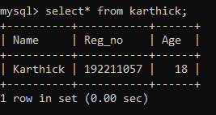

mysql> insert into Karthick Values('Trisha', 172211057,18);

Query OK, 1 row affected (0.00 sec)

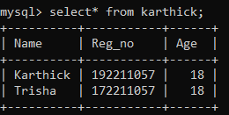

mysql> alter table Karthick add COURSE char(10);

Query OK, 0 rows affected (0.02 sec)

Records: 0 Duplicates: 0 Warnings: 0



mysql> select * from Karthick;

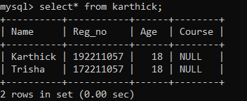

mysql> update Karthick set course='CSE';

Query OK, 2 rows affected (0.01 sec)

Rows matched: 2 Changed: 2 Warnings: 0

mysql> select * from Karthick;

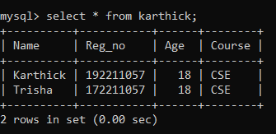

mysql> delete from Karthick where Reg_no=172211057;

Query OK, 1 row affected (0.01 sec)

mysql> select * from Karthick;

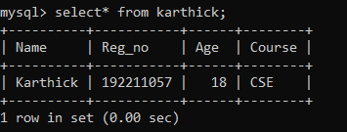

mysql> drop table Karthick;

Query OK, 8 rows affected (0.01 sec)



mysql> truncate karthick;

Query OK, 0 rows affected (0.57 sec)

mysql> select * from karthick;

Empty set (0.00 sec)