Generating a new token for each and every request – automated with the help of postman and java script.
- Parameterize the {{accessToken}}
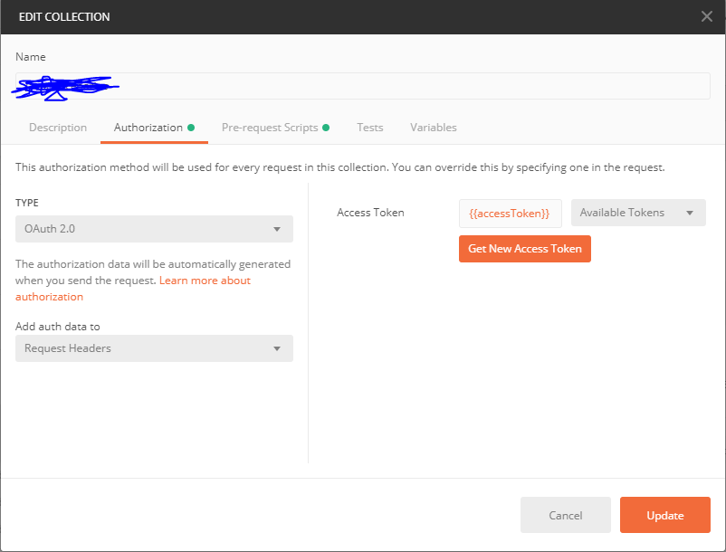
- Write the below code in pre request script

let tokenUrl = ‘<URL>’;
let clientId = ‘’;
let clientSecret = ‘’;
let scope = ‘’;

let getTokenRequest = {
method: 'POST',
url: tokenUrl,
auth: {
type: "basic",
basic: [
{ key: "username", value: clientId },
{ key: "password", value: clientSecret }
]

},
body: {
mode: 'urlencoded',
urlencoded: [
{ key: 'grant_type', value: 'client_credentials' },
{ key: 'scope', value: scope }
]

}

};

pm.sendRequest(getTokenRequest, (err, response) => {
let jsonResponse = response.json(),
newAccessToken = jsonResponse.access_token;

console.log({ err, jsonResponse, newAccessToken })

pm.globals.set('accessToken', newAccessToken);
pm.environment.set('accessToken', newAccessToken);
pm.variables.set('accessToken', newAccessToken);
});

- Change the authorization type of all the requests in the collection to ‘Inherit from parent’
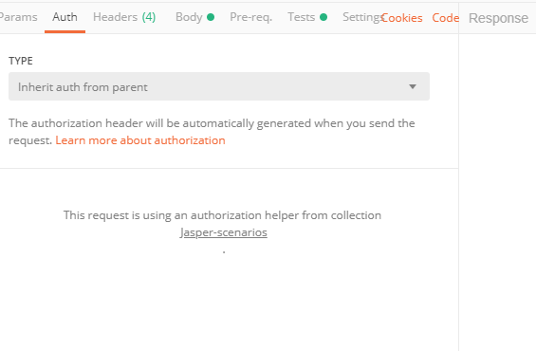
4.Run the collection and all the requests should be placed successfully as a new token will be generated each time

