WebServices / REST API Testing Automation: via SoapUI
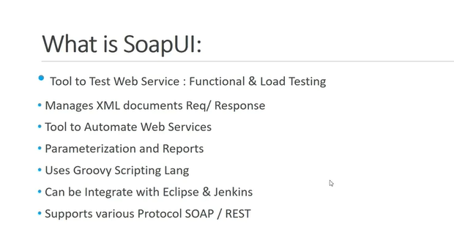
Groovy is the native language supported by SOAP UI. But Java can also be used.
Eclipse or VS Code can be used as Groovy IDE.
Eclipse --> Market place --> Groovy --> Install groovy plugin
If Eclipse throws
What to do about Eclipse's “No repository found containing: …” error messages?

Go to Window > Preferences > Install/Update > Available Software Sites, then for each enabled site I added a / to the end of the URL (if it wasn't there already), then clicked Reload.

New --> Other --> Groovy --> Groovy project
By default JRE libraries and Groovy DSL and support libraries are required to run the Groovy project
Groovy uses JVM as the engine by default

In SOAP UI --> The hierarchy is as follows
Test Project(New SOAP project)
Test Suite (Ctrl + T)
Test Case (Ctrl + N)
Test Steps (Groovy Script)

2 Types of logs in SOAP UI
1.Info Logs (log.info "abc…") --Green color
- Error logs log.error "abc…") -- Red color

SOAP UI Installation folder --> bin --> soapui.log -- gives the complete history of logs. In SOAP free version the log rotation is not available. Log rotation is separating today's logs from yesterday's logs.

Bin --> soapui-log4j.xml will have the path where the log file will be generated, the max size of log file, max no. of log file. Once the max size and no. are reached the logs will be flushed out. If needed a custom path will be provided where the logs can be stored.

In Groovy we don't have the concept of data types. Every variable has the data type of 'def'. It will automatically get configured according to the value provided
E.g -
def a = 100; //considered as int
def b = "Ash"; //considered as String
def c = "1.34"; //considered as double
log.info a;
log.info b;
log.info c;

//If condition:
def x = 1;
if(x==1){
log.info "The value is 1";
}else{
log.info "The value is not 1";
}

//For loop:

for(def y = 0;y<10;y++){
log.info y;
}

Note: If we get an error like scope is already defined, it means we have used the same variable name more than once in the same program elsewhere.

In Free version of SOAP UI, auto save option is not enabled by default.
Go to --> Preference--> UI Settings--> Auto Save--> 1 (in minutes)

Whenever declaring a class, declare log as a static variable first. The first line of the file should be Classname.log = log. Refer eg. Code below

The object creation, variable definition and method calling should be outside the class. Only variable declaration and method definition should be inside the class.

Employee.log = log;
Employee e1= new Employee();
Employee e2 = new Employee();

Public class Employee(){
Def static log;
Def name;
Def salary;
Def dept;

Public void printEmployee(){
Log.info “employee name is $name;
}}

Code to print dynamic names -- $ symbol is used instead of +

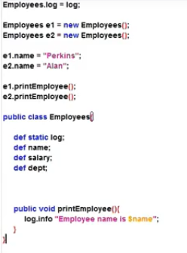

Code to do some addition operations
e1.salary=1000;
e1.printname();
def newAmount=e1.addSalary(1000);
log.info "$newAmount of $e1.name"

public class Employee{
def static log;
def name;
def age;
def salary;
static def dept;

public void printname(){
log.info "$name";
}

public def addSalary(def amount){
salary+=amount;
return salary;
}

If we want to call a dynamic variable, add $ sign in front of the variable inside the logs.

