**WEEK-6**

**REACT**

**ReactJS-HOL-1**

**Objective:**

Create a new React app named myfirstreact and display the heading:

“Welcome to the first session of React”

**Step 1: Install Node.js and npm**

To check if it's installed correctly:

node -v

npm -v

**Step 2: Install Create React App (Optional in newer versions)**

Open Command Prompt and run:

npm install -g create-react-app

**Step 3: Create the React App**

npx create-react-app myfirstreact

**Step 4: Navigate to the App Directory**

cd myfirstreact

**Step 5: Open the Project in Visual Studio Code**

code .

**Step 6: Edit App.js**

import React from 'react';

function App() {

return (

<div className="App">

<h1>Welcome to the first session of React</h1>

</div>

);

}

export default App;

**Step 7: Run the React App**

npm start

This will compile and automatically open http://localhost:3000 in your browser.

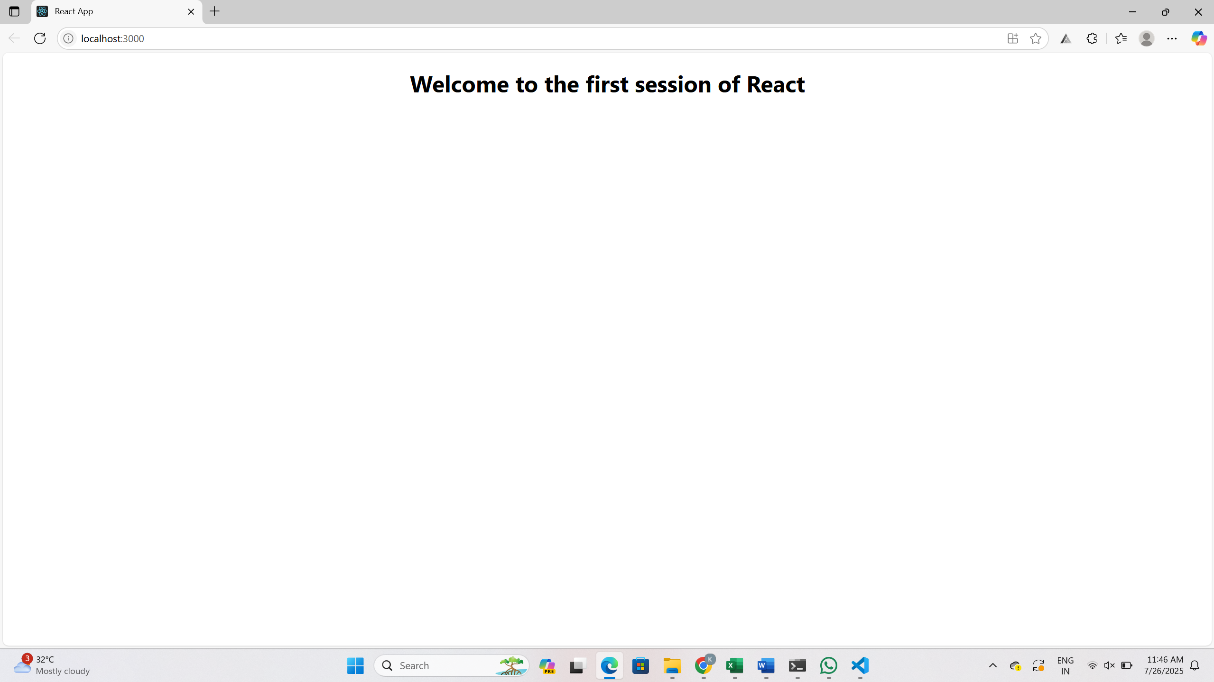

**ReactJS-HOL-2**

**Step 1: Create the React App**

npx create-react-app StudentApp

cd StudentApp

**Step 2: Create Components Folder**

1. Inside Components Folder, create 3 files:
   * Home.js
   * About.js
   * Contact.js

**Step 3: Code for Home.js**

import React from 'react';

function Home() {

return (

<div>

<h2>Welcome to the Home page of Student Management Portal</h2>

</div>

);

}

export default Home;

**Step 4: Code forAbout.js**

import React from 'react';

function About() {

return (

<div>

<h2>Welcome to the About page of the Student Management Portal</h2>

</div>

);

}

export default About;

**Step 5: Code for Contact.js**

import React from 'react';

function Contact() {

return (

<div>

<h2>Welcome to the Contact page of the Student Management Portal</h2>

</div>

);

}

export default Contact;

**Step 6: Update App.js**

import React from 'react';

import './App.css';

import Home from './Components/Home';

import About from './Components/About';

import Contact from './Components/Contact';

function App() {

return (

<div className="App">

<Home />

<About />

<Contact />

</div>

);

}

export default App;**Step 7: Run the App**

npm start

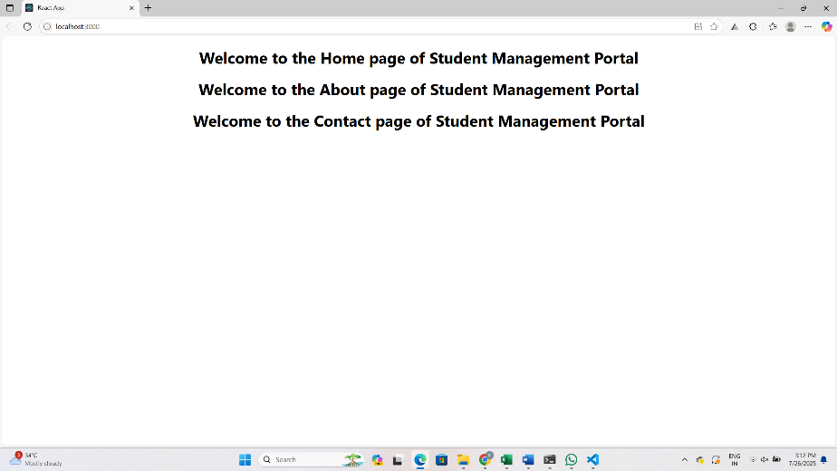

**ReactJS-HOL-3**

**Step 1: Create the React App**

npx create-react-app scorecalculatorapp

cd scorecalculatorapp

**Step 2: Create Component File**

CalculateScore.js:

import '../Stylesheets/mystyle.css'

const percentToDecimal=(decimal) => {

  return (decimal.toFixed(2) + '%');

};

const calcScore = (total, goal) => {

  return percentToDecimal(total / goal);

};

export const CalculateScore = ({ Name, School, total, goal }) => (

  <div className="formatstyle">

    <h1><font color="Brown">Student Details:</font></h1>

<div className="Name">

      <b><span>Name: </span></b>

      <span>{Name}</span>

    </div>

<div className="School">

      <b><span>School: </span></b>

      <span>{School}</span>

    </div>

    <div className="Total">

      <b><span>Total: </span></b>

      <span>{total}</span> Marks

    </div>

<div className="Score">

      <b>Score: </b>

      <span>{calcScore(total, goal)}</span>

    </div>

  </div>

);

**Step 3: Create Stylesheet**

.Name{

    font-weight: 300;

    color: blue;

}

.School{

    color:crimson

}

.Total{

    color:darkmagenta

}

.formatstyle{

    text-align: center;

    font-size: large;

}

.Score{

    color: forestgreen;

}

**Step 4: Update App.js**

import './App.css';

import { CalculateScore } from './Components/CalculateScore';

function App() {

  return (

    <div>

      <CalculateScore

      Name={"Steeve"}

      School ={"DNV Public School"}

      total={284}

      goal={3}

      />

    </div>

  );

}

export default App;

**Step 5: Run the Application**

npm start

**Step 6: View in Browser**

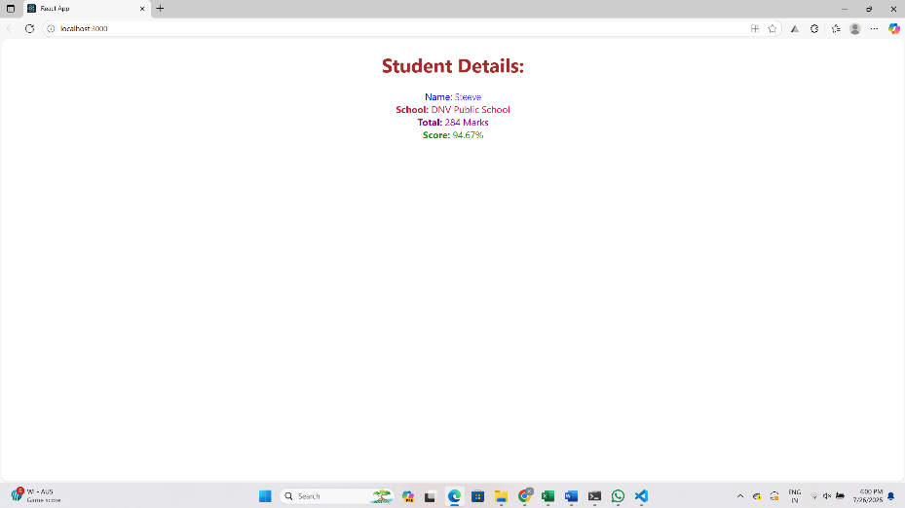

**ReactJS-HOL-4**

**Step 1: Create React App**

npx create-react-app blogapp

**Step 2: Open Project**

cd blogapp

code .

**Step 3: Create Post.js in src/**

class Post {

    constructor(id, title, body) {

      this.id = id;

      this.title = title;

      this.body = body;

    }

  }

  export default Post;

**Step 4: Create Posts.js in src/**

import React from 'react';

import Post from './Post';

class Posts extends React.Component {

  constructor(props) {

    super(props);

    this.state = {

      posts: [],

      hasError: false

    };

  }

  loadPosts() {

    fetch('https://jsonplaceholder.typicode.com/posts')

      .then(response => response.json())

      .then(data => {

        const postList = data.map(item => new Post(item.id, item.title, item.body));

        this.setState({ posts: postList });

      })

      .catch(error => {

        this.setState({ hasError: true });

        console.error('Error fetching posts:', error);

      });

  }

componentDidMount() {

    this.loadPosts();

  }

componentDidCatch(error, info) {

    alert('An error occurred while rendering posts.');

    console.error(error, info);

  }

render() {

    if (this.state.hasError) {

      return <h2>Something went wrong!</h2>;

    }

return (

      <div>

        <h1>Post List</h1>

        {this.state.posts.map(post => (

          <div key={post.id} style={{ borderBottom: "1px solid #ccc", marginBottom: "10px" }}>

            <h2>{post.title}</h2>

            <p>{post.body}</p>

          </div>

        ))}

      </div>

    );

  }

}

export default Posts;

**Step 5: App.js**

import React from 'react';

import Posts from './Posts';

function App() {

return (

<div className="App">

<Posts />

</div>

);

}

export default App;

**Step 6: Run the App**

npm start

Open <http://localhost:3000> in your browser.

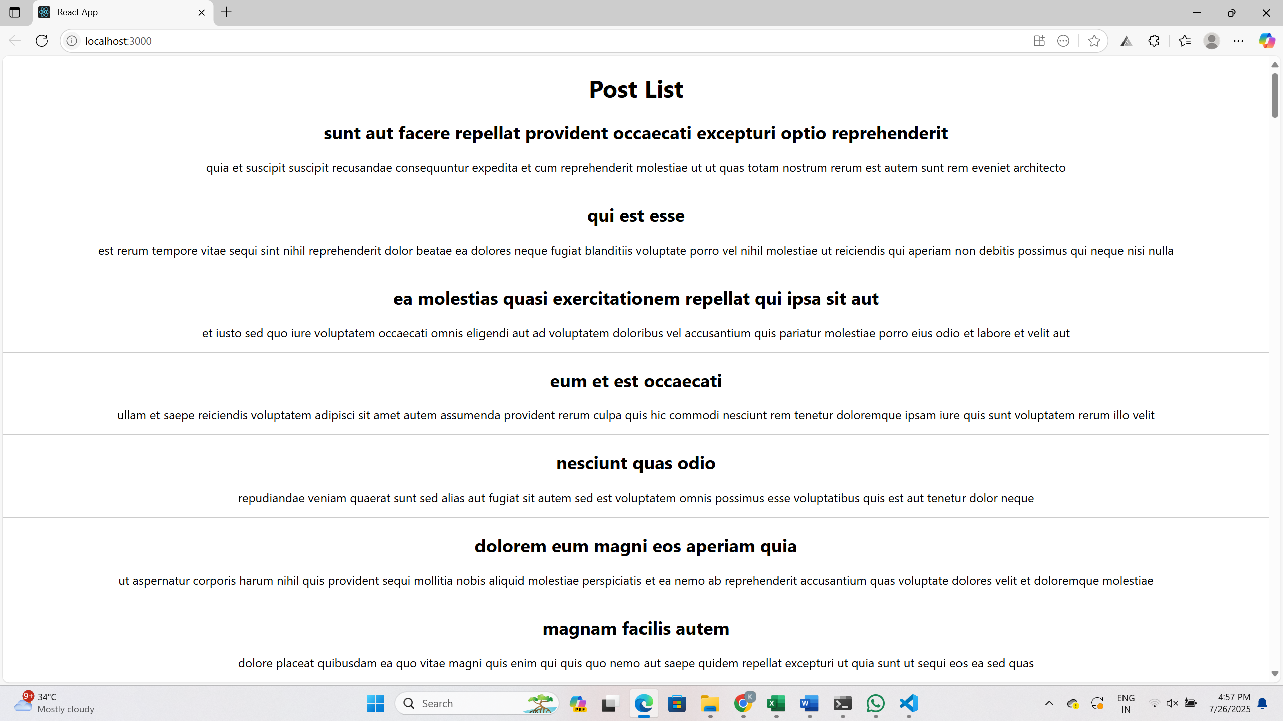

**ReactJS-HOL-5**

**1.Project Setup**

npm install

npm start

**2. Create CSS Module: CohortDetails.module.css**

.box {

width: 300px;

display: inline-block;

margin: 10px;

padding: 10px 20px;

border: 1px solid black;

border-radius: 10px;

}

dt {

font-weight: 500;

}

**3. Component: CohortDetails.js**

import React from 'react';

import styles from './CohortDetails.module.css';

function CohortDetails(props) {

    const { cohort } = props;

const headingStyle = {

        color: cohort.currentStatus.toLowerCase() === 'ongoing' ? 'green' : 'blue'

    };

return (

        <div className={styles.box}>

            <h3 style={headingStyle}>

                {cohort.cohortCode} - <span>{cohort.technology}</span>

            </h3>

            <dl>

                <dt>Started On</dt>

                <dd>{cohort.startDate}</dd>

                <dt>Current Status</dt>

                <dd>{cohort.currentStatus}</dd>

                <dt>Coach</dt>

                <dd>{cohort.coachName}</dd>

                <dt>Trainer</dt>

                <dd>{cohort.trainerName}</dd>

            </dl>

        </div>

    );

}

export default CohortDetails;

**4. App.js:**

import logo from './logo.svg';

import './App.css';

import { CohortsData} from './Cohort'

import CohortDetails from './CohortDetails';

function App() {

  return (

  <div>

    <h1>Cohorts Details</h1>

    {CohortsData.map(cohort => <CohortDetails cohort={cohort}/>)}

  </div>

  );

}

export default App;**Output:**

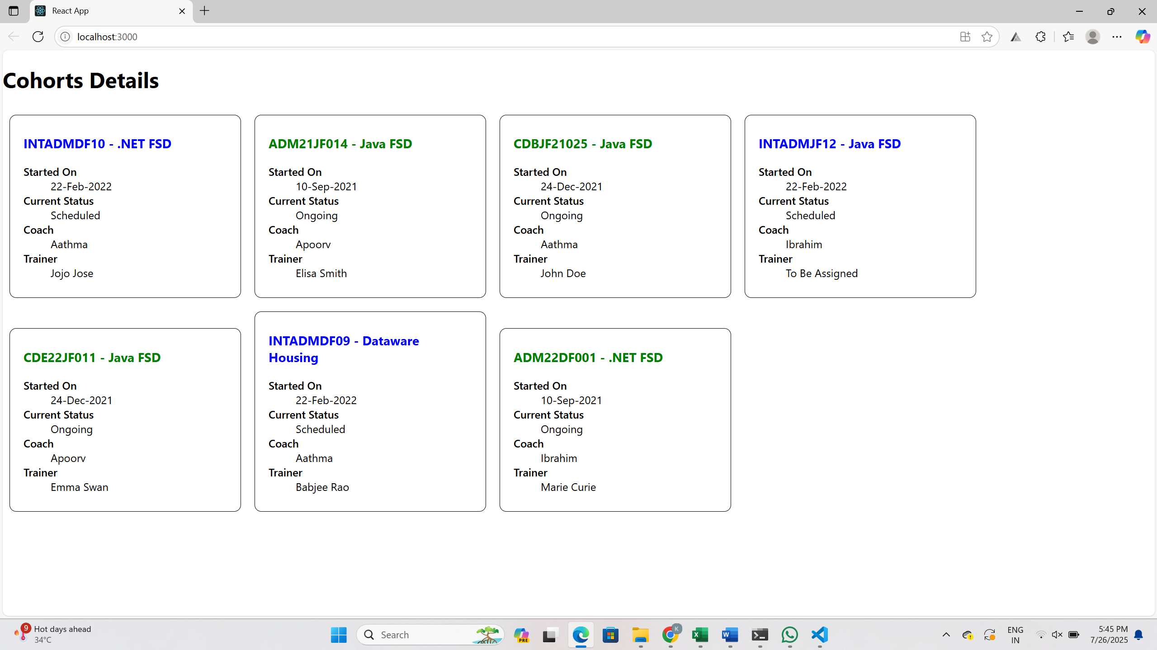

**ReactJS-HOL-6**

**1. Trainer.js**

class Trainer {

constructor(trainerId, name, email, phone, technology, skills) {

this.trainerId = trainerId;

this.name = name;

this.email = email;

this.phone = phone;

this.technology = technology;

this.skills = skills;

}

}

export default Trainer;

**2. trainersMock.js**

import Trainer from "./Trainer";

const trainersMock = [

new Trainer(

't-syed8',

'Syed Khaleelullah',

'khaleelullah@cognizant.com',

'97676516962',

'.NET',

['C#', 'SQL Server', 'React', '.NET Core']

),

new Trainer(

't-jojo',

'Jojo Jose',

'jojo@cognizant.com',

'9897199231',

'Java',

['Java', 'JSP', 'Angular', 'Spring']

),

new Trainer(

't-elisa',

'Elisa Jones',

'elisa@cognizant.com',

'9871212235',

'Python',

['Python', 'Django', 'Angular']

)

];

export default trainersMock;

**3. TrainerList.js**

import React from 'react';

import { Link } from 'react-router-dom';

function TrainerList({ trainers }) {

return (

<div>

<h2>Trainer List</h2>

<ul>

{trainers.map(trainer => (

<li key={trainer.trainerId}>

<Link to={`/trainer/${trainer.trainerId}`}>{trainer.name}</Link>

</li>

))}

</ul>

</div>

);

}

export default TrainerList;

**4. TrainerDetails.js**

import React from 'react';

import { useParams } from 'react-router-dom';

import trainersMock from './trainersMock';

function TrainerDetails() {

const { id } = useParams();

const trainer = trainersMock.find(t => t.trainerId === id);

if (!trainer) return <h2>Trainer not found!</h2>;

return (

<div>

<h2>{trainer.name}</h2>

<p><strong>Email:</strong> {trainer.email}</p>

<p><strong>Phone:</strong> {trainer.phone}</p>

<p><strong>Technology:</strong> {trainer.technology}</p>

<p><strong>Skills:</strong> {trainer.skills.join(', ')}</p>

</div>

);

}

export default TrainerDetails;

**5. Home.js**

import React from 'react';

function Home() {

return (

<div>

<h1>Welcome to Cognizant Academy Trainer Portal</h1>

<p>Use the navigation menu to explore our trainers.</p>

</div>

);

}

export default Home;

**6. App.js**

import React from 'react';

import { BrowserRouter, Routes, Route, Link } from 'react-router-dom';

import Home from './Home';

import TrainerList from './TrainerList';

import TrainerDetails from './TrainerDetails';

import trainersMock from './trainersMock';

function App() {

return (

<BrowserRouter>

<div>

<nav>

<Link to="/">Home</Link> | <Link to="/trainers">Trainers</Link>

</nav>

<Routes>

<Route path="/" element={<Home />} />

<Route path="/trainers" element={<TrainerList trainers={trainersMock} />} />

<Route path="/trainer/:id" element={<TrainerDetails />} />

</Routes>

</div>

</BrowserRouter>

);

}

export default App;

**7. Start the App**

npm install

npm start

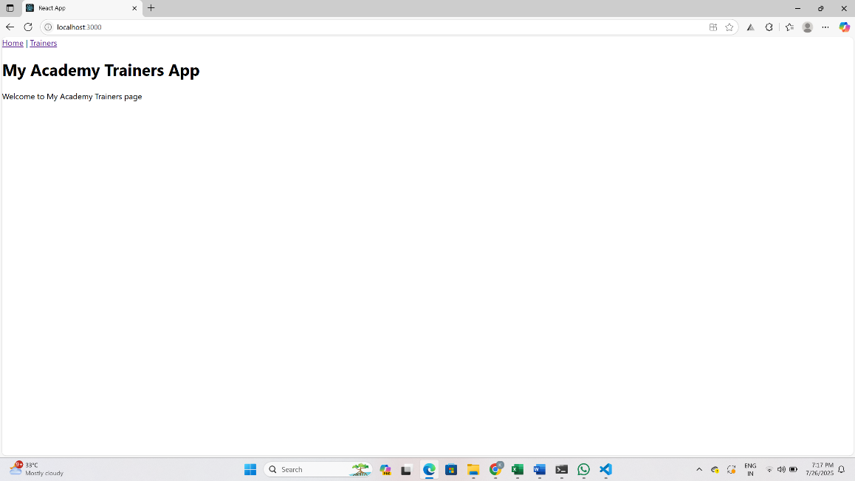**OUTPUT:**

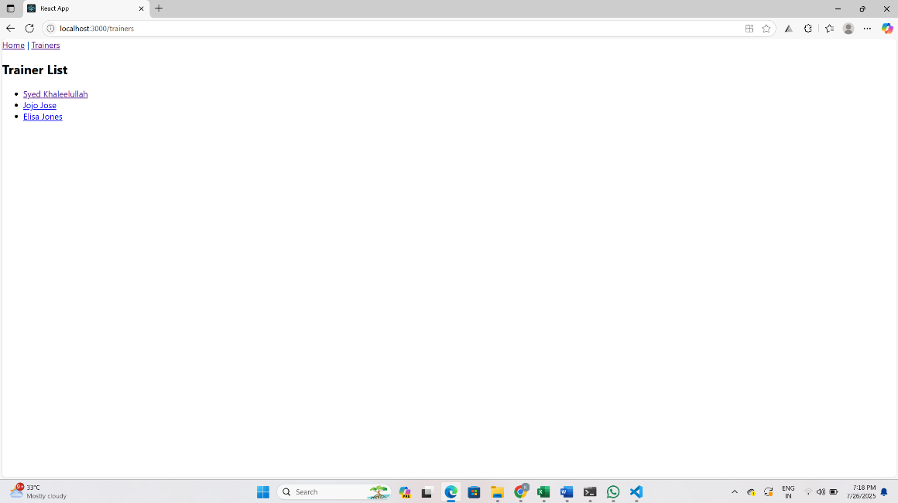

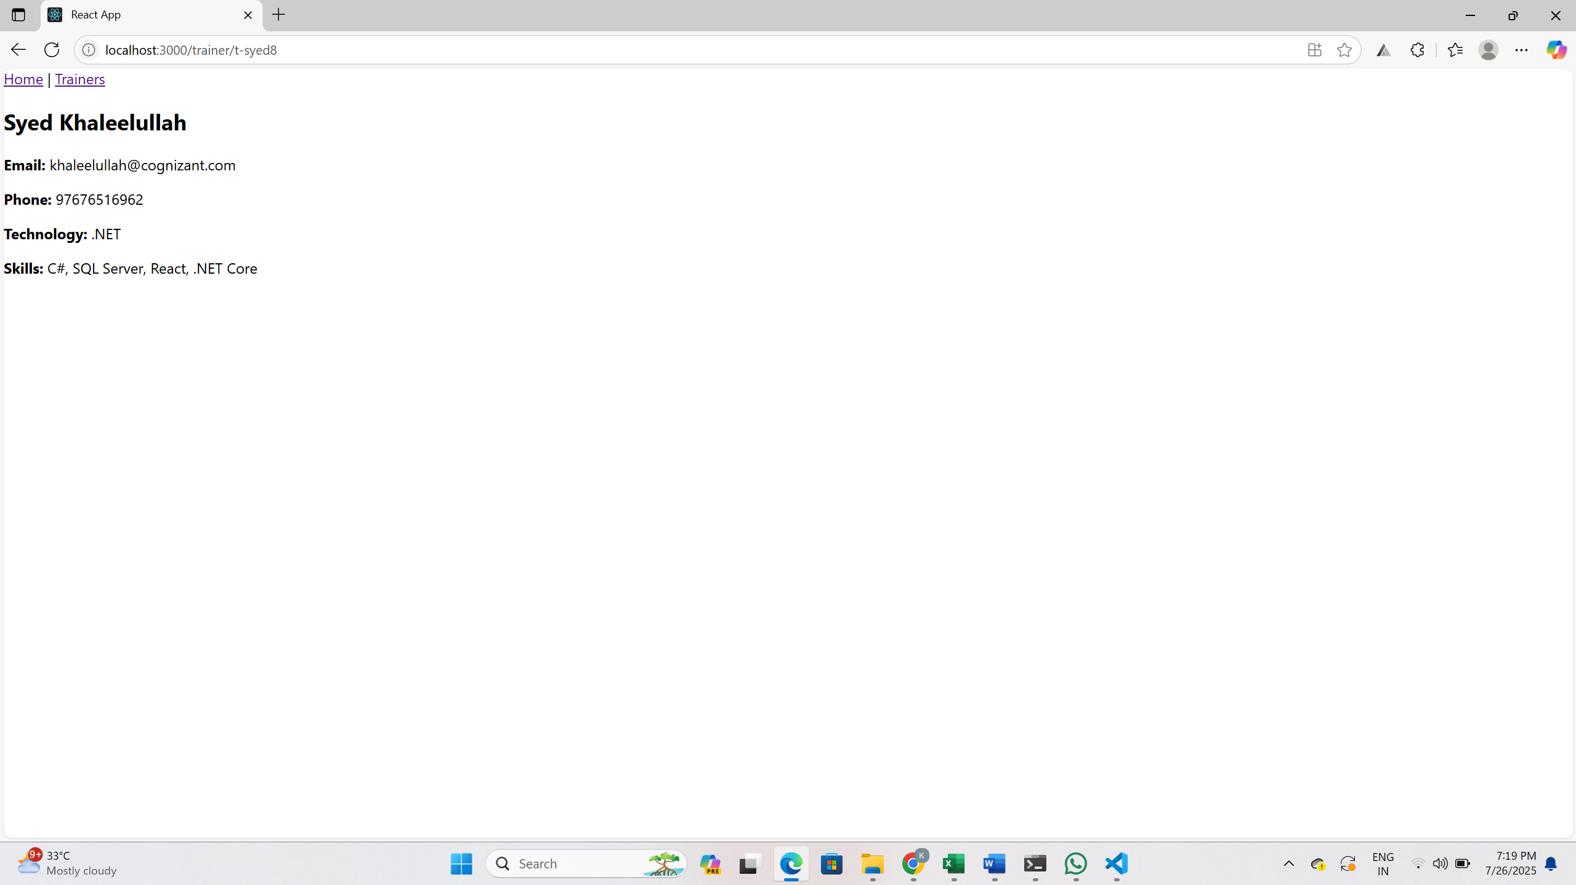

**ReactJS-HOL-7**

**1. Cart.js**

import React from 'react';

class Cart extends React.Component {

render() {

return (

<div>

<table border="1" cellPadding="10">

<thead>

<tr>

<th>Item Name</th>

<th>Price (₹)</th>

</tr>

</thead>

<tbody>

{this.props.item.map((item, index) => {

return (

<tr key={index}>

<td>{item.itemname}</td>

<td>{item.price}</td>

</tr>

);

})}

</tbody>

</table>

</div>

);

}

}

export default Cart;

**2. OnlineShopping.js**

import React from 'react';

import Cart from './Cart';

export class OnlineShopping extends React.Component {

render() {

const CartInfo = [

{ itemname: "Laptop", price: 80000 },

{ itemname: "TV", price: 120000 },

{ itemname: "Washing Machine", price: 50000 },

{ itemname: "Mobile", price: 30000 },

{ itemname: "Fridge", price: 70000 }

];

return (

<div className="mydiv">

<h1>🛒 Items Ordered :</h1>

<Cart item={CartInfo} />

</div>

);

}

}

export default OnlineShopping;

**3. index.js**

import React from 'react';

import ReactDOM from 'react-dom/client';

import './index.css';

import OnlineShopping from './OnlineShopping';

const root = ReactDOM.createRoot(document.getElementById('root'));

root.render(<OnlineShopping />);

**Output:**

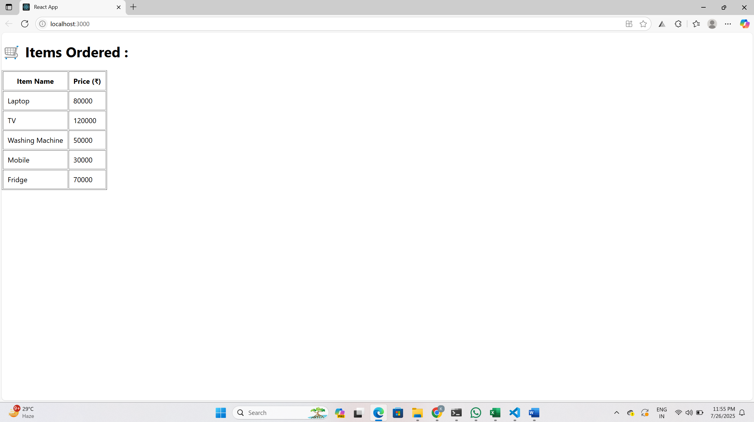

**ReactJS-HOL-8**

**1.Created app:**

npx create-react-app counterapp

cd counterapp

**2.code :**

**CountPeople.js**

import React from 'react';

class CountPeople extends React.Component {

  constructor() {

    super();

    this.state = {

      entrycount: 0,

      exitcount: 0

    };

  }

updateEntry = () => {

    this.setState((prevState) => {

      return { entrycount: prevState.entrycount + 1 };

    });

  };

updateExit = () => {

    this.setState((prevState) => {

      return { exitcount: prevState.exitcount + 1 };

    });

  };

  render() {

    return (

      <div style={{ padding: "20px", fontFamily: "Arial" }}>

        <h1>Mall Entry Tracker</h1>

        <p>People Entered: <b>{this.state.entrycount}</b></p>

        <p>People Exited: <b>{this.state.exitcount}</b></p>

        <button onClick={this.updateEntry} style={{ marginRight: '10px' }}>Login</button>

        <button onClick={this.updateExit}>Exit</button>

      </div>

    );

  }

}

export default CountPeople;

**index.js**

import React from 'react';

import ReactDOM from 'react-dom/client';

import './index.css';

import CountPeople from './CountPeople';

const root = ReactDOM.createRoot(document.getElementById('root'));

root.render(<CountPeople />);

**3.Run the app:**

npm start

**Output:**

