**WEEK-7**

**REACT**

**React Hol-9:**

**Create React App**

npx create-react-app cricketapp

cd cricketapp

**Create ListofPlayers.js**

Inside Components folder, create ListofPlayers.js:

import React from 'react';

function ListofPlayers() {

const players = [

{ name: "Virat", score: 85 },

{ name: "Rohit", score: 60 },

{ name: "Dhoni", score: 90 },

{ name: "Hardik", score: 50 },

{ name: "KL Rahul", score: 45 },

{ name: "Gill", score: 75 },

{ name: "Jadeja", score: 65 },

{ name: "Bumrah", score: 40 },

{ name: "Shami", score: 55 },

{ name: "Ashwin", score: 78 },

{ name: "Surya", score: 30 }

];

// Filter players with score < 70 using arrow function

const below70 = players.filter(p => p.score < 70);

return (

<div>

<h2>All Players</h2>

<ul>

{players.map((player, index) => (

<li key={index}>{player.name} - {player.score}</li>

))}

</ul>

<h2>Players with Score Below 70</h2>

<ul>

{below70.map((player, index) => (

<li key={index}>{player.name} - {player.score}</li>

))}

</ul>

</div>

);

}

export default ListofPlayers;

**Create IndianPlayers.js**

Inside Components, create IndianPlayers.js:

import React from 'react';

function IndianPlayers() {

const oddPlayers = ["Virat", "Dhoni", "Gill", "Jadeja", "Surya"];

const evenPlayers = ["Rohit", "Hardik", "KL Rahul", "Shami", "Ashwin"];

// Destructuring Example

const [odd1, odd2, ...oddRest] = oddPlayers;

const [even1, even2, ...evenRest] = evenPlayers;

// Merge T20 and Ranji players

const T20 = ["Virat", "Rohit", "Dhoni"];

const Ranji = ["Pujara", "Rahane", "Ishant"];

const allPlayers = [...T20, ...Ranji];

return (

<div>

<h2>Using Destructuring</h2>

<p>Odd Players: {odd1}, {odd2}, {oddRest.join(", ")}</p>

<p>Even Players: {even1}, {even2}, {evenRest.join(", ")}</p>

<h2>Merged Players (T20 + Ranji)</h2>

<ul>

{allPlayers.map((p, i) => (

<li key={i}>{p}</li>

))}

</ul>

</div>

);

}

export default IndianPlayers;

**Update App.js**

import React from 'react';

import ListofPlayers from './Components/ListofPlayers';

import IndianPlayers from './Components/IndianPlayers';

function App() {

const flag = true; // change to false to see IndianPlayers

return (

<div className="App">

<h1>🏏 Welcome to Cricket App</h1>

{flag ? <ListofPlayers /> : <IndianPlayers />}

</div>

);

}

export default App;

**Run the App**

In your terminal:

npm start

**OUTPUT:**

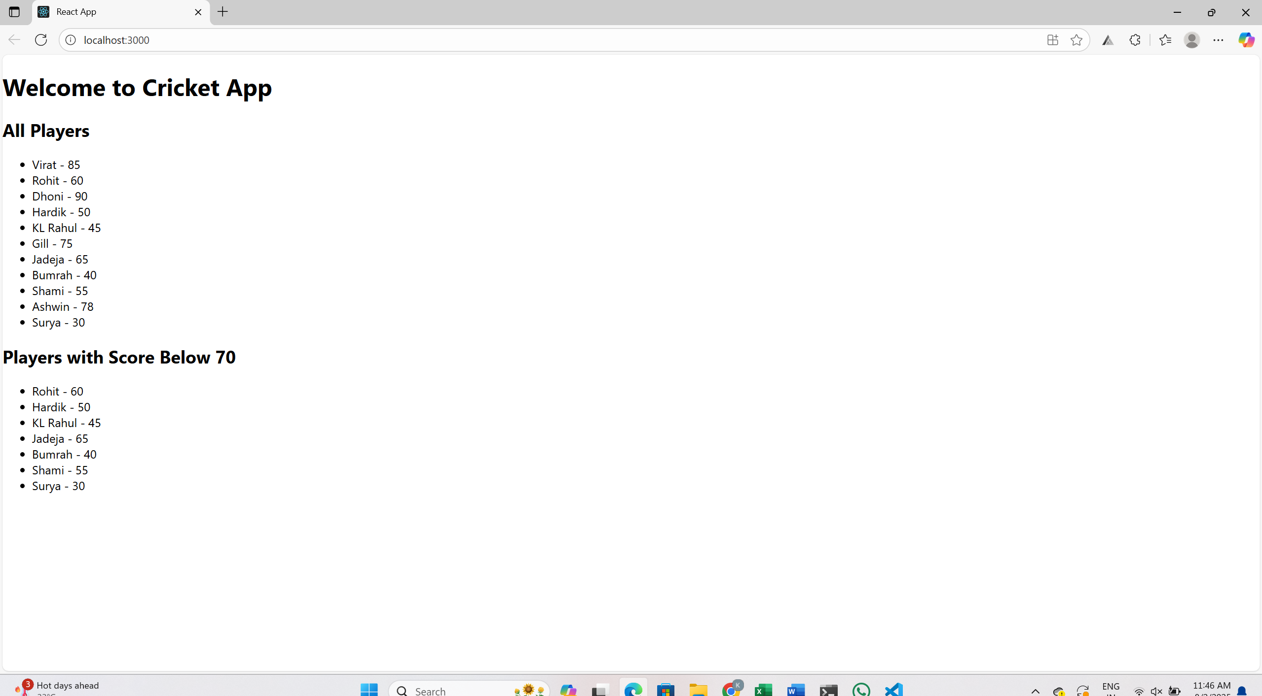

**React Hol-10:**

**Create Your React App**

Open your terminal and run:

npx create-react-app officespacerentalapp

cd officespacerentalapp

**Create a Component**

Inside src/, create a new file:

OfficeSpace.js

**JSX & JavaScript Code**

import React from 'react';

const offices = [

{ name: "Tech Hub", rent: 55000, address: "Mount Road, Chennai", image: "office1.jpg" },

{ name: "Startup Loft", rent: 67000, address: "Indiranagar, Bangalore", image: "office2.jpg" },

{ name: "BizNest", rent: 45000, address: "Hitech City, Hyderabad", image: "office3.jpg" }

];

function OfficeSpace() {

return (

<div>

<h1>Office Space Rental App </h1>

{offices.map((office, index) => (

<div key={index} style={{ border: '1px solid gray', marginBottom: '15px', padding: '10px' }}>

<img

src={office.image}

alt={office.name}

width="300"

style={{ borderRadius: '8px' }}

/>

<h2>{office.name}</h2>

<p>{office.address}</p>

<p style={{ color: office.rent < 60000 ? 'red' : 'green' }}>

Rent: ₹{office.rent}

</p>

</div>

))}

</div>

);

}

export default OfficeSpace;

**Update App.js to Render Your Component**

import React from 'react';

import OfficeSpace from './OfficeSpace';function App() {

return (

<div className="App">

<OfficeSpace />

</div>

);

}

export default App;

**Run Application**

npm start

**output:**

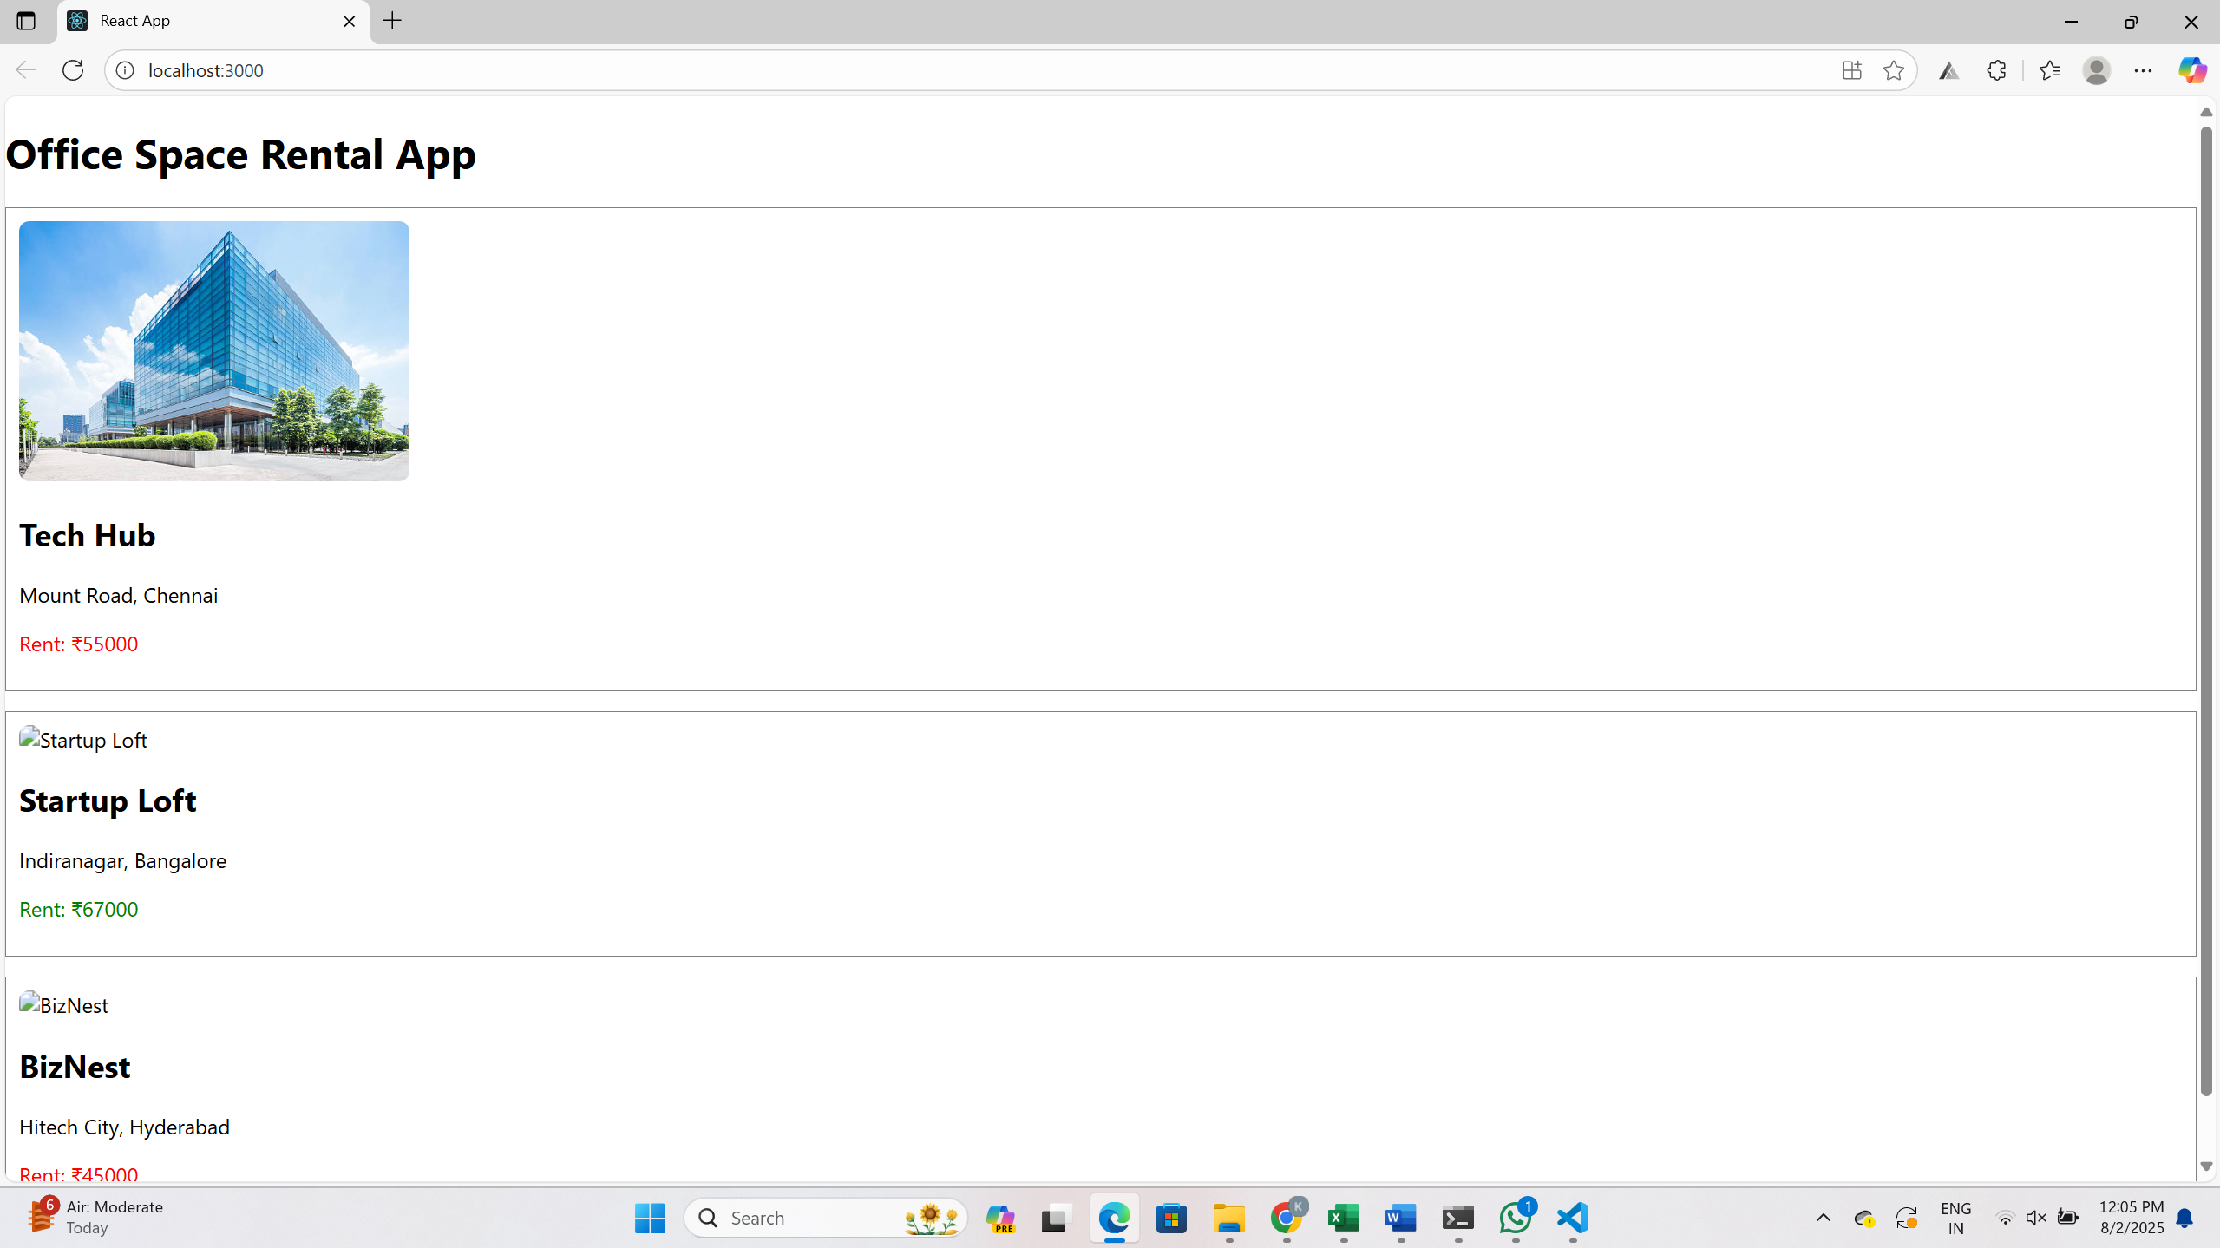

**React Hol-11:**

**Create React Project**

npx create-react-app eventexamplesapp

cd eventexamplesapp

**Create EventExamples.js Component**

Inside the src folder, create:

EventExamples.js

**Write React Event Handling Code**

import React from 'react';

class EventExamples extends React.Component {

constructor(props) {

super(props);

this.state = {

count: 0,

message: ''

};

// Bind 'this' for regular functions

this.handleDecrement = this.handleDecrement.bind(this);

this.sayWelcome = this.sayWelcome.bind(this);

}

// Multiple functions on Increment

handleIncrement = () => {

this.setState({ count: this.state.count + 1 });

this.sayHello();

};

sayHello = () => {

this.setState({ message: 'Hello! Keep clicking ' });

};

handleDecrement() {

this.setState({ count: this.state.count - 1, message: 'Decreased!' });

}

sayWelcome(welcome) {

this.setState({ message: welcome });

}

handleSyntheticEvent = (e) => {

e.preventDefault(); // Synthetic Event in action

this.setState({ message: 'I was clicked 🖱️ (Synthetic Event)' });

};

render() {

return (

<div>

<h1>Event Examples App</h1>

<h2>Count: {this.state.count}</h2>

<button onClick={this.handleIncrement}>Increment</button>

<button onClick={this.handleDecrement}>Decrement</button>

<button onClick={() => this.sayWelcome('Welcome to the event app!')}>

Say Welcome

</button>

<button onClick={this.handleSyntheticEvent}>Synthetic Click</button>

<p>{this.state.message}</p>

</div>

);

}

}

export default EventExamples;

**Create CurrencyConvertor.js**

This will convert INR to EURO (example rate: 1 EUR = 85 INR)

import React, { useState } from 'react';

function CurrencyConvertor() {

const [rupees, setRupees] = useState('');

const [euros, setEuros] = useState('');

const handleSubmit = () => {

const converted = parseFloat(rupees) / 85;

setEuros(converted.toFixed(2));

};

return (

<div>

<h2>Currency Convertor </h2>

<input

type="number"

value={rupees}

onChange={(e) => setRupees(e.target.value)}

placeholder="Enter amount in ₹"

/>

<button onClick={handleSubmit}>Convert to €</button>

<p>{euros && `Converted Amount: €${euros}`}</p>

</div>

);

}

export default CurrencyConvertor;

**Use Components in App.js**

import React from 'react';

import EventExamples from './EventExamples';

import CurrencyConvertor from './CurrencyConvertor';

function App() {

return (

<div className="App">

<EventExamples />

<CurrencyConvertor />

</div>

);

}

export default App;

**Run App**

npm start

**OUTPUT:**

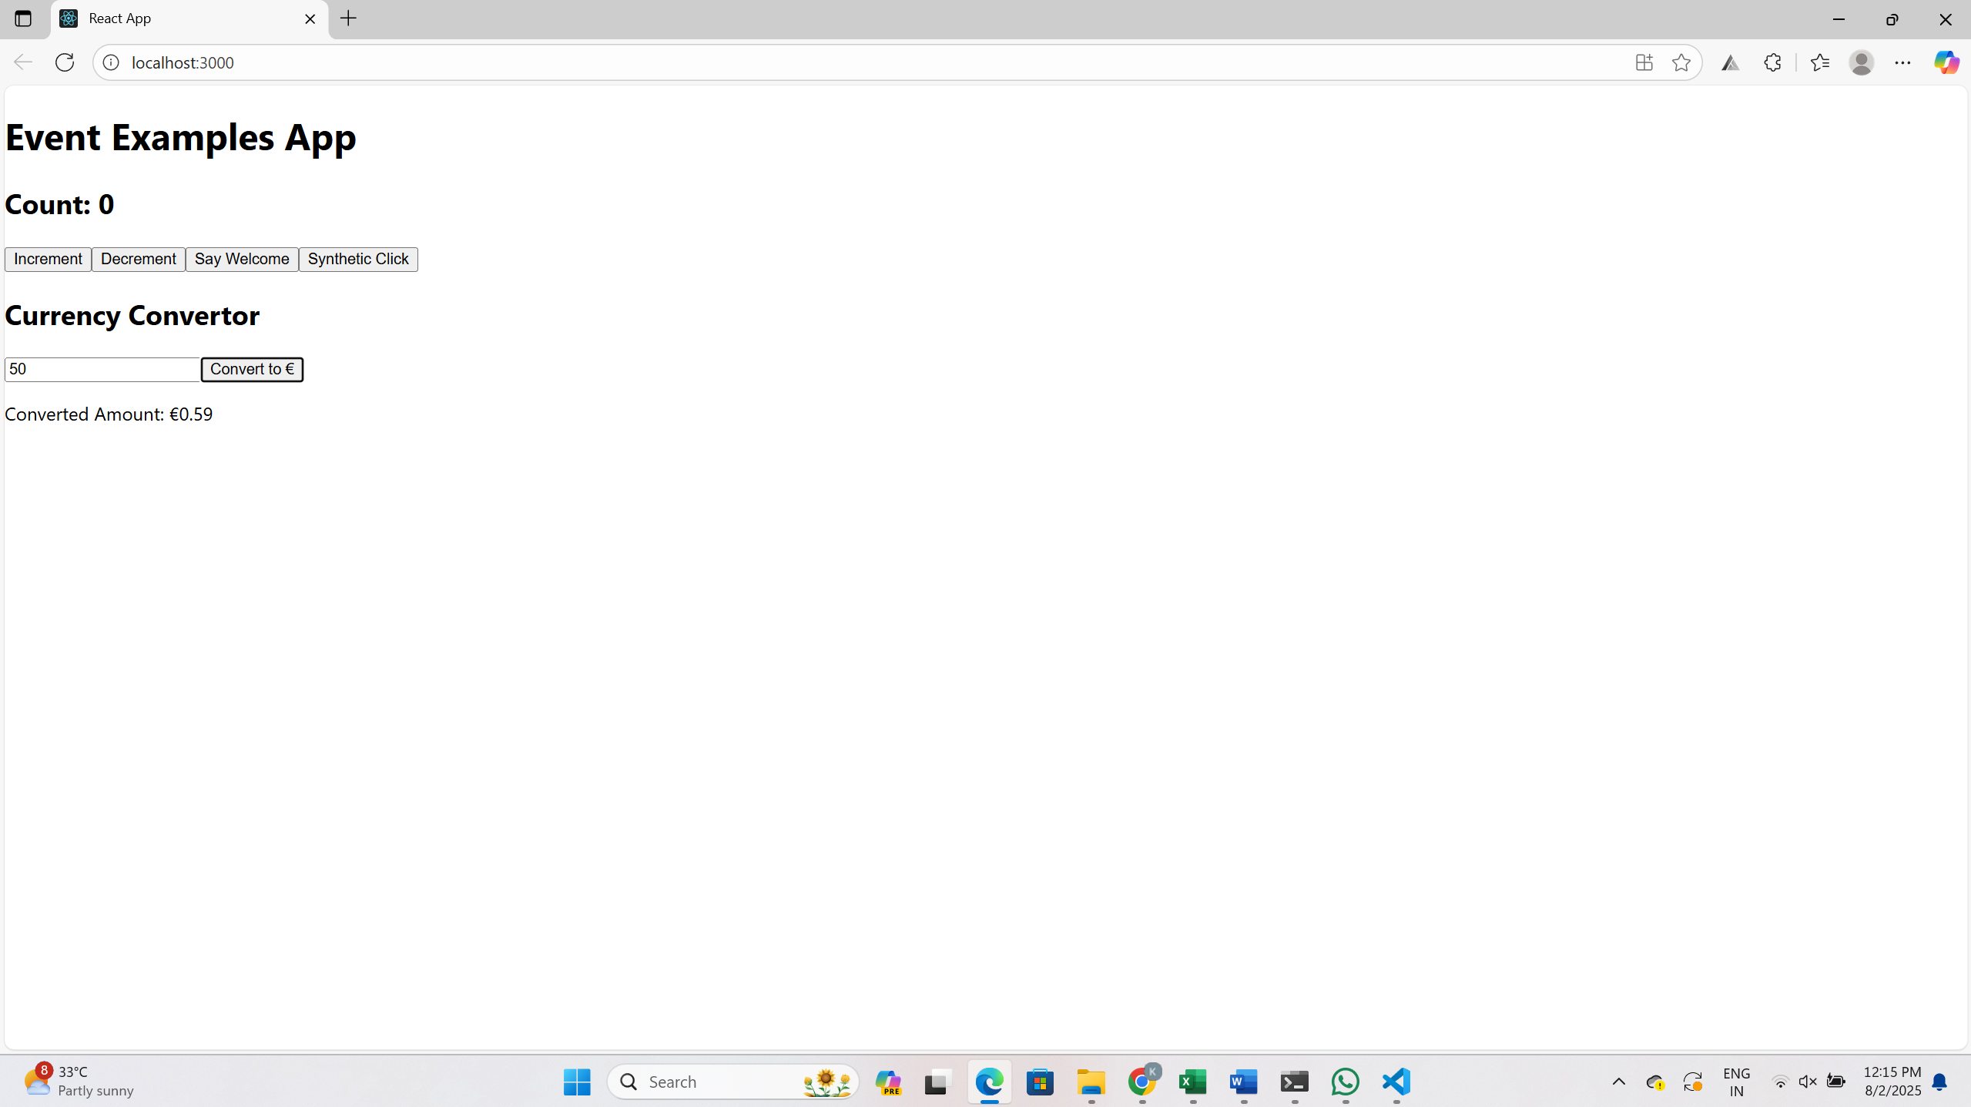

**React Hol-12:**

**Create a React App**

npx create-react-app ticketbookingapp

cd ticketbookingapp

**Set Up Basic Components**

* **LoginButton**
* **LogoutButton**
* **GuestPage**
* **UserPage**
* **FlightDetailsPage**

**LoginButton.js**:

function LoginButton({ onLogin }) {

return <button onClick={onLogin}>Login</button>;

}

export default LoginButton;

Do similar for Logout and the pages.

**Set Up App State in App.js**

This is where conditional rendering magic happens.

import React, { useState } from 'react';

import LoginButton from './components/LoginButton';

import LogoutButton from './components/LogoutButton';

import GuestPage from './components/GuestPage';

import UserPage from './components/UserPage';

import FlightDetailsPage from './components/FlightDetailsPage';

function App() {

const [isLoggedIn, setIsLoggedIn] = useState(false);

const handleLogin = () => setIsLoggedIn(true);

const handleLogout = () => setIsLoggedIn(false);

let button;

let page;

if (isLoggedIn) {

button = <LogoutButton onLogout={handleLogout} />;

page = <UserPage />;

} else {

button = <LoginButton onLogin={handleLogin} />;

page = <GuestPage />;

}

return (

<div>

<h1>Ticket Booking App</h1>

{button}

<FlightDetailsPage />

{page}

</div>

);

}

export default App;

**Run the App**

npm start

**OUTPUT:**

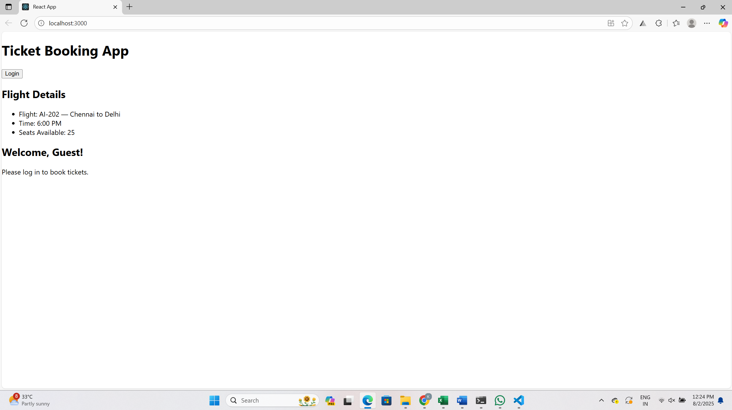

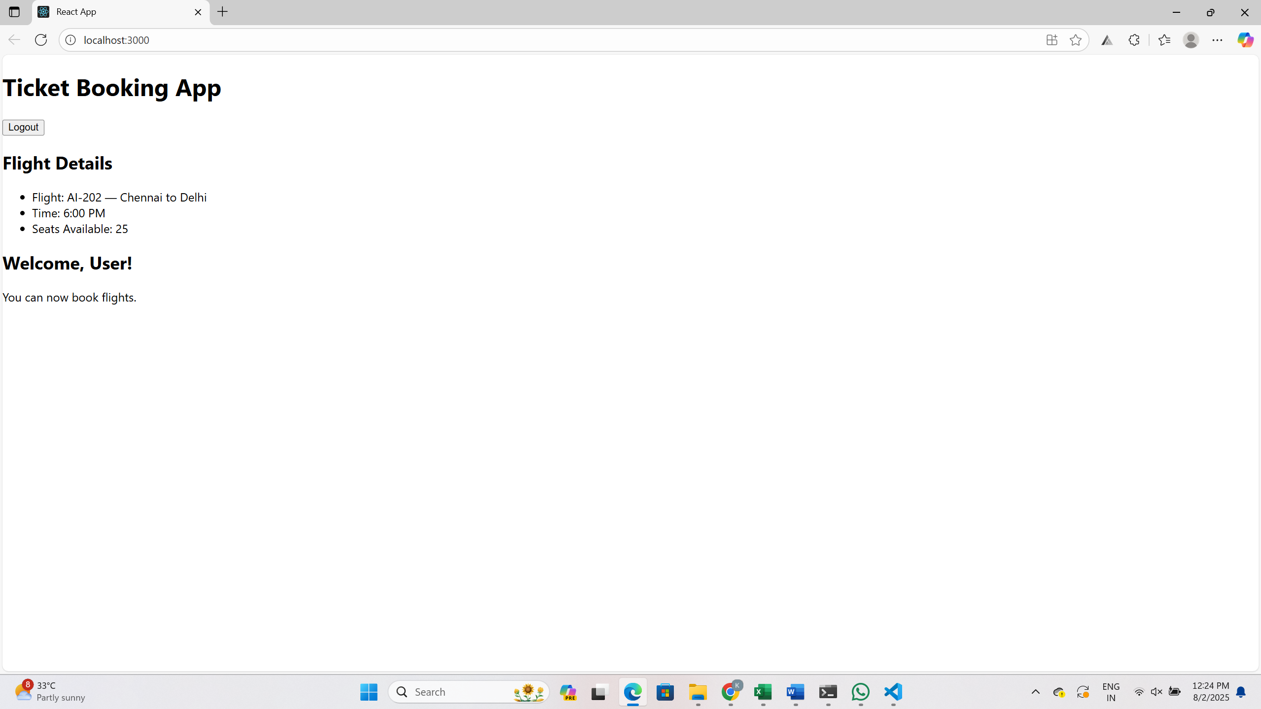

**React Hol-13:**

Create App

npx create-react-app bloggerapp

cd bloggerapp

code .

**Create Components Folder**

Inside the src/ folder, make a folder called components, and inside that, create these files:

* BookDetails.js
* BlogDetails.js
* CourseDetails.js

**Add Dummy Data**

You can define some basic list data in each component for practicing map() and keys.

BookDetails.js

const books = [

{ id: 1, title: 'React for Beginners' },

{ id: 2, title: 'Advanced JavaScript' }

];

function BookDetails() {

return (

<div>

<h2>Books</h2>

<ul>

{books.map(book => (

<li key={book.id}>{book.title}</li>

))}

</ul>

</div>

);

}

export default BookDetails;

**BlogDetails.js**

const blogs = [

{ id: 1, title: 'React Hooks Deep Dive' },

{ id: 2, title: 'State Management Made Easy' },

{ id: 3, title: 'Conditional Rendering Tricks' }

];

function BlogDetails() {

return (

<div>

<h2>Blog Posts</h2>

<ul>

{blogs.map(blog => (

<li key={blog.id}>{blog.title}</li>

))}

</ul>

</div>

);

}

export default BlogDetails;

**CourseDetails.js**

const courses = [

{ id: 101, title: 'Frontend Development' },

{ id: 102, title: 'ReactJS Masterclass' },

{ id: 103, title: 'JavaScript Essentials' }

];

function CourseDetails() {

return (

<div>

<h2>Courses Offered</h2>

<ul>

{courses.map(course => (

<li key={course.id}>{course.title}</li>

))}

</ul>

</div>

);

}

export default CourseDetails;

**Add Conditional Rendering in App.js**

**App.js**

import { useState } from 'react';

import BookDetails from './components/BookDetails';

import BlogDetails from './components/BlogDetails';

import CourseDetails from './components/CourseDetails';

function App() {

const [selectedTab, setSelectedTab] = useState('books');

let content;

if (selectedTab === 'books') content = <BookDetails />;

else if (selectedTab === 'blogs') content = <BlogDetails />;

else content = <CourseDetails />;

return (

<div>

<h1>Blogger App</h1>

<button onClick={() => setSelectedTab('books')}>Books</button>

<button onClick={() => setSelectedTab('blogs')}>Blogs</button>

<button onClick={() => setSelectedTab('courses')}>Courses</button>

{content}

</div>

);

}

export default App;

**Run the App**:

npm start

**OUTPUT:**

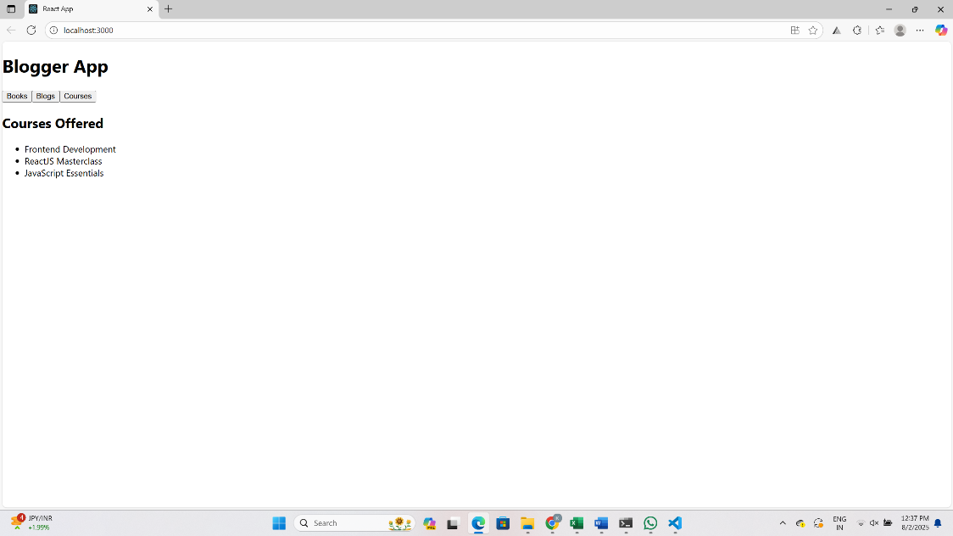

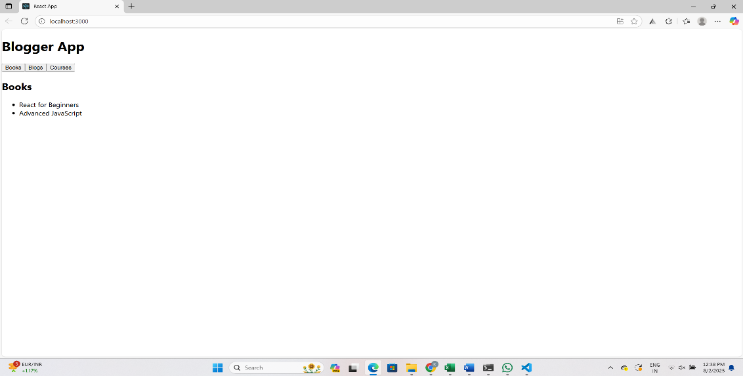

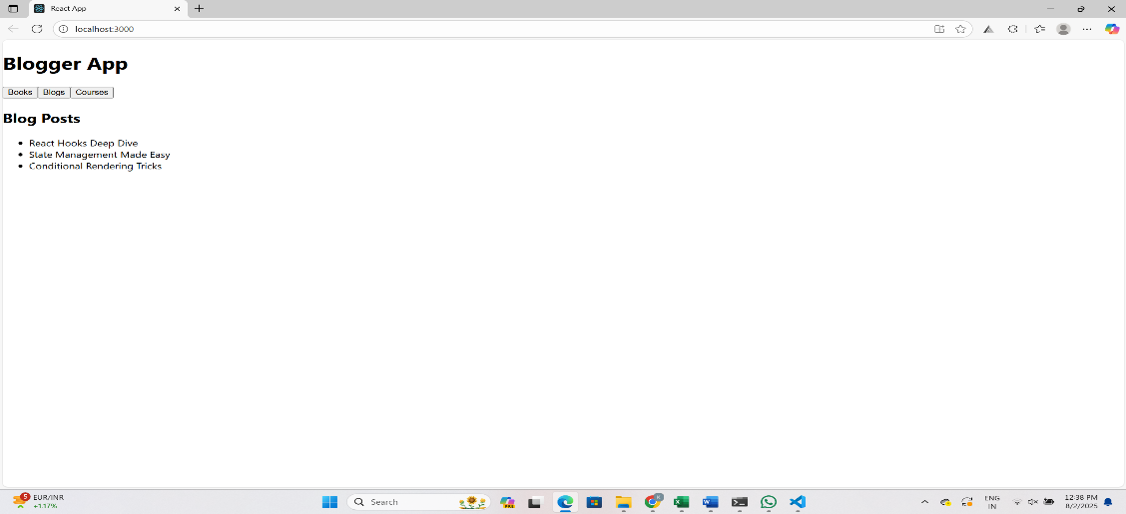

**React Hol-14:**

**Create the Project**

npx create-react-app themingapp

cd themingapp

code .

**Create ThemeContext.js**

import React from 'react';

// Creating the context with default value 'light'

const ThemeContext = React.createContext('light');

export default ThemeContext;

**App.js**

import React, { useState } from 'react';

import EmployeeList from './EmployeesList';

import ThemeContext from './ThemeContext';

function App() {

const [theme, setTheme] = useState('light'); // use 'dark' to test dark theme

return (

<ThemeContext.Provider value={theme}>

<div>

<h1>Employee Theming App</h1>

<EmployeeList />

</div>

</ThemeContext.Provider>

);

}

export default App;

**EmployeesList.js**

import React from 'react';

import EmployeeCard from './EmployeeCard';

function EmployeesList() {

const employees = [

{ id: 1, name: 'Alice', role: 'Developer' },

{ id: 2, name: 'Bob', role: 'Tester' },

{ id: 3, name: 'Charlie', role: 'Manager' }

];

return (

<div>

<h2>Employees List</h2>

{employees.map(emp => (

<EmployeeCard key={emp.id} employee={emp} />

))}

</div>

);

}

export default EmployeesList;

**EmployeeCard.js**

import React, { useContext } from 'react';

import ThemeContext from './ThemeContext';

function EmployeeCard({ employee }) {

const theme = useContext(ThemeContext);

const buttonStyle = {

backgroundColor: theme === 'light' ? '#ddd' : '#444',

color: theme === 'light' ? '#000' : '#fff',

padding: '10px',

margin: '5px',

border: 'none',

borderRadius: '5px'

};

return (

<div style={{ border: '1px solid gray', padding: '15px', margin: '10px' }}>

<p><strong>Name:</strong> {employee.name}</p>

<p><strong>Role:</strong> {employee.role}</p>

<button style={buttonStyle}>Send Email</button>

</div>

);

}

export default EmployeeCard;

**Run the App**

npm start

**OUTPUT:**

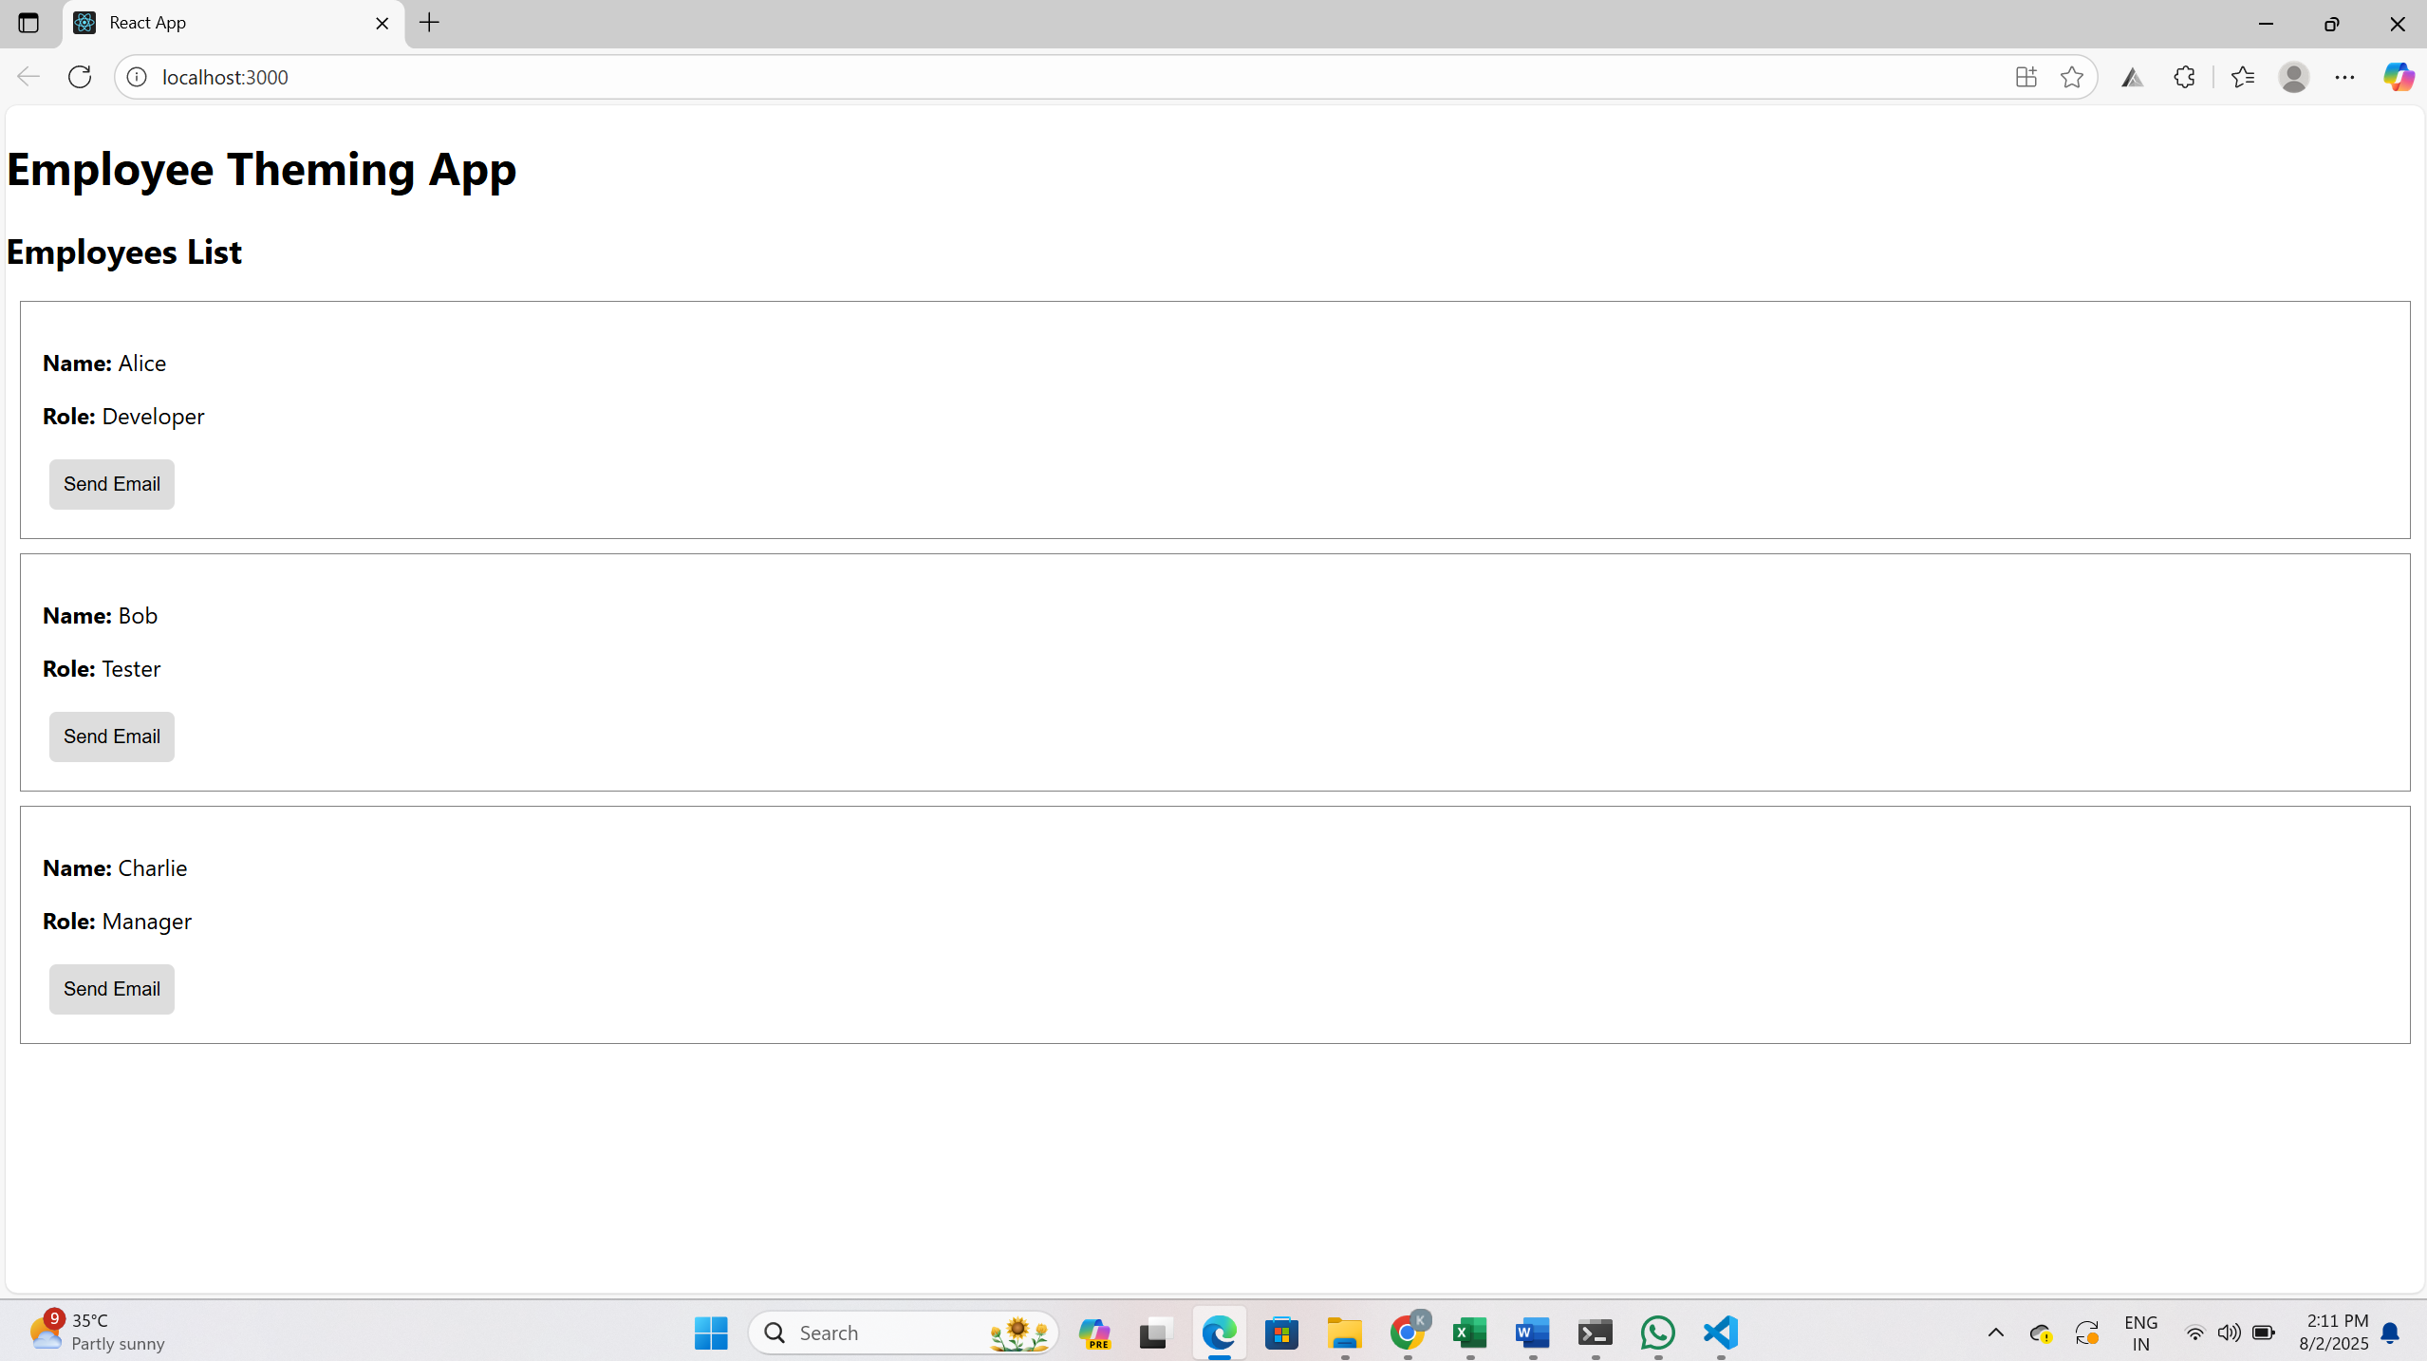

**React Hol-15:**

**Create the React App**

npx create-react-app ticketraisingapp

cd ticketraisingapp

code .

**Build the ComplaintRegister Component**

src/components/ComplaintRegister.js

import React, { useState } from 'react';

function ComplaintRegister() {

const [name, setName] = useState('');

const [complaint, setComplaint] = useState('');

const handleSubmit = (e) => {

e.preventDefault();

// Generate a simple reference number (random 6-digit)

const refNumber = Math.floor(100000 + Math.random() * 900000);

alert(`Complaint registered for ${name}. Reference Number: ${refNumber}`);

// Clear form

setName('');

setComplaint('');

};

return (

<div>

<h2>Complaint Form</h2>

<form onSubmit={handleSubmit}>

<label>

Employee Name:

<input

type="text"

value={name}

onChange={(e) => setName(e.target.value)}

/>

</label>

<br /><br />

<label>

Complaint:

<textarea

rows="4"

value={complaint}

onChange={(e) => setComplaint(e.target.value)}

/>

</label>

<br /><br />

<button type="submit">Submit Complaint</button>

</form>

</div>

);

}

export default ComplaintRegister;

**Use the Component in App.js**

import React from 'react';

import ComplaintRegister from './components/ComplaintRegister';

function App() {

return (

<div>

<h1>Ticket Raising App </h1>

<ComplaintRegister />

</div>

);

}

export default App;

**Run the App**

npm start

**OUTPUT:**

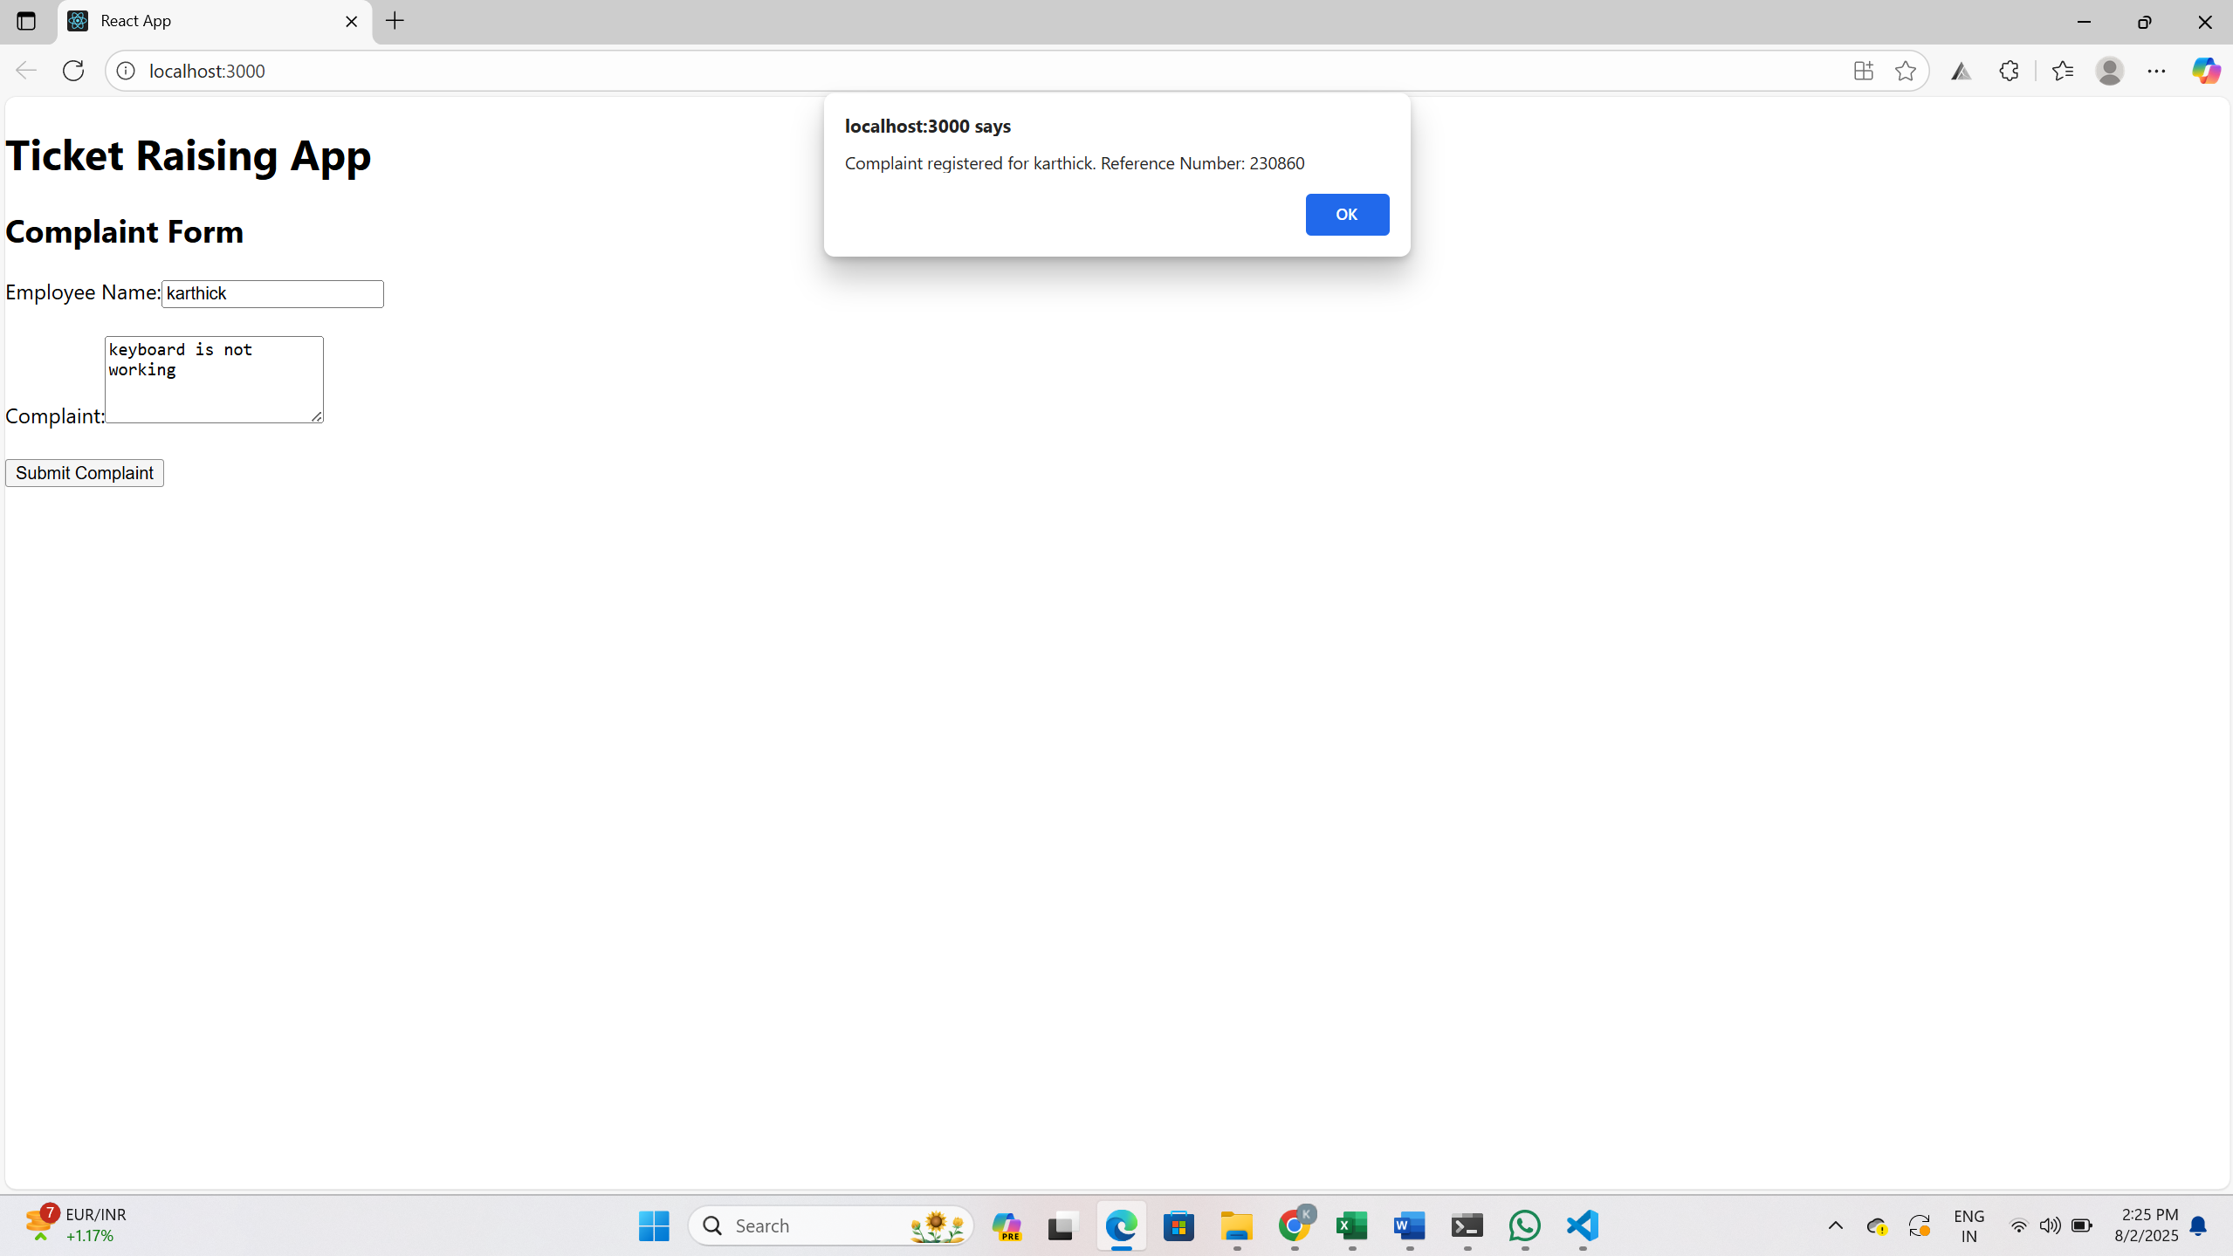

**React Hol-16:**

**Create React App**

npx create-react-app mailregisterapp

cd mailregisterapp

**Create the Component register.js**

**Code inside Register.js**

import React, { useState } from 'react';

function Register() {

const [formData, setFormData] = useState({

name: '',

email: '',

password: ''

});

const [formErrors, setFormErrors] = useState({

name: '',

email: '',

password: ''

});

const handleChange = (e) => {

const { name, value } = e.target;

setFormData({ ...formData, [name]: value });

// Validation

if (name === 'name') {

setFormErrors({

...formErrors,

name: value.length < 5 ? 'Name should be at least 5 characters' : ''

});

}

if (name === 'email') {

setFormErrors({

...formErrors,

email: value.includes('@') && value.includes('.') ? '' : 'Invalid email'

});

}

if (name === 'password') {

setFormErrors({

...formErrors,

password: value.length < 8 ? 'Password should be at least 8 characters' : ''

});

}

};

const handleSubmit = (e) => {

e.preventDefault();

const { name, email, password } = formData;

if (name && email && password && !formErrors.name && !formErrors.email && !formErrors.password) {

alert('Registration Successful!');

} else {

alert('Please correct the errors in the form.');

}

};

return (

<div style={{ padding: "30px", maxWidth: "400px", margin: "auto" }}>

<h2>Register</h2>

<form onSubmit={handleSubmit}>

<div>

<label>Name: </label><br />

<input type="text" name="name" value={formData.name} onChange={handleChange} />

<div style={{ color: "red" }}>{formErrors.name}</div>

</div>

<div>

<label>Email: </label><br />

<input type="email" name="email" value={formData.email} onChange={handleChange} />

<div style={{ color: "red" }}>{formErrors.email}</div>

</div>

<div>

<label>Password: </label><br />

<input type="password" name="password" value={formData.password} onChange={handleChange} />

<div style={{ color: "red" }}>{formErrors.password}</div>

</div>

<button type="submit" style={{ marginTop: "15px" }}>Register</button>

</form>

</div>

);

}

export default Register;

**Modify App.js to Use Register**

import React from 'react';

import Register from './Register';

function App() {

return (

<div className="App">

<Register />

</div>

);

}

export default App;

**Run the App**

npm start

**OUTPUT:**

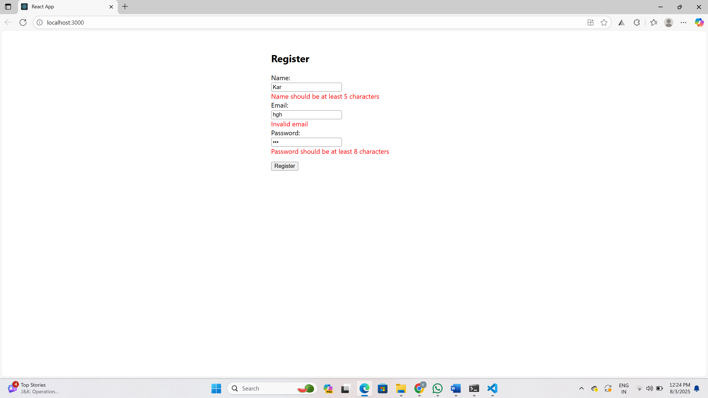

**React Hol-17:**

**Create the React App**

npx create-react-app fetchuserapp

cd fetchuserapp

**Create Getuser.js Component**

src/Getuser.js

import React from "react";

class Getuser extends React.Component {

constructor(props) {

super(props);

this.state = {

person: {},

loading: true

};

}

async componentDidMount() {

const url = "https://api.randomuser.me/";

const response = await fetch(url);

const data = await response.json();

this.setState({ person: data.results[0], loading: false });

console.log(data.results[0]); // Debug output

}

render() {

const { loading, person } = this.state;

if (loading) {

return <div>Loading...</div>;

}

return (

<div style={{ textAlign: "center", marginTop: "50px" }}>

<h1>

{person.name.title} {person.name.first} {person.name.last}

</h1>

<img src={person.picture.large} alt="User" />

</div>

);

}

}

export default Getuser;

**Use Getuser in App.js**

import React from "react";

import Getuser from "./Getuser";

function App() {

return (

<div className="App">

<Getuser />

</div>

);

}

export default App;

**Run the App**

npm start

**OUTPUT:**

