**WEEK-5**

**WebApi-Handson**

**Objective**

To create a Kafka-based chat application using C# Windows Forms that allows sending messages to a Kafka topic and consuming them via a console-based Kafka consumer.

**Setup & Installation**

1. Kafka and Zookeeper Installation

* Extracted Kafka from kafka_2.12-2.7.0.zip.

Started Zookeeper using:

.\bin\windows\zookeeper-server-start.bat .\config\zookeeper.properties

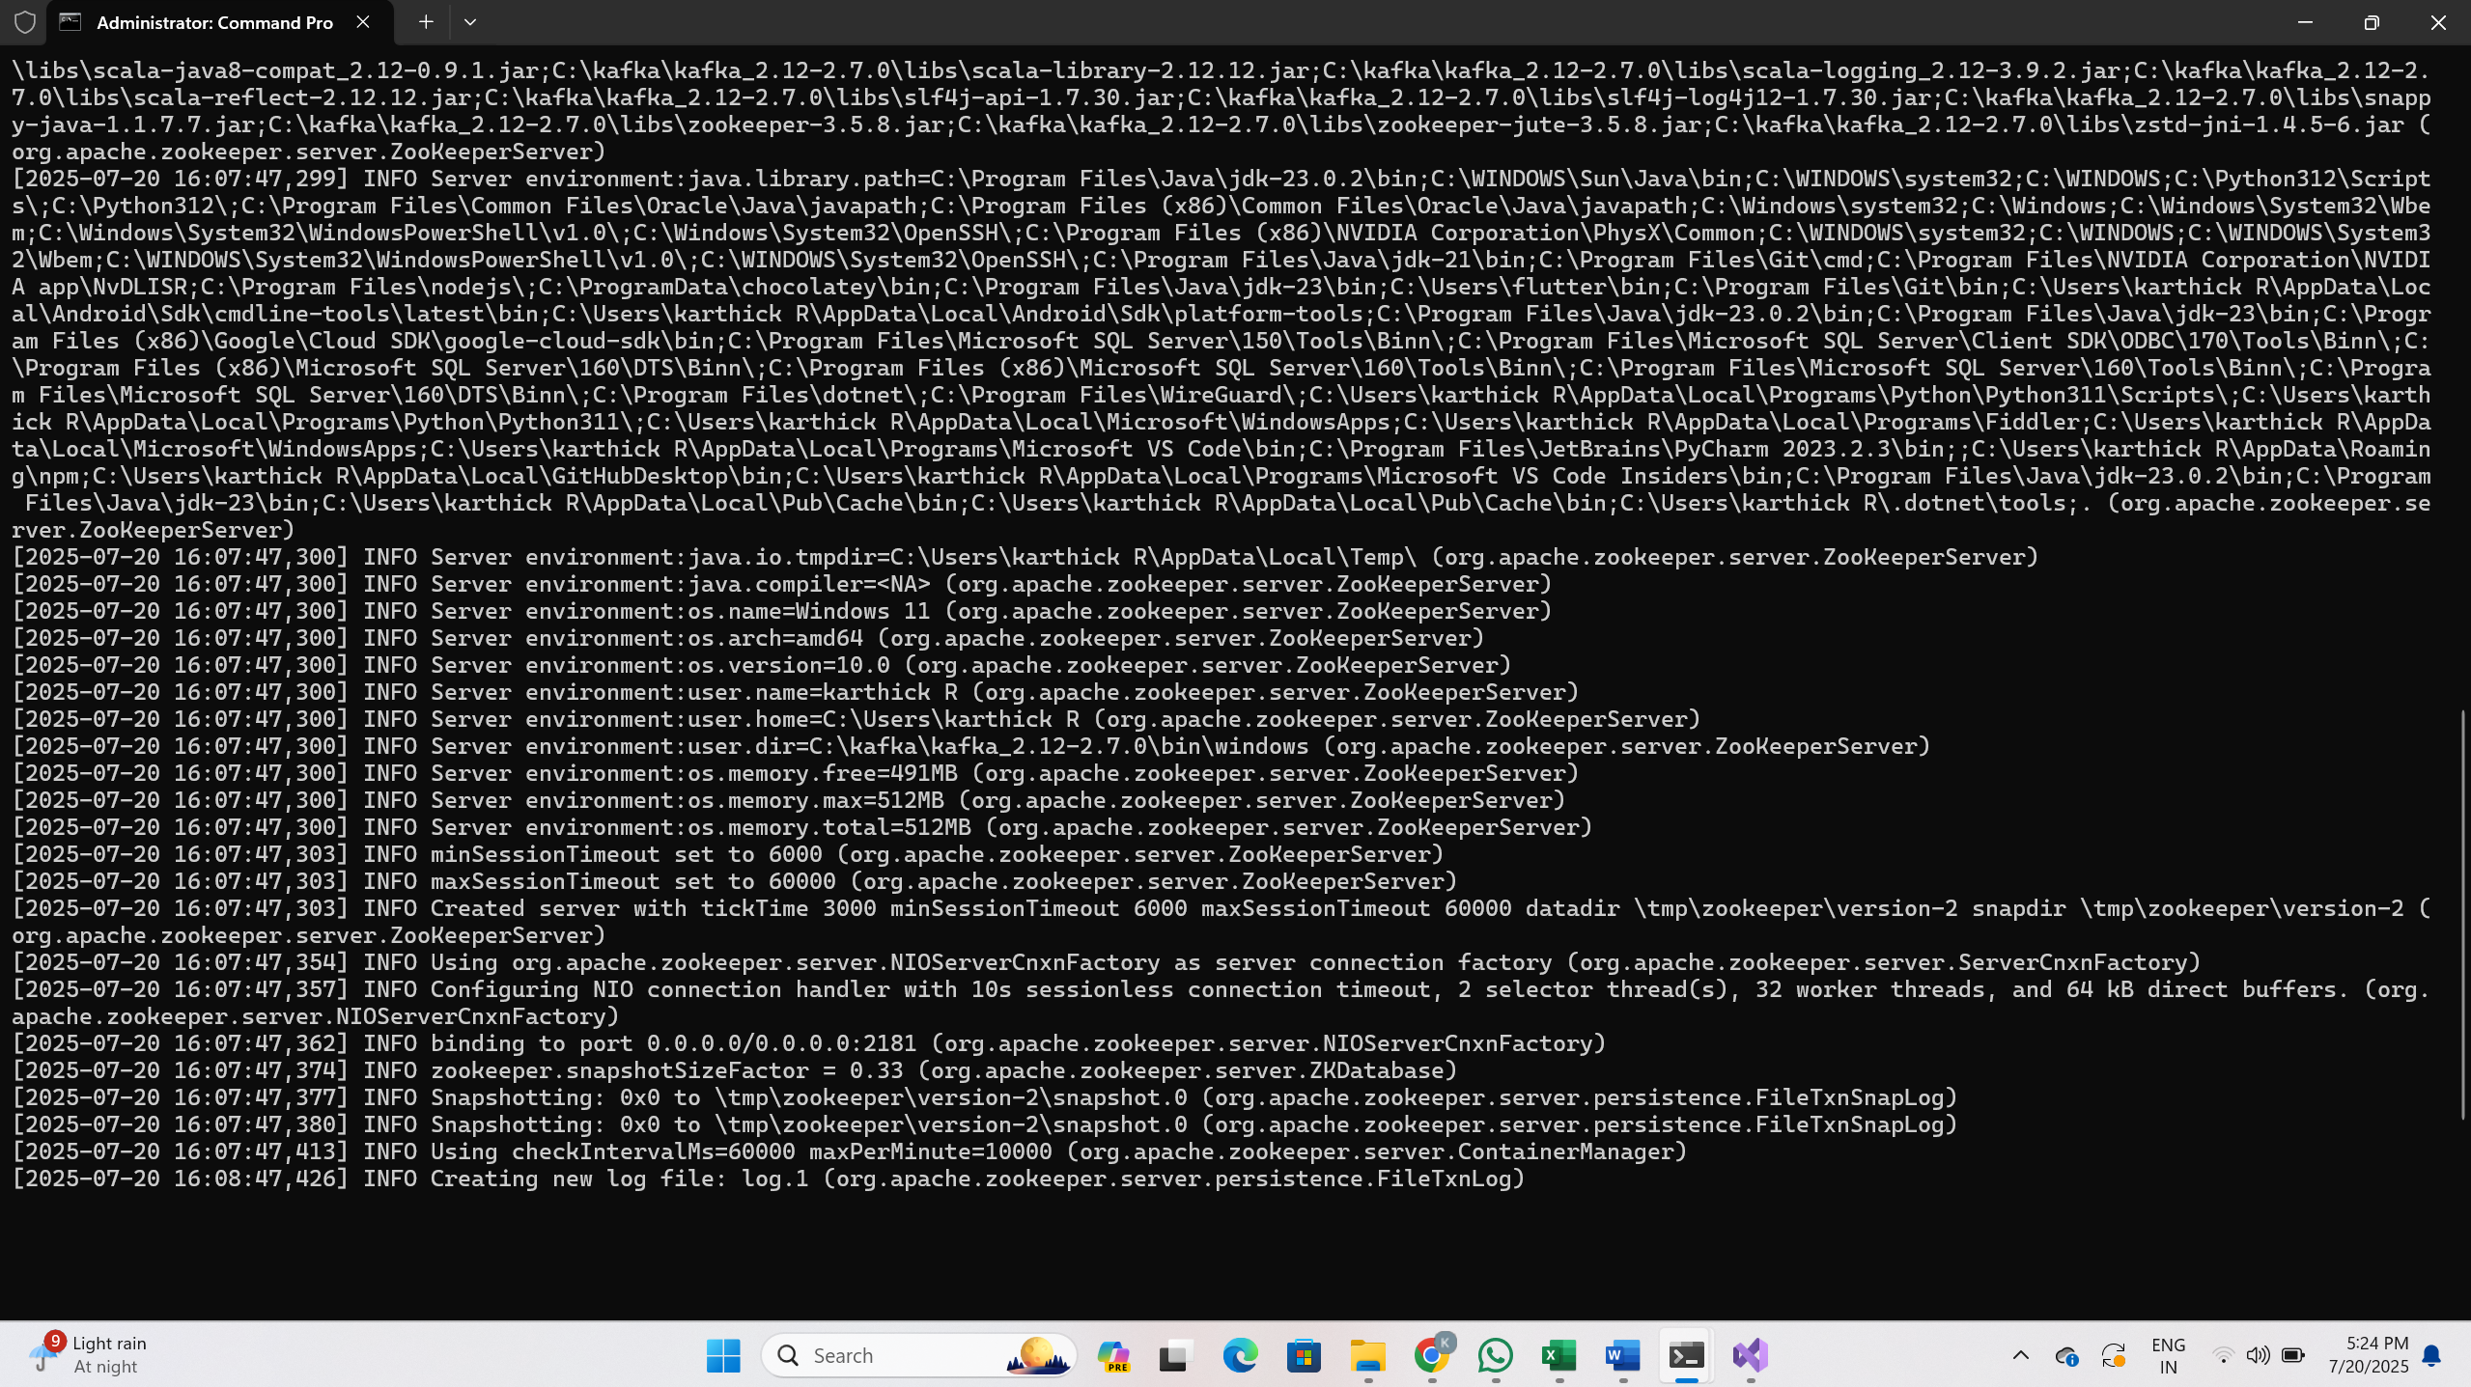

Started Kafka broker using:

.\bin\windows\kafka-server-start.bat .\config\server.properties

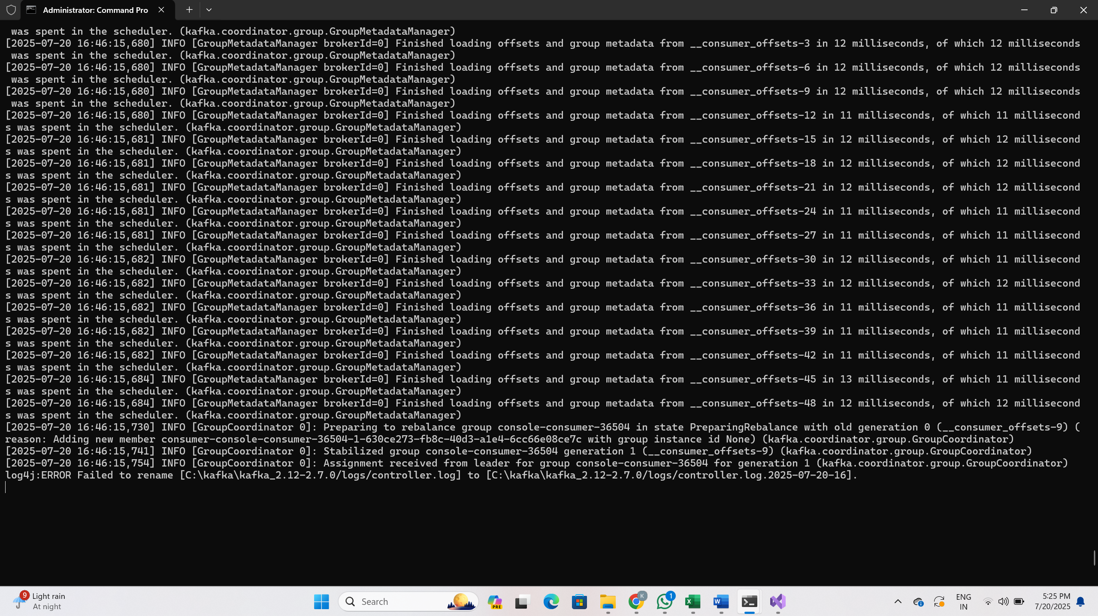

Created topic chat-message:  
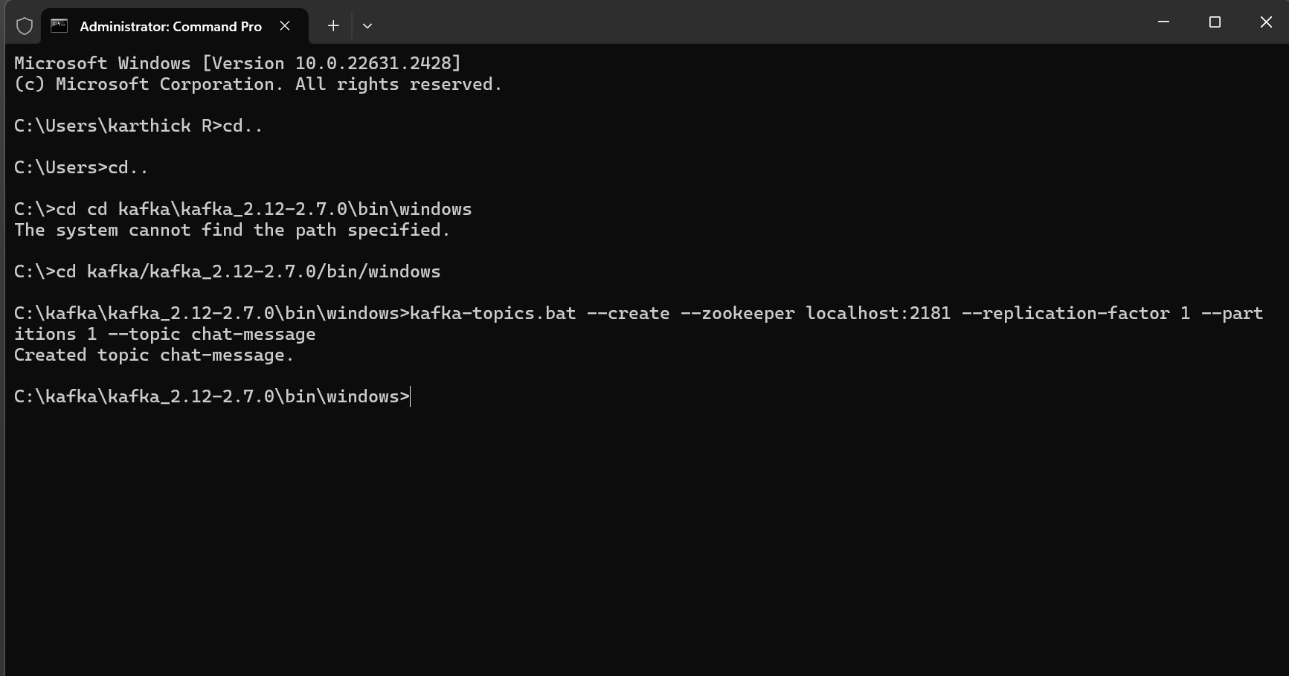

**Project Setup**

2. Windows Forms Application in Visual Studio

* Created project: KafkaChatProducer
* Type: Windows Forms App (.NET Framework)

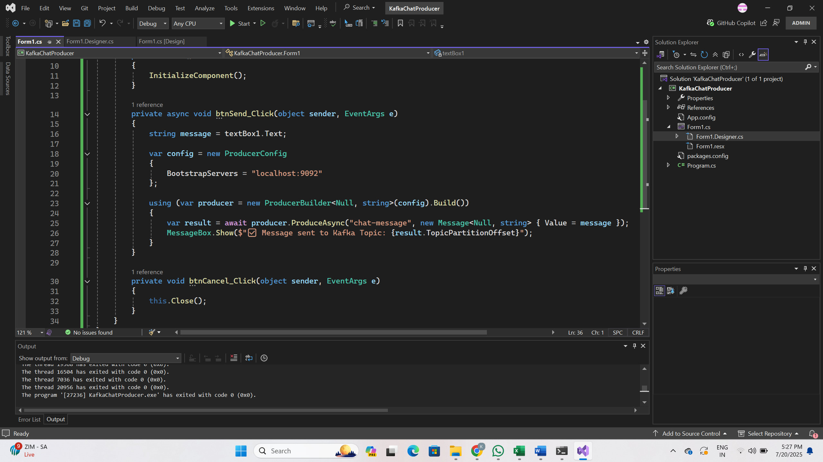

3. Designer Elements

* Added a Label with text: “Please Enter Your Message Here:”
* Added a Multiline TextBox: textBox1
* Added two Buttons:
  + btnSend → Send
  + btnCancel → Cancel

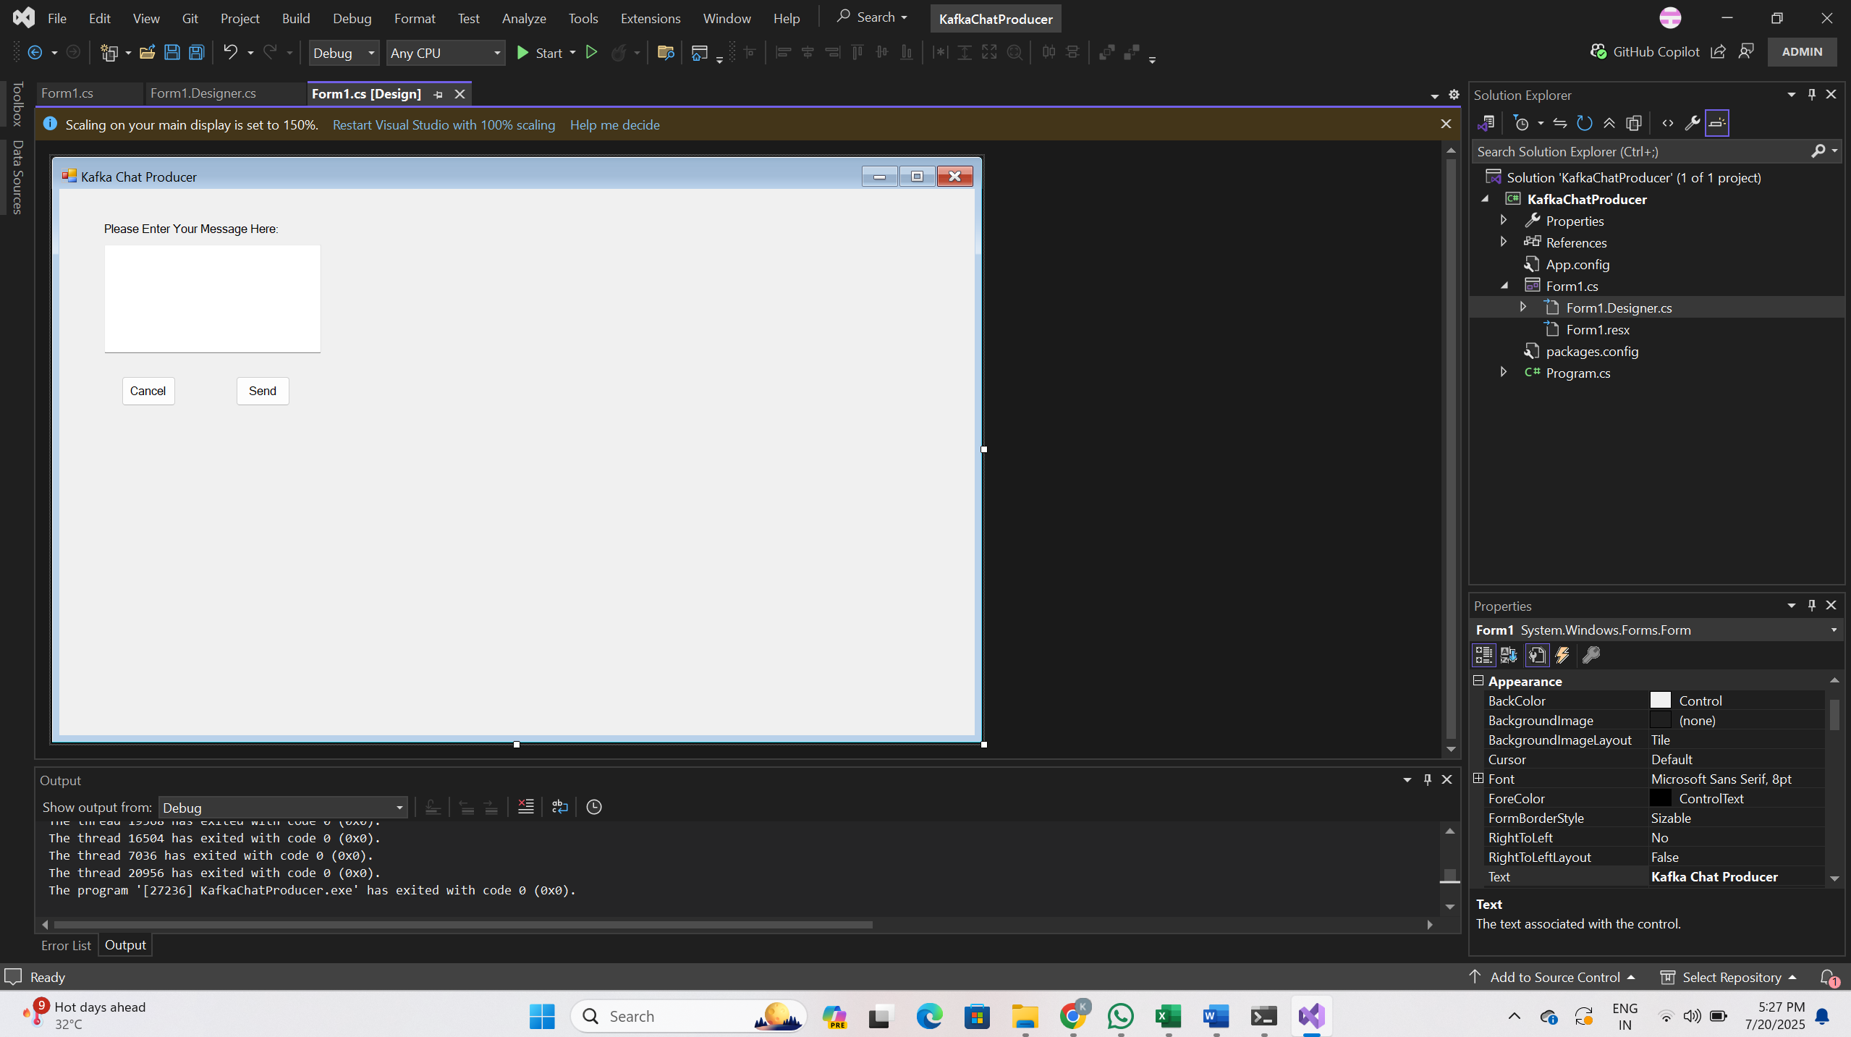

**Kafka Producer Code**

**Form1.cs**

using Confluent.Kafka;

using System;

using System.Windows.Forms;

namespace KafkaChatProducer

{

public partial class Form1 : Form

{

public Form1()

{

InitializeComponent();

}

private async void btnSend_Click(object sender, EventArgs e)

{

string message = textBox1.Text;

var config = new ProducerConfig

{

BootstrapServers = "localhost:9092"

};

using (var producer = new ProducerBuilder<Null, string>(config).Build())

{

var result = await producer.ProduceAsync("chat-message", new Message<Null, string> { Value = message });

MessageBox.Show($"Message sent to Kafka Topic: {result.TopicPartitionOffset}");

}

}

private void btnCancel_Click(object sender, EventArgs e)

{

this.Close();

}

}

}

**Form1.Designer.cs Code Snippet**

Key UI Controls:

* Label: label1
* TextBox: textBox1
* Buttons: btnSend, btnCancel

namespace KafkaChatProducer

{

partial class Form1

{

private System.ComponentModel.IContainer components = null;

protected override void Dispose(bool disposing)

{

if (disposing && (components != null))

{

components.Dispose();

}

base.Dispose(disposing);

}

#region Windows Form Designer generated code

private void InitializeComponent()

{

this.label1 = new System.Windows.Forms.Label();

this.textBox1 = new System.Windows.Forms.TextBox();

this.btnSend = new System.Windows.Forms.Button();

this.btnCancel = new System.Windows.Forms.Button();

this.SuspendLayout();

//

// label1

//

this.label1.AutoSize = true;

this.label1.Location = new System.Drawing.Point(58, 45);

this.label1.Name = "label1";

this.label1.Size = new System.Drawing.Size(250, 20);

this.label1.TabIndex = 0;

this.label1.Text = "Please Enter Your Message Here:";

//

// textBox1

//

this.textBox1.Location = new System.Drawing.Point(62, 77);

this.textBox1.Multiline = true;

this.textBox1.Name = "textBox1";

this.textBox1.Size = new System.Drawing.Size(300, 150);

this.textBox1.TabIndex = 1;

//

// btnSend

//

this.btnSend.Location = new System.Drawing.Point(244, 259);

this.btnSend.Name = "btnSend";

this.btnSend.Size = new System.Drawing.Size(75, 41);

this.btnSend.TabIndex = 2;

this.btnSend.Text = "Send";

this.btnSend.UseVisualStyleBackColor = true;

this.btnSend.Click += new System.EventHandler(this.btnSend_Click);

//

// btnCancel

//

this.btnCancel.Location = new System.Drawing.Point(86, 259);

this.btnCancel.Name = "btnCancel";

this.btnCancel.Size = new System.Drawing.Size(75, 41);

this.btnCancel.TabIndex = 3;

this.btnCancel.Text = "Cancel";

this.btnCancel.UseVisualStyleBackColor = true;

this.btnCancel.Click += new System.EventHandler(this.btnCancel_Click);

//

// Form1

//

this.AutoScaleDimensions = new System.Drawing.SizeF(9F, 20F);

this.AutoScaleMode = System.Windows.Forms.AutoScaleMode.Font;

this.ClientSize = new System.Drawing.Size(1265, 755);

this.Controls.Add(this.btnCancel);

this.Controls.Add(this.btnSend);

this.Controls.Add(this.textBox1);

this.Controls.Add(this.label1);

this.Name = "Form1";

this.Text = "Kafka Chat Producer";

this.ResumeLayout(false);

this.PerformLayout();

}

#endregion

private System.Windows.Forms.Label label1;

private System.Windows.Forms.TextBox textBox1;

private System.Windows.Forms.Button btnSend;

private System.Windows.Forms.Button btnCancel;

}

}

**Kafka Consumer**

Kafka Consumer Started in CMD

kafka-console-consumer.bat --bootstrap-server localhost:9092 --topic chat-message --from-beginning

This terminal listens to all messages sent by the producer.

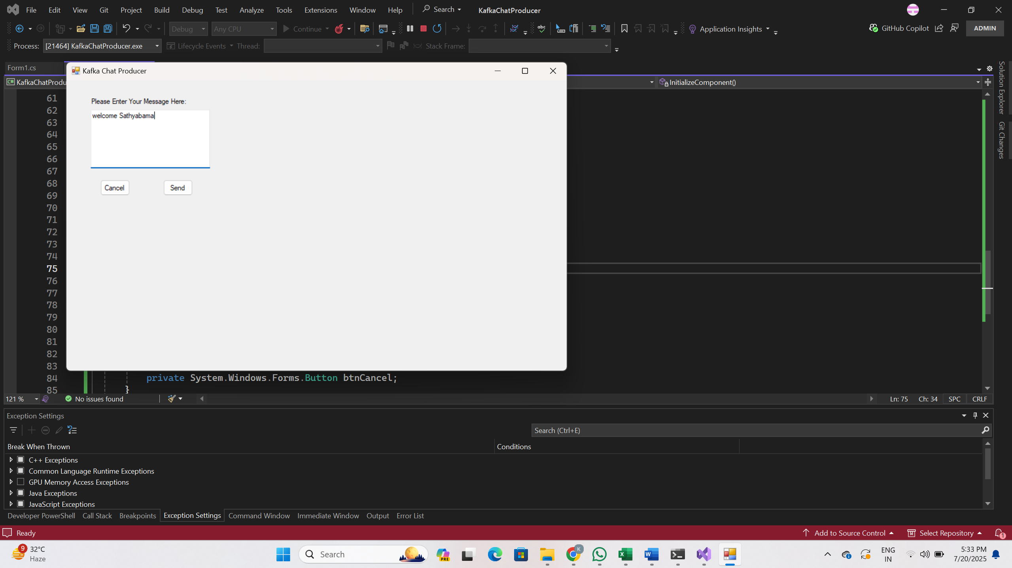

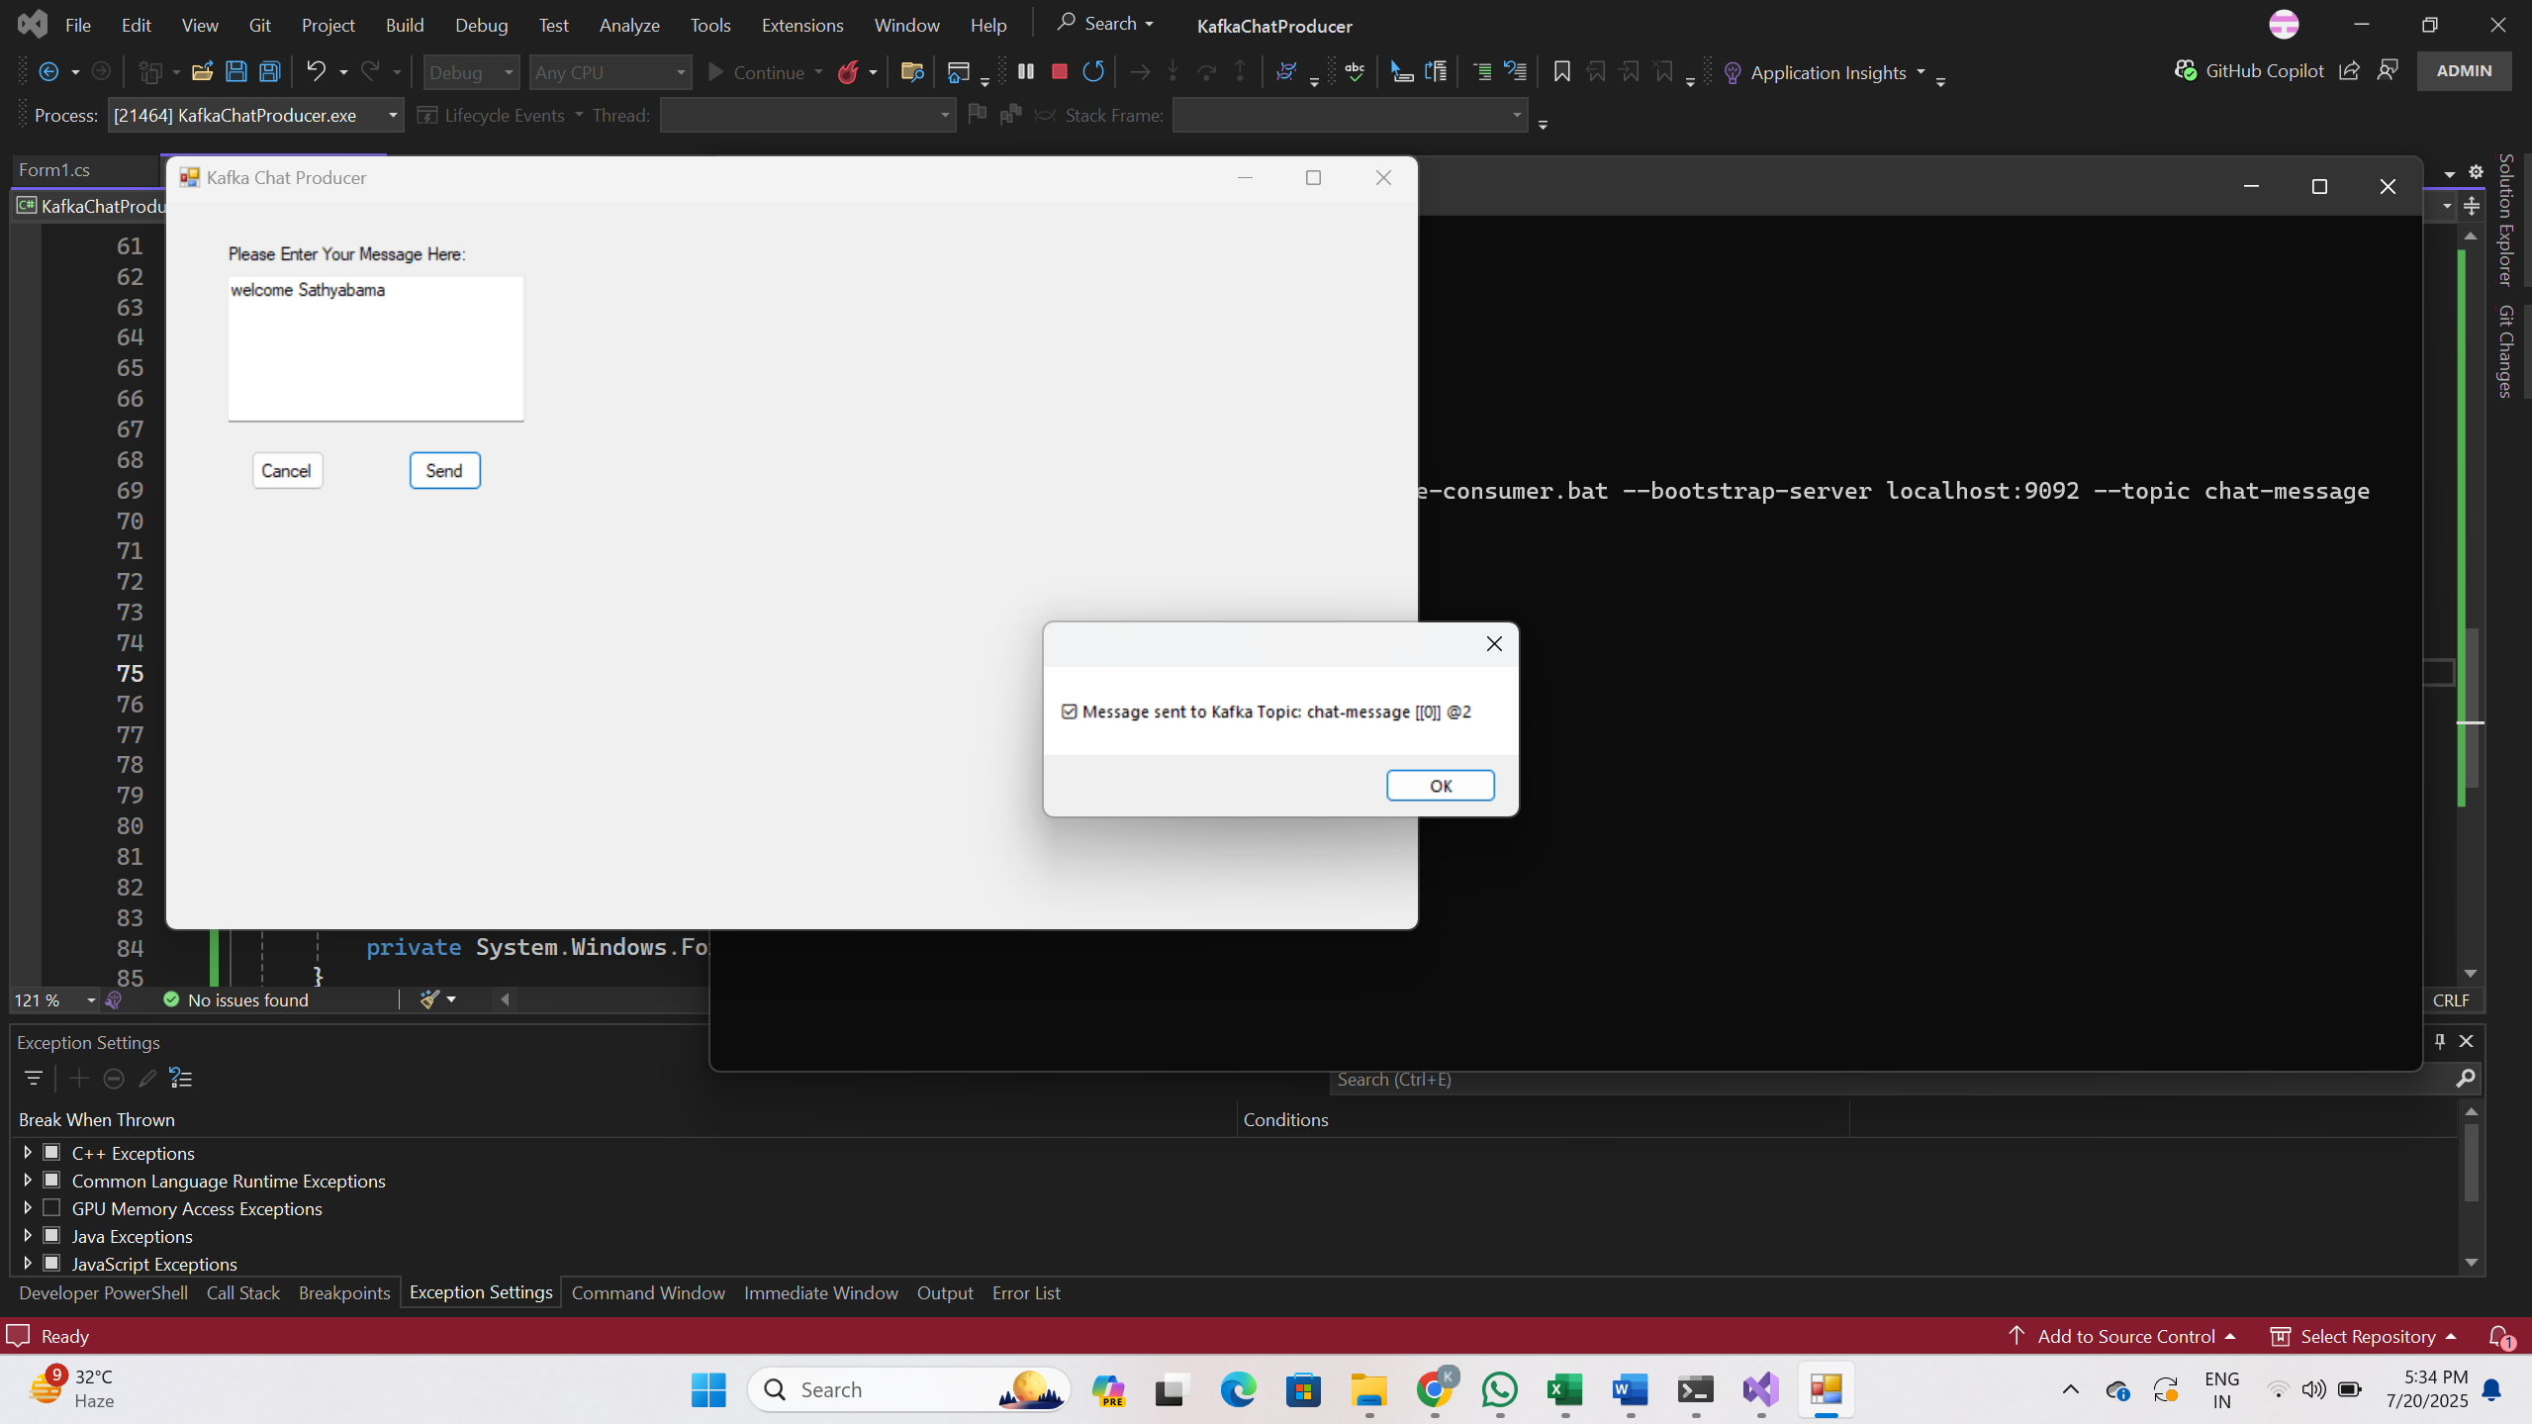

**OUTPUT:**

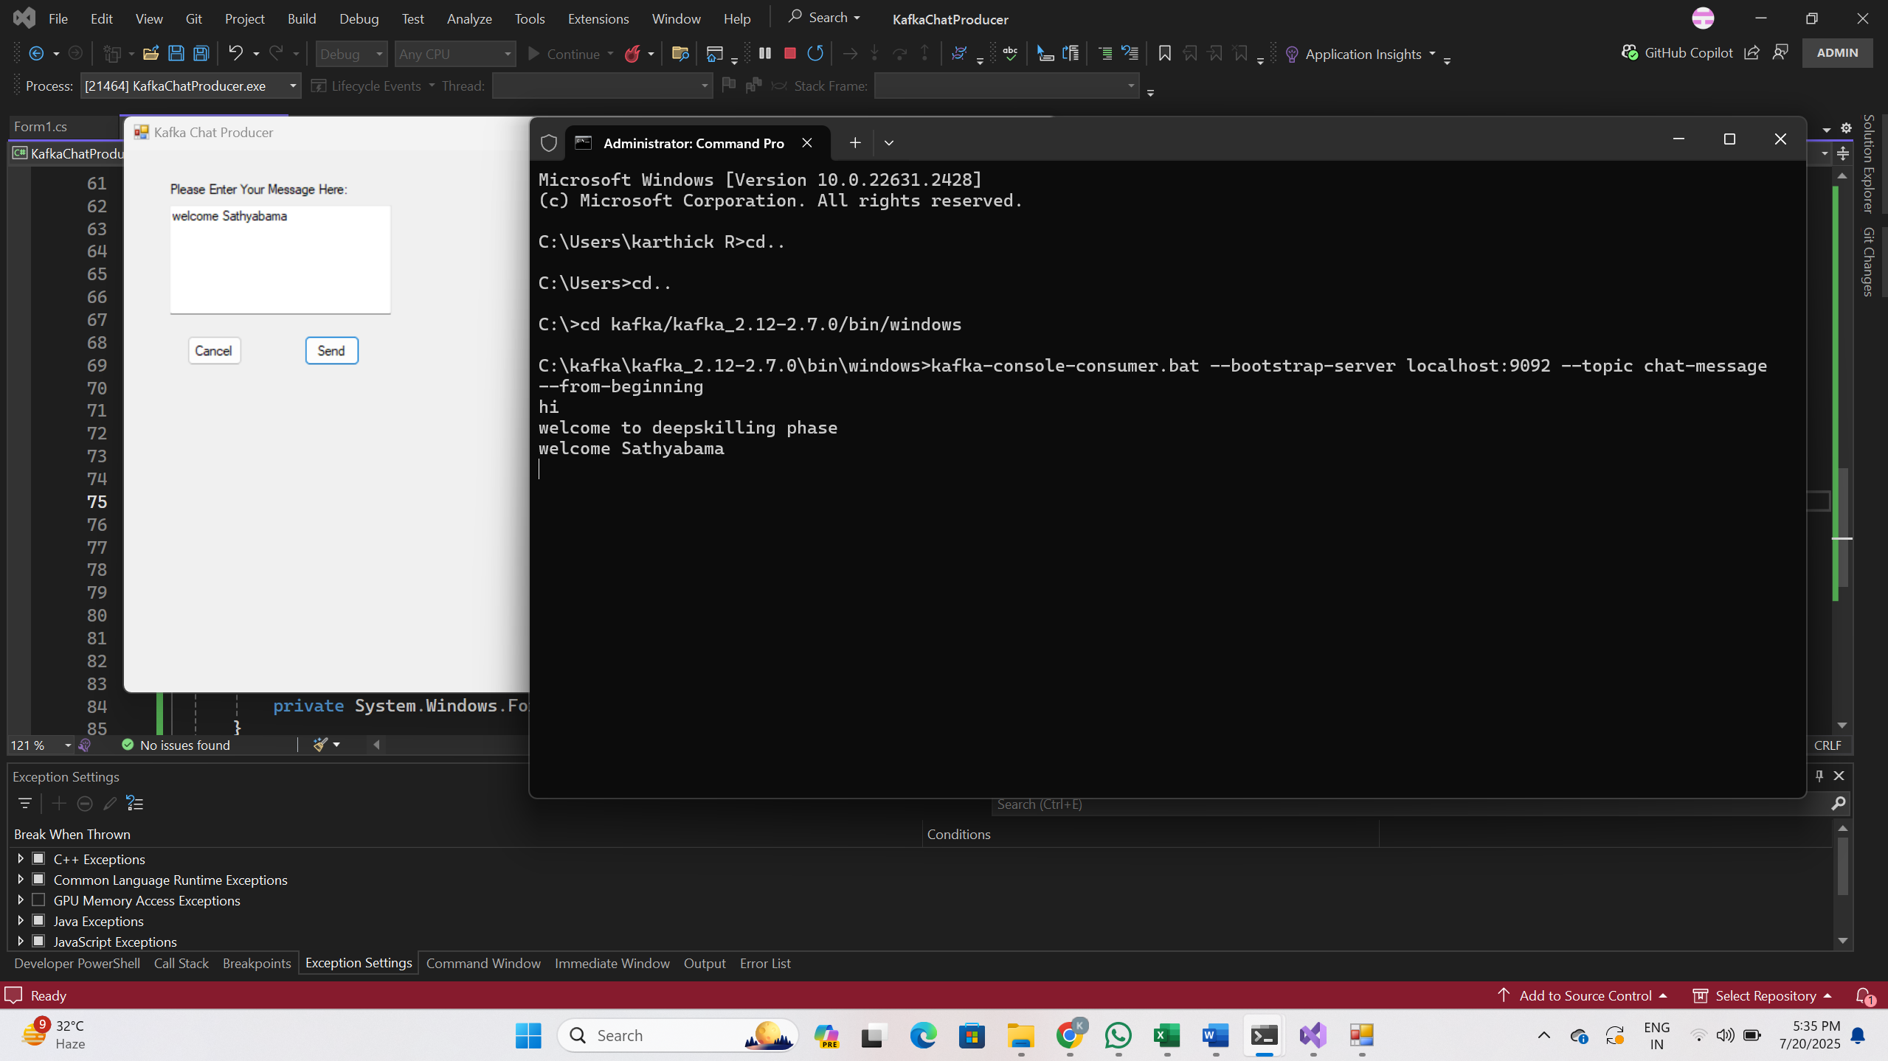

**Microservices-JWT-HandsOn**

# **Objective**

The goal of this lab is to implement JWT (JSON Web Token) authentication in an ASP.NET Core Web API microservice. We create a secure login endpoint that returns a JWT token on successful login. We then secure another endpoint using the [Authorize] attribute, which validates incoming requests based on the provided token.

# **Steps Followed**

## **1. Created a new ASP.NET Core Web API project**

Project Name: JwtAuthApi

## **2. Added NuGet Package**

Installed the following package using NuGet Package Manager:

Microsoft.AspNetCore.Authentication.JwtBearer (version compatible with .NET 8)

## **3. Updated appsettings.json**

Added the following JWT configuration:

"Jwt": {  
 "Key": "ThisIsAStrongSecretKeyForJwtToken123!",  
 "Issuer": "MyAuthServer",  
 "Audience": "MyApiUsers",  
 "DurationInMinutes": 60  
}

## **4. Updated Program.cs**

Configured authentication and authorization services:

builder.Services.AddAuthentication("Bearer")  
 .AddJwtBearer("Bearer", options =>  
 {  
 options.TokenValidationParameters = new TokenValidationParameters  
 {  
 ValidateIssuer = true,  
 ValidateAudience = true,  
 ValidateLifetime = true,  
 ValidateIssuerSigningKey = true,  
 ValidIssuer = builder.Configuration["Jwt:Issuer"],  
 ValidAudience = builder.Configuration["Jwt:Audience"],  
 IssuerSigningKey = new SymmetricSecurityKey(  
 Encoding.UTF8.GetBytes(builder.Configuration["Jwt:Key"]))  
 };  
 });  
builder.Services.AddAuthorization();  
  
// Middleware  
app.UseAuthentication();  
app.UseAuthorization();

## **5. Created AuthController.cs**

using JwtAuthApi.Models;

using Microsoft.AspNetCore.Mvc;

using Microsoft.IdentityModel.Tokens;

using System.IdentityModel.Tokens.Jwt;

using System.Security.Claims;

using System.Text;

namespace JwtAuthApi.Controllers

{

[ApiController]

[Route("api/[controller]")]

public class AuthController : ControllerBase

{

[HttpPost("login")]

public IActionResult Login([FromBody] LoginModel model)

{

// Step 1: Validate username & password

if (IsValidUser(model))

{

// Step 2: Generate token

var token = GenerateJwtToken(model.Username);

return Ok(new { token });

}

return Unauthorized(); // 401

}

private bool IsValidUser(LoginModel model)

{

// Dummy logic - replace with DB validation in real apps

return model.Username == "admin" && model.Password == "admin123";

}

private string GenerateJwtToken(string username)

{

var key = new SymmetricSecurityKey(Encoding.UTF8.GetBytes("ThisIsAStrongSecretKeyForJwtToken123!"));

var creds = new SigningCredentials(key, SecurityAlgorithms.HmacSha256);

var claims = new[]

{

new Claim(ClaimTypes.Name, username)

};

var token = new JwtSecurityToken(

issuer: "MyAuthServer",

audience: "MyApiUsers",

claims: claims,

expires: DateTime.Now.AddMinutes(60),

signingCredentials: creds

);

return new JwtSecurityTokenHandler().WriteToken(token);

}

}

}

## **6. Created Protected WeatherController.cs**

using Microsoft.AspNetCore.Authorization;

using Microsoft.AspNetCore.Mvc;

namespace JwtAuthApi.Controllers

{

[ApiController]

[Route("api/[controller]")]

public class WeatherController : ControllerBase

{

[HttpGet]

[Authorize]

public IActionResult GetWeather()

{

var data = new[]

{

new { Date = DateTime.Now, Temperature = "30°C", Forecast = "Sunny" },

new { Date = DateTime.Now.AddDays(1), Temperature = "28°C", Forecast = "Cloudy" }

};

return Ok(data);

}

}

}

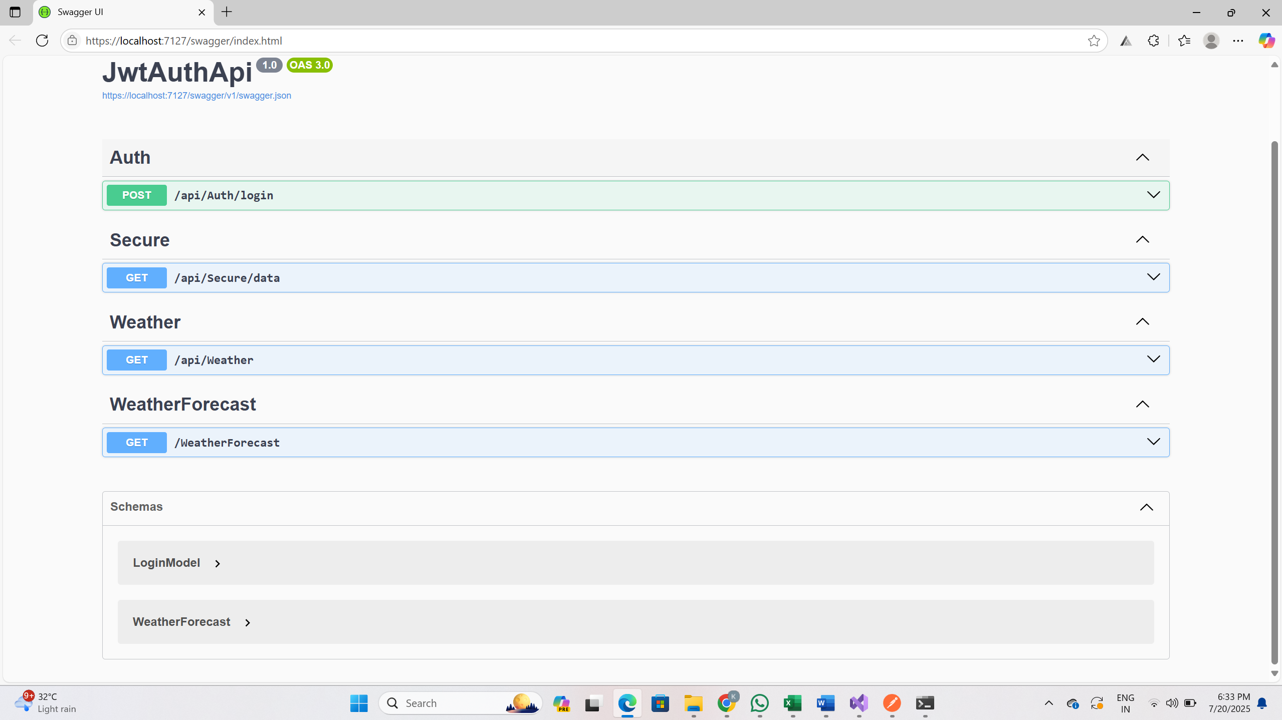

## **7. Tested in Postman**

Step-by-step testing in Postman:

• Sent POST request to /api/Auth/login with username/password to get token.

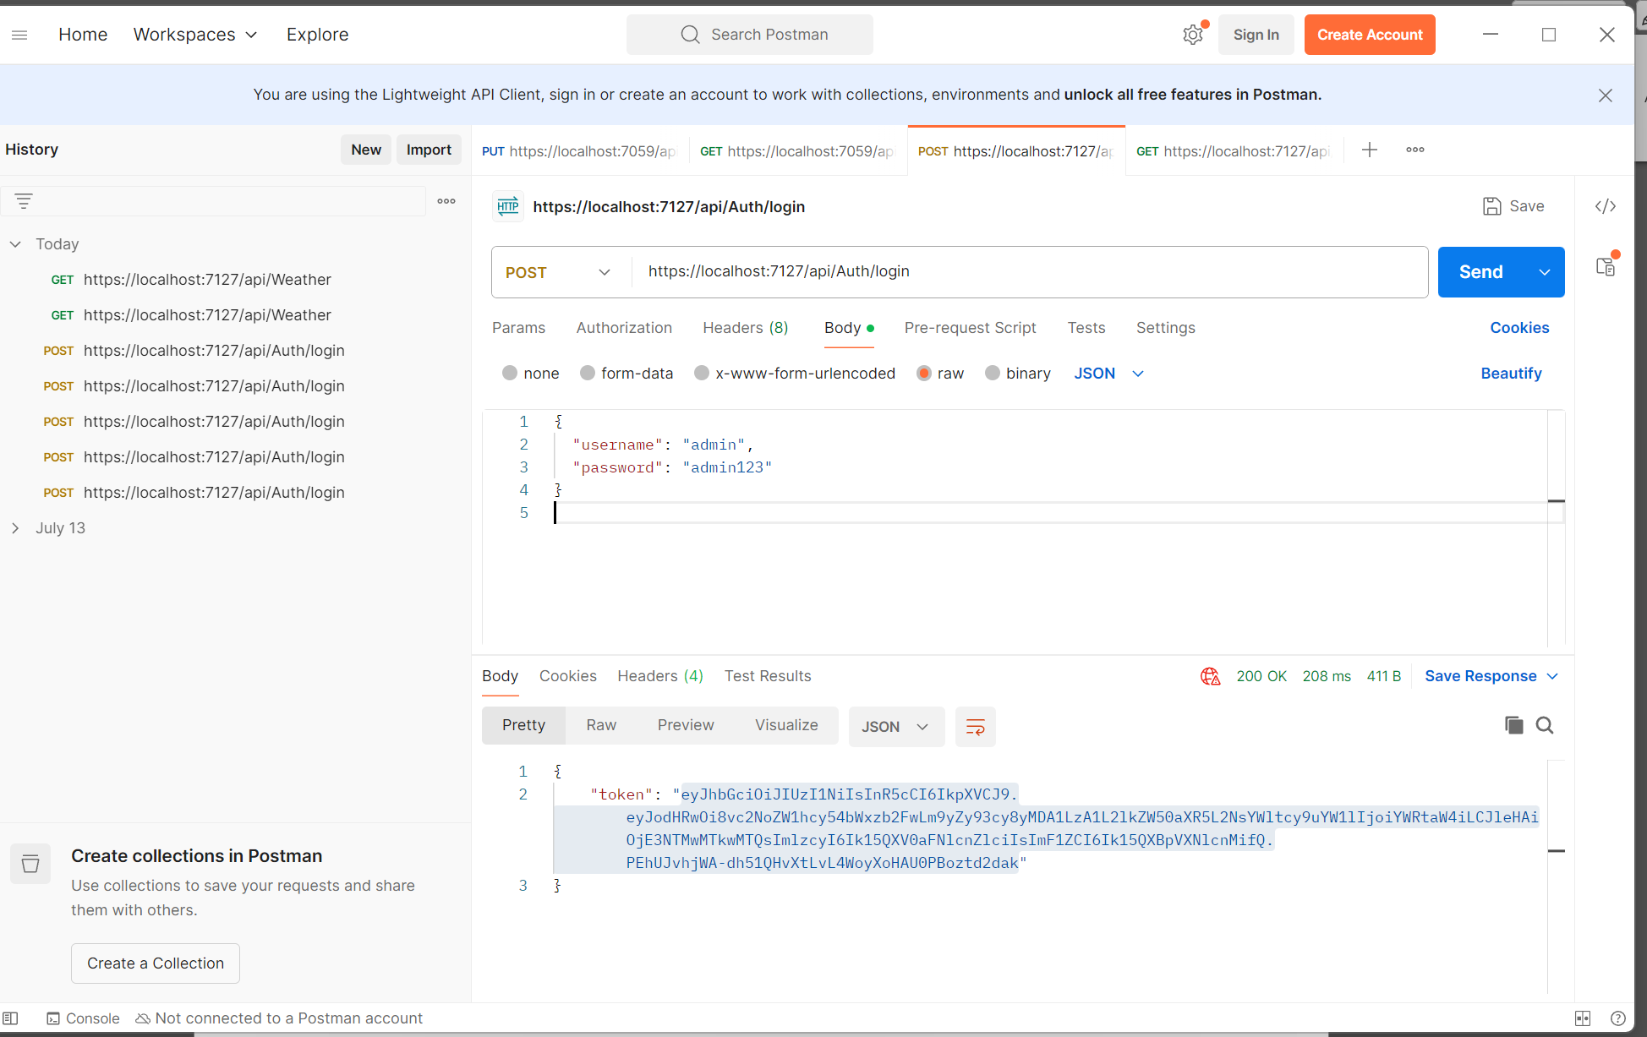

• Sent GET request to /api/Weather with token in Authorization header.

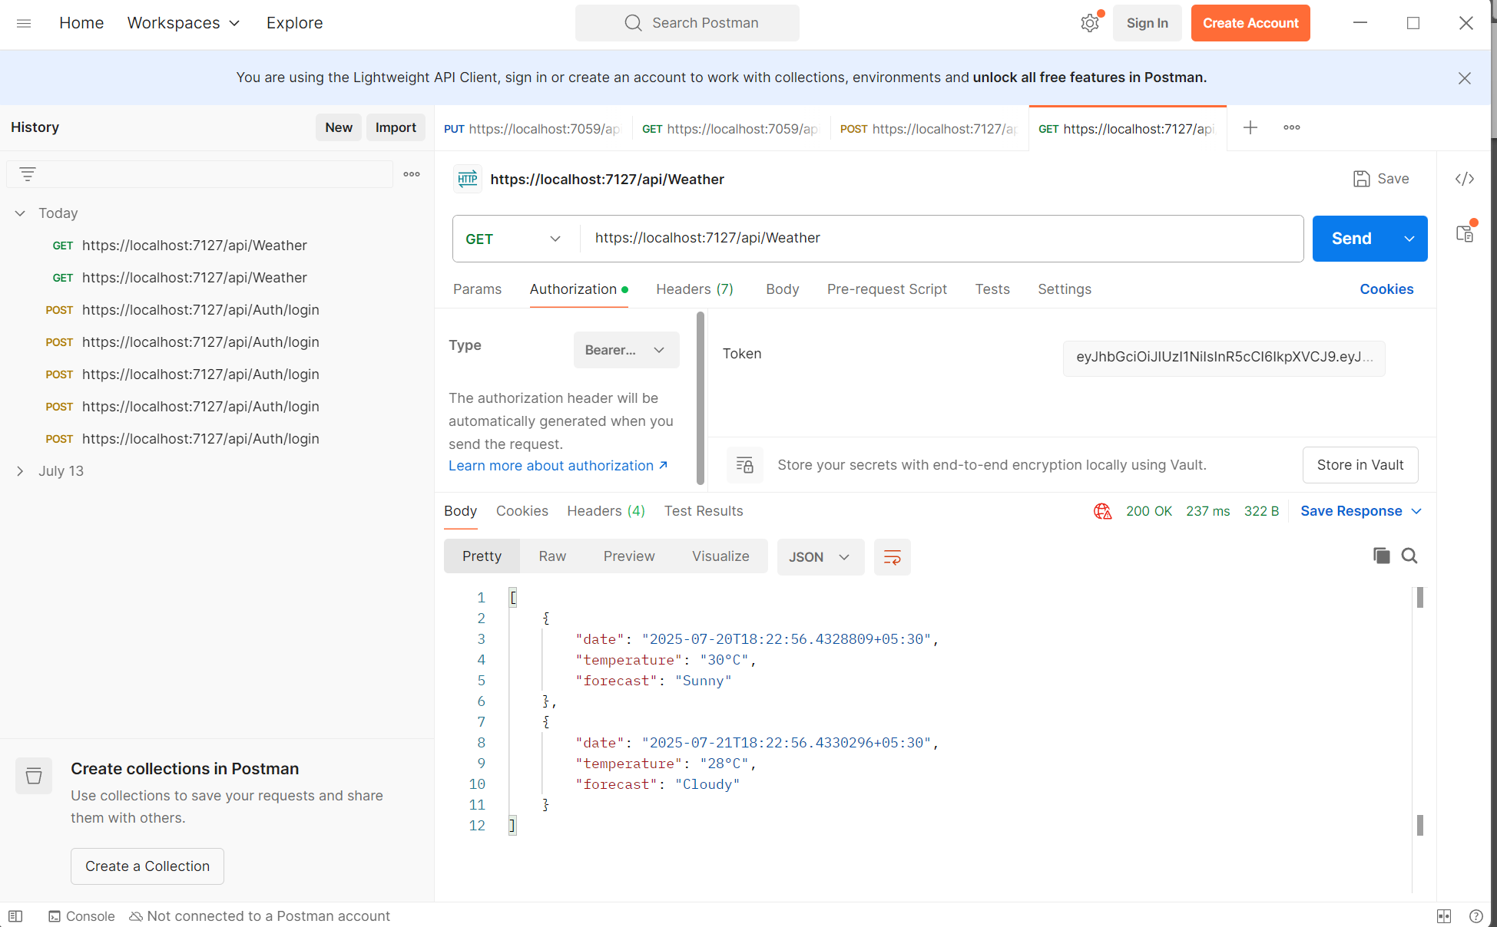

# **Result**

JWT token was successfully generated and validated. Protected endpoints only allowed access with valid token. Implementation was verified through Postman.