

A Project Report On

**Student Management System**

**By**

**Batch:** 2021 – 6518

**Center: Chennai**

Under the Guidance of,

**Chittaranjan Ghosh.**

**Technical Trainer**

**EduBridge**

(School of coding)

## Introduction:

Student Management System manages student information in the college. It improves existing system. It has the facility of maintaining the details of the student, thereby reducing the manual work. It will save time and energy which are spending in making reports and collecting data. Student Management System can be accessed throughout the college with proper login provided.

. **Modules:-**

* Admin Module
* Student Module

I have developed this Application in **Java and MySQL.**

The main objective of the student management system is to reduce manual work and time. It is difficult and time-consuming to collect all the details from each student. To avoid this problem, we have planned to develop Student management system. In Admin module, admin can add the Category and Products in the specific category. He can also view the total number of users at present in the website. And category and product details also. Admin can only see the admin page and cart if he wants to order something.

* It manages the details of student records, placement training, different placements happening in and out of the college.
* Saves the time of placement officer and faculties.
* This system makes student information more secure.

Admin Module: Admin can able to handle student portal. It provides access to the Recruiter for uploading new jobs as well as to track the process of job application with a username and password.

Student Module: Student can be able to check their individual information. It provides to find the reports, fees by login with the

Student Id and password.

**Software Requirements:**

**Front end:** Java/J2EE technologies (Servlet, JSP)

**Back end**: MySQL workbench 8.0 CE.

**Operating System:** Window

# Data Dictionary:

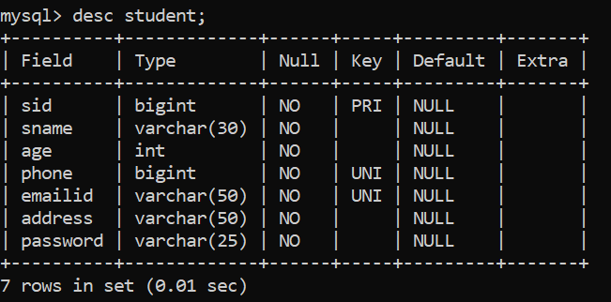

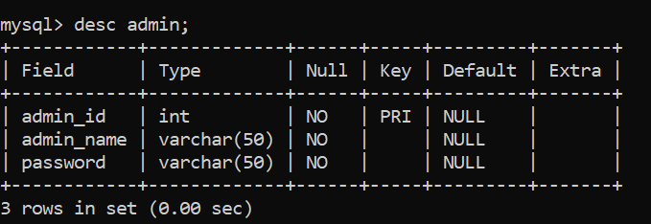

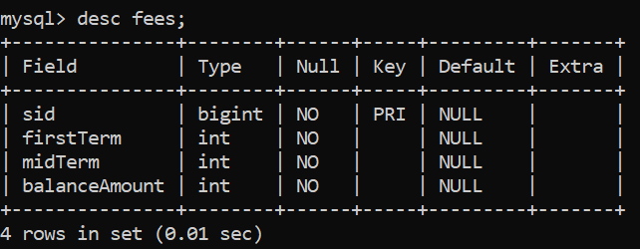

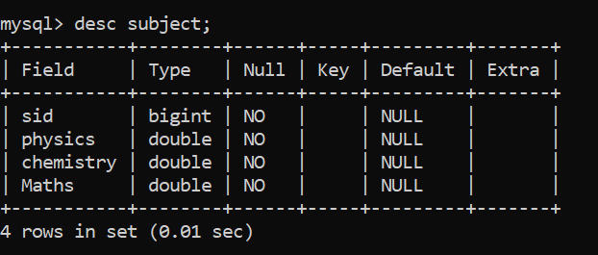

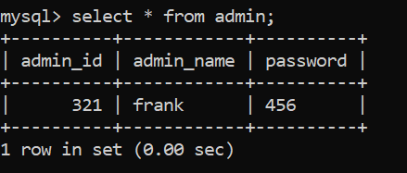

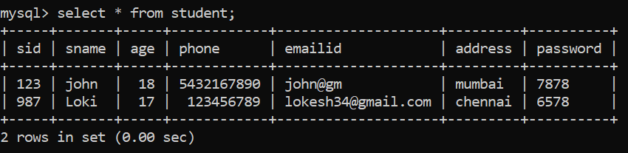

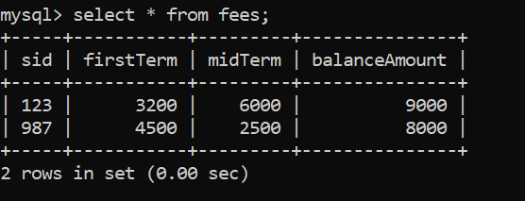

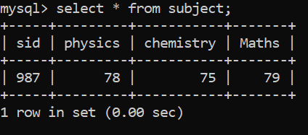

# Screenshots:-

**Admin Login Page:**

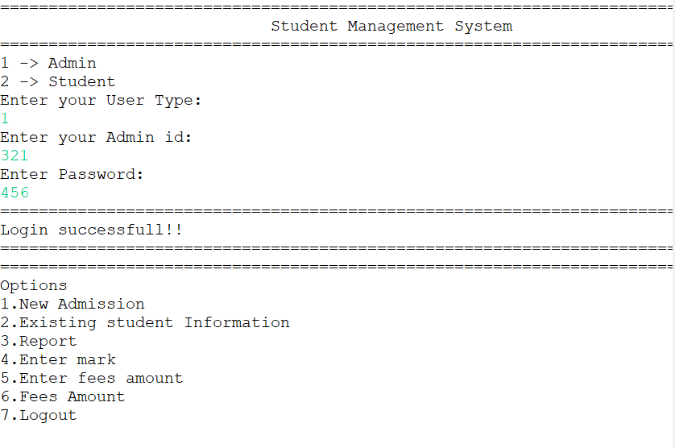

**Menu Option:**

## 

**Adding New Student**:

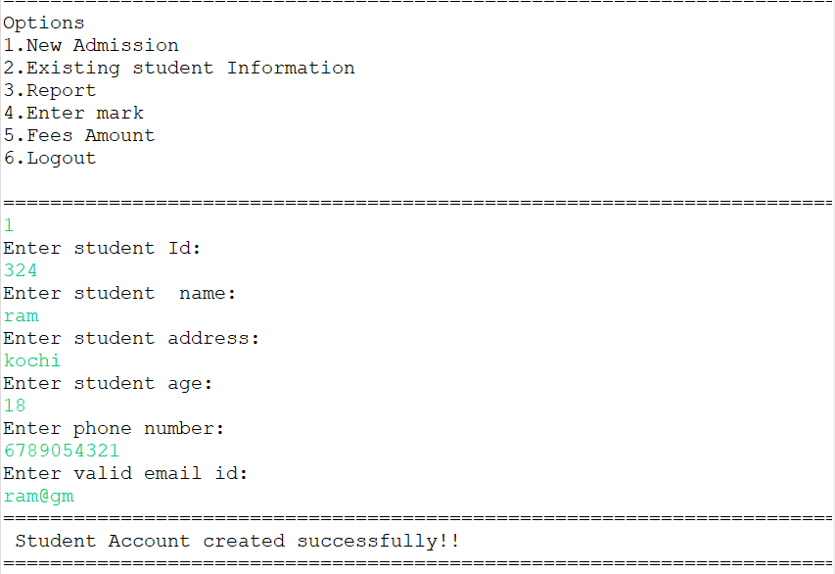

**Student info:**

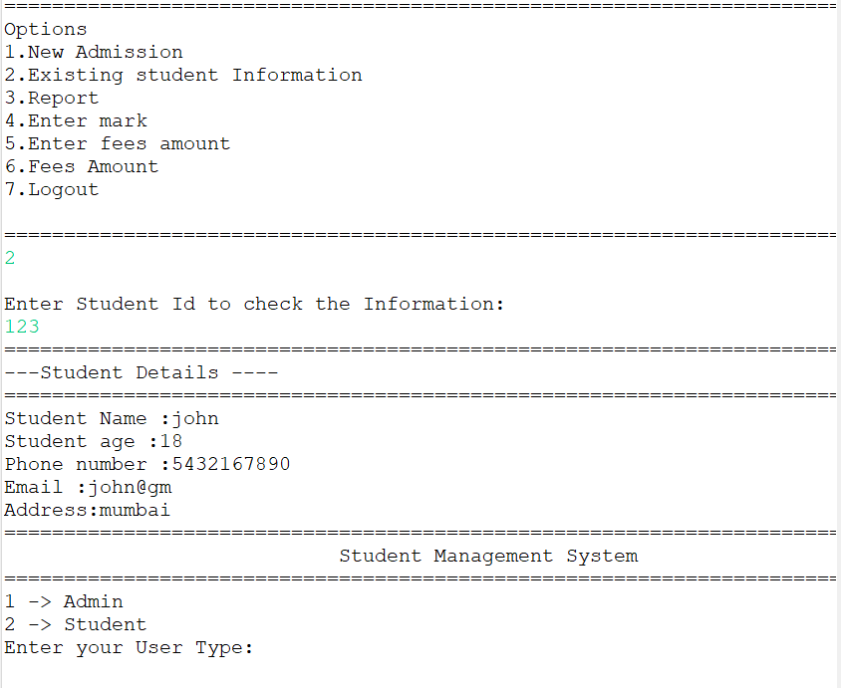

**Report**

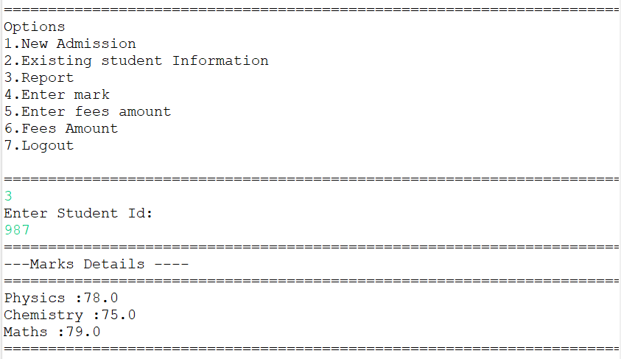

**Fees Amount:**

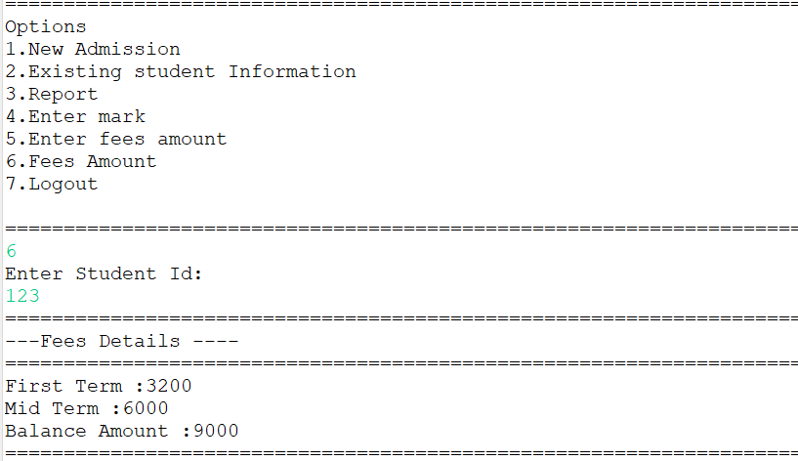

**Logout:**

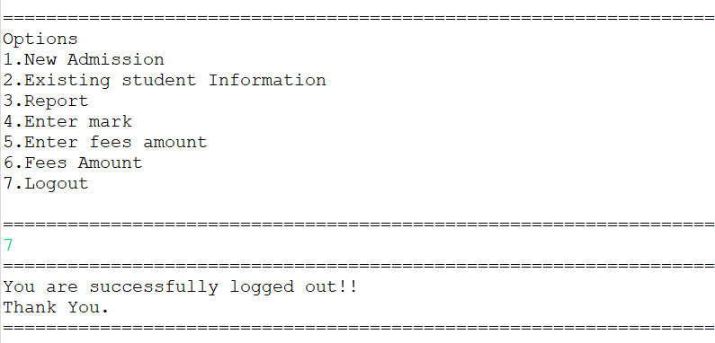

**Thank you….**