Linux Environment Setup & Exploration (Ubuntu via Vagrant)
Objective
Set up a Linux environment using Ubuntu and practice basic Linux navigation, file operations, permissions, and system monitoring commands using terminal.
Environment Details
- OS: Ubuntu Linux (VM)
- Setup Method: Vagrant + VirtualBox/VM provider
- Access: Terminal / SSH into VM
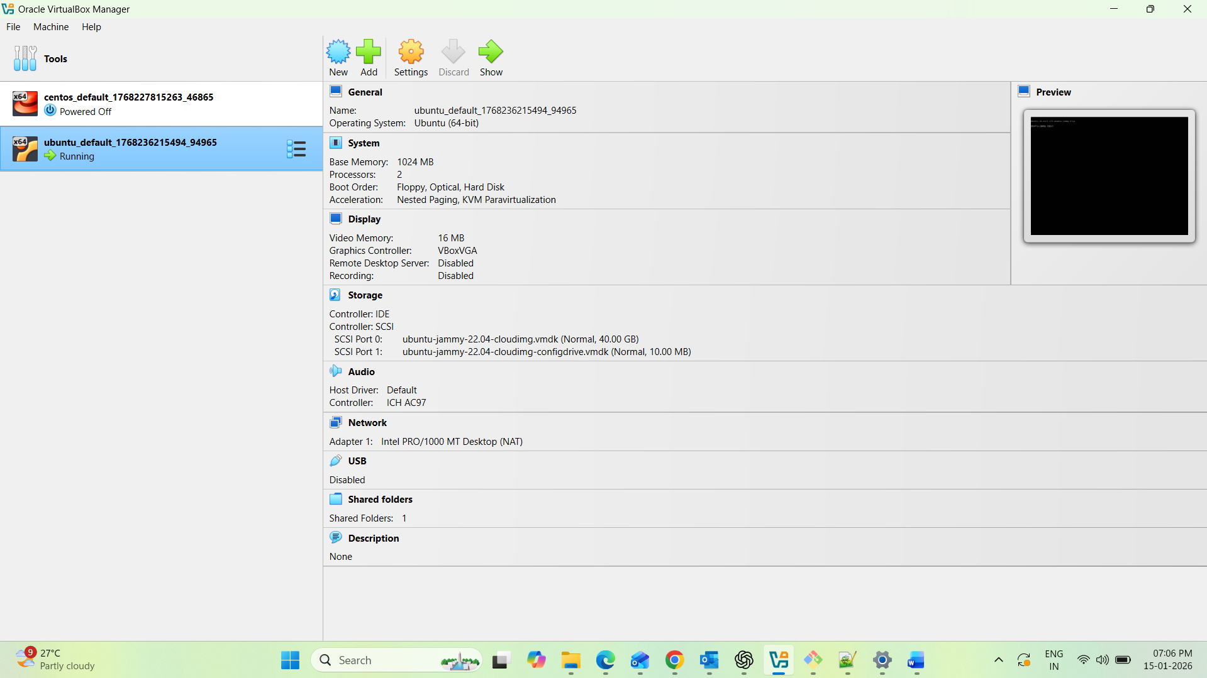
Work Completed
1) Verified Ubuntu VM Access
- Successfully started the VM using Vagrant
- Logged into the VM using terminal access
Commands used:
- vagrant up
- vagrant ssh
- whoami
- hostname
- uname -a
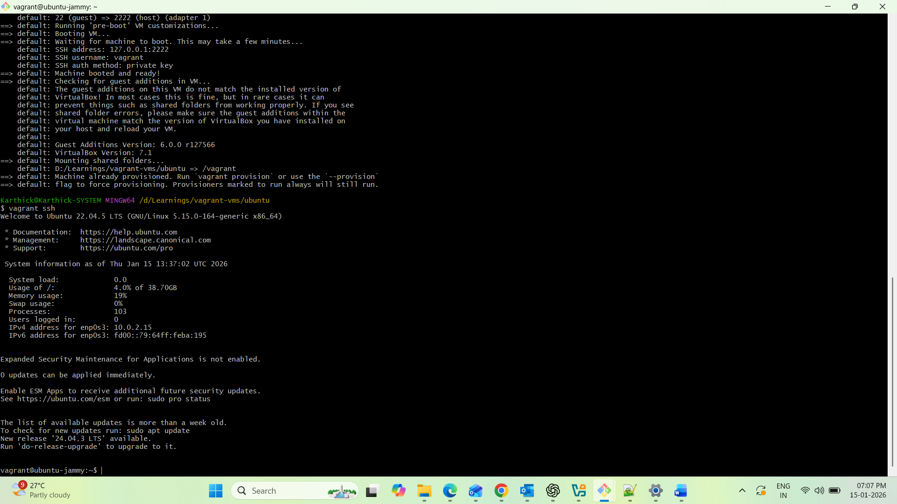
2) Explored Linux Directory Structure
Understood the difference between root directory / and home directory /home/vagrant and navigated between directories.
Commands used:
- pwd
- ls
- ls -la
- cd /
- cd ~
- cd ..
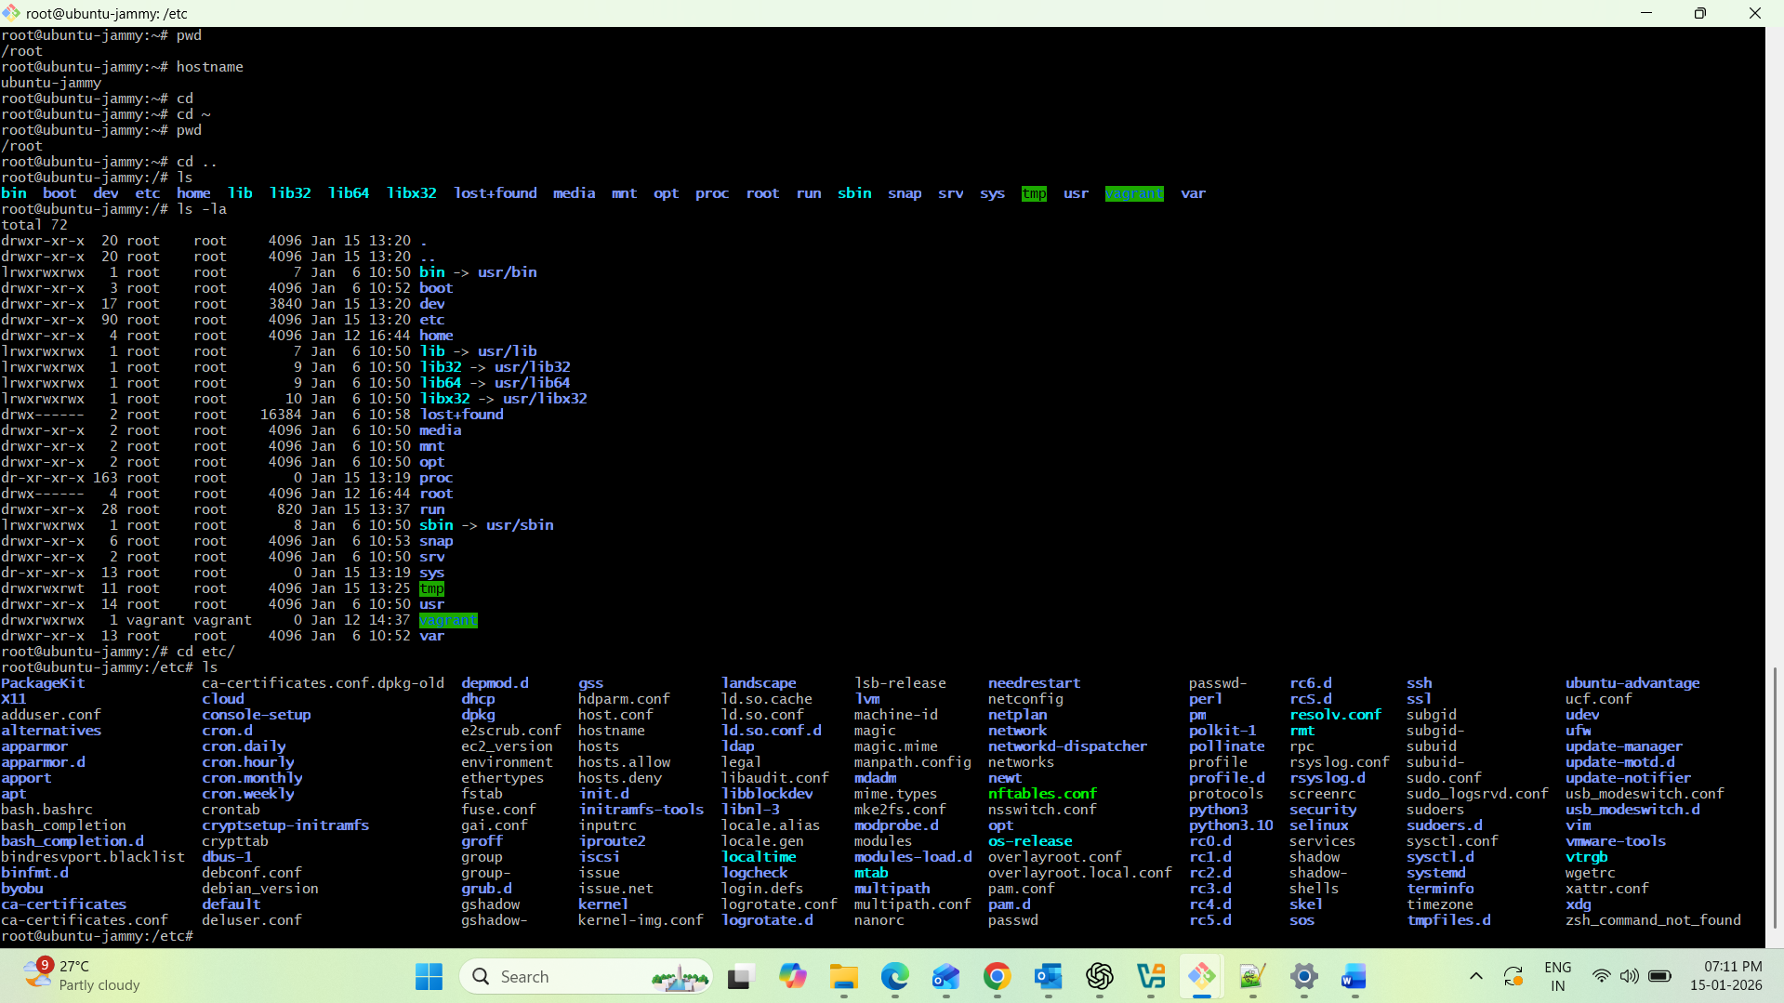
3) Created and Removed Directories & Files
Created sample folders/files for practice and removed them safely.
Commands used:
- mkdir devops-task1
- cd devops-task1
- mkdir logs scripts backup
- touch notes.txt test1.txt test2.txt
- rm test2.txt
- rmdir backup (only works if empty)
- rm -r logs (removes directory recursively)
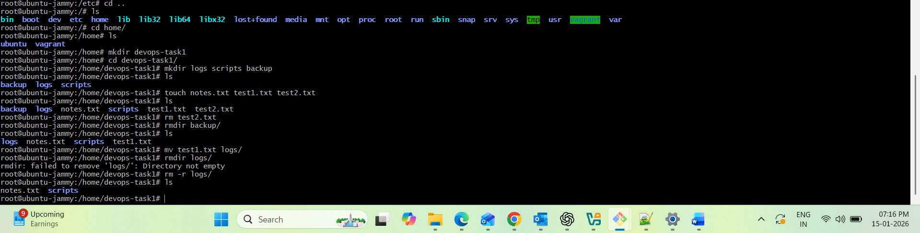
4) Practiced Viewing and Editing Files
Viewed and edited files using Linux text commands and editors.
Commands used:
- cat notes.txt
- echo "Task 1 completed" > notes.txt
- echo "Linux practice ongoing" >> notes.txt
- less notes.txt
- vim notes.txt
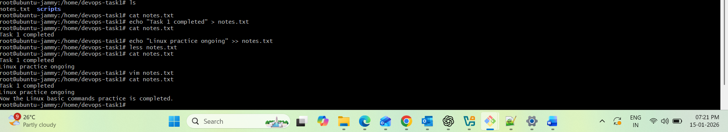
5) Checked and Modified File Permissions
Understood Linux file permission structure and updated permissions when required.
Commands used:
- ls -l
- chmod 644 notes.txt
- chmod 600 notes.txt
- chmod 755 scripts
- chown <user>:<user> notes.txt (if required)
Learning:
- Permissions are controlled using Read (r), Write (w), Execute (x)
- chmod changes permission modes
- chown changes file ownership
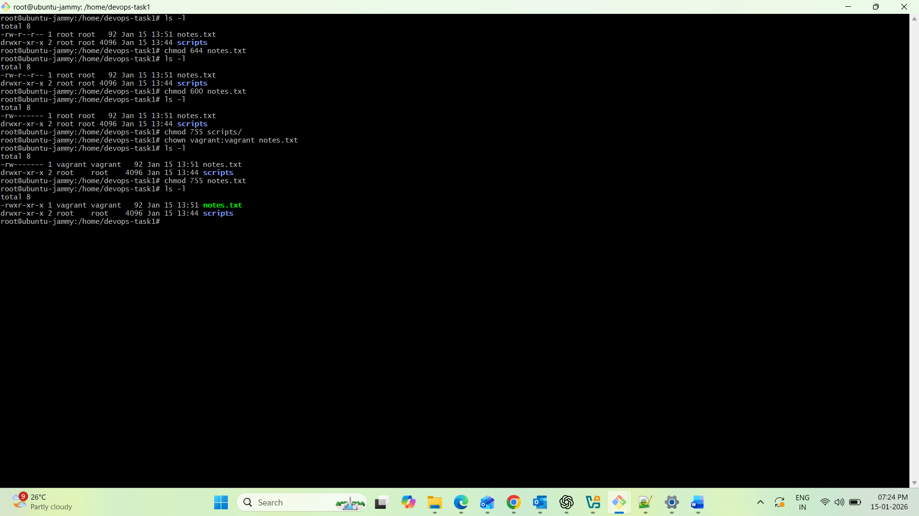
6) System Monitoring & Resource Checks
Learned basic monitoring commands to check CPU, memory, and disk usage.
Commands used:
- top
- htop (if installed)
- df -h
- free -m
- uptime
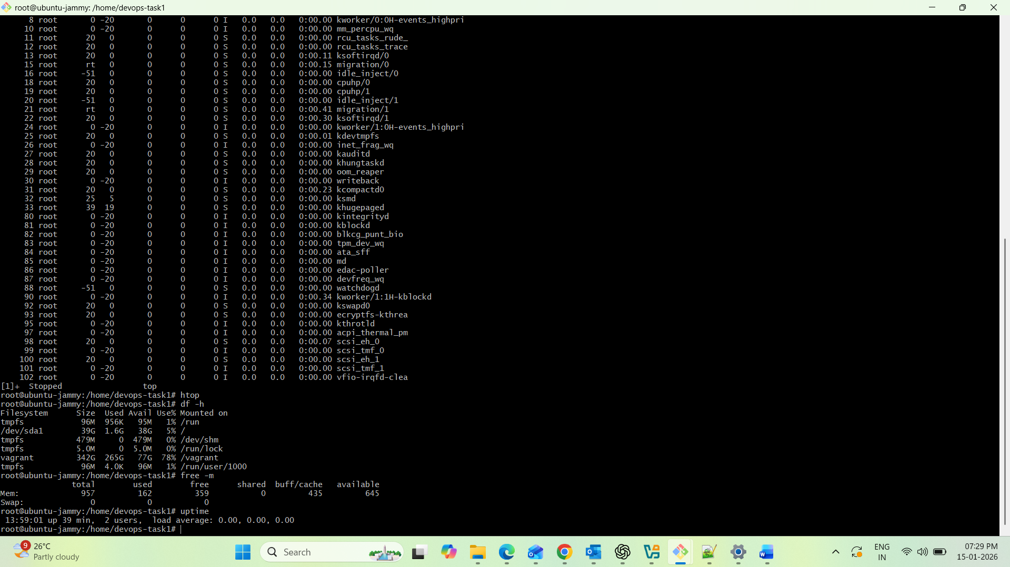
Key Learnings
- Learned how to access a Linux VM and work in terminal confidently
- Understood Linux directory navigation and structure
- Practiced creating, editing, and deleting files/directories safely
- Learned file permissions and ownership concepts (chmod, chown)
- Checked system resource usage using monitoring commands
Deliverables Included
- Command log file (commands used + outputs)
- Screenshots of terminal usage
- Summary markdown document
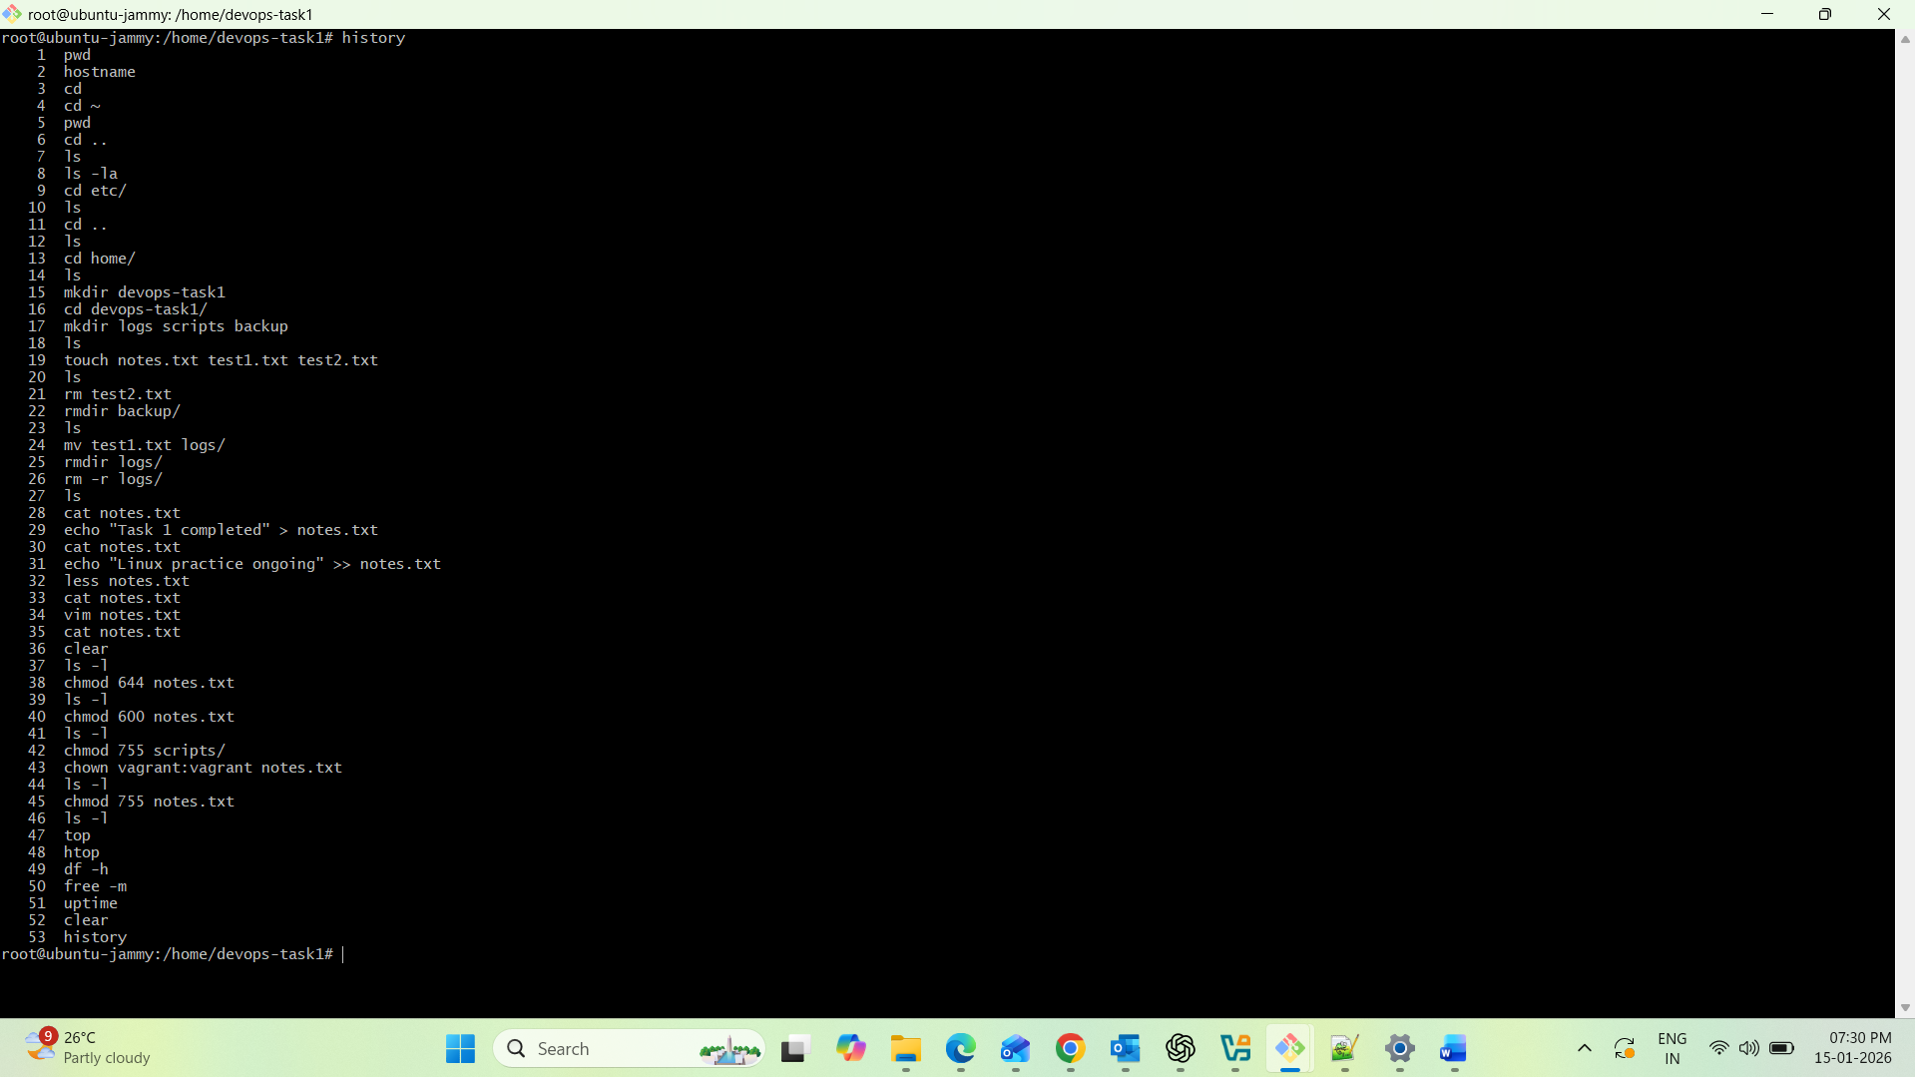
Interview Questions (Prepared)
task 1-14
- What is the difference between root user and normal user in Linux?
- What is chmod and why is it needed?
- Explain the Linux directory structure.
- How do you check disk usage in Linux?
- What happens when you get “Permission denied”? How do you fix it?

Final Outcome
After completing this task, I am confident in basic Linux navigation, file management, permissions handling, and monitoring system resources in Ubuntu Linux.

