DevOps Internship – Task 2
Git & GitHub Fundamentals (Version Control Workflow)

Purpose: This document is written in a simple and beginner-friendly way so I can learn Git and GitHub fundamentals, practice real-world version control workflow, and submit it as Task 2 deliverable.

1. What is Git and Why It Is Used?
Git is a version control system that helps track changes in files and source code.
Why Git is important:
• Tracks every change with history
• Helps multiple people work on the same project
• Allows branching and safe experimentation
• Makes rollback easy when something breaks
2. What is GitHub?
GitHub is a cloud platform used to store Git repositories online.
GitHub helps with:
• Remote backup of your code
• Collaboration with teams
• Pull requests, code review
• CI/CD integration
Simple difference:
• Git = tool
• GitHub = platform
3. Install Git and Configure Username/Email
Step 1: Verify Git installation
Command:
git --version
Step 2: Configure global username and email
Commands:
git config --global user.name "Karthick T"
git config --global user.email "karthickmech055@gmail.com"
Step 3: Verify configuration
Command:
git config --global --list
Note: Git uses this information to attach author details to commits.
4. Initialize a Local Git Repository (.git Folder)
Step 1: Create a project folder
mkdir devops-task2-git
cd devops-task2-git
Step 2: Initialize Git
git init
What is the .git directory?
• It is the hidden folder where Git stores history, commits, branches, and configuration.
• Without .git, it is not a Git repository.
5. Create Files and Track Changes (status, add, commit)
Step 1: Create a file
echo "DevOps Internship Task 2 - Git Practice" > notes.txt
Step 2: Check status
git status
Step 3: Stage the file
git add notes.txt
Step 4: Commit changes
git commit -m "Initial commit - added notes.txt"
What happens here?
• git add = prepares changes for commit
• git commit = saves snapshot in Git history
6. Create GitHub Repo and Link Local Repo (HTTPS/SSH)
Step 1: Create a new repository in GitHub
Example name: elevate-devops-task-02-git-github-workflow
Step 2: Rename branch to main (if needed)
git branch -M main
Step 3: Add remote origin (HTTPS example)
git remote add origin https://github.com/karthick4055/elevate-devops-task-02-git-github-workflow.git
Step 4: Push commits to GitHub
git push -u origin main
Note:
• HTTPS is easy to start.
• SSH is more secure and avoids repeated password prompts if configured.
7. Branching and Merging (Real-World Workflow)
Step 1: Create and switch to a new branch
git checkout -b feature-update
Step 2: Make changes in the branch
echo "This line was added in feature branch" >> notes.txt
Step 3: Stage and commit
git add notes.txt
git commit -m "Feature: updated notes in feature branch"
Step 4: Switch back to main
git checkout main
Step 5: Merge branch into main
git merge feature-update
Step 6: Push updated main branch
git push
Why branching is used?
• Keeps main branch stable
• Allows safe development and testing
8. Rollback Practice (git log, git reset, git checkout)
Step 1: View commit history
git log --oneline
Rollback option A: Undo last commit but keep changes (soft reset)
git reset --soft HEAD~1
Then commit again:
git commit -m "Re-commit after soft reset"
Rollback option B: Restore a file from previous commit (safe)
git checkout HEAD~1 -- notes.txt
Then commit:
git add notes.txt
git commit -m "Rollback notes.txt to previous version"
Important note:
• Avoid git reset --hard unless you fully understand it, because it can delete changes permanently.
9. OS / DevOps Best Practices While Using Git
• Commit frequently with meaningful messages
• Use branches for new changes
• Push code regularly to remote repo
• Keep README.md updated
• Do not commit secrets (passwords, tokens, keys)
• Use .gitignore for unwanted files
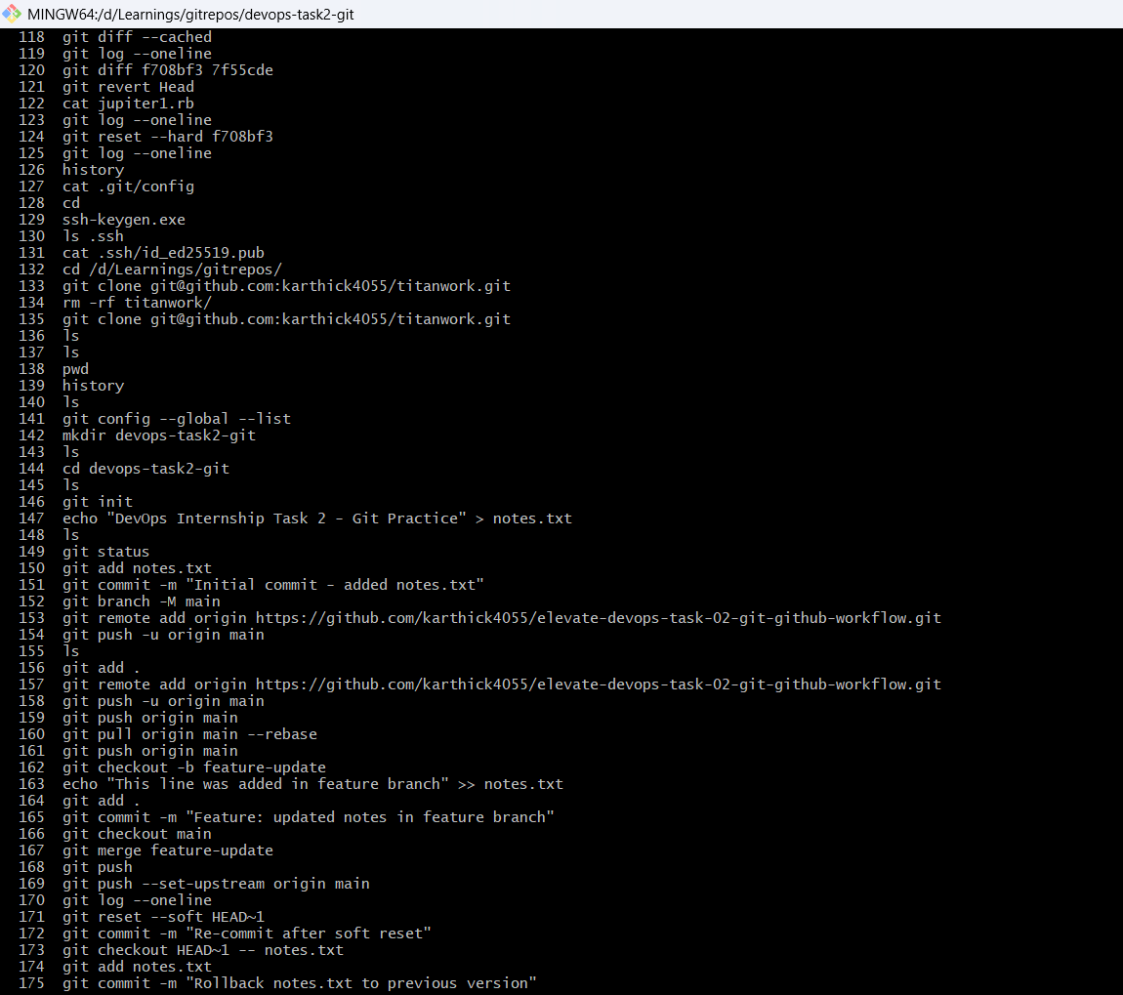
10. Interview Questions
1) Difference between Git and GitHub?
Git is a version control tool used locally. GitHub is a cloud platform to host Git repositories and collaborate.
2) What is a commit?
A commit is a snapshot of changes saved into Git history with a message.
3) Explain branching.
Branching creates a separate line of development so changes can be made without affecting the main branch.
4) What is merge conflict?
A merge conflict happens when Git cannot automatically merge changes because the same part of a file was modified differently.
5) Difference between reset and revert?
Reset rewrites commit history by moving HEAD to a previous commit. Revert creates a new commit that safely undoes changes.

11. Reference Links
- Git Official Documentation: https://git-scm.com/doc
- Git Book (Free): https://git-scm.com/book/en/v2
- GitHub Docs: https://docs.github.com/
- GitHub SSH Setup: https://docs.github.com/en/authentication/connecting-to-github-with-ssh

