DevOps Internship – Task 4
Shell Scripting Basics (Bash)
1. What is Shell Scripting?
A shell script is a text file containing Linux commands written in sequence to automate tasks.
Why DevOps uses shell scripting:
• Automate repetitive tasks (backup, cleanup, monitoring)
• Reduce manual work and human errors
• Useful in CI/CD pipelines and server administration
2. Creating a Shell Script File + Shebang Line
Step 1: Create a script file
Example:
nano system-info.sh
Step 2: Add shebang at the top
#!/bin/bash
Meaning:
• Shebang tells the OS which interpreter should run the script.
• /bin/bash means the script will run using Bash shell.
3. Script 1: Print System Information
Example script: system-info.sh
#!/bin/bash
echo "===== System Information ====="
echo "Hostname: $(hostname)"
echo "Date & Time: $(date)"
echo "Current User: $(whoami)"
echo "Uptime: $(uptime -p)"
echo "OS Details: $(lsb_release -d 2>/dev/null | cut -f2)"
echo "IP Address: $(hostname -I)"
echo "Disk Usage:"
df -h
Expected Output:
• Shows basic server details useful for DevOps troubleshooting.
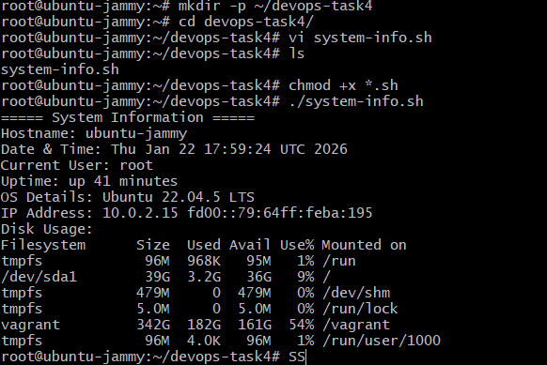
4. Using Variables in Bash
Variables store values that can be reused.
Example:
NAME="Karthick"
echo "Hello $NAME"
Important:
• No spaces around '='
• Use $VARIABLE_NAME to access value
5. Using Conditionals (if/else)
Conditionals help make decisions.
Example: Check if a file exists
#!/bin/bash
FILE="/etc/passwd"
if [ -f "$FILE" ]; then
echo "$FILE exists"
else
echo "$FILE not found"
fi
Use cases:
• Check service status
• Validate input
• Verify file/directory availability
6. Using Loops in Bash (for/while)
Loops are used to repeat actions.
Example: for loop
for i in 1 2 3 4 5
do
echo "Iteration: $i"
done
Example: while loop
count=1
while [ $count -le 3 ]
do
echo "Count: $count"
count=$((count+1))
done
Use cases:
• Loop through files
• Monitor processes
• Run health checks
7. Script 2: Automate Log Cleanup (Safe Practice)
This script deletes old log files to free disk space.
For safe internship practice, use your own test folder instead of /var/log.
Create test logs:
mkdir -p ~/test-logs
touch ~/test-logs/app1.log ~/test-logs/app2.log
Example script: log-cleanup.sh
#!/bin/bash
LOG_DIR="$HOME/test-logs"
DAYS=0
echo "Cleaning logs older than $DAYS days in $LOG_DIR"
find "$LOG_DIR" -type f -name "*.log" -mtime +$DAYS -print -delete
echo "Cleanup completed"
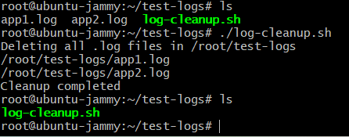
Note:
• Use with caution because it deletes files.
8. Script 3: Backup Automation (Simple)
This script creates a backup of a folder into a .tar.gz file.
Create sample data:
mkdir -p ~/mydata
echo "sample file" > ~/mydata/file1.txt
Example script: backup.sh
#!/bin/bash
SOURCE_DIR="$HOME/mydata"
BACKUP_DIR="$HOME/backups"
DATE=$(date +%F)
mkdir -p "$BACKUP_DIR"
tar -czf "$BACKUP_DIR/mydata-backup-$DATE.tar.gz" "$SOURCE_DIR"
echo "Backup created at: $BACKUP_DIR/mydata-backup-$DATE.tar.gz"
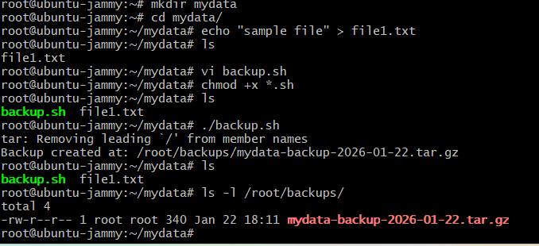
Use cases:
• Backup configs
• Backup application files
• Backup logs
9. Making Script Executable and Running It
To give execute permission:
chmod +x system-info.sh
Run script:
./system-info.sh
Alternative run method:
bash system-info.sh
10. Redirect Output to Files
Output redirection helps save logs.
Save output to a file:
./system-info.sh > output.txt
Append output:
./system-info.sh >> output.txt
Redirect errors:
./system-info.sh 2> error.log
Redirect both output and errors:
./system-info.sh > output.txt 2>&1
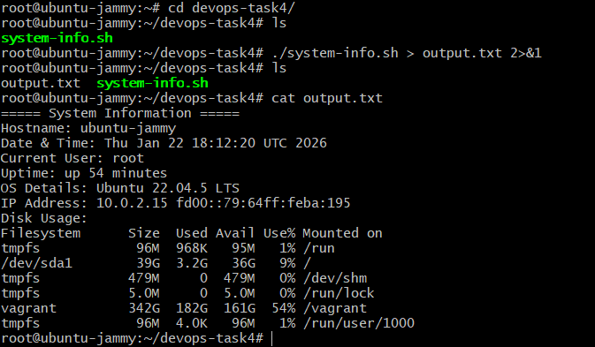
11. Comments and Documentation in Scripts
Comments start with #
Example:
# This script prints system information
# Author: Karthick
# Date: 2026-01-22
Good practices:
• Add clear comments
• Use meaningful variable names
• Keep scripts simple and readable
13. Interview Questions (Prepared Answers)
1) What is a shell script?
A shell script is a file containing Linux commands to automate tasks.
2) What is shebang?
Shebang is the first line (#!/bin/bash) that tells the system which interpreter to use.
3) Explain loops in bash.
Loops repeat actions. Bash supports for loops and while loops to run commands multiple times.
4) How to schedule scripts?
Scripts can be scheduled using cron jobs (crontab) in Linux.
5) Difference between $@ and $*?
$@ → Treats each argument separately (best choice)
$* → Treats all arguments as one single string (when quoted)
14. Reference Links
- Bash Guide for Beginners: https://tldp.org/LDP/Bash-Beginners-Guide/html/
- GNU Bash Manual: https://www.gnu.org/software/bash/manual/
- Cron Jobs (Ubuntu): https://help.ubuntu.com/community/CronHowto

