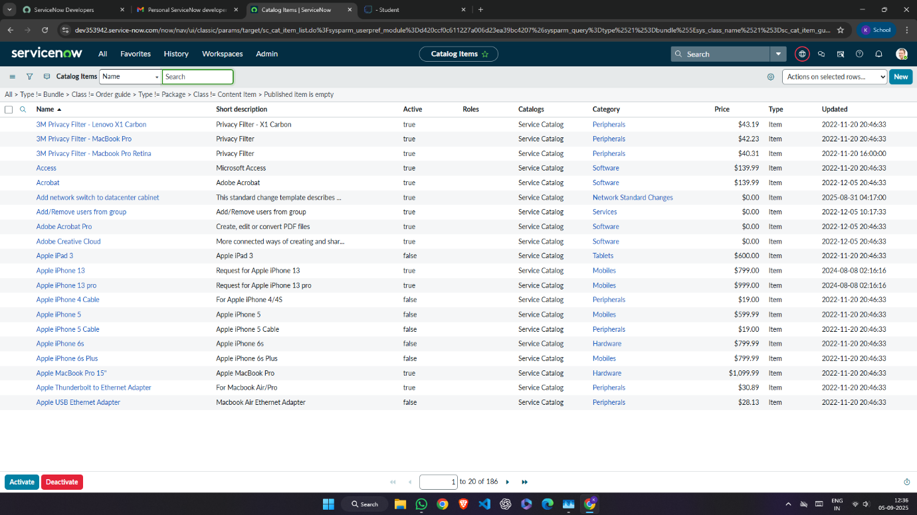

Naan Mudhalvan Project

Laptop Requesting Catalog Item



