**Ex.No : 2**

**Date : 23/11/2020**

**AIM :**

To write a python program to count(print) the number of occurrences of a number in a list.

**PROGRAM :**

def countX(lst0,x0):

count=0

for i in range(0,len(lst0)):

if(x0==lst0[i]):

count=count+1

return count

lst=[]

a=int(input("Enter total number of elements in the list : "))

for i in range(0,a):

b=int(input())

lst.append(b)

print(lst)

x=int(input("Enter the number(x) to be searched in the given list : "))

y=countX(lst,x)

print(y)

**OUTPUT:**

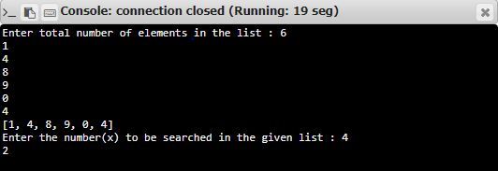

**RESULT:**

Thus, the program is executed and the number of occurrence is printed.