**Ex.No : 3**

**Date : 23/11/2020**

**AIM:**

To write a python program to remove and print every second number from the list and display it in the order of removal.

**PROGRAM :**

def removeThirdNumber(lst):

lst0=[]

p=1

s=0

for i in range(0,len(lst)):

s=(p+s)%len(lst)

element=lst.pop(s)

lst0.append(element)

return lst0

a=int(input("Enter the number of elements : "))

int_list=[]

for i in range(0,a):

element1=int(input())

int_list.append(element1)

b=removeThirdNumber(int_list)

print(b)

**OUTPUT :**

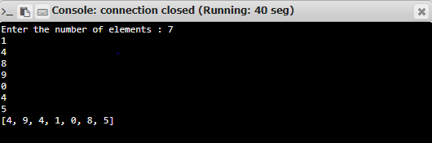

**RESULT :**

Thus, the program is created for removing and printing every second number from the list and the output is obtained.