**Ex.No : 8**

**Date : 21/11/20**

**AIM:**

To write a Python program to get a list, sorted in increasing order by the last element in each tuple from a given list of non-empty tuples.

**PROGRAM:**

def last(n):

return n[-1]

def sort_list_last(tuples):

return sorted(tuples, key=last)

print(sort_list_last([(2,5), (1,2), (4,4), (2,3), (2,1)]))

**OUTPUT:**

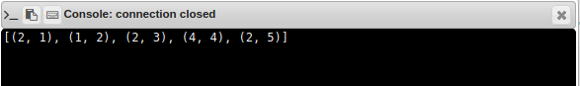

**RESULT:**

Thus the program to sort the given non-empty tuples increasing order by the last element in each tuple is executed and output is obtained.