**Ex.No : 11**

**Date : 21/11/20**

**AIM:**

To write a Python program to find the greatest common divisor (gcd) of two integers using recursion.

**PROGRAM:**

def gcd(a,b):

if(a==0):

return a

if(b==0):

return b

if(a==b):

return b

if(a>b):

return (gcd(a-b,b))

else:

return gcd(a,b-a)

a=int(input("Enter First Number:"))

b=int(input("Enter Second Number:"))

GCD=gcd(a,b)

print("GCD is:")

print(GCD)

**OUTPUT:**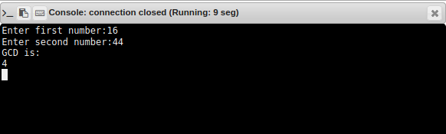

**RESULT:**

Thus the program to find the greatest common divisor of two integers using recursion is executed and the output is obtained.