**Ex.No : 14**

**Date : 21/11/20**

**AIM:**

To write a a python program to find the validity of a string of parentheses.

**PROGRAM:**

def areBracketsBalanced(expr):

stack=[]

open_expressions=['{','[','(']

for i in range(len(expr)):

if(expr[i] in open_expressions):

stack.append(expr[i])

else:

if not stack:

return False

curr=stack.pop()

if(curr == '{' and expr[i]!='}'):

return False

if(curr == '[' and expr[i]!=']'):

return False

if(curr == '(' and expr[i]!=')'):

return False

if stack:

return False

else:

return True

if __name__ == "__main__":

expr=input()

if(areBracketsBalanced(expr)):

print("valid")

else:

print("invalid")

**OUTPUT:**

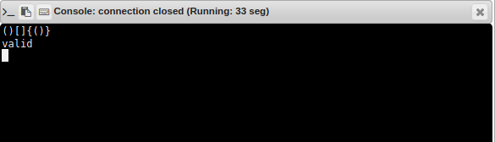

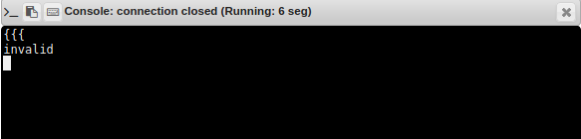

**RESULT:**

Thus the program to to find the validity of a string of parentheses is executed and the output is obtained.