Here is what is stated in Sidney's paper:

## Reconciliation

**To add more details on the requirements and validate with OPS.**

Reconciliation data are stored in TLM RP application. There is a regulatory need to keep those data as well as an operational need in case of litigation.

For each reconciliation matching Item as well as breaks needs to be retain. Criteria should be:

1. Breaks should be retained as long as they are opened.
2. Matching items should be retained for 13 month online.

Breaks are already stored daily in the data warehouse, but not the matching items. Smartstream provides an archival framework but it is not satisfactory as the restitution of archive data cannot be exploited.

NB: APTP have also have a full access to the application DB, and could create a custom archival processing.

## Corporate Action

Data related to corporate action application needs to be retained or archive for a 10 years period.

**To add more details on the requirements.**

In SmartStudio on the LPS4 environment:

Three initiations are already present:



Three Pass Lists already present:

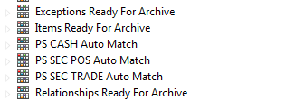

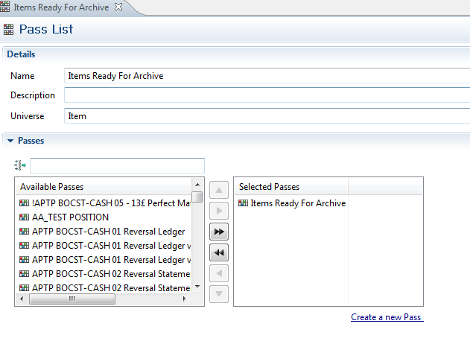

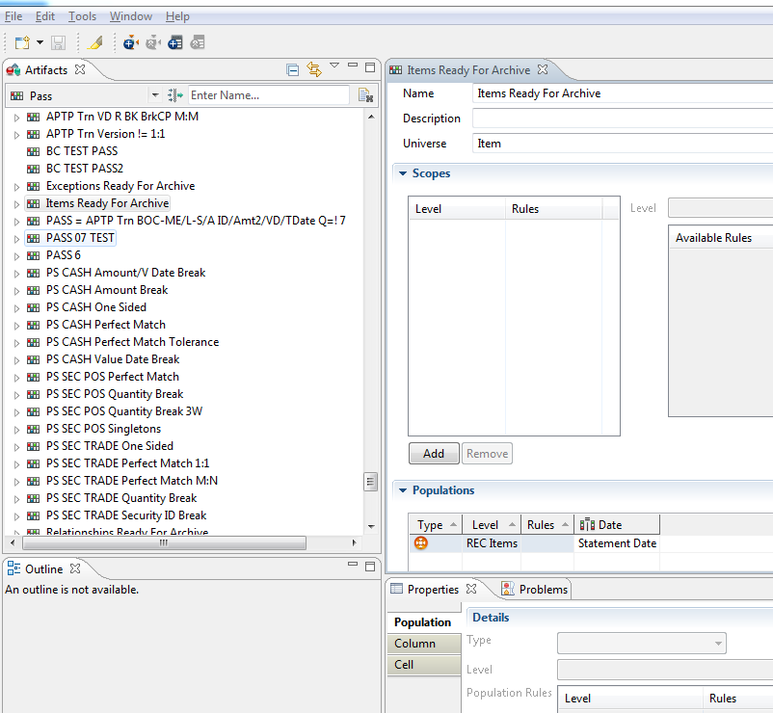

For Test:

Not used

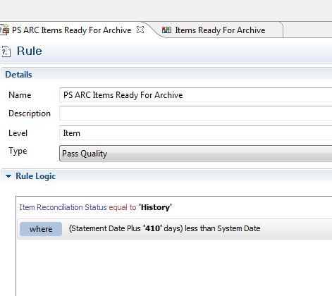

Used:

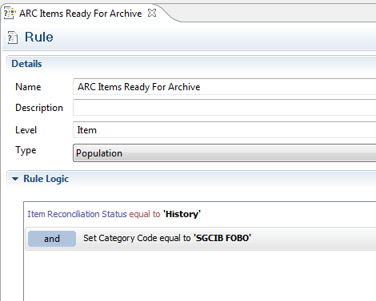

Perimeter of test:

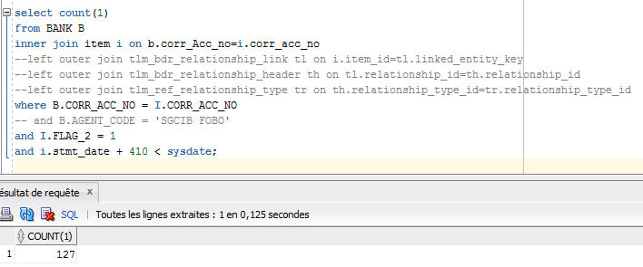

In the end, we should not do this at the level of Items but at the level of Relations.

Indeed, according to GOPALA, when we archive the relations, it also archives the ITEMS and associated Exceptions.

The three target tables are empty:

Select * from RECS_ARCHIVE_ITEM;

Select * from RECS_ARCHIVE_EXCEPTION;

Select * from RECS_ARCHIVE_RELATIONSHIP;

Test with this rule:

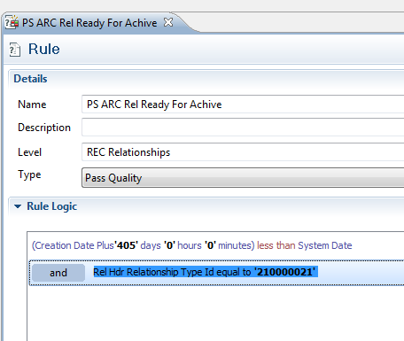

The 210000021 is:

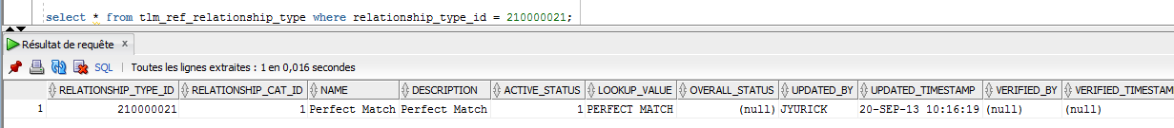

REM INSERTING into WORKFLOW_QUEUE

SET DEFINE OFF;

Insert into WORKFLOW_QUEUE (CORR_ACC_NO,LOCK_FLG,PASS_LIST_ID,PRIORITY,USER_ID,INITIATION_ID,EVENT_GROUP_ID,TYPE,WORKFLOW_LIST_ID,REMOTE_INTEGER_VALUE,REMOTE_STRING_VALUE,EVENT_DATE,PROPOSAL_TIME,WORKFLOW_QUEUE_ID,ENTITY_TYPE) values (0,0, 10004,0,'AP100081', 10042,0,1,0,0,' ',to_date('01-JAN-00 00:00:00','DD-MON-RR HH24:MI:SS'),to_date('01-JAN-00 00:00:00','DD-MON-RR HH24:MI:SS'),select WORKFLOW_QUEUE_ID_SEQ.NEXTVAL from dual,0);

Insert into WORKFLOW_QUEUE (CORR_ACC_NO,LOCK_FLG,PASS_LIST_ID,PRIORITY,USER_ID,INITIATION_ID,EVENT_GROUP_ID,TYPE,WORKFLOW_LIST_ID,REMOTE_INTEGER_VALUE,REMOTE_STRING_VALUE,EVENT_DATE,PROPOSAL_TIME,WORKFLOW_QUEUE_ID,ENTITY_TYPE)

select 0,0, 10005,0,'AP100081', 10044,0,1,0,0,' ',to_date('01-JAN-00 00:00:00','DD-MON-RR HH24:MI:SS'),to_date('01-JAN-00 00:00:00','DD-MON-RR HH24:MI:SS'),WORKFLOW_QUEUE_ID_SEQ.NEXTVAL ,0

from dual;

INSERT INTO WORKFLOW_QUEUE (CORR_ACC_NO, LOCK_FLG, PASS_LIST_ID, PRIORITY, TYPE) VALUES (0, '0', '10005', '0', '11');

This one works but does not archive anything.

INSERT INTO WORKFLOW_QUEUE (CORR_ACC_NO, LOCK_FLG, INITIATION_ID, PRIORITY, TYPE, PASS_LIST_ID) VALUES (0, '0', '10044', '0', '11','10005');

Same for this one

INSERT INTO WORKFLOW_QUEUE (CORR_ACC_NO, LOCK_FLG, PASS_LIST_ID, PRIORITY, TYPE) VALUES (100008340, '0', '10005', '0', '11');

Hristo insert statement :

INSERT INTO WORKFLOW_QUEUE (CORR_ACC_NO, LOCK_FLG, PASS_LIST_ID, PRIORITY, TYPE) VALUES (100008414, '0', '10209', '0', '11');

Open questions for Hristo:

It is said that the process has to write a properties file on the system :

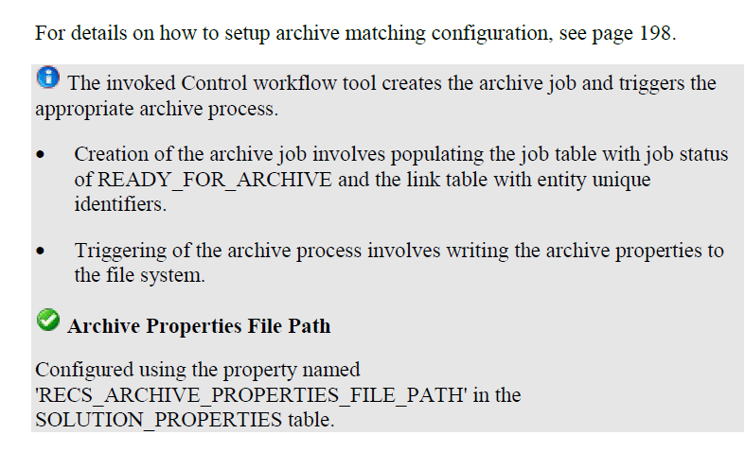

Actually the setting is as follow:

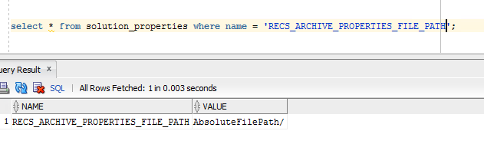

Is it OK ?

Is Morpheus (Servicemix) needed for the data to be archived or is it only useful for viewing already archived data ?

with link

as

(

select tl.linked_entity_key from tlm_bdr_relationship_link tl, tlm_bdr_relationship_header th, tlm_ref_relationship_type tr where tl.relationship_id=th.relationship_id

and th.relationship_type_id=tr.relationship_type_id

and tl.CREATED_DATETIME + 445 < sysdate

and tr.relationship_type_id = 210000021

)

select b.corr_acc_no, b.local_acc_no, i.* from link, item i, bank b

where i.item_id=link.linked_entity_key

and b.corr_Acc_no=i.corr_acc_no;

Following Hristo meeting :

