DevSecOps Workshop with SUSE Rancher 2.5 Pre-Flight document - Linux

Build your DevSecOps Environment using SUSE Rancher

**Table of Contents**

Hands-on Workshop - Briefing 3

What Will You Get Out of This Workshop? 3

Mark Your Calendar 3

Target Audience & Pre-requisites 3

Preflight Check 4

Cisco Webex 4

GitHub 4

Amazon Web Services. 4

Pricing Breakup 7

Notes: 7

Reference 8

# Hands-on Workshop - Briefing

This hands-on workshop is a continuation of our webinar – Digital Transformation with DevSecOps using SUSE Rancher on 10th August 2021. We will show you step-by-step, with detailed documentation, on how you can replicate the DevSecOps on SUSE Rancher demo environment in your own environment and start engaging a better conversation with your customers.

## What Will You Get Out of This Workshop?

* Step into Developer’s world to experience Application Delivery in Cloud Native world.
* Develop your own Demo Environment to demonstrate DevSecOps using SUSE Rancher to your customers.

## Mark Your Calendar

|  |  |
| --- | --- |
| Date/time | 8th September 2021 11:30am – 2pm SGT |
| Duration | 2 – 2.5 hours |
| Delivery | Online (Cisco Webex) |

# Target Audience & Pre-requisites

* Presales Consultants or Technical Consultants
* Watch the “Digital Transformation using DevSecOps with SUSE Rancher” webinar.
* **Bring your own AWS (Amazon Web Service) account** with full administrative access. We will be using AWS Lightsail service to build out the whole DevSecOps on SUSE Rancher environment in this workshop.
* **Please be prepared to spend up to under USD 3 on your AWS account for this workshop.** Pricing including breakup covered in separate pricing section below. For our partners, if you have issues in bringing your own AWS account, please contact your SUSE Partner Executive to get further assistance.
* **We will be using AWS Cli version 2** for VM (Virtual Machine) deployment. Please refer to Pre-Flight Check document below for instruction
* **Bring your own GitHub account.** If you do not have it, please create one on GitHub.
* **Bring your own laptop (Windows, Mac, or Linux)** with Chrome browser installed to complete the lab exercises.
* We will also access the Linux terminal on the VM running on AWS from your laptop. A fast, reliable internet access with SSH (Secure Shell) tools installed is required. For Windows users, please install **Putty** prior to joining the workshop.
* **Cisco Webex & MicroSoft Team** incase access to participant system is required for troubleshooting.

# Preflight Check

Tool required for the workshop

1. Cisco Webex
2. GitHub
3. AWS CLI

## Cisco Webex

* Register to the Webinar
* Use your Browser (Chrome, Firefox, Internet Explorer)
* <https://signin.webex.com/join>
* Follow the instructions on URL below to join the Webinar
  + <https://help.webex.com/en-us>
  + <https://ebooks.cisco.com/story/webexteamsessentials/page/2/1>
* People interested in using the Desktop client version, please follow the URL to get going. https://www.webex.com/downloads.html

## GitHub

* User needs GitHub Account. Signup to create one if you do not have. URL below.

<https://github.com/signup?ref_cta=Sign+up&ref_loc=header+logged+out&ref_page=%2F&source=header-home>

* Install Git Client (Open SUSE Leap 15.2)
  + zypper in -y git
* Install Git Client (CentOS8.x)
  + yum in -y git
* For other Linux distributions, refer to the link below for Installing Git Client.
  + https://git-scm.com/download/linux

## Amazon Web Services.

* For this workshop, we assume you already have AWS Access. We will use AWS LightSail Service.
* Please ensure your AWS User has administrator privileges.
* Below is sample IAM (Identity & Access Management) User



* Be sure to have your appropriate IAM user have Administrator Access which will allow him access to AWS LightSail.

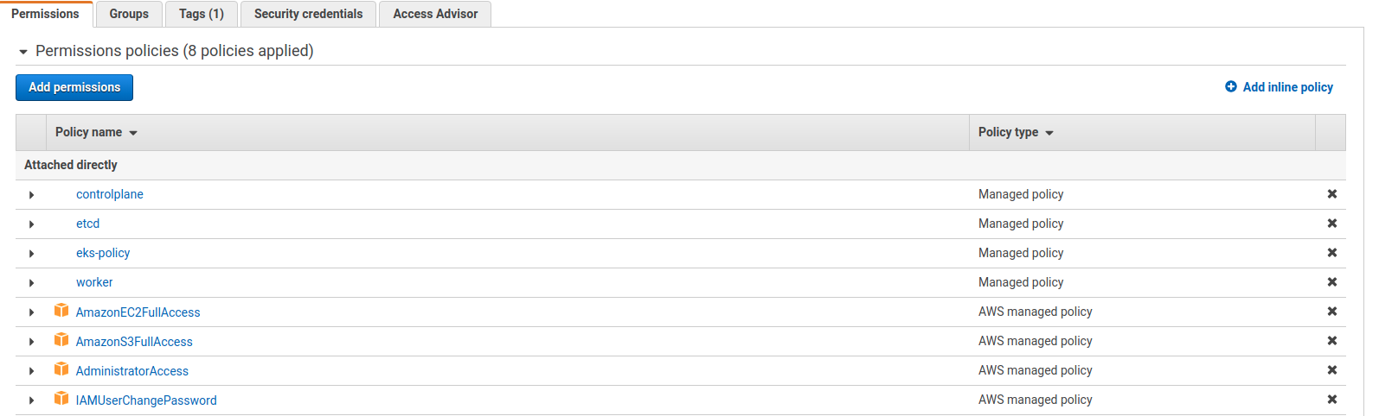

* AWS CLI (Command Line Interface) for programmatic access. We would require AWS CLI ver2(minimum). For Linux users, please follow the instructions on the link below to complete the installation/update.

<https://docs.aws.amazon.com/cli/latest/userguide/install-cliv2-linux.html#cliv2-linux-install>

* Command to install the AWC CLI

#curl "<https://awscli.amazonaws.com/awscli-exe-linux-x86_64.zip>" -o "awscliv2.zip"

#unzip awscliv2.zip

#sudo ./aws/install

# aws –version (To verify the client is installed).

Sample output:



* Next step is to configure AWS Client:

<https://docs.aws.amazon.com/cli/latest/userguide/cli-configure-files.html>

#aws configure. You will be prompted to provide value for below.

AWS Access Key ID [None]:

AWS Secret Access Key [None]:

Default region name [None]:

Default output format [None]:

Sample output:

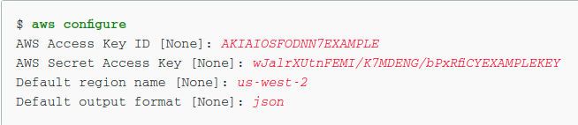

* Validate AWS CLI & LightSail services are working properly?
  + Create an AWS Lightsail instance

Please refer to below table to adapt to creating your lightsail instance in one of your preferred AWS regions from the list below.

# Table – Provide AWS Region, Availability Zone & Bundle-id

|  |  |  |
| --- | --- | --- |
| AWS_Region | Availability Zone | Bundle-ID |
| Tokyo | ap-northeast-1a | medium_2_0 |
| Seoul | ap-northeast-2a | medium_2_0 |
| Singapore | ap-southeast-1a | medium_2_0 |
| Sydney | ap-southeast-1a | micro_2_1 |
| Mumbai | ap-south-1a | micro_2_1 |

Use <availability-zone> & <bundle-id> from table to match your region. <Blueprint-id> will remain opensuse_15-2.

For me, I am close to Mumbai & hence for this demonstration purpose, I will be deploying the instance in Mumbai <ap-south-1a> using Bundle Id <micro2_1>

* + Sample Command to create a lightsail instance in AWS Mumbai Region.

# aws lightsail create-instances --instance-names my-test_instance-1 --availability-zone ap-south-1a --blueprint-id opensuse_15_2 --bundle-id micro_2_1.

* + Get Instance details.

# aws lightsail get-instance --instance-name my-test_instance-1

* + Delete the AWS lightsail instance

# aws lightsail delete-instance --instance-name my-test_instance-1

**If the instance is running in LIghtsail, we are ready for the workshop. Congratulations! Looking forward to seeing you in the workshop**

Incase if you have any questions, feel free to reach out to

Deepak Patel - [deepak.patel@suse.com](mailto:deepak.patel@suse.com)

Roger Brown - [roger.brown@suse.com](mailto:roger.brown@suse.com)

# Pricing Breakup

For sample pricing, we have chosen AWS Region Mumbai (ap-south-1).

|  |  |  |  |  |  |  |  |  |  |  |  |  |  |
| --- | --- | --- | --- | --- | --- | --- | --- | --- | --- | --- | --- | --- | --- |
| **DevSecOps AWS Lightsail Lab requirement**  **Region - Mumbai <ap-south-1>** | | | | | | | | | | | | | |
| **VM Name** | | | **VM Size** | | | | | **RAM & Disk** | | | **Pricing** | | |
| Rancher | | | Medium | | | | | 4 GB RAM,  80 GB SSD Disk | | | USD 20/Month | | |
| Harbor | | | Medium | | | | |
| Cluster1 | | | Medium | | | | |
| Cluster2 | | | Medium | | | | |
| Devsecops-m1 | | | Large | | | | | 8 GB RAM,  160 GB SSD Disk | | | USD 40/Month | | |
| Devsecops-w1 | | | Large | | | | |
| Devsecops-w2 | | | Large | | | | |
| Devsecops-w3 | | | Large | | | | |
| Devsecops-w4 | | | Large | | | | |
| **Instance Name** | | | **Instance Category** | | | | | **Total Instances** | | | **Pricing** | | |
| 1) Rancher 2) Harbor 3) Cluster 1  4) Cluster2 | | | Medium | | | | | 4 | | | USD 20/Month | | |
| 1) Devsecops-m1 2) Devsecops-w1  3) Devsecops-w2 4) Devsecops-w3  5) Devsecops-w4 | | | Large | | | | | 5 | | |  | | |
| **Bundle ID** | **Instance Category** | **Total USD** | | **Days in month** | **Hours/Day** | **Pricing**  **USD** **Per hour/Instance** | **Total Instances** | | **Pricing** **USD** **Total Instance/Hour** | **Workshop Duration** | | **Pricing**  **USD**  **All instances for Workshop duration** | **Notes** |
| Micro_2_1 | Medium | 20.00 | | 30.00 | 24.00 | 0.03 | 4.00 | | 0.11 | 3.00 | | 0.33 |  |
| Large | 40.00 | | 30.00 | 24.00 | 0.06 | 5.00 | | 0.28 | 3.00 | | 0.83 |  |
| AWS Lightsail Expenses |  |  | |  |  |  |  | |  |  | | 1.17 | Pricing are excluding Taxes |

Reference Link

AWS Lightsail - Virtual Servers

<https://aws.amazon.com/lightsail/pricing/?opdp1=pricing>

### Notes:

|  |
| --- |
| 1) Fees estimated does not include tax to be applied on your AWS account if any. |
| 2) AWS Free Tier does not cover the instance type used in this workshop. Fees incurred in this workshop cannot be covered by the AWS Free Tier pricing scheme. |
| 3) The pricing is charged on hourly basis in AWS Lightsail. The fees incurred in this workshop beyond 3 hours will be charged on hourly basis. |

# Reference

* Cisco Webex
  + <https://essentials.webex.com/get-started/essentials.html>
* Microsoft Teams
  + <https://teams.microsoft.com>
* GitHub
  + <https://docs.github.com/en/get-started/signing-up-for-github/signing-up-for-a-new-github-account>
  + <https://docs.github.com/en/desktop/installing-and-configuring-github-desktop>
* AWS Lightsail.
  + <https://aws.amazon.com/lightsail/>
  + <https://awscli.amazonaws.com/v2/documentation/api/latest/reference/index.html>
  + <https://docs.aws.amazon.com/cli/latest/reference/>
  + <https://docs.aws.amazon.com/cli/latest/userguide/cli-chap-welcome.html>
  + <https://aws.amazon.com/lightsail/pricing/?opdp1=pricing>