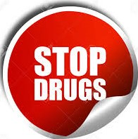

THE MAATRAM REHABILITATION CENTER
& DE ADDICTION FOR DRUGS
Govt. Regt No :00529
SF. No : 332/5, Nehru Nagar West, Kalapatti Main Road, Sitra, Coimbatore – 641 014
Ph : 94437 95265 / 97901 33349 / 98650 81843

PATIENT SUMMARY DETALS

Bill Number : 01138 Admission Date : 28-06-2025
IP Number : 01138 Discharge Date : 28-09-2025
Patient Name : SANTHOSH KUMAR.C
Age / Sex : 40 / M
Address : SIRUMUGAI, COIMBATORE
Contact No : 88254 23344
Patient Case : ADS


SUMMARY CASH BILL

- MONTHLY (18,000) * 3 = 54,000
- EXTRA DAYS = -
- MEDICINES = 2,470
- PATIENT PICK CHARGES = -
- BLOOD TEST = -
- SCAN = -
- OTHER EXPENSES = -
- INJECTIONS / FLUIDS = -

TOTAL = 56,470
RECEIVED =
DISCOUNT = -

COMPANY SEAL AND SIGN

