
MIP-Cambodia Smart
This document comprises Business information about products.

17/05/2020
MIP Quality Assurance

BIMA
BIMA is a leading insurance tech player that uses mobile technology to disrupt the global insurance industry and fuel financial inclusion.
- Affordable insurance and mobile health services for low-income families
- All our products are registered and paid for using mobile technology.
- We work with a range of partners, like mobile operators, MFIs & banks.

Amendment History:

SL.No | Author(s) | Version | Date | Change Description
1. | Karthick J | 0 | 17/05/2020 | Initial Version
2. | Stephina | 1 | 05/11/2020 | KH Billing Migration Phase 2

Table of Contents

Amendment History: 3
Table of Contents 4
MARKET DETAILS 5
Channel: 5
Languages: 5
Customers: 5
Subscriber Channel: 5
Product details: 5
Server details: 5
Business Specifications: 6
Customer details: 6
Available products: 6
Insured Relative details: 6
Technical Specifications: 7
Registration Process: 7
Smart Hospital Registration: 7
Smart Life Registration: 9
Product details: 11
Confirmation Process: 12
Deduction Process: 12
Search & Modify Process: 13
Deregistration Process: 13
SendSMSInQueue Scheduler: 14
SendCoverSMS Scheduler: 14
DeregOverAgedCustomer Scheduler: 15
UnsubscribeSmartOverDeductedCustomerScheduler 16
SmartCdrChurnScheduler 16
Mobile App: 17
Smart Hospital 17
Smart Life(1+1) 19
Smart Life(1+0) 20
Smart Hospital and Smart Life(1+1) 21
Smart Hospital and Smart Life (1+0) 23

MARKET DETAILS

Channel:
- Dashboard
- USSD
- Mobile App

Languages:
- English
- khmer

Customers:
- Prepaid

Subscriber Channel:
- Smart

Product details:
- Smart Life Insurance
- Smart Health Insurance

Server details:

- Application server:
kh-app-01.sg.bimamobile.internal
kh-esb-01.sg.bimamobile.internal

- Database server: kh-rds-01.sg.bimamobile.internal:3306
- Application server:
- Dashboard: MIP
- USSD: USP (jar file)
- MIP SERVICES: mip-services
- Database server:
- Schema: mip

Business Specifications:

Customer details:

- Customer name and surname can contain only alphabets, one single quote, space and hyphen
- Customer Age should be 18 and 69.
- Customer gender: Male/Female
- Customer msisdn:
- msisdn_codes: 010,015,016,069,070,081,086,087,093,098
- msisdn_length : 9 digits

- msisdn_codes: 096
- msisdn_length : 10 digits

Available products:

Smart Life : Available benefit level: $5000
Smart Hospital : Available benefit level: $3200

Insured Relative details:

- Only for Smart Life Customers.

- Insured Relative details is as “Nominee”
- Msisdn : No need to be a smart valid prepaid msisdn
- Nominee Name: can contain only alphabets, one single quote, space and hyphen
- Nominee Surname: can contain only alphabets, one single quote, space and hyphen
- Nominee Age: 1-100
- Nominee Gender: Male / Female
- NID : 9 digits
- Relationship with Customer: Parent, Child, Sibling, Spouse and others.

- Insured Relative details is as “Beneficiary”
- Msisdn : Need to be a smart valid prepaid msisdn and covered for Product
- Beneficiary Name: can contain only alphabets, one single quote, space and hyphen
- Beneficiary Surname: can contain only alphabets, one single quote, space and hyphen
- Beneficiary Age: 1-100
- Beneficiary Gender: Male / Female
- NID : 9 digits
- Relationship with Customer: Parent, Child, Sibling, Spouse and others.

Note: In Life (1+1), Beneficiary is also considered to be covered for the product and the valid smart msisdn is captured during registration of Life product. In the process of registration, this insured relative is blocked from registration of Life as he/she is already an insured relative of Life product of some other customer.

Technical Specifications:

Registration Process:

During Registration, PrepostCheck is invoked and only valid Smart prepaid msisdn’s are registered in the system.
prePostCheck endpoint URL: http://10.12.5.205:7080/custom/SELFCARE/HWBSS_Subscriber

msisdn_codes_6digs 010,015,016,069,070,081,086,087,093,098 |
msisdn_codes_7digs 096

On Successful registration of customer through Dashboard Agents, Customer is sent with Registration SMS in English and Khmer languages.

Smart Hospital Registration:

Customer details are captured and by default, $3200 level is registered in the system. In this process, No insured relative is captured in the system for Smart hospital product.
Customer is sent with registration communication sms in English and Khmer languages.
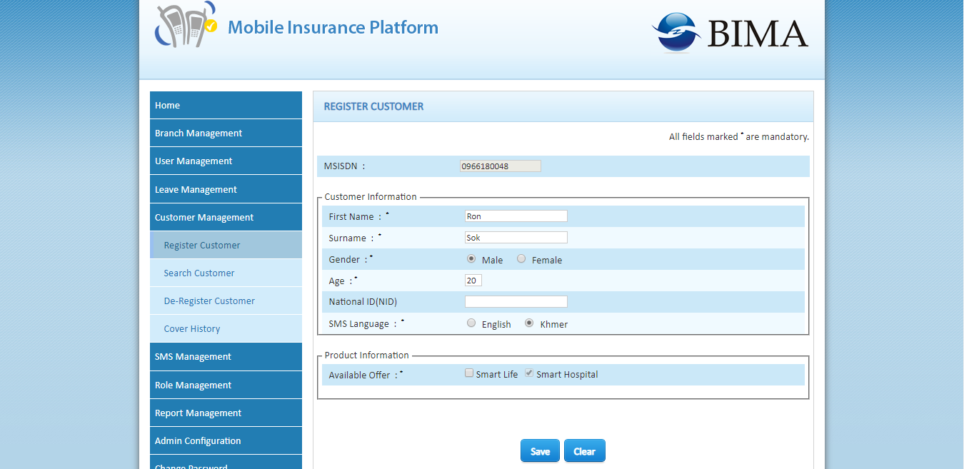
DB Updates:
Customer details:
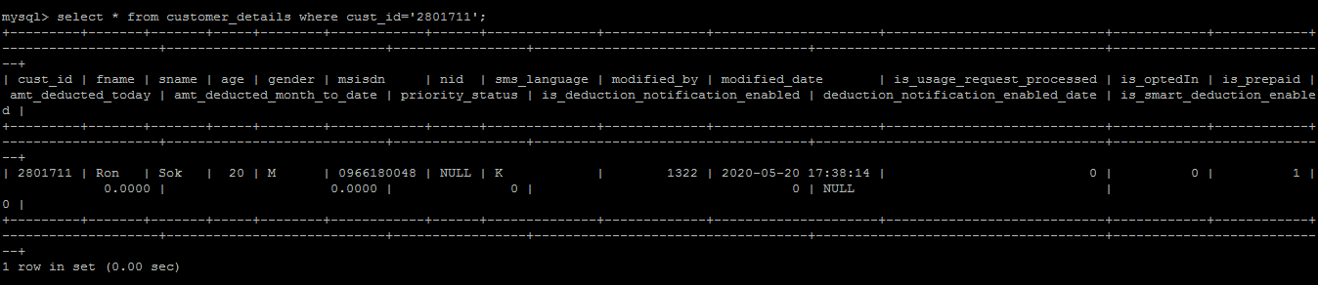
Offer_subscription:
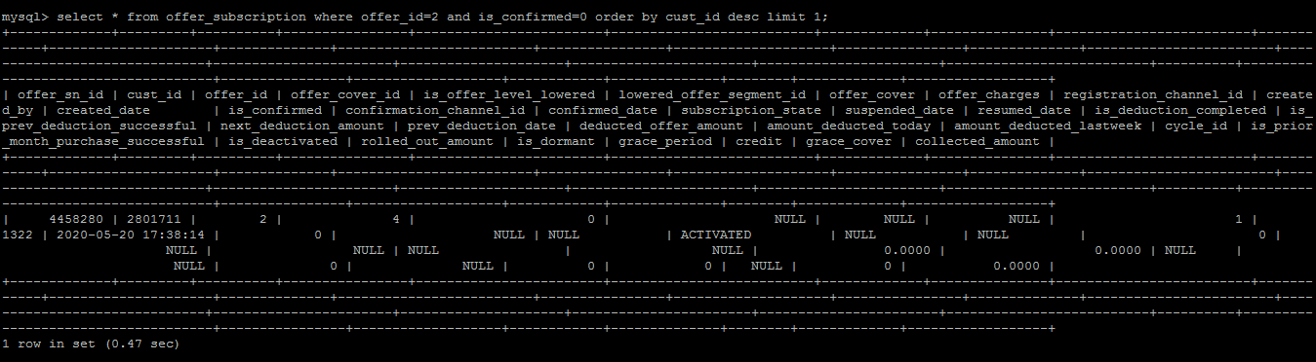
Insured_relative_details:
No Insured Relative details

Smart Life Registration:

Customer details are captured and by default, $5000 level is registered in the system. In this process, insured relative is captured in the system for Smart Life product.
Insured Relative as “Nominee”: Life (1+0)
- In this process, No prepost check for Nominee msisdn and not covered for the product.
- This Nominee can subscribe for Smart Life product
Insured Relative as “Beneficiary”: Life (1+1)
- In this process, Beneficiary msisdn should be valid Smart Prepaid msisdn and covered for the product.
- This Beneficiary cannot subscribe for Smart Life product as this Beneficiary is considered to be customer for this product
Customer is sent with registration communication sms in English and Khmer languages.
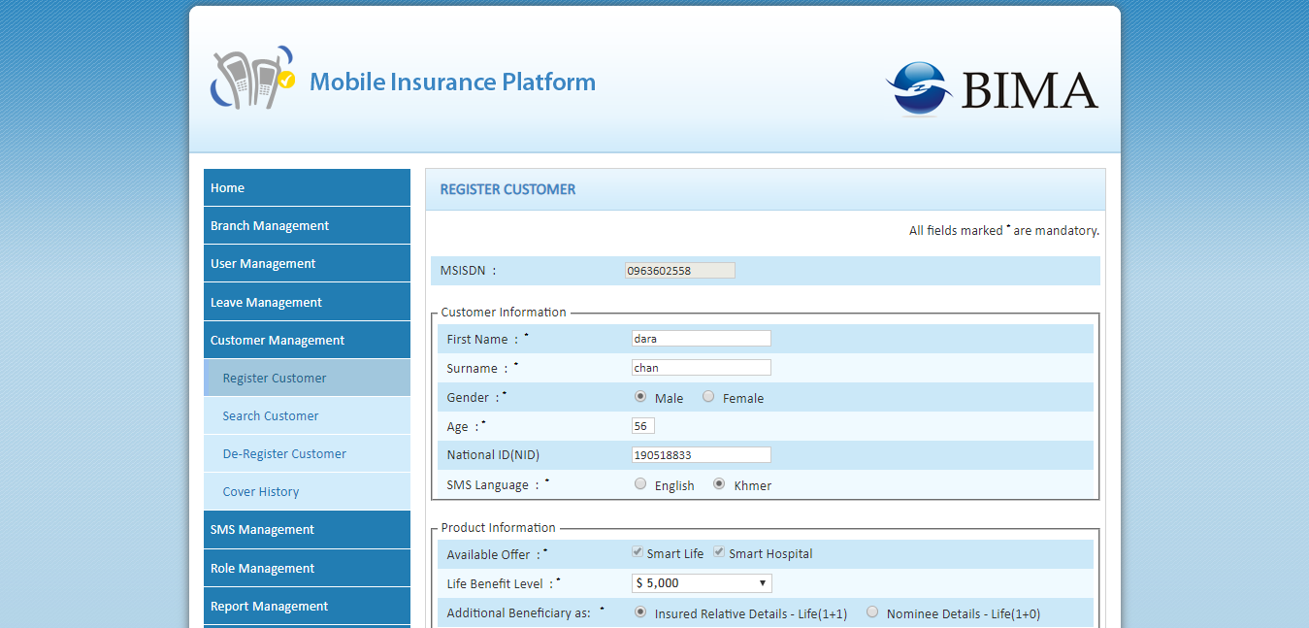

DB Updates:
Customer details:

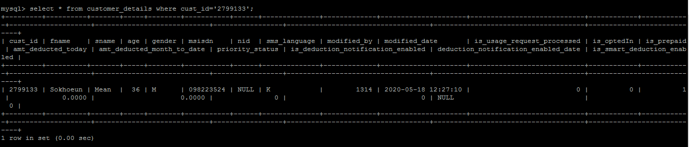

Offer_subscription:
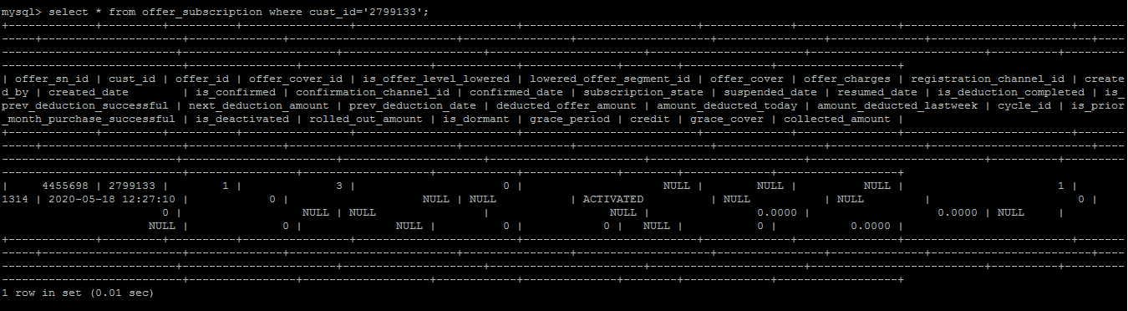
Insured_relative_details: (Life 1+0)
Is_insured_relative=0
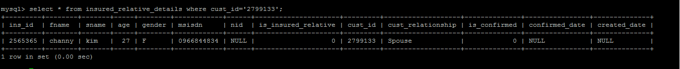
Customer_details:
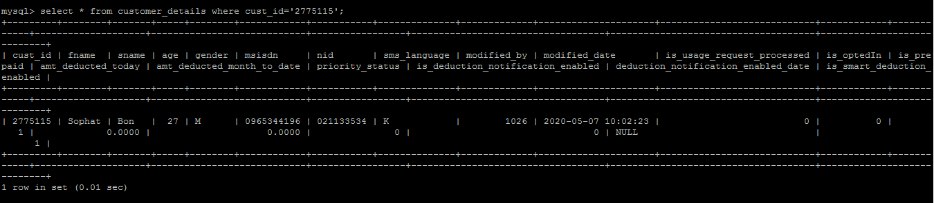

Offer_subscription:
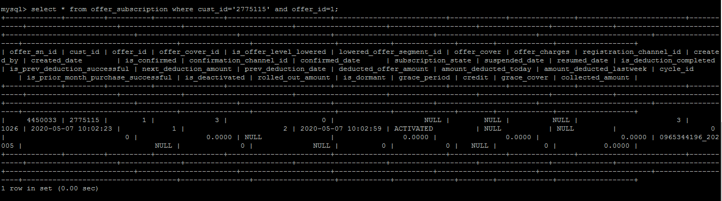
Insured_relative_details: (Life 1+1)
Is_insured_relative=1
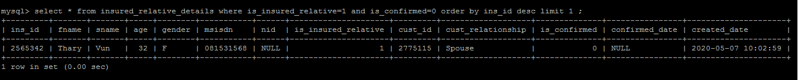

Product details:

Offer_details:
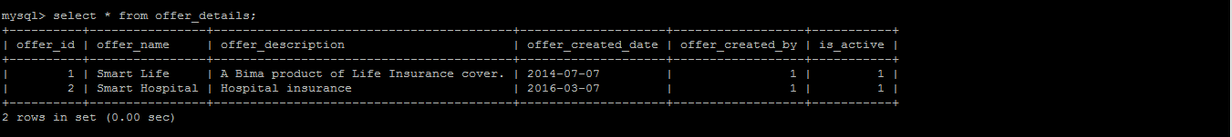
offer_cover_details:

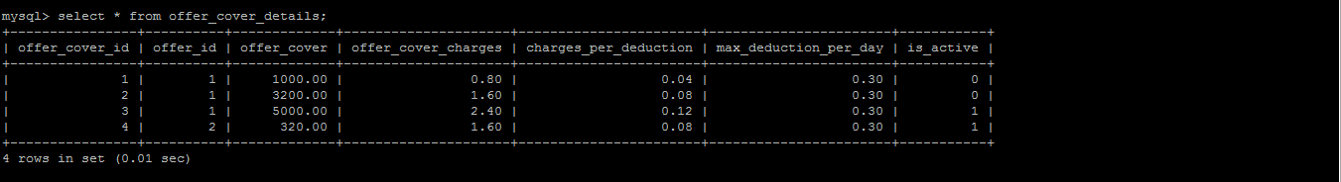

Confirmation Process:

Customers are registered through Dashboard Agents and customer sent with communication sms in English and Khmer language. Later, customer confirms the registration through USSD.
DB Updates:
Offer_subscription
Is_confirmed=1
Confirmed_date= 2020-05-20 14:05:23
Confirmation_channel_id=2
subscription_state=ACTIVATED

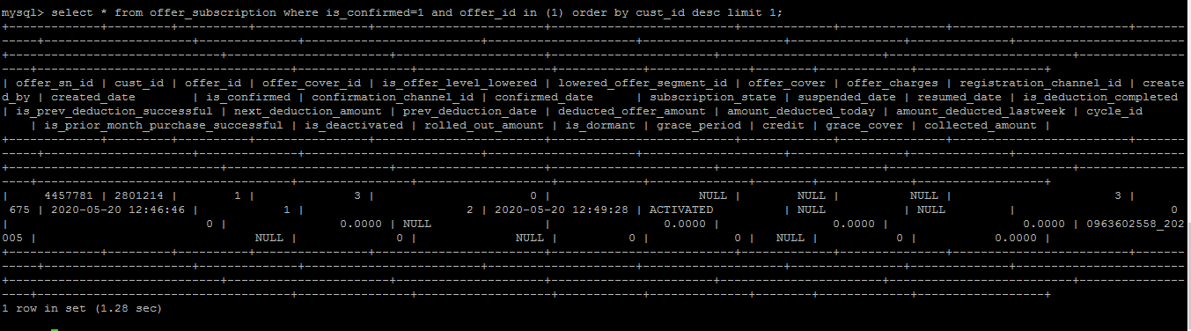

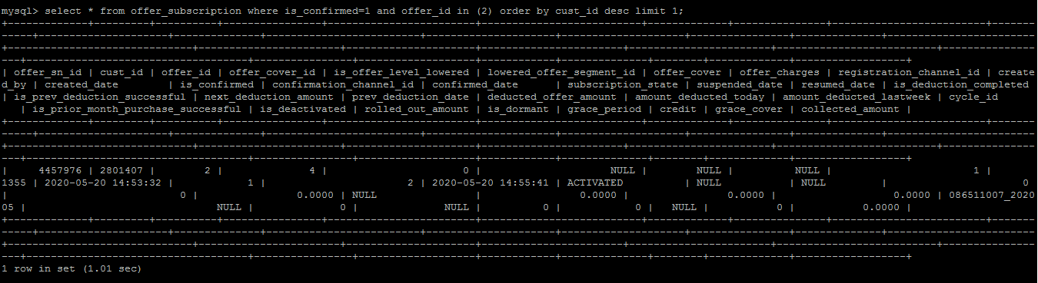

Deduction Process:

Deduction process in Cambodia is carried out by Smart: NBSS System which deducts customer per day amount and shares the deduction report to BIMA. Customers who are confirmed at BIMA are shared with NGBSS System by BIMA L2 Support team. Once after sharing the file customers are marked is_smart_deduction_enabled=1 at BIMA end.
Once after sharing the file, it is assumed that customers are deducted at NGBSS system and BIMA doesn’t perform any deductions on customer.

Search & Modify Process:

Customer registered for Smart Life and Smart hospital can be modified under Search customer and the changes are immediately processed in backend.
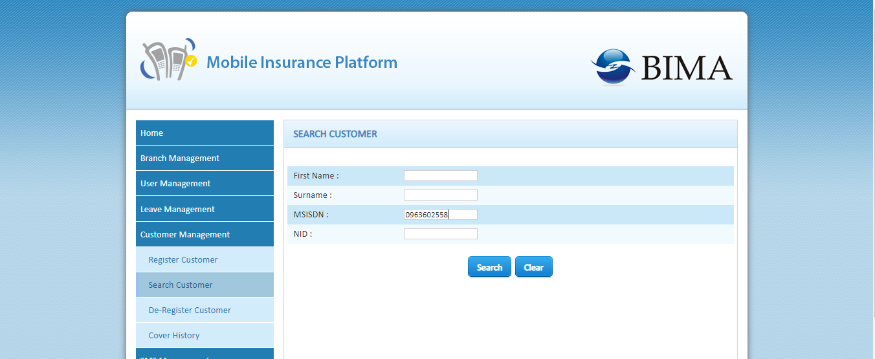

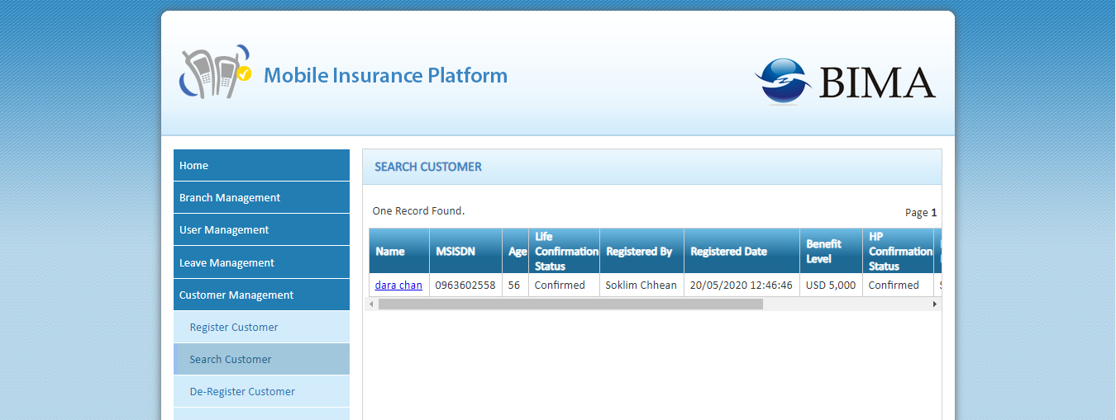

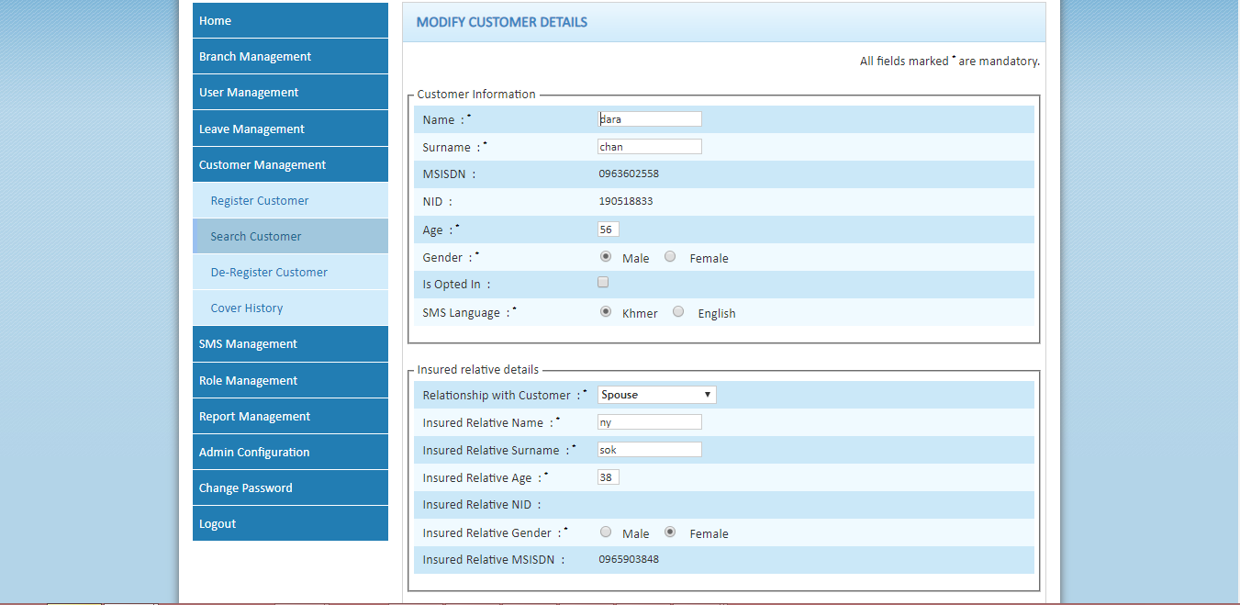

DB Updates:
Customer_details
Offer_subscription
Insured_relative_details

Deregistration Process:

Customer who are registered and not confirmed in the system can be direct deregistered at BIMA. However, Customer who are registered and confirmed in the system attached at NGBSS system for deductions. Those customers should be detached from NGBSS System. On success detachment from NGBSS System, Customer deregistered at BIMA.
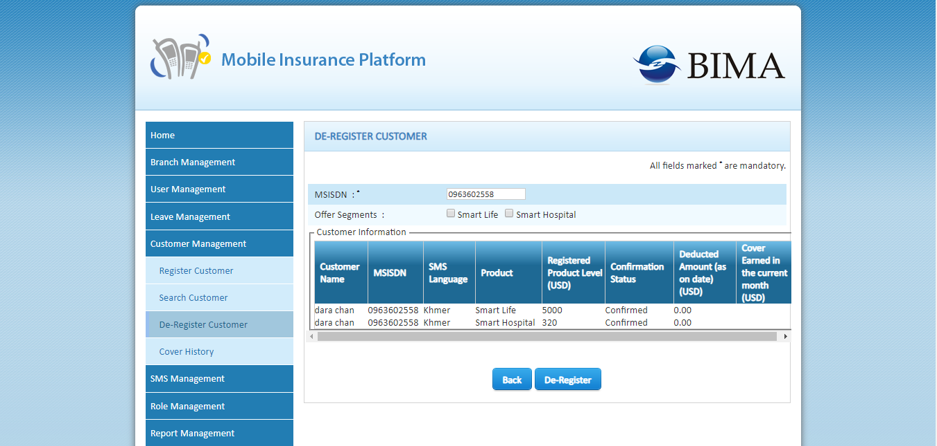
DB Updates:
subscriptionState: DEACTIVATED
is_deactivated=1

Insert into bima_cancellation and offer_cancellation tables.

Unsubscription API response from Smart:

0000: Success : Deregister at BIMA
1009: the offering doesnt exist: Deregister at BIMA
1005: the subscriber doesnt exist : Deregister at BIMA

{"ChangeSupplementaryOfferingRspMsg":{"RspHeader":{"ReturnCode": 1005,"ReturnMsg": "The subscriber does not exist.","RspTime": 20190509102248}}}
{"ChangeSupplementaryOfferingRspMsg":{"RspHeader":{"ReturnCode": 0000,"ReturnMsg": "Success","RspTime": 20190509102248}}}
{"ChangeSupplementaryOfferingRspMsg":{"RspHeader":{"ReturnCode": 1009,"ReturnMsg": "The offering does not exist.","RspTime": 20190509102248}}}

Note: Customers who already detached from Smart NGBSS System i.e., SUSPENDED State. In this case, Customer should direct deregistered at BIMA.
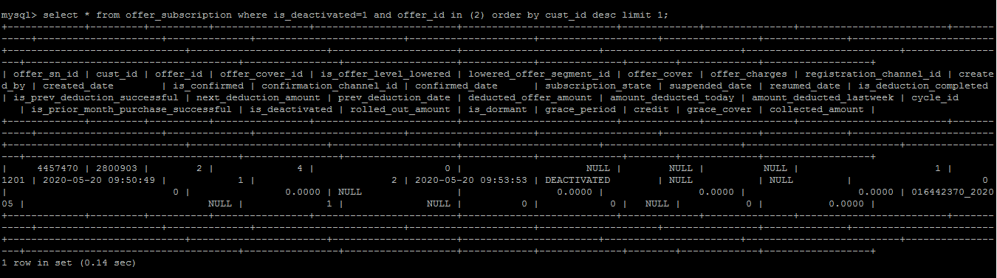
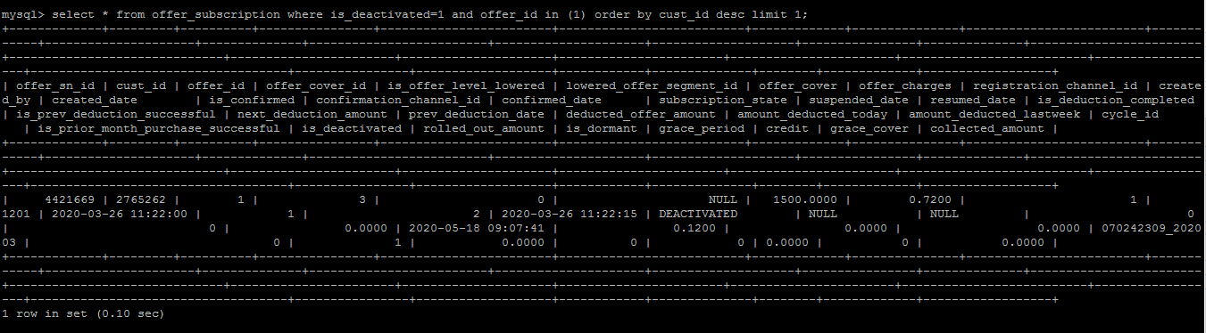

SendSMSInQueue Scheduler:

All communication sms are processed into “sms_in_queue” entity. All the sms which are inserted into this table is processed by SendSMSInQueue Scheduler and send to customers.
###################### JSMPP Configurations #########################

bind.userName=Bima
bind.password=b1main
bind.system.type=

# SMPP Session parameters
smpp.session.host=10.12.9.70
smpp.session.port=15019
#TEST
#smpp.session.host=localhost
#smpp.session.port=2775

# Source MSISDN
source.msisdn=BIMA

country.code=855

SendCoverSMS Scheduler:

All communication sms are processed into “sms_in_draft” entity. All the sms which are inserted into this table is processed by SendCoverSMS Scheduler and send to customers.
###################### JSMPP Configurations #########################

bind.userName=Bima
bind.password=b1main
bind.system.type=

# SMPP Session parameters
smpp.session.host=10.12.9.70
smpp.session.port=15019
#TEST
#smpp.session.host=localhost
#smpp.session.port=2775

# Source MSISDN
source.msisdn=BIMA

country.code=855

DeregOverAgedCustomer Scheduler:

Customers who are over aged are picked by the scheduler for deregistration process. ID mapped for this job : 1549
Unconfirmed customers are deregistered at BIMA by updating is_deactivated=1 and insert into cancellations tables.
For Confirmed customers, Customers are detached from Smart NGBSS System and On success response , Customer is deregistered at BIMA.

Query:
select cd.msisdn as msisdn ,cd.is_smart_deduction_enabled as isSmartDeductionEnabled, group_concat(cs.subscription_state order by cs.offer_cover_id separator ',') as subscriptionState, group_concat(cs.offer_id order by cs.offer_id separator ',') as productIds, group_concat(cs.offer_cover_id order by cs.offer_cover_id separator ',') as offerCoverIds from customer_details cd inner join offer_subscription cs on cd.cust_id= cs.cust_id where (floor(datediff(curdate(), cs.created_date) / 365) + cd.age) > 70 and cs.is_deactivated = 0 group by cd.cust_id;
DB Updates:
subscriptionState: DEACTIVATED
is_deactivated=1

Insert into bima_cancellation and offer_cancellation tables.

Unsubscription API response from Smart:

0000: Success : Deregister at BIMA
1009: the offering doesnt exist: Deregister at BIMA
1005: the subscriber doesnt exist : Deregister at BIMA

{"ChangeSupplementaryOfferingRspMsg":{"RspHeader":{"ReturnCode": 1005,"ReturnMsg": "The subscriber does not exist.","RspTime": 20190509102248}}}
{"ChangeSupplementaryOfferingRspMsg":{"RspHeader":{"ReturnCode": 0000,"ReturnMsg": "Success","RspTime": 20190509102248}}}
{"ChangeSupplementaryOfferingRspMsg":{"RspHeader":{"ReturnCode": 1009,"ReturnMsg": "The offering does not exist.","RspTime": 20190509102248}}}

Note: Customers who already detached from Smart NGBSS System i.e., SUSPENDED State. In this case, Customer should direct deregistered at BIMA.

UnsubscribeSmartOverDeductedCustomerScheduler

(Not Active)
Scheduler picks Smart pilot customers reaching threshold deduction amount of $1.6 and will detach customer from Smart end.
On success detachment, it suspends the customers from BIMA END by updating the subscription_state and suspended_date.

Query:
SELECT cd.msisdn AS msisdn,os.offer_id AS offerID, os.offer_cover_id as offerCoverId, os.deducted_offer_amount AS deductedOfferAmt,subscription_state AS subscriptionState,cd.is_smart_deduction_enabled AS isSmartDeductionEnabled FROM customer_details cd INNER JOIN offer_subscription os ON cd.cust_id = os.cust_id WHERE os.is_confirmed = 1 AND os.is_deactivated = 0 AND cd.is_smart_deduction_enabled = 1 AND os.subscription_state = 'ACTIVATED' AND os.is_dormant <= 3 AND os.is_deduction_completed = 0 AND os.deducted_offer_amount >= 1.6;
DB updates:
Offer_subscription table:
subscriptionState: SUSPENDED
suspended_state: <date>
is_deduction_completed=1

SmartCdrChurnScheduler
(Not Active)
Process the record which is in the cdr_churn_data of only Pilot customers. Deactivates the record in main tables and insert into cancellations tables.
Query:
select cd.msisdn as msisdn, group_concat(os.offer_id order by os.offer_id SEPARATOR ',') as offerId, group_concat(os.offer_cover_id order by os.offer_cover_id SEPARATOR ',') as offerCoverId, group_concat(os.subscription_state order by os.offer_cover_id SEPARATOR ',') as subscriptionState, cd.is_smart_deduction_enabled as isSmartDeductionEnabled from customer_details cd inner join offer_subscription os on cd.cust_id = os.cust_id inner join cdr_churn_data ccd on ccd.cust_id = cd.cust_id where os.is_deactivated = 0 and ccd.is_smart_deduction_enabled = 1 and os.subscription_state = 'ACTIVATED' or os.subscription_state = 'SUSPENDED' group by ccd.cust_id;
DB Updates:
subscriptionState: DEACTIVATED
is_deactivated=1

Insert into bima_cancellation and offer_cancellation tables.

Unsubscription API response from Smart:

0000: Success : Deregister at BIMA
1009: the offering doesnt exist: Deregister at BIMA
1005: the subscriber doesnt exist : Deregister at BIMA

{"ChangeSupplementaryOfferingRspMsg":{"RspHeader":{"ReturnCode": 1005,"ReturnMsg": "The subscriber does not exist.","RspTime": 20190509102248}}}
{"ChangeSupplementaryOfferingRspMsg":{"RspHeader":{"ReturnCode": 0000,"ReturnMsg": "Success","RspTime": 20190509102248}}}
{"ChangeSupplementaryOfferingRspMsg":{"RspHeader":{"ReturnCode": 1009,"ReturnMsg": "The offering does not exist.","RspTime": 20190509102248}}}

Note: Customers who already detached from Smart NGBSS System i.e., SUSPENDED State. In this case, Customer should direct deregistered at BIMA.

Mobile App:

Smart Hospital

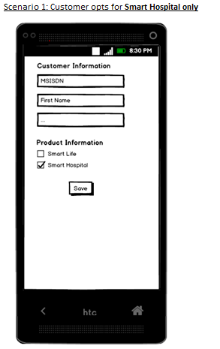
Preconditions:
1. Customer opts for Smart Hospital only
Steps:
1. Enter Customer MSISDN and other details (only some of these fields are displayed in the wireframe)
2. Check "Smart Hospital" option
3. Click Save
Validations:
1. Check if the Customer MSISDN is already registered for one of the following:
a. Customer of "Smart Hospital"
b. Customer of "Smart Life" - either (1+1) or (1+0)
If yes, <Message 1> will be displayed on screen and the agent has to then modify the customer record, instead of creating a fresh registration.
2. Check if the Customer MSISDN is already registered as Insured Relative of "Smart Life (1+1)". If yes, <Message 2> will be displayed on screen and the option of "Smart Life" checkbox will be disabled.
3. Check if the Customer MSISDN is a valid Smart Prepaid number. If not, <Message 3> will be displayed on screen and the agent is not allowed to proceed with this MSISDN.
4. Validate other text fields and display relevant <CustValidationMessages> on screen.
Assumptions:
1. It is okay to register an existing nominee of Smart Life (1+0) as a customer via this screen.
2. Not all input fields are displayed in the wireframes. Following are the full set of Input Fields:
- Customer Information: MSISDN *, First Name *, Surname*, Age (18-69), Gender*, National ID

Smart Life(1+1)

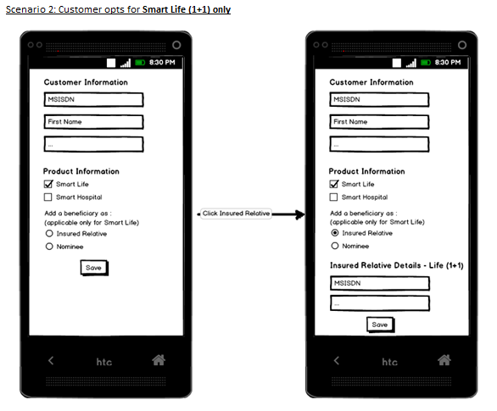
Preconditions:
1. Customer opts for Smart Life (1+1) only
Steps:
1. Enter Customer MSISDN and other details (only some of these fields are displayed in the wireframe)
2. Check "Smart Life" option
3. Choose "Insured Relative" option
4. Enter Insured Relative MSISDN and other details (only some of these fields are displayed in the wireframe)
5. Click Save
Validations:
1. Check if the Customer MSISDN is already registered for one of the following:
a. Customer of "Smart Hospital"
b. Customer of "Smart Life" - either (1+1) or (1+0)
If yes, <Message 1> will be displayed on screen and the agent has to then modify the customer record, instead of creating a fresh registration.
2. Check if the Customer MSISDN is already registered as Insured Relative of "Smart Life (1+1)". If yes, <Message 2> will be displayed on screen and the option of "Smart Life" checkbox will be disabled. This person will not be allowed to choose the product.
3. Check if the Insured Relative MSISDN is already registered for one of the following:
a. Customer of "Smart Life" - either (1+1) or (1+0)
b. Insured Relative of "Smart Life" (1+1)
If yes, <Message 4> will be displayed on a pop-up screen and the agent has to click either a "Yes" or a "No". If agent clicks "Yes", the workflow changes to Registration Scenario 3; and with a "No", the agent will have to ask the Customer to provide another relative's MSISDN.
4. Check if the Customer MSISDN is a valid Smart Prepaid number. If not, <Message 3> will be displayed on screen and the agent is not allowed to proceed with this MSISDN.
5. Check if the Insured Relative MSISDN is a valid Smart Prepaid number. If not, <Message 5> will be displayed on a pop-up screen and the agent has to click either a "Yes" or a "No". If agent clicks "Yes", the workflow changes to Registration Scenario 3; and with a "No", the agent will have to ask the Customer to provide another relative's MSISDN.
6. Validate other text fields and display relevant <CustValidationMessages> and <InsuredRelativeValidationMessages> on screen.
Assumptions:
1. It is okay to register an existing nominee of Smart Life (1+0) as a customer via this screen.
2. It is okay to register an existing nominee of Smart Life (1+0) as an insured relative via this screen.
3. Not all input fields are displayed in the wireframes. Following are the full set of Input Fields:
a. Customer Information: MSISDN *, First Name *, Surname*, Age (18-69), Gender*, National ID
b. Insured Relative Details: MSISDN *, First Name *, Surname*, Age (18-69), Gender*, National ID, Relation

Smart Life(1+0)

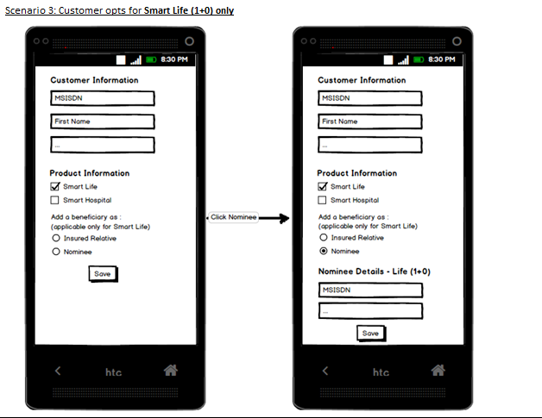

Preconditions:
1. Customer opts for Smart Life (1+0) only
Steps:
1. Enter Customer MSISDN and other details (only some of these fields are displayed in the wireframe)
2. Check "Smart Life" option
3. Choose "Nominee" option
4. Enter Nominee MSISDN and other details (only some of these fields are displayed in the wireframe)
5. Click Save
Validations:
1. Check if the Customer MSISDN is already registered for one of the following:
 | a. Customer of "Smart Hospital"
 | b. Customer of "Smart Life" - either (1+1) or (1+0)
If yes, <Message 1> will be displayed on screen and the agent has to then modify the customer record, instead of creating a fresh registration.
2. Check if the Customer MSISDN is already registered as Insured Relative of "Smart Life (1+1)". If yes, <Message 2> will be displayed on screen and the option of "Smart Life" checkbox will be disabled. This person will not be allowed to choose the product.
3. Check if the Customer MSISDN is a valid Smart Prepaid number. If not, <Message 3> will be displayed on screen and the agent is not allowed to proceed with this MSISDN.
4. Validate other text fields and display relevant <CustValidationMessages> and <NomineeValidationMessages> on screen.
Assumptions:
1. It is okay to register an existing nominee of Smart Life (1+0) as a customer via this screen.
2. It is okay to register an existing nominee of Smart Life (1+0) as a nominee via this screen.
3. Not all input fields are displayed in the wireframes. Following are the full set of Input Fields:
 | a. Customer Information: MSISDN *, First Name *, Surname*, Age (18-69), Gender*, National ID
Smart Hospital and Smart Life(1+1) | b. Nominee Details: MSISDN, First Name *, Surname*, Age (18-69), Gender*, National ID, Relation
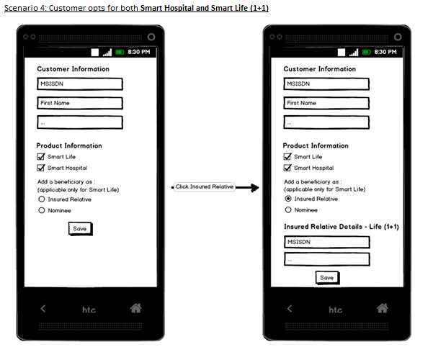

Preconditions:
1. Customer opts for Smart Hospital and Smart Life (1+1).
Steps:
1. Enter Customer MSISDN and other details (only some of these fields are displayed in the wireframe)
2. Check "Smart Hospital" option
3. Check "Smart Life" option
4. Choose "Insured Relative" option
5. Enter Insured Relative MSISDN and other details (only some of these fields are displayed in the wireframe)
6. Click Save
Validations:
1. Check if the Customer MSISDN is already registered for one of the following:
a. Customer of "Smart Hospital"
b. Customer of "Smart Life" - either (1+1) or (1+0)
If yes, <Message 1> will be displayed on screen and the agent has to then modify the customer record, instead of creating a fresh registration.
2. Check if the Customer MSISDN is already registered as Insured Relative of "Smart Life (1+1)". If yes, <Message 2> will be displayed on screen and the option of "Smart Life" checkbox will be disabled. This person will not be allowed to choose the product.
3. Check if the Insured Relative MSISDN is already registered for one of the following:
a. Customer of "Smart Life" - either (1+1) or (1+0)
b. Insured Relative of "Smart Life" (1+1)
If yes, <Message 4> will be displayed on a pop-up screen and the agent has to click either a "Yes" or a "No". If agent clicks "Yes", the workflow changes to Registration Scenario 3; and with a "No", the agent will have to ask the Customer to provide another relative's MSISDN.
4. Check if the Customer MSISDN is a valid Smart Prepaid number. If not, <Message 3> will be displayed on screen and the agent is not allowed to proceed with this MSISDN.
5. Check if the Insured Relative MSISDN is a valid Smart Prepaid number. If not, <Message 5> will be displayed on a pop-up screen and the agent has to click either a "Yes" or a "No". If agent clicks "Yes", the workflow changes to Registration Scenario 3; and with a "No", the agent will have to ask the Customer to provide another relative's MSISDN.
6. Validate other text fields and display relevant <CustValidationMessages> and <InsuredRelativeValidationMessages> on screen.
Assumptions:
1. It is okay to register an existing nominee of Smart Life (1+0) as a customer via this screen.
2. It is okay to register an existing nominee of Smart Life (1+0) as an insured relative via this screen.
3. Not all input fields are displayed in the wireframes. Following are the full set of Input Fields:
a. Customer Information: MSISDN *, First Name *, Surname*, Age (18-60), Gender*, National ID
- Insured Relative Details: MSISDN *, First Name *, Surname*, Age (18-60), Gender*, National ID, Relation

Smart Hospital and Smart Life (1+0)

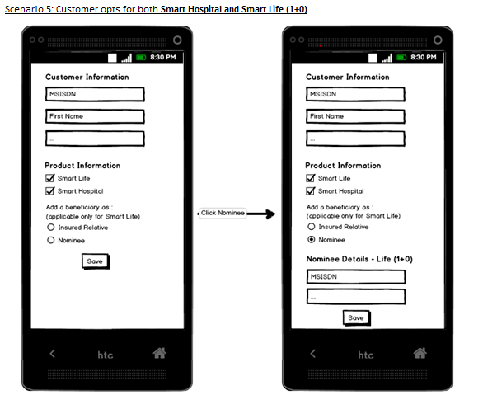

Preconditions:
1. Customer opts for Smart Hospital and Smart Life (1+0).
Steps:
1. Enter Customer MSISDN and other details (only some of these fields are displayed in the wireframe)
2. Check "Smart Hospital" option
3. Check "Smart Life" option
4. Choose "Nominee" option
5. Enter Nominee MSISDN and other details (only some of these fields are displayed in the wireframe)
6. Click Save
Validations:
1. Check if the Customer MSISDN is already registered for one of the following:
a. Customer of "Smart Hospital"
b. Customer of "Smart Life" - either (1+1) or (1+0)
If yes, <Message 1> will be displayed on screen and the agent has to then modify the customer record, instead of creating a fresh registration.
2. Check if the Customer MSISDN is already registered as Insured Relative of "Smart Life (1+1)". If yes, <Message 2> will be displayed on screen and the option of "Smart Life" checkbox will be disabled. This person will not be allowed to choose the product.
3. Check if the Customer MSISDN is a valid Smart Prepaid number. If not, <Message 3> will be displayed on screen and the agent is not allowed to proceed with this MSISDN.
4. Validate other text fields and display relevant <CustValidationMessages> and <NomineeValidationMessages> on screen.
Assumptions:
1. It is okay to register an existing nominee of Smart Life (1+0) as a customer via this screen.
2. It is okay to register an existing nominee of Smart Life (1+0) as a nominee via this screen.
3. Not all input fields are displayed in the wireframes. Following are the full set of Input Fields:
a. Customer Information: MSISDN *, First Name *, Surname*, Age (18-60), Gender*, National ID
b. Nominee Details: MSISDN, First Name *, Surname*, Age (18-60), Gender*, National ID, Relation.

KH Billing Migration Phase 2:

Confirmation Process:
Customers are registered through Dashboard Agents and customer sent with communication sms in English and Khmer language. Later, Agent confirms the registration through Confirm Customer menu under Customer Management Menu, In this case , Flash is sent to customer and on Customer accepting the confirmation , Customer and Insured_relative is successfully confirmed at BIMA.
DB Updates:
Offer_subscription:
Is_confirmed=1
Confirmed_date= 2020-05-20 14:05:23
Confirmation_channel_id=2
subscription_state=ACTIVATED
correlation_id = 01077777742020-08-18 09:08:50
sms_in_queue =confirmation sms is sent

**Note**: USSD short code will be blocked for confirmation.

Deregistration Process:
Ouery API (ACTIVE/MOC state):
Customer who are registered and not confirmed in the system can be direct deregisered at BIMA. However, Customer who are registered and confirmed in the system attached at NGBSS system for deductions. Those customers should be detached from NGBSS System. On success detachment from NGBSS System, Customer deregistered at BIMA.

DB updates:
offer_subscription:
is_deactivated=1
subscription_state: DEACTIVATED

Record remains till month end as he is not deducted :
bima_cancellations:
bima_cancellations bc_by
offer_cancellations:
offer_cancellations oc_by

Query API (MTC state):
Customer who are registered and confirmed in the system with MTC state cannot be deregistered.
UI response: "Subscription could not be cancelled due to MTC Status. Customer is required to request for cancellation after top-up customer remains in confirm status" .Customer is not De-registered.(is_deactivated= 0).De-registration SMS is not sent to customers.

DB updates:
offer_subscription:
is_deactivated= 0
is_confirmed =1
subscription_state = ACTIVATED
A new record is inserted in below table
mtc_customer_details:

Query API (NULL state):
Customer who are registered and confirmed in the system but is in NULL state can be direct deregisered at BIMA. This indicates customer does not exits at smart.
DB updates:
offer_subscription:
is_deactivated=1
subscription_state: DEACTIVATED

Insert into cancellation tables;
bima_cancellations bc_by
offer_cancellations oc_by

SubscriptionCallback : Attachment to Smart-NGBSS
1)On Customer receiving the flash SMS and clicks on "OK" ,success response from subscriptionCallback is received as below:
"subscription_status":"Accepted/Completed"

Curl command:
curl http://cit-ap-app-01.sg.bimamobile.internal:8080/SmartEventNotificationsListener/subscriptionCallback --header "Content-Type: application/json" --header "Accept: application/json" --request POST --data '{"correlation_id": "01077777742020-08-18 09:08:50","subscriber_id": "tel:+85510777777","subscription_status": "Completed"}'
Response:
{"correlation_id":"01077777742020-08-18 09:08:50","status":202,"message":"The subscription status is Completed for the msisdn 010777777"}

DB Updates:
is_confirmed= 7 retained
correlation_id is updated

2)On Customer not receiving / Declines the flash SMS and clicks on "Cancel" ,Declined response from subscriptionCallback is received as below:
"subscription_status":"Declined/Unconfirmed/Failed"

Curl command:
curl http://cit-ap-app-01.sg.bimamobile.internal:8080/SmartEventNotificationsListener/subscriptionCallback --header "Content-Type: application/json" --header "Accept: application/json" --request POST --data '{"correlation_id": "01044444642020-08-18 11:27:08","subscriber_id": "tel:+85510444446","subscription_status": "DECLINED"}'
Response:
{"correlation_id":"01044444642020-08-18 11:27:08","status":201,"message":"reverted confirmation"}

DB Updates:
is_confirmed= 0
correlation_id = NULL

SmartEventNotificationListener:
SmartEventNotificationsListener Service is deployed in the server and it is exposed for Client to continuously listen the MNO responses. On success response, Customer is deregistered from the system. Notification sent from MNO based on notification_type : Subscription/ Unsubscription

For Confirmation: notification_type = 1 ( Attachment to Smart-NGBSS)
Curl Command:
curl http://cit-ap-app-01.sg.bimamobile.internal:8080/SmartEventNotificationsListener/CustomerSubscriptionNotification --header "Content-Type: application/json" --header "Accept: application/json" --request POST --data '{ "correlation_id": "01077777742020-08-18 09:08:50", "subscriber_id": "tel:+85510777777", "service_id": "1814803583", "notification_type": "1", "meta_data": { "channel": "1" } }'

Response:
{"correlation_id":"01077777742020-08-18 09:08:50","subscriber_id":"tel:+85510777777","code":200,"message":"OK"}

DB updates:
offer_subscription:
is_confirmed=1
Confirmed_date= 2020-05-20 14:05:23
subscription_state=ACTIVATED
correlation_id = 01077777742020-08-18 09:08:50

For Deregistration: notification_type = 0 ( Detachment from Smart-NGBSS)
Curl Command:
curl http://cit-ap-app-01.sg.bimamobile.internal:8080/SmartEventNotificationsListener/CustomerSubscriptionNotification --header "Content-Type: application/json" --header "Accept: application/json" --request POST --data '{ "correlation_id": "01077777742020-08-18 09:08:50", "subscriber_id": "tel:+85510777777", "service_id": "1814803583", "notification_type": "0", "meta_data": { "channel": "1" } }'

Response:
{"correlation_id":"01077777742020-08-18 09:08:50","subscriber_id":"tel:+85510777777","code":200,"message":"OK"}

DB updates:
offer_subscription:
is_deactivated=1
subscription_state: DEACTIVATED
bima_cancellations:
bima_cancellations bc_by
offer_cancellations:
offer_cancellations oc_by

User ID's created in LIVE for the Backend update .
1468 - DashboardDirect Deregistration -- Dashboard(NULL)
1469 - DormantCustomerDirectDereg Scheduler -- DeregDormant(NULL response)
1470 - DormantCustomerRegular Scheduler ---DeregDormant Process(ACTIVE/MOC)
1471 - UnprocessedDereg Scheduler --serviceId not found( Direct dereg procedure call)

Scheduler:
DeregisterDormantCustomerScheduler:
DeregisterDormantCustomerScheduler Picks customer who is registered , confirmed but not deducted for 90 and greater than 90 days. (prev_deduction_date >= 90 , prev_deduction_date == 90)

Ouery API (ACTIVE/MOC state):
DeregisterDormantCustomerScheduler.jar is ran and picks customers who satisfy above criteria.
"notification_type = 0" response is sent to SmartEventNotificationsListener
Customer is De-registered. Records Insert into cancellation tables.
De-registration SMS is sent to customers.
****Note**** user _id's should be mapped in cancellation_tables bc_by and oc_by

Ouery API (MTC state):
DeregisterDormantCustomerScheduler.jar is ran , but it doesnt pick MTC State customer.
Note : If customer status at SMART is MTC status then we does not call De-Reg API for de-registration and Customer should be active in BHIMA
Customer is not De-registered.(is_deactivated= 0)
De-registration SMS is not sent to customers
DB : mtc_customer_details

UnprocessedDeregScheduler:
UnprocessedDeregScheduler picks customers from intermediate state (is_deactivated=2).
Checks for service_id , if service_id doesnt exists then customer is deactivated and made is_deactivated=1
if service_id exists then customer is not deactivated and made is_deactivated=0

offering id's:
1815752766 3 1 Smart Life Insurance
1814803583 4 2 Smart Hospital Insurance

SmartBillingUpdate Scheduler:

Customer registered at BIMA : T date
Customer confirmed and attached at Smart : T date
Customer attempted for deductions at NGBSS : T+1 date
BIMA expected to be notified with the deductions in the deduction file CDR1_01Sep2020.txt on T+2 date
BIMA process the file with prev_datetimeStamp and cover related updates on T+2 date in Backend

DB updates:
offer_subscription:
amount_deducted_today: 0.08
deducted_offer_amount : value + 0.08
prev_deduction_date : file_date

cover_history table:
cdr_info
is_processed=1

USSD :
Root short code: *2248#
Direct short codes for customers:
Main menu = *2248#
1- Register (*2248*1#)
2- Confirmation (*2248*2#)
3- Terms and conditions (*2248*3#)
4- Get balance (*2248*4#)
5- Cover Info (*2248*5#)

USSD Testing:

USSD testing is done through SMPP with csv file containing MSISDN with country code,Short code,Full short code.
Example : 85510449403,2248,*2248#
Country code :855

Once we get response in logs we have to change the last short code by selecting proper options in menu level.

On trying for Confirmation the below example step is followed,
Step1: 85510449403,2248,*2248#
Step2: 85510449403,2248,2

Confirmation:
Customer on dialing short code (*2248*2#) , Customer is confirmed to all active products.
Auto confirmation of Insured Relative on USSD confirmation.
DB updates:
offer_subscription:
is_confirmed=1
Confirmed_date= 2020-05-20 14:05:23
subscription_state=ACTIVATED
sms_in_queue =confirmation sms is sent
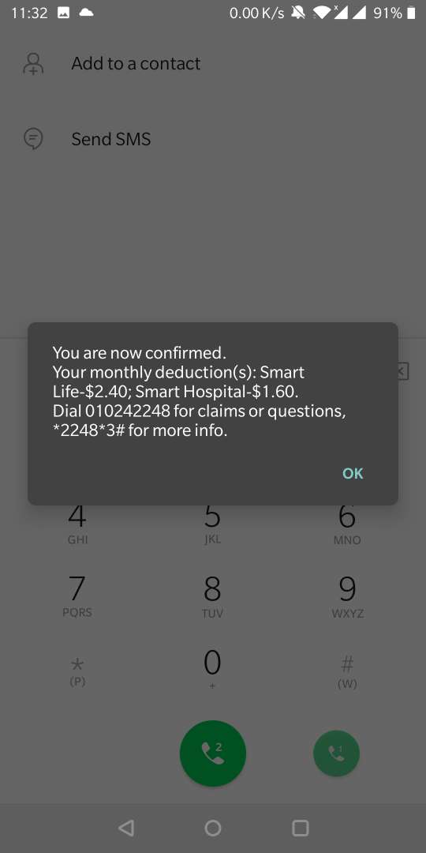

Get balance (*2248*4#):
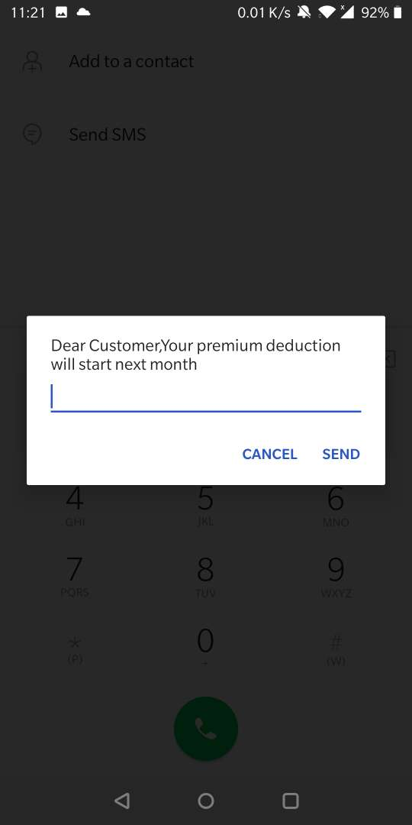

Terms and conditions (*2248*3#):
Customer is already registered for products , dials the USSD code (*2248*3#) for terms and conditions customer is displayed with below options on screen.
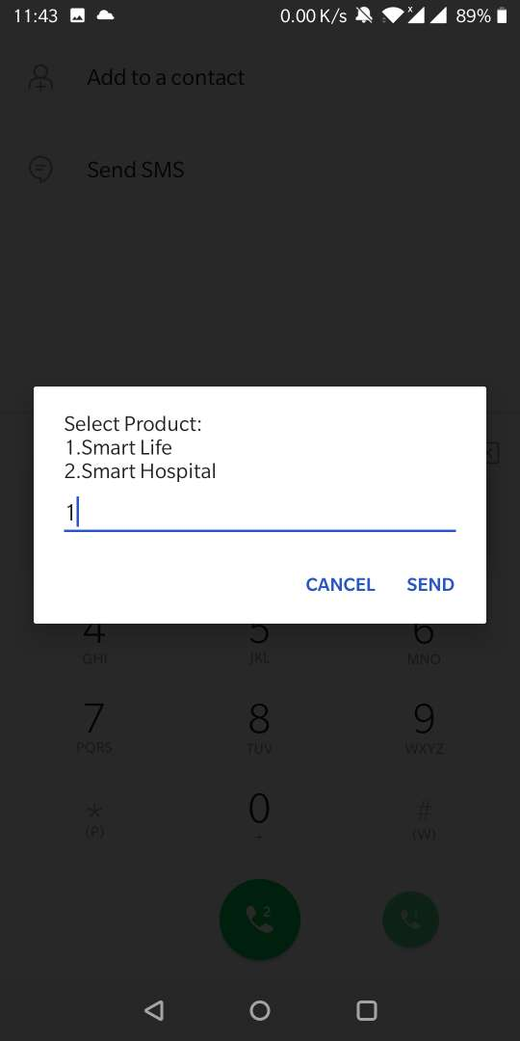

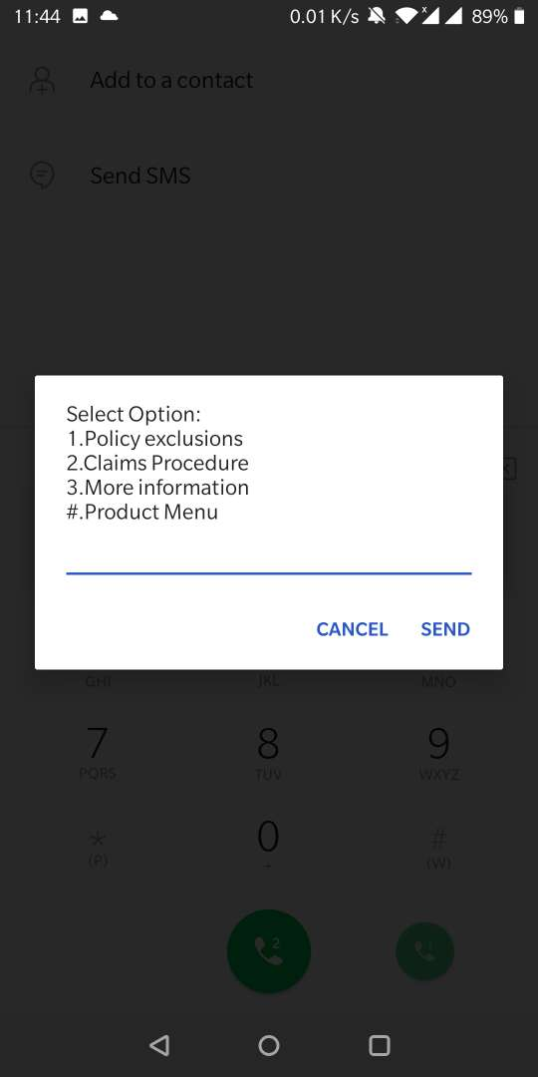

Customer on selecting option 1, the below screen is displayed.

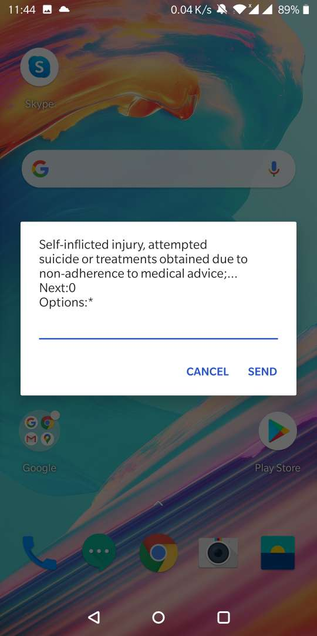

post live deployment observations:

Below are the observations and issues identified post live deployment of MIP Cambodia SMART side billing Migration(immediate deduction) with real-time subscription & unsubscription APIs,

1. Customer's not receiving the flash message on their handset screen - this issue is happening for some of the customers, not for all the customers. The issue at SMART end flash message, we have informed SMART team on this.

2. We are not receiving the Callbacks from SMART server to our instances - MIP sends the request to SMART server and for the confirmation, the customer responds to the flash message appeared on the handset, then are we getting notification/callbacks. We are getting notification only in case the customer confirms the flash. If they reject/timeout, we should get the Callbacks which we are not getting. The issue is happening with callbacks to reaching to our servers - troubleshooting in progress.

RollBack of KH Billing Migration Phase 2:

Below points are the current functionality in LIVE after rollback of KH Billing Migration Phase 2:
a. Disable confirm_customer menu in dashboard
b. Rollback older deduction jar from live
SmartBillingUpdateJob:
No insertions into Cover_history
Cover amount will not be updated in offer_subscription table.
For amount "Zero" in cdr file , record will get processed into main table with deducted_offer_amount=0.0000
For deductions happened current day in cdr_file , record will be inserted into cdr_info which will be processed into main tables the next day along with that day's file
c. Auto confirmation of Insured Relative on USSD confirmation by customer.
d. Registration SMS sendouts are enabled.
e. Rollback older ussd jar from live (USSD Confirmation)
f. SmartEventNotificationListener : Blocking of callBack and Notification request from Smart & only logging them and no DB actions.
g. Deregistration flow no changes

