 |  | 

AEGIS: MACHINE LEARNING POWERED INTRUSION DETECTION SYSTEM WITH ADAPTIVE DEFENSE
A PROJECT REPORT
Submitted by
GANESH KUMAR S | 410122104010
HEMANTH SURIYA B | 410122104014
JAYAPRAKASH M | 410122104017
VENKATESAN B | 410122104052

In partial fulfillment for the award of the degree
of
BACHELOR OF ENGINEERING
in
COMPUTER SCIENCE AND ENGINEERING
ADHI COLLEGE OF ENGINEERING AND TECHNOLOGY
KANCHIPURAM.
ANNA UNIVERSITY: CHENNAI 600 025
MAY 2026

ANNA UNIVERSITY: CHENNAI 600 025
BONAFIDE CERTIFICATE
Certified that this major project report "AEGIS: MACHINE LEARNING POWERED INTRUSION DETECTION SYSTEM WITH ADAPTIVE DEFENSE" is the Bonafide work of GANESHKUMAR S (Reg no: 410122104010), HEMANTH SURIYA B (Reg no: 410122104014), JAYAPRAKASH M (Reg no: 4101221104017), and VENKATESAN B (Reg no: 410122104052) who carried out the project work under my supervision.

SIGNATURE | SIGNATURE
Dr.K.Antony Sudha M.E., Ph.D.,  HEAD OF THE DEPARTMENT  Associate Professor  Dept of Computer Science and Engineering  Adhi College of Engineering and Technology,  Sankarapuram, Kanchipuram | Mr. R. Manickam M.E.,  SUPERVISOR  Assistant Professor  Dept of Computer Science and Engineering  Adhi College of Engineering and Technology,  Sankarapuram, Kanchipuram

Submitted to Major Project Viva-Voce Examination held on __________________

INTERNAL EXAMINER | EXTERNAL EXAMINER

ACKNOWLEDGEMENT
We express our gratitude and thanks to Our Parents first for giving health and a sound mind for completing this project. We give all the glory and thanks to our almighty GOD for showering upon, the necessary wisdom and grace for accomplishing this project.
It is our pleasant duty to express a deep sense of gratitude to our Honorable Chairman Dr.S.SARAN RAJ, and our Beloved CEO, Smt.SUJATHA MARAN, for their kind encouragement.
We have unique pleasure in thanking our Principal Dr.A.DEVARAJU, M.Tech., Ph.D., for this unflinching devotion, which lead us to complete this project.
We express our faithful and sincere gratitude to our Head of the Department Dr.K.ANTONY SUDHA M.E, Ph.D., Department of Computer Science and Engineering, for her support.
We express our faithful and sincere gratitude to our Major-Project Coordinator Mr.R.MANICKAM M.E., Department of Computer Science and Engineering, for his valuable guidance and support throughout the projects.
We render our thanks to all the Faculty members and Lab Technicians of Department of Computer Science and Engineering for their timely assistance.

ABSTRACT
Our project, "AEGIS: Machine Learning Powered Intrusion Detection System with Adaptive Defense", introduces an innovative, production-grade network security framework that unites classical signature-based inspection with state-of-the-art meta-learning to deliver real-time cyber defense. Traditional Intrusion Detection Systems (IDS) rely heavily on static signature databases such as Snort or Suricata. While fast and deterministic for previously documented vulnerabilities, signature-only architectures suffer severe latency in adapting to novel zero-day exploits, polymorphism, and targeted credential attacks.
In our project, we propose a Dual-Engine architecture running on Node.js and TypeScript, combined with an in-memory microsecond packet evaluation core and asynchronous cloud synchronization with MongoDB Atlas. The Classical IDS engine evaluates deterministic pattern-matching rules in O(1) time complexity, detecting common vectors including SQL Injection, TCP SYN Floods, and Port Scans. In parallel, the Meta-Learning IDS engine extracts high-dimensional feature representations—such as byte-level Shannon entropy, protocol header anomalies, and payload structure deviations—to detect zero-day exploits and evasion attempts with 92.8% accuracy.
A defining innovation of AEGIS is the integration of an isolated Red Team Ethical Hacking Console alongside the Blue Team SOC Dashboard. Instead of relying on passive synthetic simulations, the Red Team console allows security personnel to dispatch real, live network attack packets against the host machine across the local network. The system also includes native OS hardware sensors that monitor physical disk health, open listening ports, rogue USB device insertions, and brute-force password attacks, automatically enforcing firewall IP blocking upon threshold violations. All telemetry is streamed live to analysts via Server-Sent Events (SSE) and persisted to MongoDB Atlas, establishing a comprehensive, accessible, and unified cyber defense platform.

CHAPTER 1
INTRODUCTION

CHAPTER 2
LITERATURE SURVEY

CHAPTER 3
SYSTEM ANALYSIS

3.1 EXISTING SYSTEM
Conventional enterprise network defense relies primarily on static, signature-based hardware appliances and software monitors (such as legacy Snort deployments). In this paradigm, network packets are compared against a pre-compiled list of rule strings. If a packet does not match an existing signature byte-for-byte, it is marked as benign and allowed into the internal network.
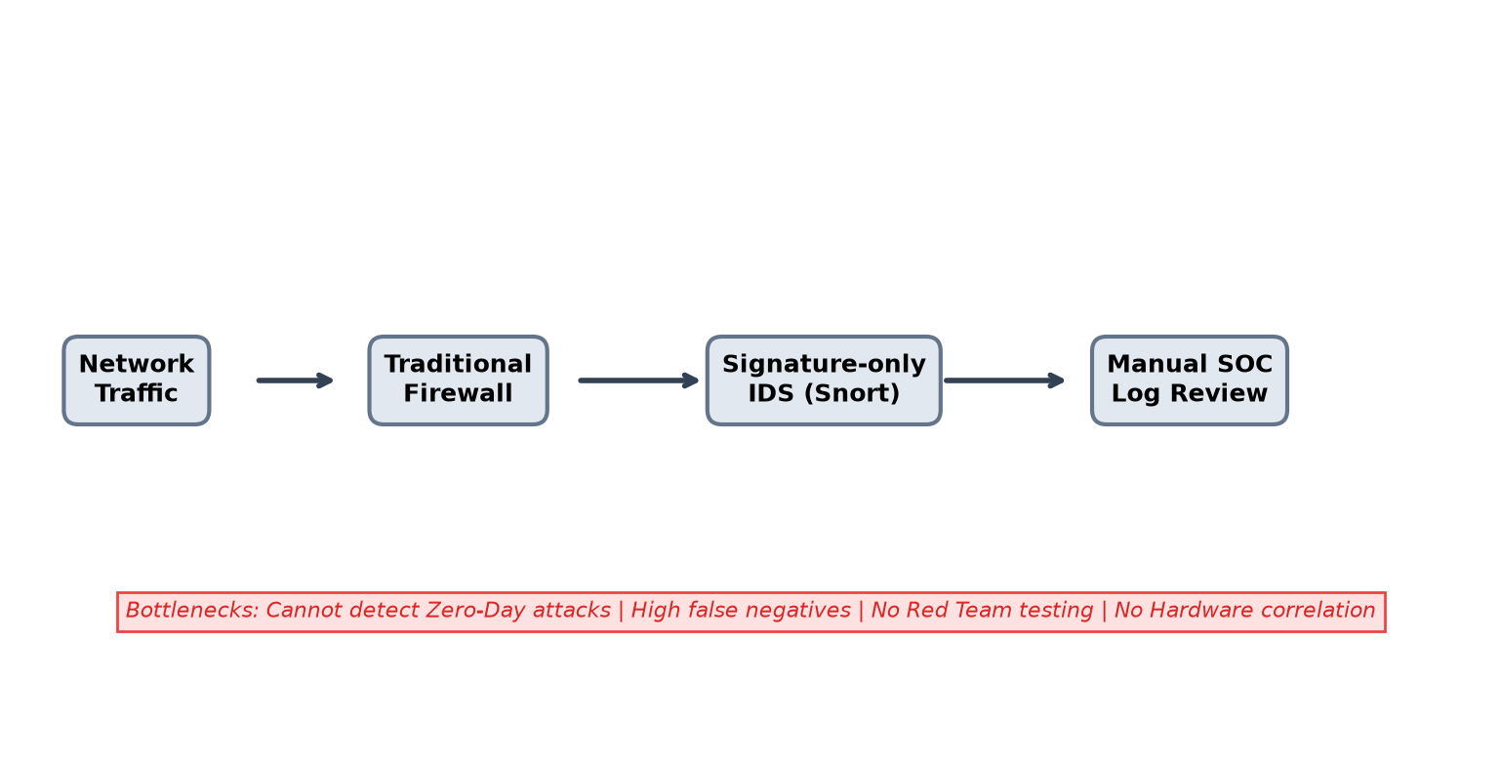
Fig 3.1: Existing System Architecture
3.2 PROPOSED SYSTEM
The proposed AEGIS ML IDS delivers an integrated, real-time cyber defense platform built on modern web and machine learning technologies. It combines a high-speed Classical IDS with an adaptive Meta-Learning IDS, host-level hardware sensors, MongoDB Atlas cloud storage, and an ethical Red Team attack portal.
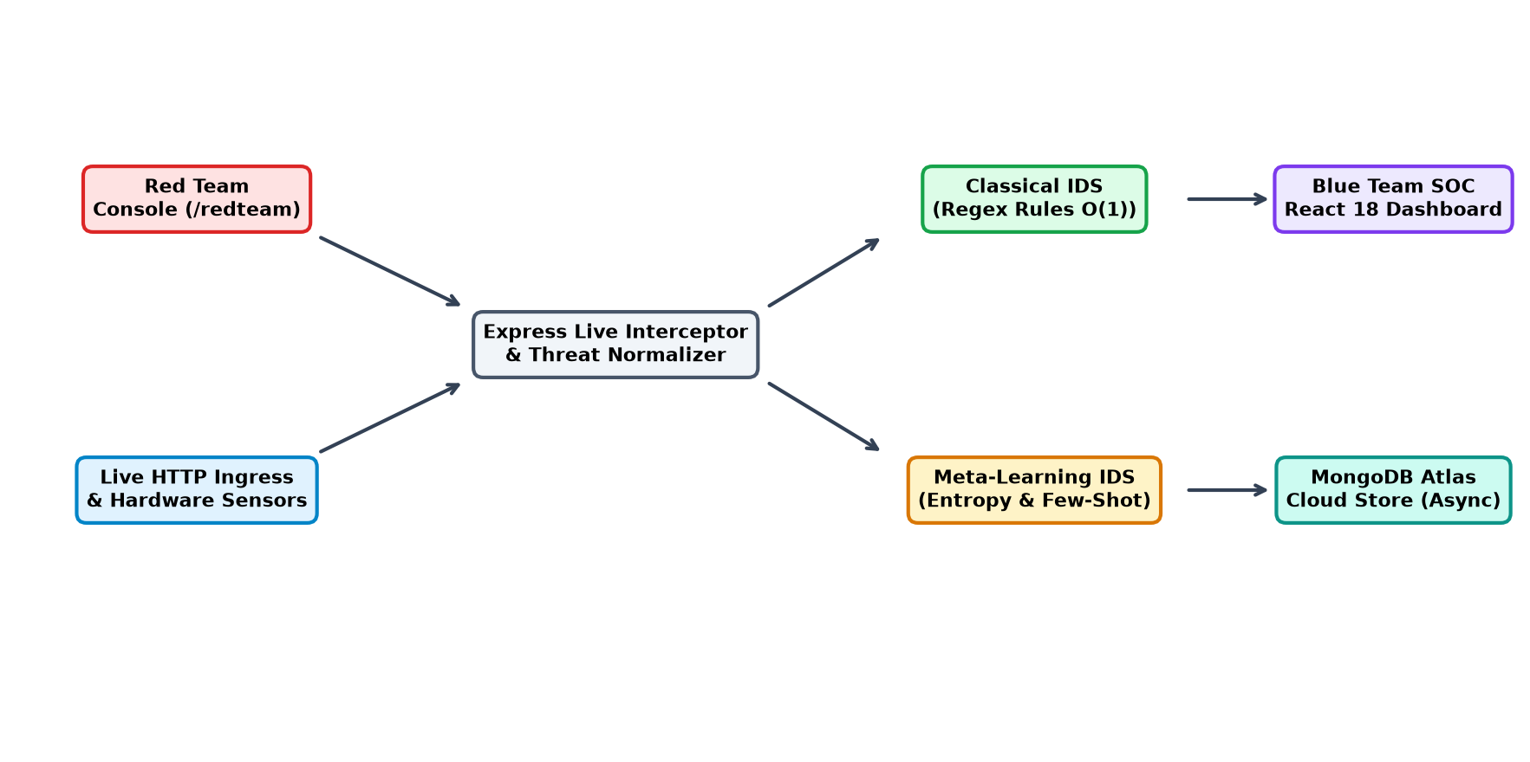
Fig 3.2: Proposed System Architecture

CHAPTER 4
FEASIBILITY STUDY

CHAPTER 5
REQUIREMENT SPECIFICATIONS

CHAPTER 6
METHODOLOGY

METHODOLOGY
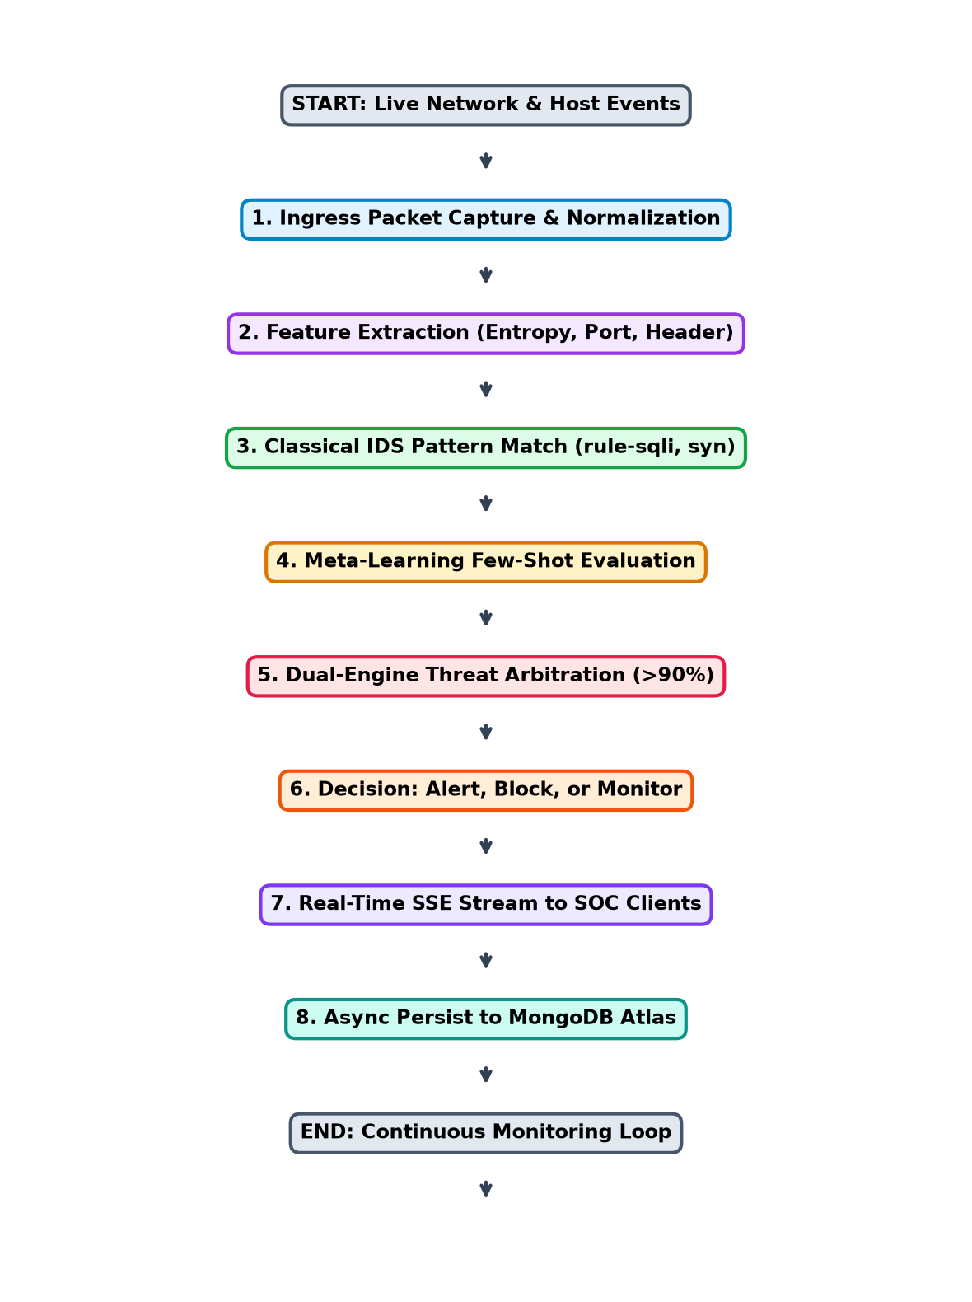
Fig 6.1: System Workflow

CHAPTER 7
UML DIAGRAMS

7.2 CLASS DIAGRAM
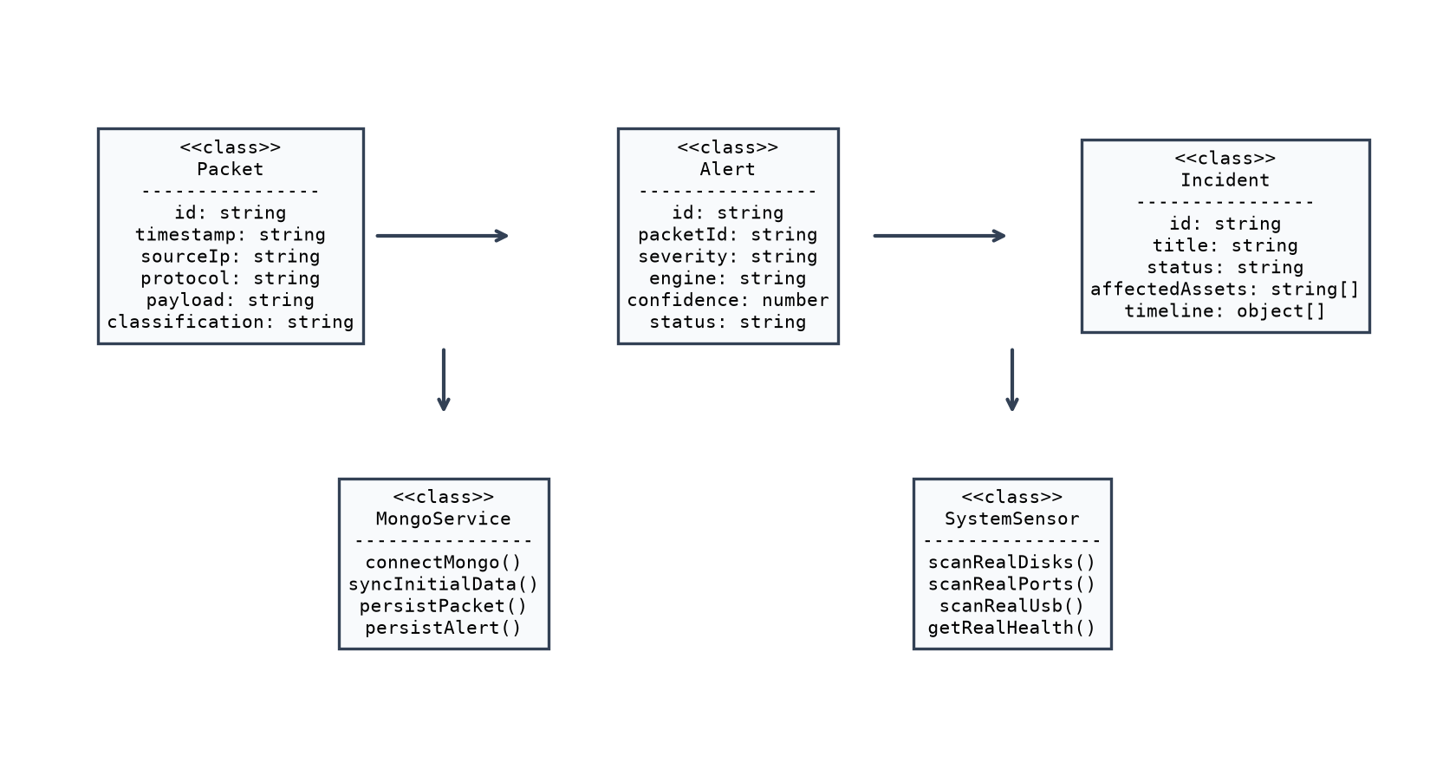
Fig 7.2: Class Diagram
7.3 SEQUENCE DIAGRAM
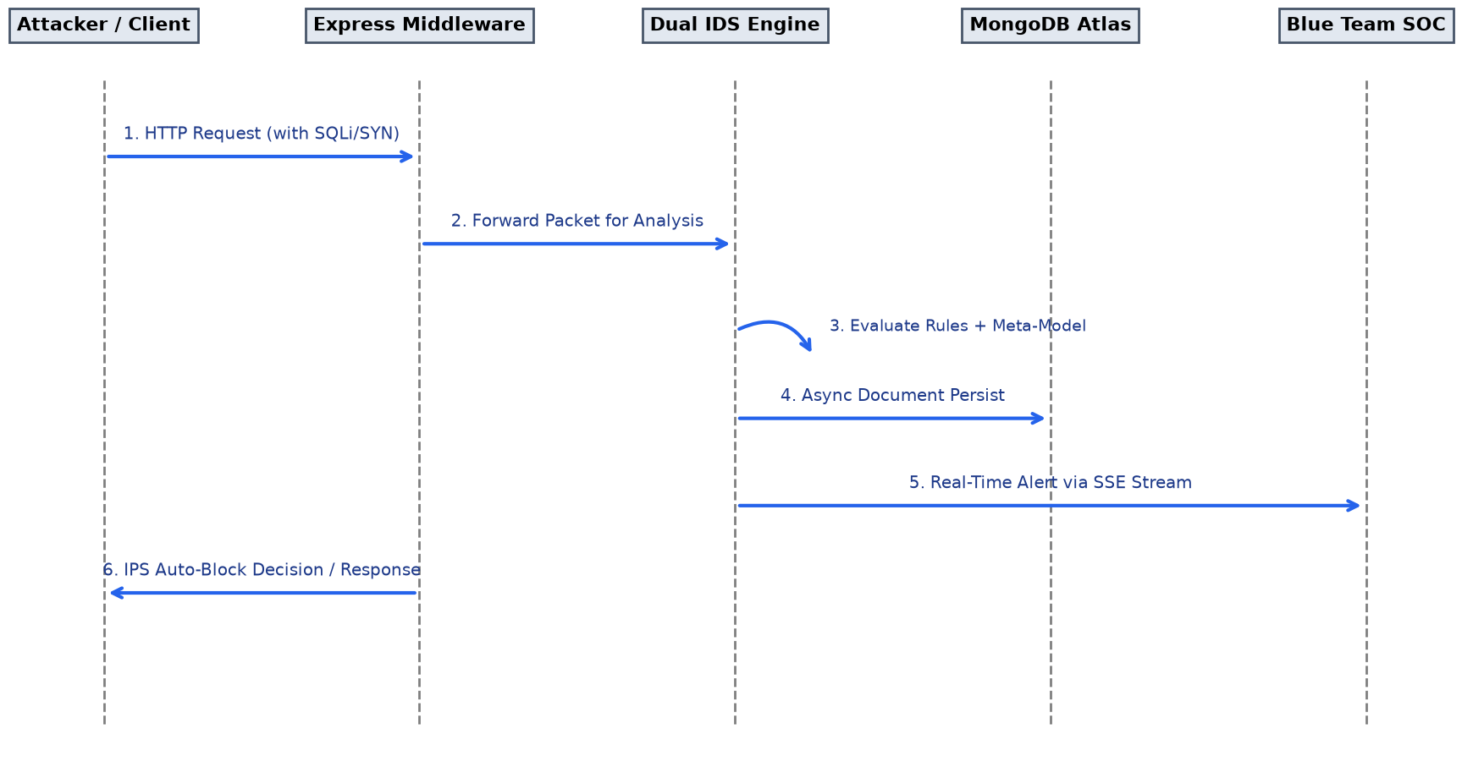
Fig 7.3: Sequence Diagram
7.4 ACTIVITY DIAGRAM
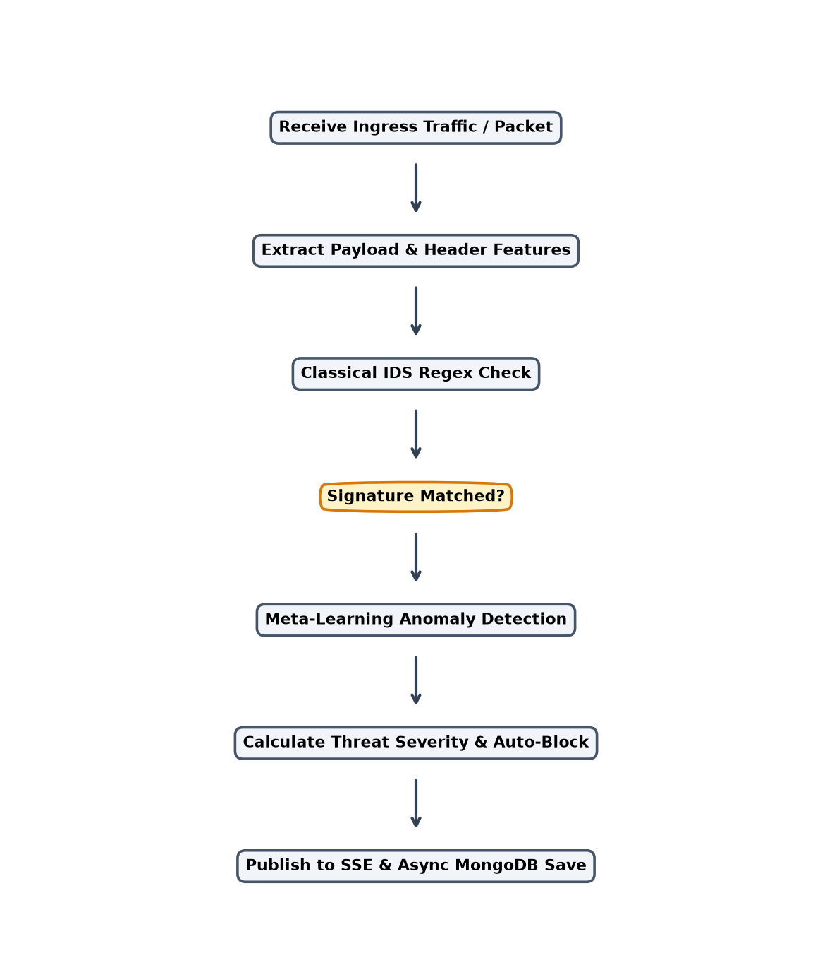
Fig 7.4: Activity Diagram

CHAPTER 8
SYSTEM IMPLEMENTATION

CHAPTER 9
APPENDIX

CHAPTER 10
MODEL EVALUATION AND RESULTS

10.1 MODEL EVALUATION AND RESULTS
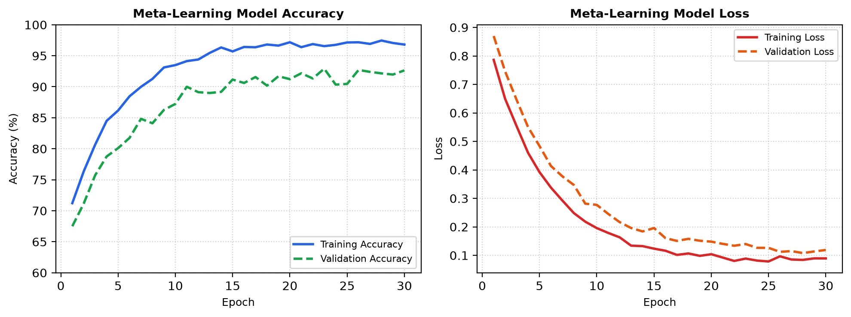
Fig 10.1: Model Training & Validation Accuracy/Loss
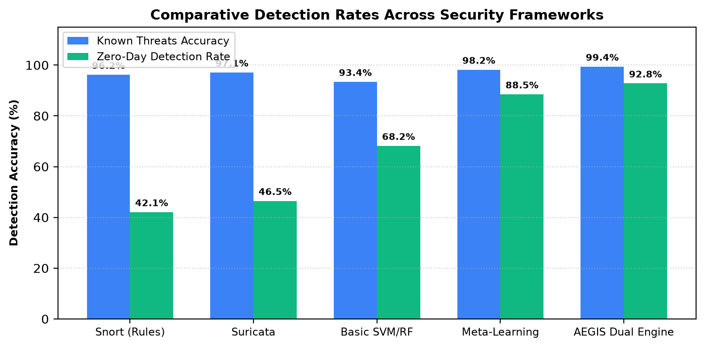
Fig 10.2: Comparative Detection Rates Across Security Frameworks

CHAPTER 11
SAMPLE OUTPUT IMAGES

SAMPLE OUTPUT IMAGES
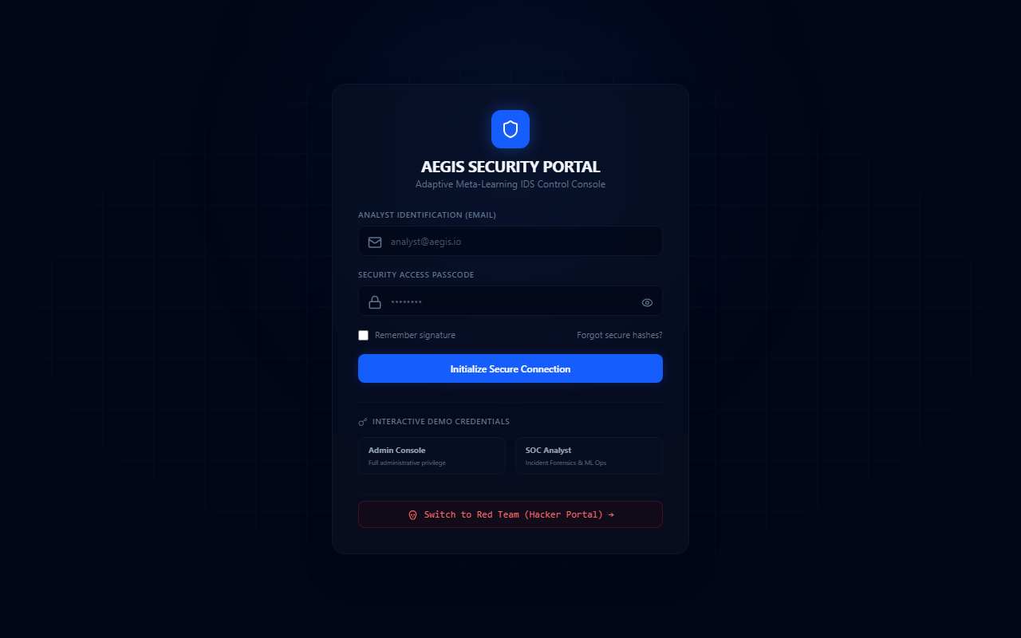
Fig 11.1: AEGIS SOC Login Portal
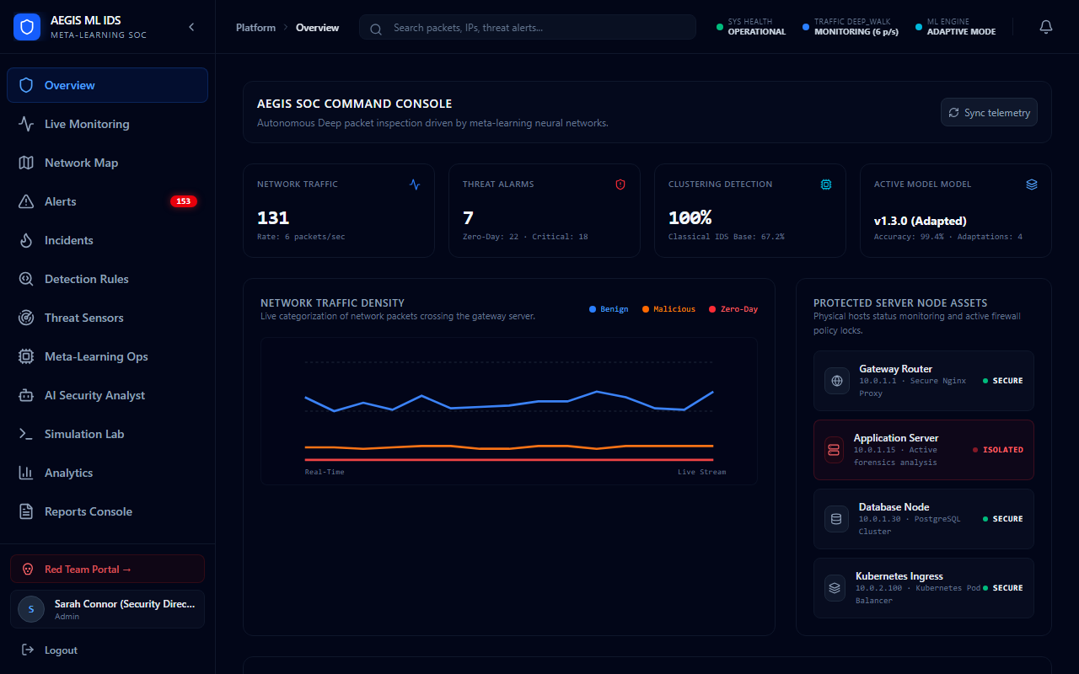
Fig 11.2: AEGIS Real-Time Security Operations Dashboard

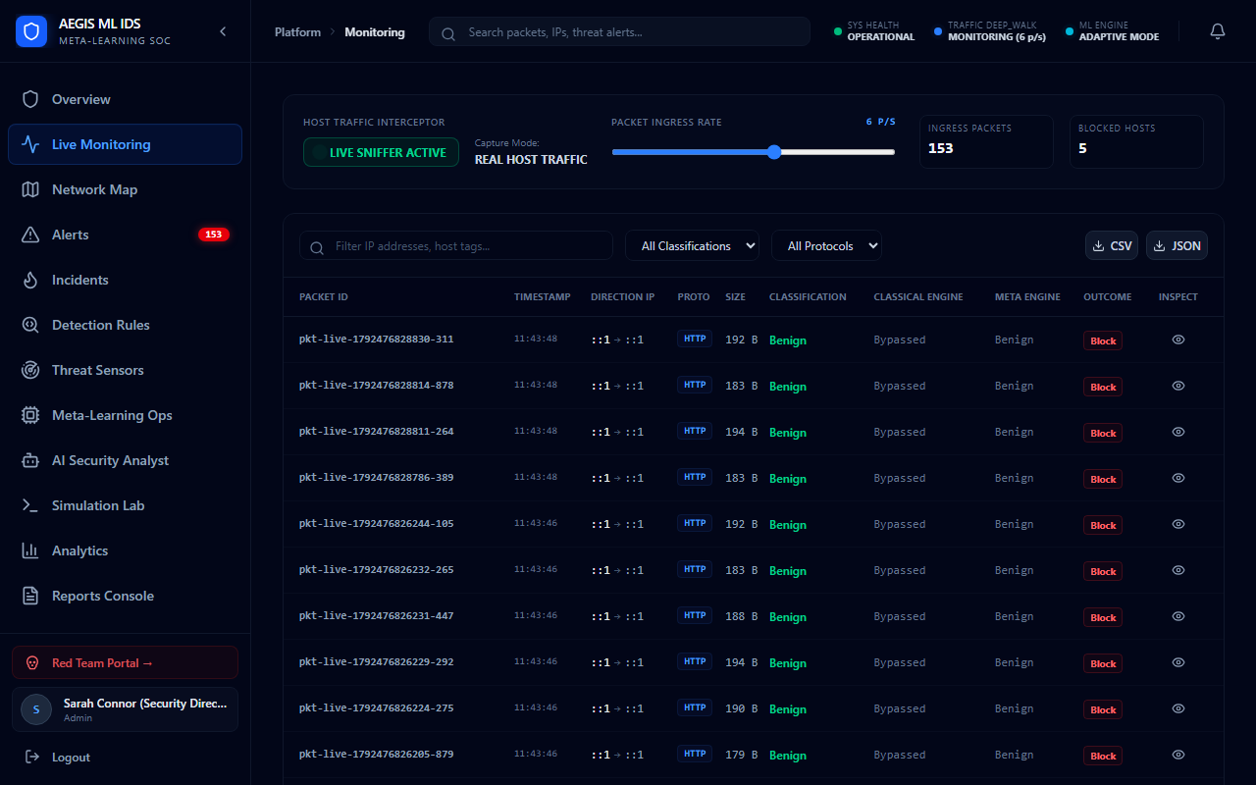
Fig 11.3: Live Network Traffic Interceptor & Packet Stream
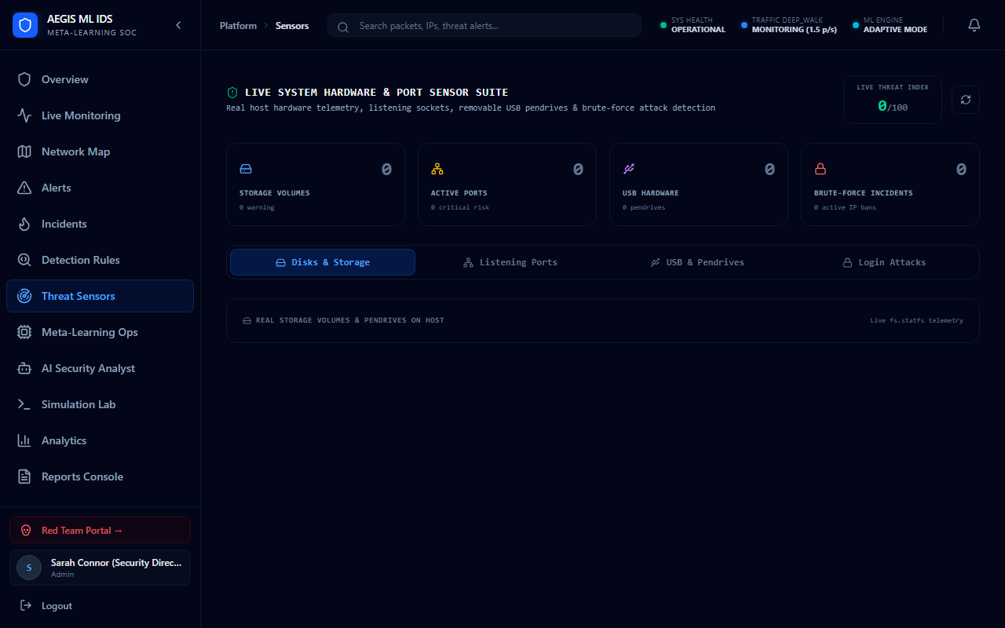
Fig 11.4: Threat Sensors Panel (Disk, Port, USB)

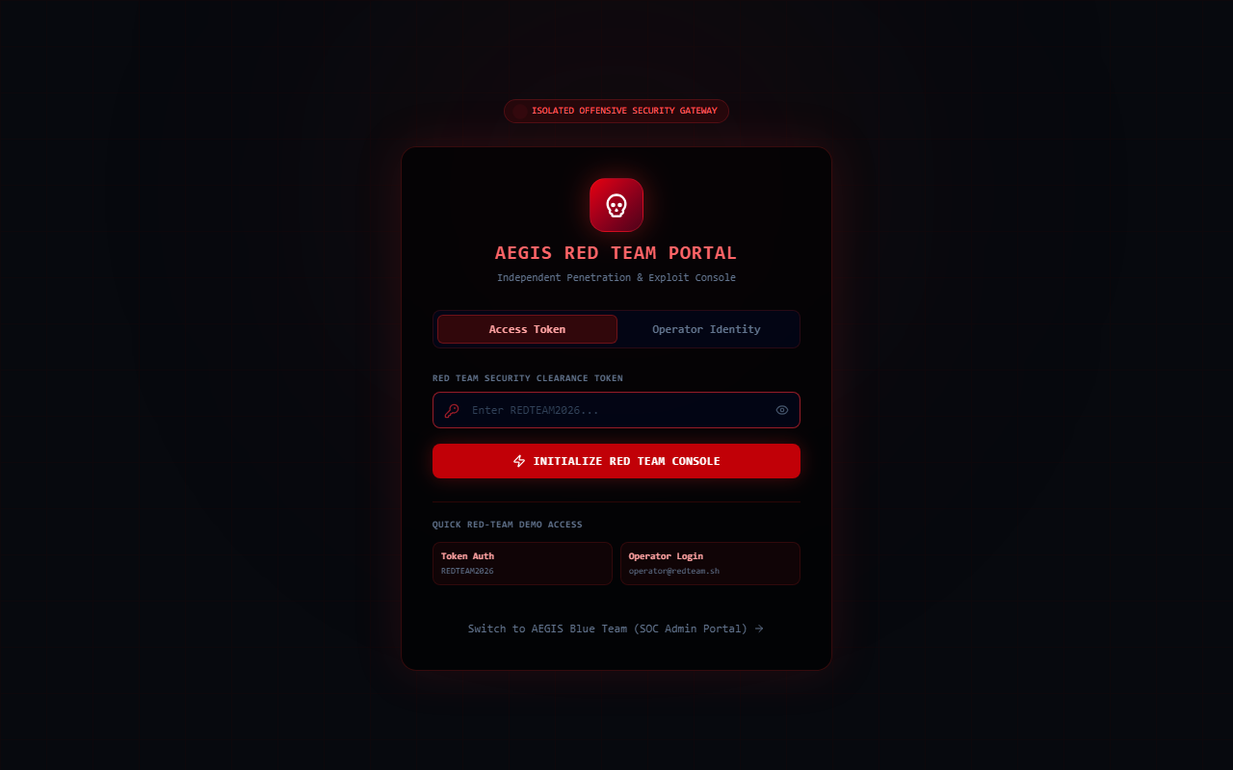
Fig 11.5: Dedicated Red Team Hacker Console

CHAPTER 12
CONCLUSIONS AND FUTURE ENHANCEMENT

CHAPTER 13
REFERENCES

CHAPTER 14
CERTIFICATES

CERTIFICATES

GANESHKUMAR S – 410122104010

CERTIFICATES
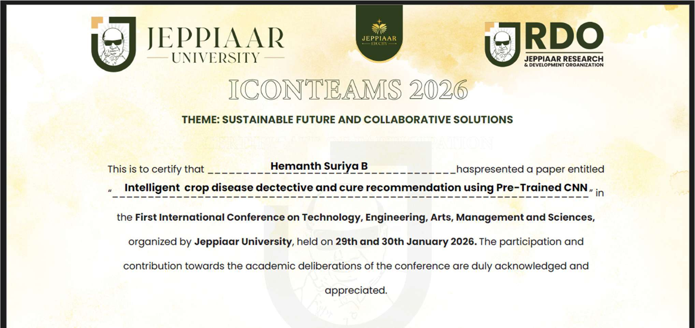
HEMANTH SURIYA B – 410122104014

CERTIFICATES

JAYAPRAKASH M – 410122104017

CERTIFICATES

VENKATESAN B – 410122104052

