Digital Asset Management (DAM) and Tasks Execution Guide

**Applying CSS Styling**

To ensure proper styling, inspect the page using **Developer Tools (F12) > Elements Tab** and verify the following styles:

h2 { color: green; }

p { color: yellow; }

.date { color: black; }

**Steps to Apply CSS in AEM:**

1. **Locate the Component’s CSS File:** Navigate to **ui.frontend → clientlibs → your-component → css/style.css**.
2. **Apply the CSS Styles:** Add the styles inside the appropriate CSS file:
3. h2 { color: green; }
4. p { color: yellow; }
5. .date { color: black; }
6. **Ensure the Styles Are Loaded:** Verify that the **CSS client library** is included in your component’s HTML file:
7. <cq:includeClientLib categories="your-component"/>
8. 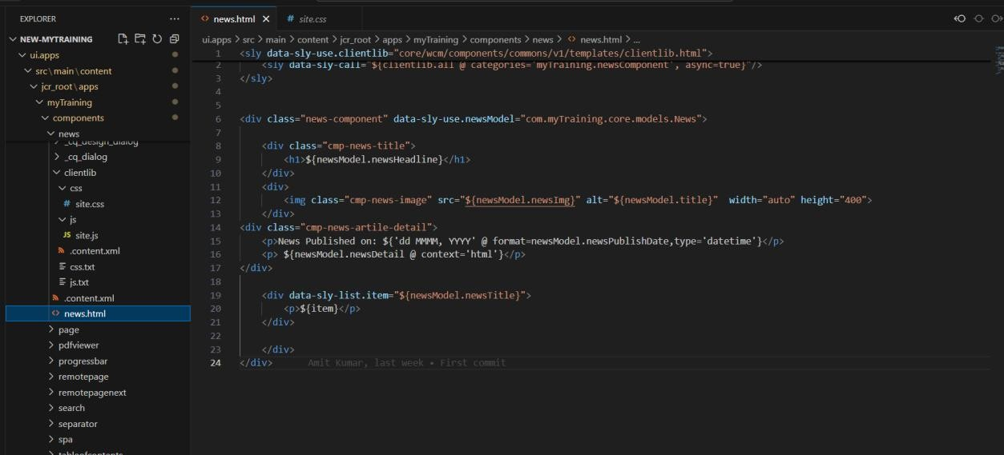**Check in Browser:** Open **Developer Tools (F12) > Elements Tab** and confirm that **Heading (<h2>)** is **green**, **News details (<p>)** are **yellow**, and **Date** is **black**.

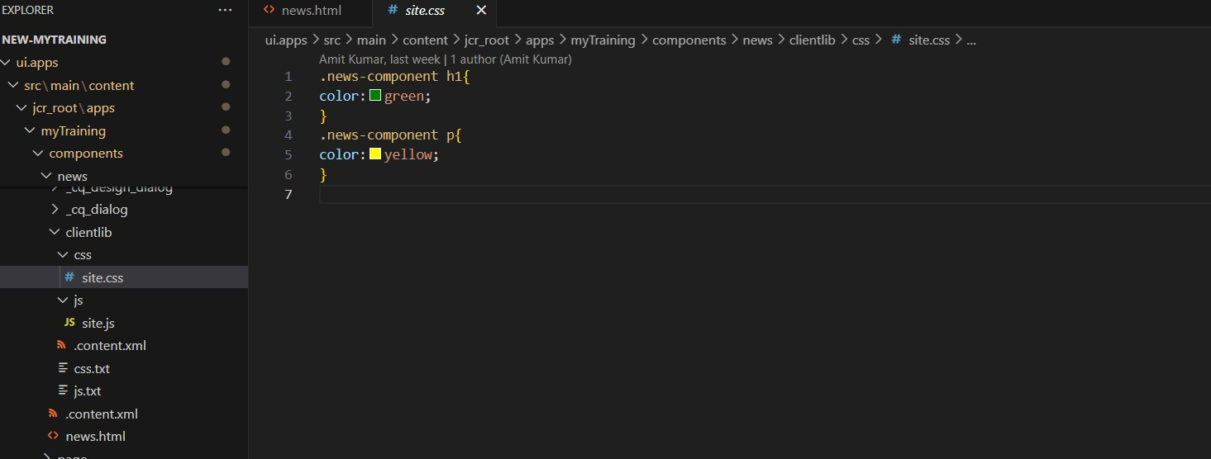

8. Extra ClientLibs (extraClientLibs) How to Check:

• Open the multi-field component’s HTL (HTML Template Language) file.

