Digital Asset Management (DAM) and Tasks Execution Guide

**Steps to Check Custom Workflow in AEM**

1. **Verify Workflow Model:**
   * **Navigate to AEM Start → Tools → Workflow → Models.**
   * **Ensure "my custom workflow" is listed.**
   * **Open it and confirm that the custom workflow process step is properly configured.**
2. **Trigger the Workflow on a Page:**
   * **Go to AEM > Sites and select a page.**
   * **Click on Page Properties → Start Workflow.**
   * **Choose your custom workflow and start it.**
3. **Check Logs:**
   * **Open AEM error.log file located at crx-quickstart/logs/error.log.**
   * **Look for log statements that print the page title to confirm execution.**

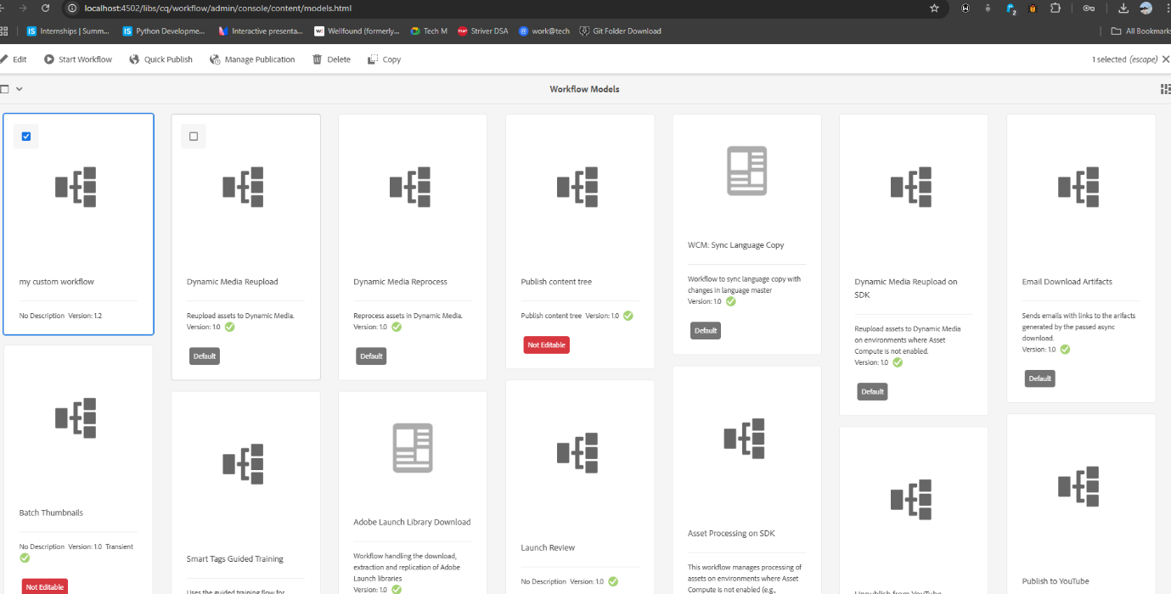

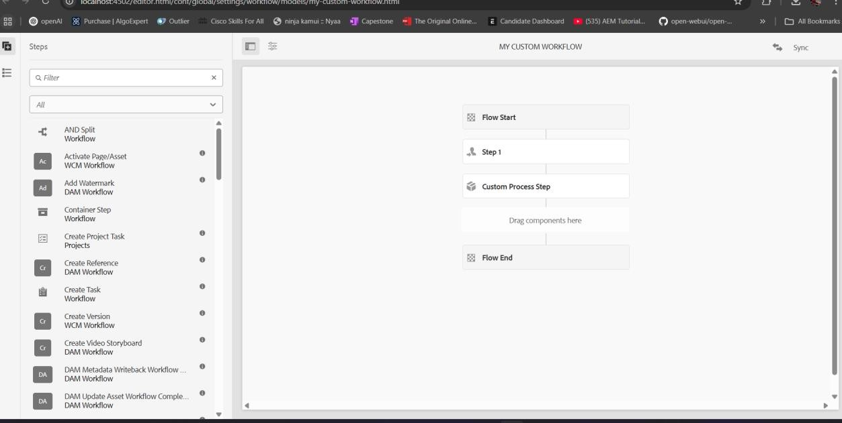

1. Verify Event Handler Execution Steps to Check:
   * Perform an action that triggers the event (e.g., creating, modifying, or deleting a page or an asset).

Check Logs:

* + Open error.log and look for log messages related to the resource path.

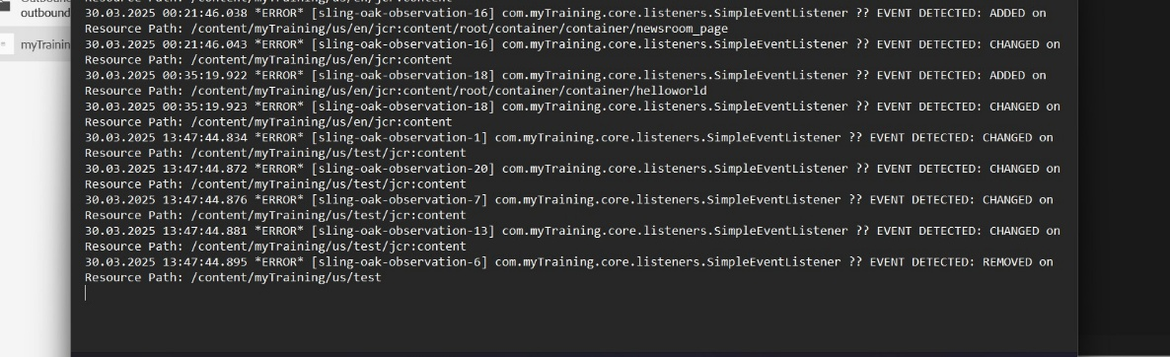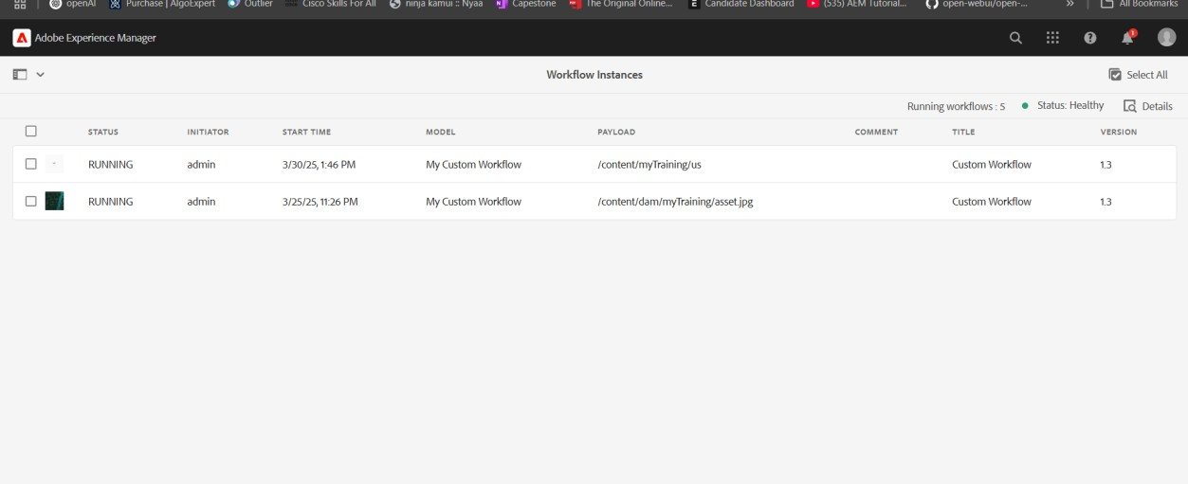

Verifying Sling Job Execution in AEM

## 1. Create the Sling Job Handler:

## Custom Sling Job Handler (HelloWorldJobHandler.java):

## Path: /apps/newsroom/core/jobs/HelloWorldJobHandler.java

## package com.newsroom.core.jobs;

## import org.apache.sling.api.servlets.SlingAllMethodsServlet;

## import org.apache.sling.api.resource.Resource;

## import org.apache.sling.api.resource.ResourceResolver;

## import org.slf4j.Logger;

## import org.slf4j.LoggerFactory;

## @Component(service = JobHandler.class, immediate = true)

## public class HelloWorldJobHandler implements JobHandler {

## private static final Logger LOG = LoggerFactory.getLogger(HelloWorldJobHandler.class);

## @Override

## public void execute(JobExecutionContext context) {

## LOG.info("Hello World from Sling Job!");

## }

## }

## 2. Schedule the Job:

## o This job can be triggered through the Sling Job Scheduler. You can configure

it through AEM's OSGi console or create a scheduled job trigger.

Steps to Check:

1. Navigate to Jobs Console:
   * Go to AEM Start → Tools → Operations → Jobs.
   * Ensure your custom Sling Job appears in the list.
2. Check Logs:
   * Open error.log file located at crx-quickstart/logs/error.log

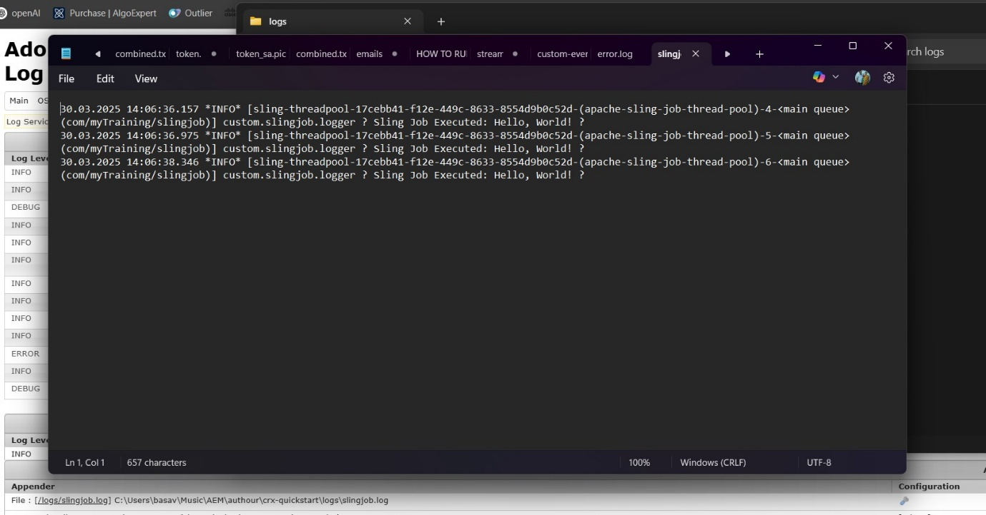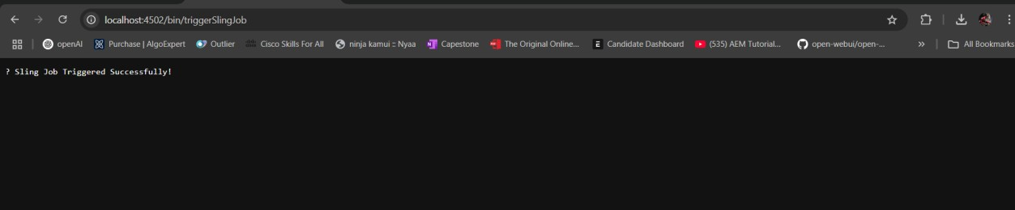

1. Verify Scheduler Execution Steps to Check:
   * Wait for 5 minutes after deploying the scheduler.
   * Check Logs: o Open error.log and look for "Yellow World" printed at every 5-minute interval.

Expected Output in Logs:

Yellow World printed by Scheduler

1. Verify User Group & Permissions Steps to Check:
   * Go to AEM Start → Tools → Security → Groups.
   * Find "Dev Author" group and open it.
   * Ensure the three users are added.
   * Check Permissions:
     + Go to /useradmin (http://localhost:4502/useradmin). o Select the group and verify Read access is set for /content and /dam.
     + Ensure Replication Access is enabled under Replicator Permissions.

Test Permissions by Logging in as a User in the Group

* + Login with one of the created users.
  + Try to view a page under /content and an asset in /dam.
  + Try editing or deleting content (should be restricted).
  + 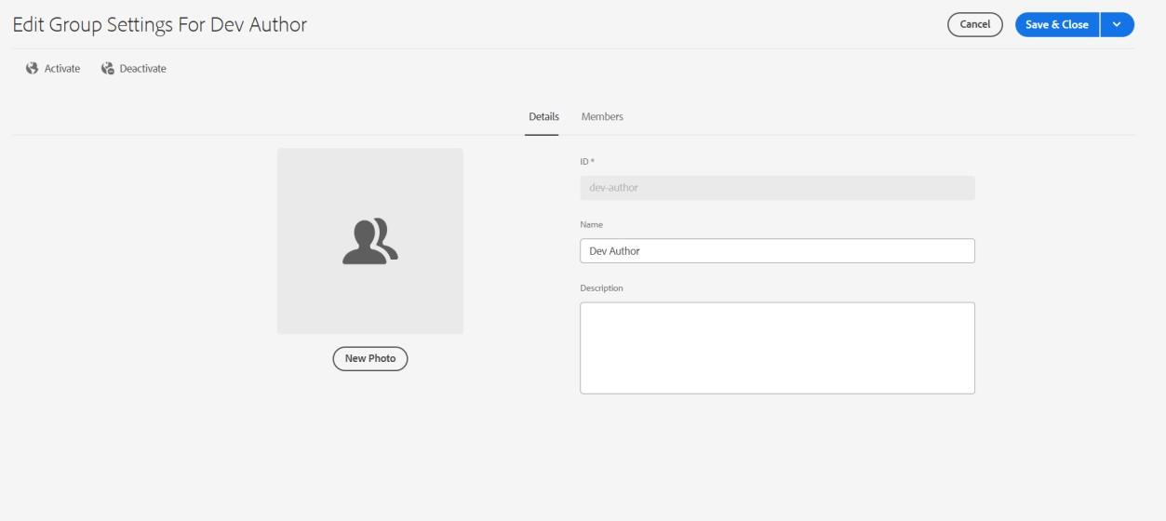Try replicating content (should be allowed).

