Digital Asset Management (DAM) and Tasks Execution Guide

1. SampleServlet (resourceType-based registration) Check Output:
   * URL Format: http://localhost:4502/content/samplepage.sample.json • Replace samplepage with the actual page where you registered the servlet.
   * If it returns the expected JSON response, the servlet is working.

1. CreatePageServlet (Registered via path) Check Output:

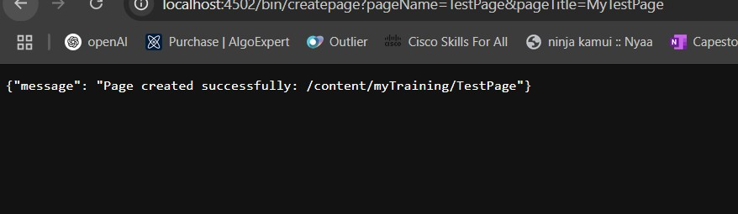

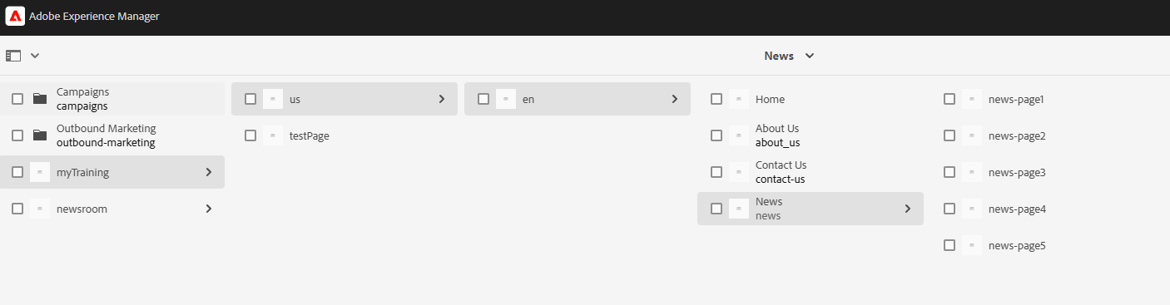

1. Page Creation Using PageManager API Check Output:
   * Steps:

1. Run CreatePageServlet (Step 2).

Page created:

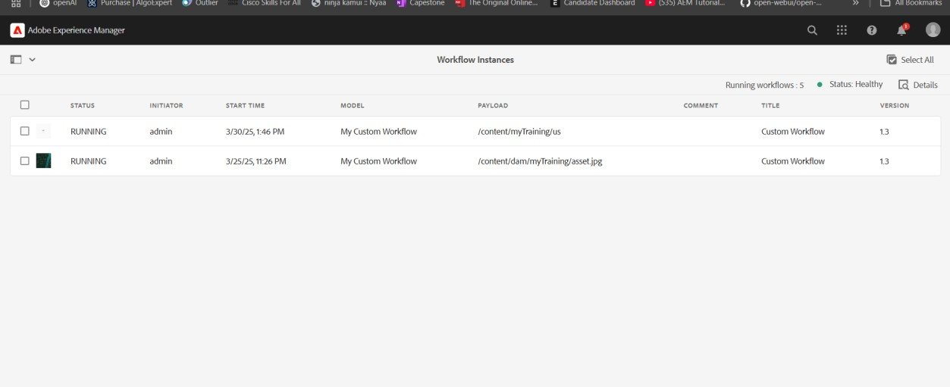

1. SearchServlet (PredicateMap-based search)

