**Q: Create your first repository, then add and commit files.**

**Ans:** Created gitexam repo

**Q: Verify that you have Git installed**

**Ans:**

**Q: Initialize the git repo.**

**Ans:**

**Q: Configure your username and email address.**

**Ans:**

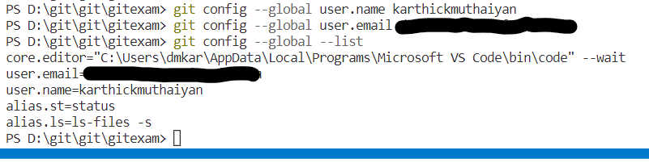

**Q: Create a Repository from GUI with Readme file.**

**Q: Generate the Personal Token from Github GUI.**

**Ans:**

**Q: Clone a repository on local laptop**

**Ans:**

**Q: Please make the default branch 'master'**

**Ans:**

**Q: Create 2 files index.html and welcome.txt (with some text) using vi editor and save the files.**

**Ans:**

**Q: Add proper tags (try from both from GUI and CLI)**

**Ans:**

**From:CLI**

**From: GUI**

**Q: Add newly created files in git metadata.**

**Ans:**

**Q: Commit the changes in Git with proper commit message (show both option nano and direct command line)**

**Ans:**

**Q: Check all the logs that should display all your commits with the author and hash.**

**Ans:**

**Q: Push a specific object to a remote branch.**

**Ans:**

**Send only the index file commit to remote repo**

**Q: Next try Pushing all the changes to a remote branch.**

**Ans:**

**Q: Create one new feature branch 'development'.**

**Ans:**

**Q: Create more branches in the same wayoutl0strokewidth0**

**Ans:**

**Q: Switch to Development branch.**

**Ans:**

**Q: Modify 2 files index.html and welcome.txt (with some text) using vi editor and save the files.**

**Ans:**

**Q: Add the changes into git metadata.**

**Ans:**

**Q: Stage All Changes to Files.**

**Ans:**

**Q: Switch the branch to master.**

**Ans:**

**Q: Make some changes in master files and switch back to development branch.**

**Ans:**

**Q: Add one more file dev_file.txt in development branch.**

**Ans:**

**Q: See the difference using git diff command (Should show unstaged changes on the current branch from the commit before it ).** **Validate the same.**

**Ans:**

**Q: Create more branches in the same way**

**Ans:**

**Q: Commit everything and merge everything in master branch.**

**Ans:**

**This assuming by stage it was meant commit**

**First we merged Main changes to Dev to resolve any conflicts**

**Then merged dev to master and committed the new file in master .**

**Q: Delete local and remote branches**

**Ans:**

