Home Assignments
1) Use Bugmagnet and Fake filler extension for form filling
2) Use grammarly extension to correct the mistakes in your content
3) Vibe Coding Generate Playwright Typescript 0r (any tool with language binding in which you are working)

1 Fake Filler

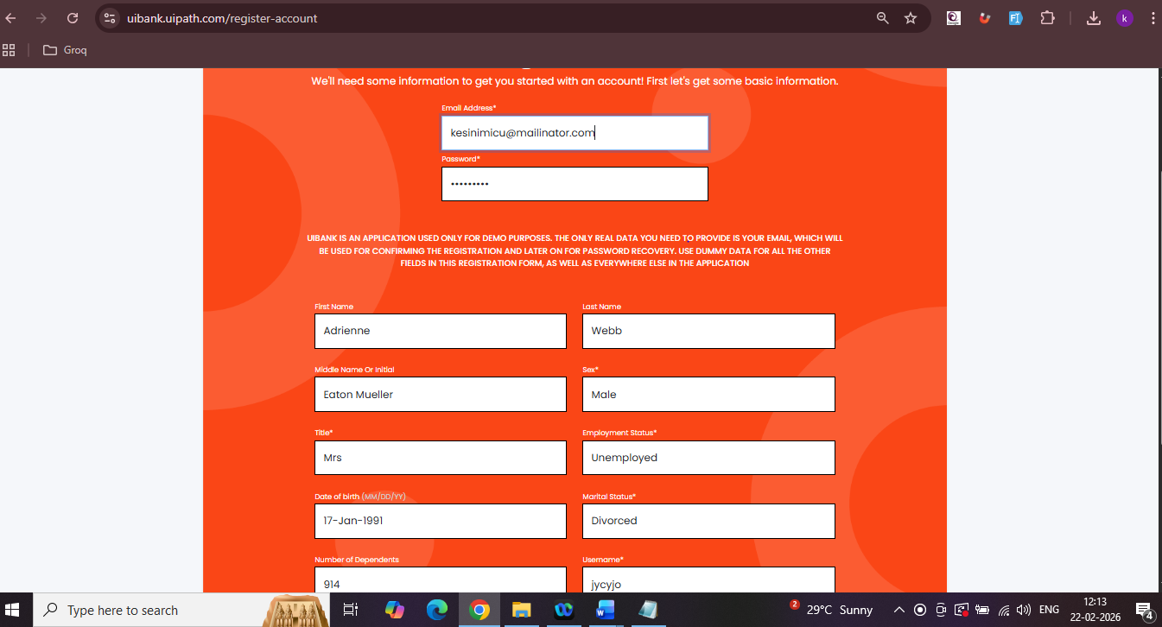

2.Grammarly extension

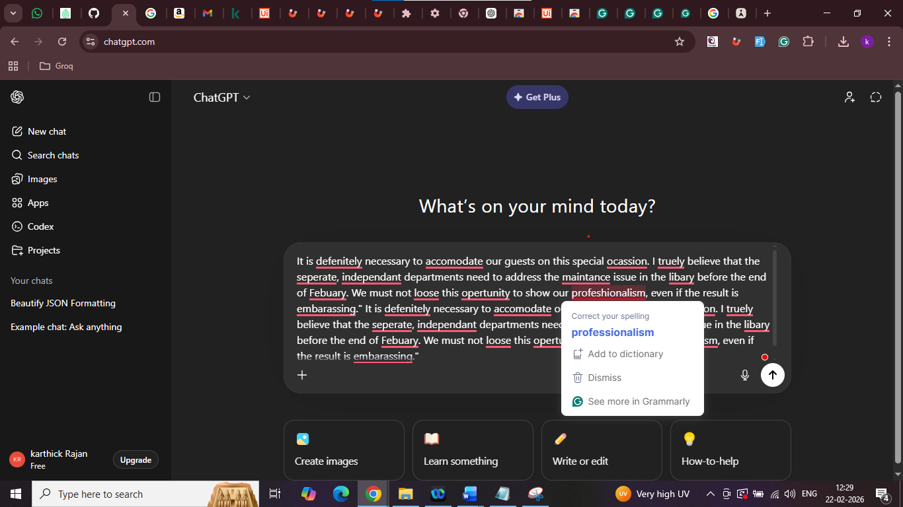

3. ) Vibe Coding Generate Playwright Typescript 0r (any tool with language binding in which you are working)

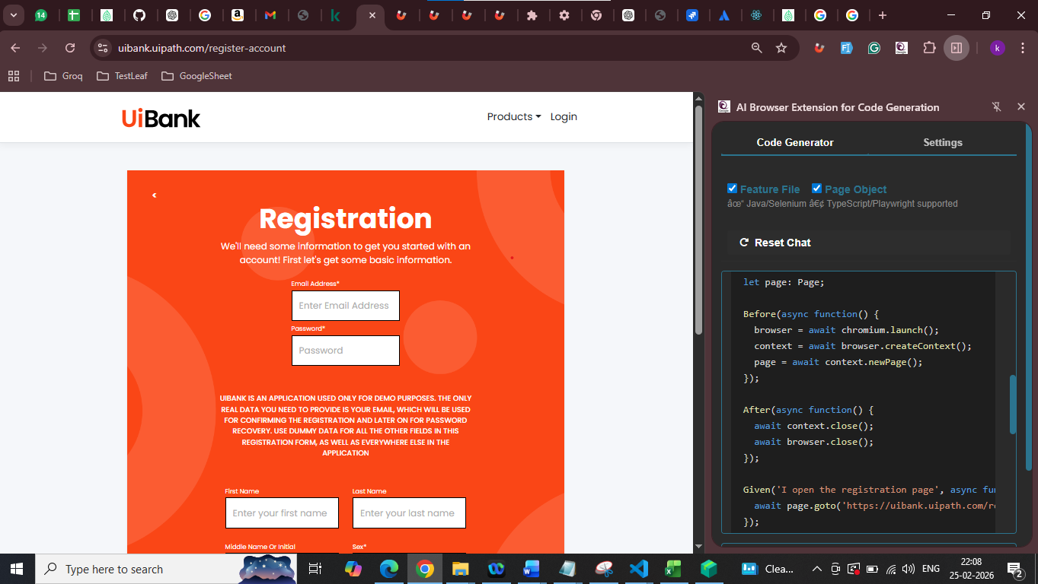

Code GeneratorSettings
Feature File Page Object
âœ“ Java/Selenium â€¢ TypeScript/Playwright supported
Reset Chat

Feature: Register Account on UIBank

Scenario Outline: Successful registration with valid credentials
Given I open the registration page
When I type "<email>" into the Email Address field
And I type "<password>" into the Password field
And I click the Register button
Then I should be registered successfully

Examples:
| email | password |
| "siva.kumar@gmail.com" | "Siva@123"|
| "ravi.shankar@gmail.com"| "Ravi@123"|
| "kumar.ganesh@gmail.com"| "Kumar@123"|

import { Given, When, Then, Before, After, setDefaultTimeout } from '@cucumber/cucumber';
import { chromium, Browser, BrowserContext, Page } from '@playwright/test';
import { expect } from '@playwright/test';

setDefaultTimeout(30 * 1000);

let browser: Browser;
let context: BrowserContext;
let page: Page;

Before(async function() {
browser = await chromium.launch();
context = await browser.createContext();
page = await context.newPage();
});

After(async function() {
await context.close();
await browser.close();
});

Given('I open the registration page', async function() {
await page.goto('https://uibank.uipath.com/register-account');
});

When('I type {string} into the Email Address field', async function(email: string) {
const emailField = page.locator('#email');
await emailField.waitFor({ state: 'visible', timeout: 5000 });
await emailField.fill(email);
});

When('I type {string} into the Password field', async function(password: string) {
const passwordField = page.locator('#password');
await passwordField.waitFor({ state: 'visible', timeout: 5000 });
await passwordField.fill(password);
});

When('I click the Register button', async function() {
// Since the provided HTML does not contain a register button,
// we will assume it's a button with the text "Register"
const registerButton = page.locator('button:has-text("Register")');
await registerButton.click();
});

Then('I should be registered successfully', async function() {
// Since the provided HTML does not contain a success message,
// we will assume it's a div with the class "success"
const successMessage = page.locator('.success');
await expect(successMessage).toBeVisible({ timeout: 5000 });
});
Copy
InspectGenerate

3. Add Connect to Jira button in UI

