**User’s Documentation**

**Team BMW**

**Web Users**

**Home page:**

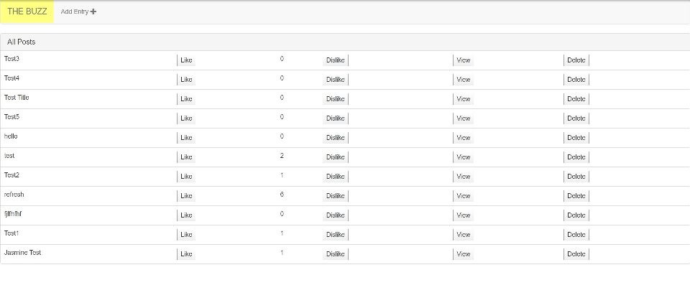

**Our home page displays a list of posts with their titles , counts of “likes”, and view and delete buttons.**

**Add Entry:**

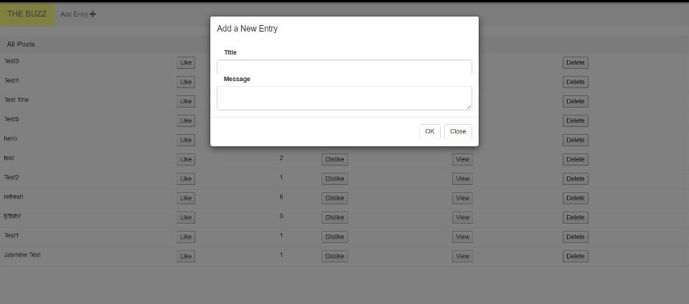

**To post a new message on the webpage, we should first click on the “Add Entry” button on the upper left corner. Then fill in the title and message. Then click on “OK” to post the message.**

**Edit Entry:**

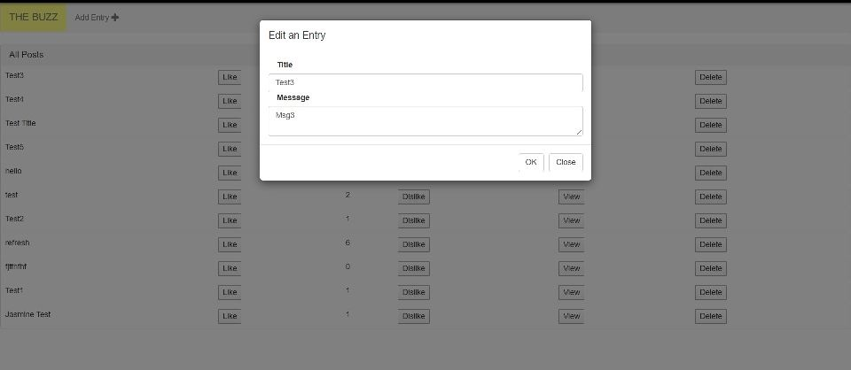

**To edit an existing entry on the website, click on the title of the post. Then fill in the new title and messages. Save the changes by clicking on the “OK” button, discard the changes by clicking on “Close” button.**

**Android Users**

**Home page:**

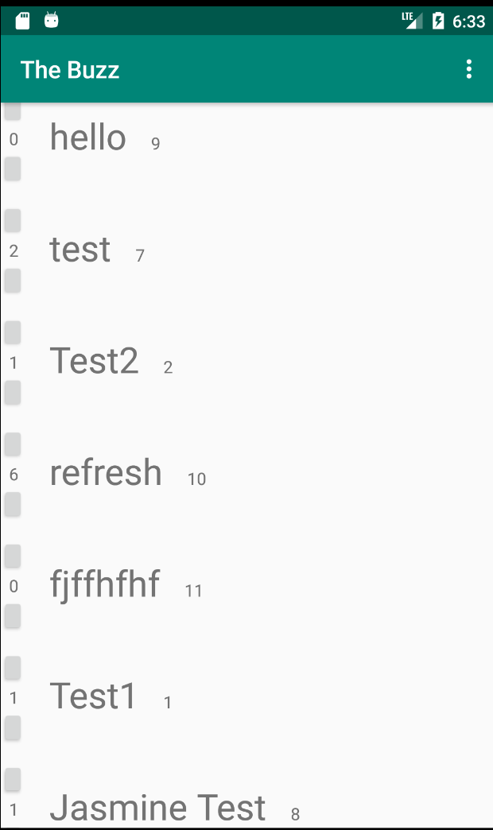

**Just like our website, the home page displays a list of posts with their titles and their counts of “likes.**

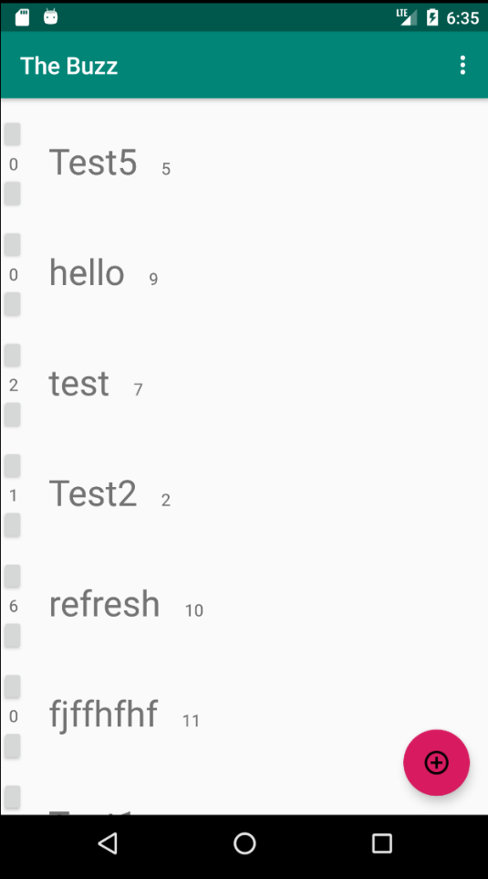**Add Entry:**

**Scroll up or down the screen, a red button “+” will show up and the bottom right of your phone. Click the button to open a new window.**

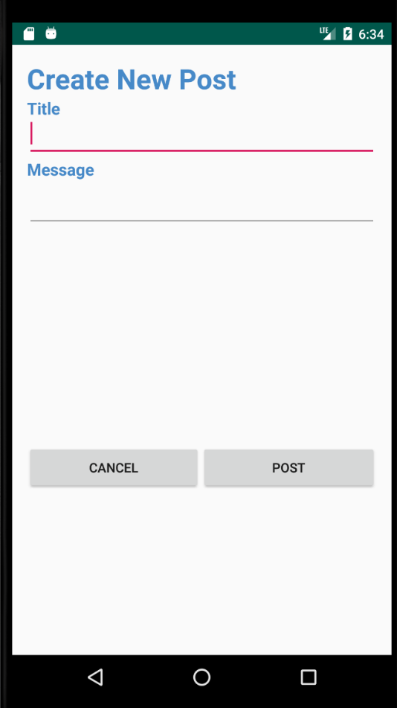

**Fill in the title and the message that you want to post to the app. Click on “POST” button to save your post, Click on “CANCEL” to discard your post.**