Customer Directory Service — Full Specification
**Document status:** Complete
**Last updated:** May 2025
**Covers:** Requirements · Architecture & Design · Azure Landing Zone · Azure WAF Policies · Cost Estimate · Implementation Tasks

Table of Contents
- [Introduction](#1-introduction)
- [Requirements — Customer Directory Service](#2-requirements--customer-directory-service)
- [Architecture & Design](#3-architecture--design)
- 3.1 [Network Topology](#31-network-topology)
- 3.2 [Azure Landing Zone](#32-azure-landing-zone)
- 3.3 [Application Architecture](#33-application-architecture)
- 3.4 [Data Models](#34-data-models)
- 3.5 [Key Design Decisions](#35-key-design-decisions)
- 3.6 [Correctness Properties](#36-correctness-properties)
- 3.7 [Error Handling](#37-error-handling)
- 3.8 [Testing Strategy](#38-testing-strategy)
- 3.9 [Azure Hosting Cost Estimate](#39-azure-hosting-cost-estimate)
- [Requirements — Azure WAF Policies](#4-requirements--azure-waf-policies)
- [Implementation Tasks](#5-implementation-tasks)

1. Introduction
The Customer Directory Service is a production-ready REST API that manages a directory of customer records. It is designed to run locally and in Kubernetes, targeting public-sector-style clients who require strong security, structured observability, comprehensive testing, and clear documentation.
The service exposes CRUD operations over customer data, enforces API key authentication, emits OpenTelemetry traces and Prometheus metrics, and ships with a Swagger UI and a complete Docker-based local development setup.

Tech Stack
Concern | Choice
Language | TypeScript
Runtime | Node.js LTS
Framework | Fastify
Persistence | SQLite (Prisma ORM)
Auth | API key (x-api-key header)
Observability | OpenTelemetry (OTLP), Prometheus (prom-client), Pino JSON logs
Dev tooling | ESLint, Prettier, Vitest, fast-check
Packaging | Dockerfile, docker-compose
Cloud | Azure (AKS, hub-and-spoke landing zone)

Glossary
Term | Definition
Service | The Customer Directory REST API application built with Node.js and Fastify
Customer | A record containing identity and contact information for a single customer entity
API_Key | A secret string passed in the x-api-key HTTP request header
Validator | The request validation layer responsible for checking input structure and field constraints
Repository | The data-access layer that mediates between the Service and the database via Prisma ORM
Telemetry | The OpenTelemetry SDK components responsible for emitting traces, metrics, and structured logs
Correlation_ID | A unique identifier attached to every request and propagated through logs and trace spans
Error_Handler | The centralised Fastify error hook that formats all error responses uniformly
Graceful_Shutdown | The process by which the Service stops accepting new requests, drains in-flight requests, and closes database connections before exiting

2. Requirements — Customer Directory Service

Requirement 1: Health Check Endpoint
User Story: As an operator, I want a public health check endpoint, so that load balancers and Kubernetes liveness probes can verify the service is running without needing credentials.

Acceptance Criteria
- WHEN a GET /health request is received, THE Service SHALL respond with HTTP 200 and a JSON body containing { "status": "ok", "version": "<semver>" }.
- THE Service SHALL serve GET /health without requiring an x-api-key header.
- WHEN the GET /health request is received, THE Service SHALL respond within 500ms under normal operating conditions.

Requirement 2: API Key Authentication
User Story: As a security officer, I want all non-health endpoints protected by an API key, so that only authorised callers can read or modify customer data.

Acceptance Criteria
- WHEN a request is received for any endpoint other than GET /health, THE Service SHALL inspect the x-api-key request header.
- IF the x-api-key header is absent, THEN THE Service SHALL respond with HTTP 401 and a JSON body { "error": "Unauthorized", "message": "Missing API key" }.
- IF the x-api-key header value does not match the configured API key, THEN THE Service SHALL respond with HTTP 401 and a JSON body { "error": "Unauthorized", "message": "Invalid API key" }.
- THE Service SHALL read the valid API key value exclusively from an environment variable named API_KEY.
- IF the API_KEY environment variable is not set at startup, THEN THE Service SHALL terminate with a non-zero exit code and log a descriptive error message.

Requirement 3: Create Customer
User Story: As an API consumer, I want to create a new customer record, so that I can add customers to the directory.

Acceptance Criteria
- WHEN a POST /customers request is received with a valid JSON body, THE Service SHALL persist a new Customer record and respond with HTTP 201 and the created Customer object.
- THE Service SHALL assign a UUID v4 value to the id field of every newly created Customer.
- THE Service SHALL set createdAt and updatedAt to the current UTC timestamp at the moment of creation.
- THE Validator SHALL require the name field to be a non-empty string with a maximum length of 255 characters.
- THE Validator SHALL require the email field to be a non-empty string in valid RFC 5322 email format.
- THE Validator SHALL accept the phone field as an optional string with a maximum length of 50 characters.
- IF the name field is absent or empty, THEN THE Validator SHALL respond with HTTP 422 and a JSON error body listing the specific field violation.
- IF the email field is absent, malformed, or not a valid email address, THEN THE Validator SHALL respond with HTTP 422 and a JSON error body listing the specific field violation.
- IF a Customer with the same email already exists, THEN THE Repository SHALL respond with HTTP 409 and a JSON body { "error": "Conflict", "message": "A customer with this email already exists" }.

Requirement 4: Retrieve Customer by ID
User Story: As an API consumer, I want to retrieve a single customer by their ID, so that I can view their details.

Acceptance Criteria
- WHEN a GET /customers/:id request is received with a valid UUID, THE Service SHALL respond with HTTP 200 and the matching Customer object.
- IF no Customer record exists for the given :id, THEN THE Service SHALL respond with HTTP 404 and a JSON body { "error": "Not Found", "message": "Customer not found" }.
- IF the :id path parameter is not a valid UUID v4 format, THEN THE Validator SHALL respond with HTTP 422 and a JSON error body describing the format violation.

Requirement 5: List and Search Customers
User Story: As an API consumer, I want to list customers with optional search and pagination, so that I can browse and find customers efficiently.

Acceptance Criteria
- WHEN a GET /customers request is received, THE Service SHALL respond with HTTP 200 and a JSON body containing { "data": [...], "total": <integer>, "page": <integer>, "pageSize": <integer> }.
- THE Service SHALL default the page query parameter to 1 when it is absent.
- THE Service SHALL default the pageSize query parameter to 20 when it is absent.
- THE Validator SHALL reject a pageSize value greater than 100 with HTTP 422 and a descriptive error message.
- THE Validator SHALL reject a page value less than 1 with HTTP 422 and a descriptive error message.
- WHEN the search query parameter is provided, THE Repository SHALL filter results to Customer records where name or email contains the search string using case-insensitive matching.
- THE Service SHALL return an empty data array and total of 0 when no customers match the search criteria.
- THE Service SHALL return customers ordered by createdAt descending by default.

Requirement 6: Update Customer
User Story: As an API consumer, I want to update an existing customer's details, so that I can correct or enrich their information.

Acceptance Criteria
- WHEN a PUT /customers/:id request is received with a valid JSON body, THE Service SHALL update the matching Customer record and respond with HTTP 200 and the updated Customer object.
- THE Service SHALL set updatedAt to the current UTC timestamp at the moment of each update.
- THE Validator SHALL apply the same field constraints for name, email, and phone as defined in Requirement 3, Acceptance Criteria 4–6.
- IF no Customer record exists for the given :id, THEN THE Service SHALL respond with HTTP 404 and a JSON body { "error": "Not Found", "message": "Customer not found" }.
- IF the updated email value conflicts with an existing Customer record with a different id, THEN THE Repository SHALL respond with HTTP 409 and a JSON body { "error": "Conflict", "message": "A customer with this email already exists" }.

Requirement 7: Delete Customer
User Story: As an API consumer, I want to delete a customer record, so that I can remove outdated or incorrect entries from the directory.

Acceptance Criteria
- WHEN a DELETE /customers/:id request is received, THE Service SHALL delete the matching Customer record and respond with HTTP 204 and no response body.
- IF no Customer record exists for the given :id, THEN THE Service SHALL respond with HTTP 404 and a JSON body { "error": "Not Found", "message": "Customer not found" }.
- IF the :id path parameter is not a valid UUID v4 format, THEN THE Validator SHALL respond with HTTP 422 and a JSON error body describing the format violation.

Requirement 8: Centralised Error Handling
User Story: As a security officer, I want all error responses to follow a consistent format without exposing internal details, so that the API surface is predictable and does not leak implementation information.

Acceptance Criteria
- THE Error_Handler SHALL intercept all unhandled errors before they reach the HTTP response.
- THE Error_Handler SHALL respond with a JSON body conforming to { "error": "<short title>", "message": "<human-readable description>" } for all error responses.
- IF an unhandled internal error occurs, THEN THE Error_Handler SHALL respond with HTTP 500 and the body { "error": "Internal Server Error", "message": "An unexpected error occurred" }.
- THE Error_Handler SHALL log the full error details including stack trace to the structured log at error level.
- THE Error_Handler SHALL never include a stack trace or internal file path in the HTTP response body.

Requirement 9: Structured Logging and Correlation IDs
User Story: As an operator, I want every log line to be structured JSON with a correlation ID, so that I can trace requests across distributed systems and query logs programmatically.

Acceptance Criteria
- THE Service SHALL emit all log output as newline-delimited JSON to stdout.
- THE Service SHALL generate a unique Correlation_ID for each incoming request.
- WHEN a request includes a x-correlation-id header, THE Service SHALL use that value as the Correlation_ID instead of generating a new one.
- THE Service SHALL include the Correlation_ID in every log line emitted during the processing of that request.
- THE Service SHALL include the Correlation_ID in the HTTP response as the x-correlation-id header.
- THE Service SHALL log each completed request at info level with fields: method, url, statusCode, responseTimeMs, and correlationId.

Requirement 10: OpenTelemetry Observability
User Story: As an operator, I want distributed traces and metrics exported via OpenTelemetry, so that I can monitor service performance and diagnose latency issues in a Kubernetes environment.

Acceptance Criteria
- THE Telemetry SHALL instrument all incoming HTTP requests as OpenTelemetry spans with attributes: http.method, http.route, http.status_code.
- THE Telemetry SHALL instrument all Prisma database queries as child spans with the query operation name as the span name.
- THE Telemetry SHALL record a custom span for the customer search operation including the sanitised search term length as a span attribute.
- THE Telemetry SHALL export traces to an OTLP endpoint configurable via the OTEL_EXPORTER_OTLP_ENDPOINT environment variable.
- WHERE the OTEL_EXPORTER_OTLP_ENDPOINT environment variable is not set, THE Telemetry SHALL default to no-op trace export without crashing.

Requirement 11: Prometheus Metrics Endpoint
User Story: As an operator, I want a /metrics endpoint in Prometheus format, so that I can scrape service metrics from a Prometheus instance.

Acceptance Criteria
- WHEN a GET /metrics request is received with a valid API key, THE Service SHALL respond with HTTP 200 and a Prometheus text exposition format body.
- THE Metrics_Endpoint SHALL expose at minimum: http_requests_total (labelled by method, route, status), http_request_duration_seconds (histogram), and process_uptime_seconds.
- THE Service SHALL protect GET /metrics with the same API key authentication defined in Requirement 2.

Requirement 12: OpenAPI Documentation
User Story: As a developer integrating with the API, I want interactive API documentation, so that I can explore endpoints and test requests without reading source code.

Acceptance Criteria
- THE Service SHALL expose a Swagger UI at GET /docs.
- THE Service SHALL serve the raw OpenAPI 3.0 JSON specification at GET /docs/json.
- THE Swagger_UI SHALL document all endpoints defined in Requirements 1–7 and 11, including request schemas, response schemas, and authentication requirements.
- THE Service SHALL serve GET /docs and GET /docs/json without requiring an API key.

Requirement 13: Persistence and Data Model
User Story: As a developer, I want the customer data persisted in a Prisma-managed SQLite database, so that data survives service restarts and the schema is version-controlled.

Acceptance Criteria
- THE Database SHALL store Customer records with fields: id (UUID, primary key), name (string, required), email (string, unique, required), phone (string, nullable), createdAt (datetime), updatedAt (datetime).
- THE Service SHALL manage all database schema changes through Prisma migrations stored in the prisma/migrations/ directory.
- WHEN the Service starts, THE Service SHALL verify the database connection and apply any pending migrations before accepting requests.
- IF the database connection fails at startup, THEN THE Service SHALL terminate with a non-zero exit code and log a descriptive error message.

Requirement 14: Graceful Shutdown
User Story: As an operator, I want the service to shut down gracefully on SIGTERM, so that in-flight requests complete and database connections are closed cleanly during Kubernetes pod termination.

Acceptance Criteria
- WHEN the Service receives a SIGTERM or SIGINT signal, THE Service SHALL stop accepting new incoming connections.
- WHEN the Service receives a SIGTERM or SIGINT signal, THE Service SHALL wait for all in-flight requests to complete before exiting, up to a maximum of 10 seconds.
- WHEN the Service receives a SIGTERM or SIGINT signal, THE Service SHALL disconnect from the Database before the process exits.
- IF in-flight requests do not complete within 10 seconds of receiving the shutdown signal, THEN THE Service SHALL forcibly close remaining connections and exit with code 1.

Requirement 15: Unit and Integration Testing
User Story: As a developer, I want a comprehensive test suite, so that I can confidently refactor and deploy the service.

Acceptance Criteria
- THE Service SHALL include unit tests for the Validator covering valid inputs, missing required fields, malformed email addresses, and out-of-range pagination values.
- THE Service SHALL include unit tests for the service layer covering create, read, update, delete, and list operations using a mocked Repository.
- THE Service SHALL include integration tests for each API endpoint defined in Requirements 1–7 and 11, using a temporary SQLite database isolated per test run.
- THE Service SHALL include a round-trip integration test: create → retrieve → update → verify updated fields match.
- WHEN npm test is executed, THE Service SHALL run all unit and integration tests and exit with code 0 when all tests pass.
- THE Service SHALL achieve a minimum of 80% line coverage across the src/ directory.

Requirement 16: Build, Lint, and Containerisation
User Story: As a developer, I want a reproducible build, lint, and Docker packaging pipeline, so that the service can be built and deployed consistently across environments.

Acceptance Criteria
- WHEN npm run build is executed, THE Service SHALL compile TypeScript sources to the dist/ directory without errors.
- WHEN npm run lint is executed, THE Service SHALL report zero ESLint violations across all src/ and tests/ files.
- THE Service SHALL include a Dockerfile that produces a minimal production image using a Node.js LTS base, copies only compiled output and production dependencies, and exposes port 3000.
- THE Service SHALL include a docker-compose.yml that starts the Service container, mounts a named volume for the SQLite database file, and passes required environment variables from a .env file.
- WHEN docker compose up is executed with a valid .env file, THE Service SHALL start and respond to GET /health within 30 seconds.
- THE Service SHALL include a .env.example file documenting all required and optional environment variables with descriptions and example values.

3. Architecture & Design
The Customer Directory Service is built with Node.js + TypeScript and the Fastify web framework. It follows a layered architecture with strict unidirectional dependencies: Fastify HTTP Server → Service Layer → Repository Layer → Prisma ORM + SQLite.
Why Fastify over Express:
- Schema-first validation — native JSON Schema integration enables automatic OpenAPI spec generation via @fastify/swagger
- Performance — low-overhead routing and serialisation pipeline
- Plugin ecosystem — first-party plugins cover all cross-cutting concerns without custom middleware boilerplate

3.1 Network Topology

Local — Docker Compose
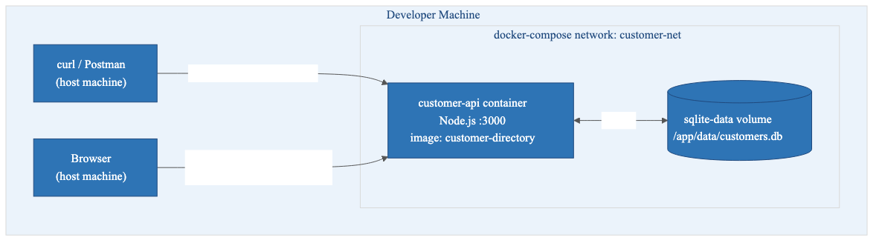
Local — Docker Compose
- Single container, port 3000 mapped to the host
- SQLite persisted on a named Docker volume — survives container restarts
- No sidecar or external services required locally; OTel is a no-op when OTEL_EXPORTER_OTLP_ENDPOINT is unset

Production — Kubernetes
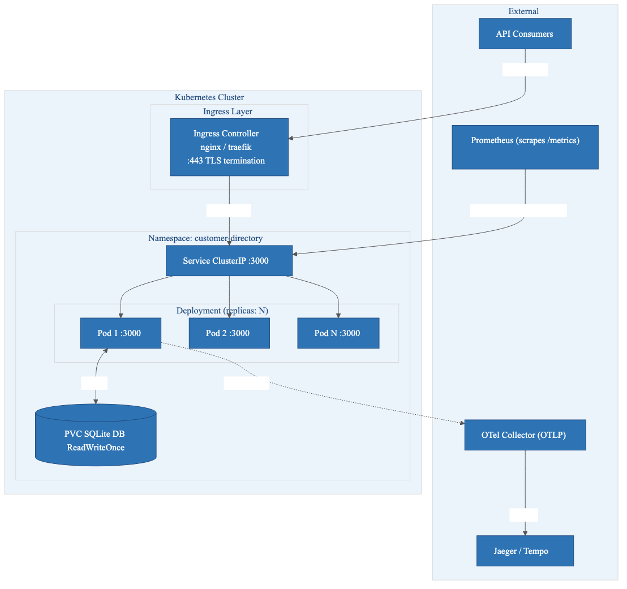
Production — Kubernetes
Concern | Decision
TLS | Terminated at the Ingress controller — pods communicate over plain HTTP internally
Auth | API_KEY injected from a Kubernetes Secret — never baked into the image
SQLite + replicas | ReadWriteOnce PVC — single writer. For true horizontal scaling, migrate to PostgreSQL
Traces | Pods push OTLP spans to OTel Collector → Jaeger/Tempo
Graceful shutdown | Kubernetes sends SIGTERM → pod drains in-flight requests (max 10s) → SIGKILL

3.2 Azure Landing Zone
The service is hosted in an Azure Landing Zone following the [ALZ conceptual architecture](https://learn.microsoft.com/en-us/azure/cloud-adoption-framework/ready/landing-zone/) with hub-and-spoke topology, centralised governance, and defence-in-depth security.

Management Group Hierarchy
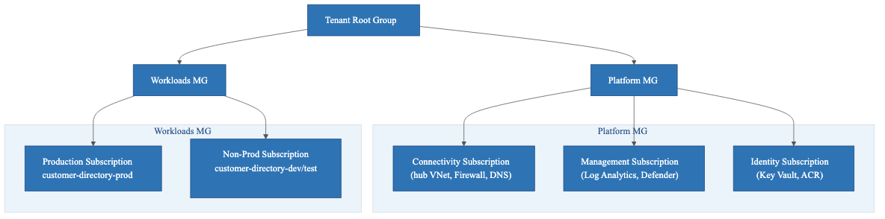
Management Group Hierarchy
Policy assignments at Management Group level:
- Deny public IP on resources without explicit exemption
- Require diagnostic settings forwarded to central Log Analytics Workspace
- Require private endpoints for PaaS services (Key Vault, ACR, etc.)
- Audit resources without resource locks on production

Hub-and-Spoke Network
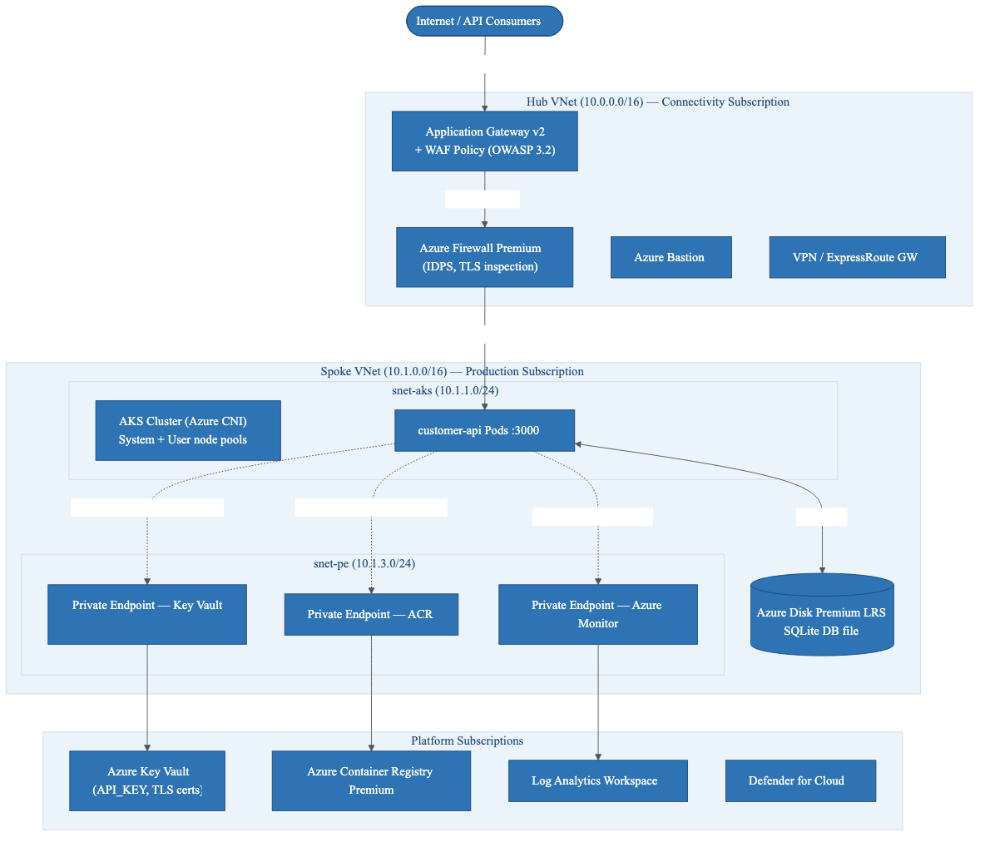
Hub-and-Spoke Network

Resource Inventory
Resource | SKU / Tier | Purpose
Application Gateway v2 | WAF_v2 | TLS termination, WAF (OWASP 3.2), path-based routing
Azure Firewall Premium | Premium | IDPS, TLS inspection, east-west + egress filtering
AKS Cluster | Standard, Azure CNI | Hosts customer-api pods; system + user node pools
Azure Disk Premium LRS | 32 GB | Persistent volume for SQLite DB file (CSI driver)
Azure Container Registry | Premium | Private image registry
Azure Key Vault | Standard | Stores API_KEY secret, TLS certificates
User-Assigned Managed Identity | — | Grants AKS workload identity access to Key Vault and ACR
Log Analytics Workspace | Pay-as-you-go | Central sink for AKS diagnostics, container logs, metrics
Azure Monitor / App Insights | — | Receives OTLP traces
Microsoft Defender for Cloud | Defender for Containers | Runtime threat detection
Azure Bastion | Standard | Secure admin access — no public SSH
Private DNS Zones | — | Name resolution for all private endpoints
Network Security Groups | — | Subnet-level micro-segmentation
Azure Policy | Built-in + custom | Governance guardrails at Management Group level

Security Controls
Layer | Controls
Perimeter | WAF Policy (OWASP 3.2), rate limiting, bot protection, DDoS Network Protection
Network | Azure Firewall IDPS, NSGs (deny-by-default), private endpoints for all PaaS
Identity & Secrets | Workload Identity (no stored creds), Key Vault (soft-delete + purge protect), Azure RBAC least-privilege
Data | Encryption at rest (Azure-managed keys), TLS 1.2+ in transit
Detection | Defender for Containers, audit logs → Log Analytics, Azure Monitor Alerts

API Key handling: API_KEY stored in Key Vault, mounted into pods via Secrets Store CSI Driver. Pod's Managed Identity has Key Vault Secrets User RBAC role — no client secrets required.

AKS Configuration
networkPlugin: azure # Azure CNI — pods get VNet IPs
networkPolicy: calico # Pod-level network policies
privatecluster: true # API server not publicly reachable
enableOIDCIssuer: true # Required for Workload Identity
enableWorkloadIdentity: true
monitoringAddon: true
defenderAddon: true
autoUpgradeChannel: patch

systemPool:
vmSize: Standard_D2s_v5
count: 2
mode: System

userPool:
vmSize: Standard_D4s_v5
minCount: 2
maxCount: 10
mode: User
enableAutoScaling: true

Observability Pipeline
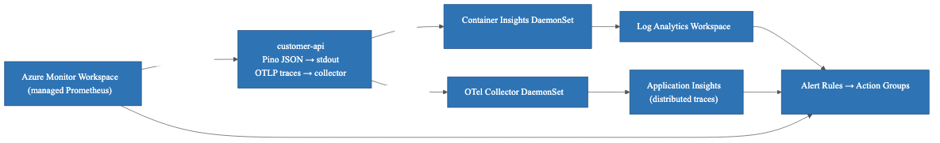
Observability Pipeline

CI/CD and Image Supply Chain
CI/CD and Image Supply Chain
- Images tagged by Git SHA, digest-pinned in manifests — no latest in production
- ACR Tasks run trivy; CRITICAL CVEs quarantine the image
- Azure Policy blocks pods pulling from non-approved registries

Environment Summary
Environment | Subscription | AKS Replicas | Storage | Notes
Local | n/a | n/a | Docker volume | docker compose up
Dev | customer-directory-nonprod | 1 | Azure Files Standard | Auto-deployed on PR merge
Test | customer-directory-nonprod | 1 | Azure Files Standard | Integration + load tests
Production | customer-directory-prod | 2–10 (autoscale) | Azure Disk Premium LRS | Manual approval gate

**SQLite scaling note:** SQLite with `ReadWriteOnce` works for single-writer workloads. For concurrent writes across multiple replicas, migrate to **Azure Database for PostgreSQL Flexible Server** and update the Prisma provider.

3.3 Application Architecture

Layered Architecture
HTTP Request
│
▼
┌─────────────────────────────────────────────────────┐
│ Fastify HTTP Server │
│ OTel Plugin │ Correlation ID Hook │ Auth Middleware │
│ Route Handlers │
│ /health /customers /metrics /docs │
│ Centralised Error Handler │
└─────────────────────────────────────────────────────┘
│
▼
┌─────────────────────────────────────────────────────┐
│ Service Layer — CustomerService │
│ (business logic, conflict checks, OTel spans) │
└─────────────────────────────────────────────────────┘
│
▼
┌─────────────────────────────────────────────────────┐
│ Repository Layer — CustomerRepository │
│ (Prisma queries, DB mapping, error translation) │
└─────────────────────────────────────────────────────┘
│
▼
┌─────────────────────────────────────────────────────┐
│ Prisma ORM + SQLite DB │
└─────────────────────────────────────────────────────┘

Request Flow
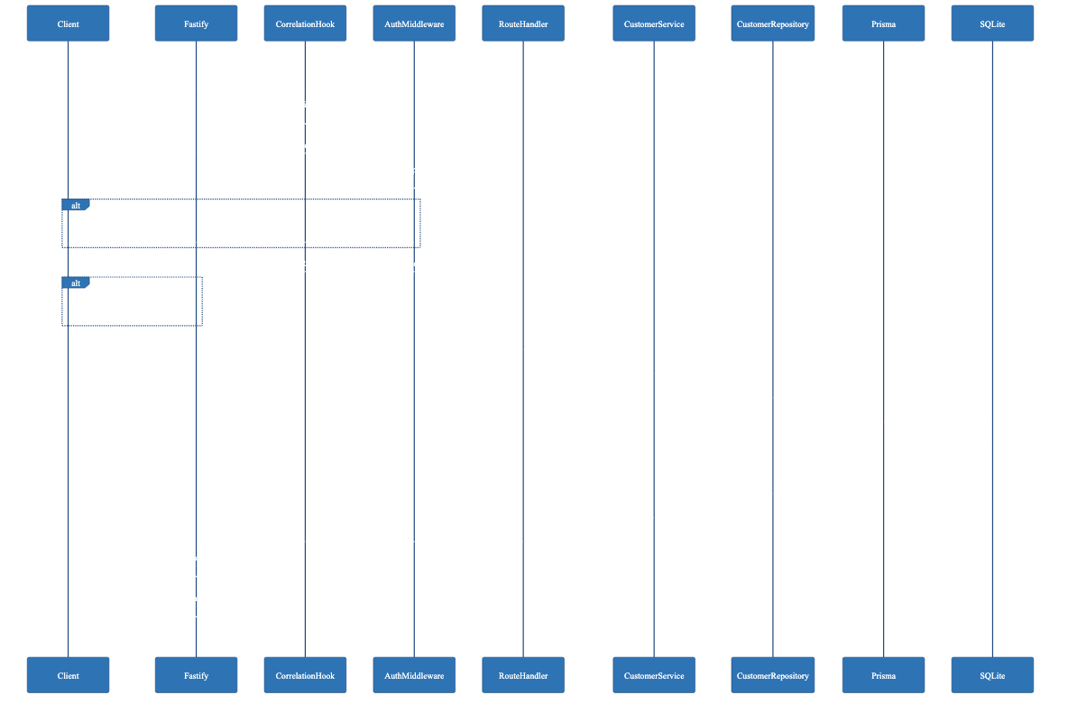
Request Flow

Component Responsibilities
Component | Responsibility
src/index.ts | Bootstrap: validate config, init OTel, create app, run migrations, start server, register signal handlers
src/app.ts | Fastify factory: register all plugins and routes, export for testing
src/config.ts | Read and validate all env vars at startup; fail fast if required vars are missing
src/plugins/telemetry.ts | Initialise OTel Node SDK with HTTP and Prisma instrumentations
src/plugins/correlation.ts | onRequest: read/generate correlation ID; onSend: write back to response header
src/plugins/auth.ts | preHandler hook scoped to all routes except /health, /docs, /docs/json
src/plugins/errorHandler.ts | Map AppError subclasses to HTTP status; 500 for unknowns; never leak stack traces
src/plugins/metrics.ts | prom-client default metrics + http_requests_total + http_request_duration_seconds; GET /metrics route
src/plugins/swagger.ts | @fastify/swagger OpenAPI 3.0 + @fastify/swagger-ui at /docs
src/routes/health.ts | GET /health — no auth, returns { status, version }
src/routes/customers.ts | CRUD routes with JSON Schema; delegates to CustomerService
src/services/CustomerService.ts | UUID generation, timestamps, conflict detection, search/pagination, custom OTel span
src/repositories/CustomerRepository.ts | All Prisma queries; translates P2002 → ConflictError
src/errors/AppError.ts | NotFoundError (404), ConflictError (409), ValidationError (422), UnauthorizedError (401)
src/schemas/customer.schema.ts | Single source of truth for validation, serialisation, and OpenAPI docs

Folder Structure
customer-directory-service/
├── prisma/
│ ├── schema.prisma
│ └── migrations/
├── src/
│ ├── index.ts
│ ├── app.ts
│ ├── config.ts
│ ├── logger.ts
│ ├── db/prisma.ts
│ ├── errors/AppError.ts
│ ├── plugins/
│ │ ├── auth.ts
│ │ ├── correlation.ts
│ │ ├── errorHandler.ts
│ │ ├── metrics.ts
│ │ ├── swagger.ts
│ │ └── telemetry.ts
│ ├── routes/
│ │ ├── health.ts
│ │ └── customers.ts
│ ├── schemas/customer.schema.ts
│ ├── services/CustomerService.ts
│ └── repositories/CustomerRepository.ts
├── tests/
│ ├── unit/
│ │ ├── validator.test.ts
│ │ └── customerService.test.ts
│ └── integration/
│ ├── health.test.ts
│ ├── customers.test.ts
│ └── metrics.test.ts
├── Dockerfile
├── docker-compose.yml
├── .env.example
├── package.json
└── tsconfig.json

3.4 Data Models

Prisma Schema
model Customer {
id String @id @default(uuid())
name String
email String @unique
phone String?
createdAt DateTime @default(now())
updatedAt DateTime @updatedAt
}

TypeScript Domain Type
interface Customer {
id: string; // UUID v4
name: string; // 1–255 chars
email: string; // RFC 5322, unique
phone: string | null; // 0–50 chars, optional
createdAt: string; // ISO 8601 UTC
updatedAt: string; // ISO 8601 UTC
}

API Shapes
POST /customers / PUT /customers/:id body:
{ "name": "string", "email": "string", "phone": "string?" }

GET /customers response:
{ "data": [Customer], "total": 42, "page": 1, "pageSize": 20 }

All error responses:
{ "error": "string", "message": "string" }

3.5 Key Design Decisions

1. OTel Initialisation Must Be First
The OTel Node SDK patches Node.js built-ins at import time. src/index.ts must call initTelemetry() before any other imports.
index.ts execution order:
1. initTelemetry() ← must be first
2. validateConfig()
3. buildApp()
4. prisma.$connect() + migrate
5. fastify.listen()
6. register SIGTERM/SIGINT handlers

When OTEL_EXPORTER_OTLP_ENDPOINT is not set, the SDK uses a NoopSpanExporter — no crash.

2. Correlation ID Flow
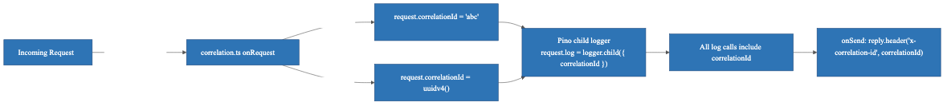
2. Correlation ID Flow

3. Auth Scope via Sub-Router
Fastify instance
├── GET /health ← no auth
├── GET /docs ← no auth
├── GET /docs/json ← no auth
└── [auth-scoped plugin]
├── preHandler: validateApiKey
├── GET /customers
├── POST /customers
├── GET /customers/:id
├── PUT /customers/:id
├── DELETE /customers/:id
└── GET /metrics

4. Graceful Shutdown Sequence
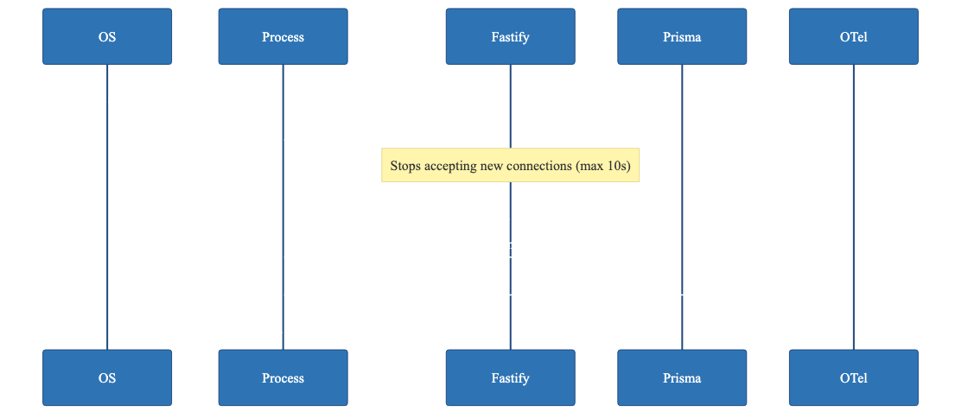
4. Graceful Shutdown Sequence

5. JSON Schema as Single Source of Truth
src/schemas/customer.schema.ts drives request validation, response serialisation, and OpenAPI spec generation — all from one place.

6. Repository Error Translation
Prisma P2002 (unique constraint) → ConflictError → HTTP 409. Prisma stays an implementation detail; the service layer never sees Prisma error types.

3.6 Correctness Properties
These properties are formally verified using property-based tests (fast-check, 100 iterations minimum each).
# | Property | Validates
P1 | Creation round-trip — POST then GET returns identical name, email, phone | Req 3.1, 4.1
P2 | Server-assigned fields — id is UUID v4; createdAt/updatedAt are valid ISO 8601 UTC | Req 3.2, 3.3
P3 | Name validation boundary — empty or >255 chars → 422; 1–255 chars → accepted | Req 3.4, 3.7
P4 | Email validation — non-RFC-5322 strings → 422; valid emails → accepted | Req 3.5, 3.8
P5 | Search correctness — every result contains the search term; no non-matching result appears | Req 5.6, 5.7
P6 | List ordering — data[i].createdAt >= data[i+1].createdAt for all i | Req 5.8
P7 | Update round-trip — GET after PUT returns updated fields; updatedAt ≥ createdAt | Req 6.1, 6.2
P8 | Delete removes record — DELETE → 204; subsequent GET → 404 | Req 7.1
P9 | Error response schema — all 4xx/5xx responses have { error, message } and no stack trace | Req 8.2, 8.3, 8.5
P10 | Correlation ID echo — provided header echoed back; absent header → UUID v4 generated | Req 9.3, 9.5

3.7 Error Handling

Error Hierarchy
AppError (base)
├── UnauthorizedError → HTTP 401
├── ValidationError → HTTP 422
├── NotFoundError → HTTP 404
├── ConflictError → HTTP 409
└── (unknown/unhandled) → HTTP 500

The setErrorHandler callback:
- AppError instance → maps to HTTP status, formats { error, message }
- Fastify schema validation error → 422 with field details
- All other errors → logs full stack at error level, returns 500 with generic message
- Never includes err.stack, file paths, or Prisma internals in the response body
Startup failures (immediate process.exit(1)):**
- API_KEY env var not set
- Database connection fails during prisma.$connect()

3.8 Testing Strategy
Unit tests (tests/unit/):
- Validator: valid inputs, missing fields, malformed emails, out-of-range pagination
- CustomerService: all CRUD operations with mocked CustomerRepository
Integration tests (tests/integration/):
- Every API endpoint with isolated temporary SQLite DB per test run
- Full CRUD round-trip, auth middleware, pagination defaults, search filtering, metrics format
Property-based tests (fast-check, 100 iterations each):
- All 10 correctness properties listed in §3.6
- Tagged with // Feature: customer-directory-service, Property N: <title>
Coverage gate: 80% line coverage across src/ via Vitest + @vitest/coverage-v8

3.9 Azure Hosting Cost Estimate
All prices are East US region, pay-as-you-go, USD, May 2025 (list price). Sources: [Azure pricing](https://azure.microsoft.com/en-us/pricing/), [vantage.sh](https://instances.vantage.sh/azure/vm/d4s-v5), [Microsoft Learn](https://learn.microsoft.com/en-us/answers/questions/1692318/defender-for-container-pricing-question).

Assumptions
Parameter | Value
AKS user nodes (prod) | 2–4 × Standard_D4s_v5 (4 vCPU, 16 GiB)
AKS system nodes | 2 × Standard_D2s_v5 (2 vCPU, 8 GiB)
Monthly traffic | ~1M requests, ~50 GB through firewall
Log ingestion | ~10 GB/month
SQLite storage | Azure Disk Premium LRS, 32 GB

Production Monthly Breakdown
Category | Resource | Monthly
Compute | AKS Standard control plane | $73
 | System nodes D2s_v5 × 2 | $140
 | User nodes D4s_v5 × 2 (baseline) | $280
 | User nodes D4s_v5 × 2 (burst ~20%) | $56
 | Compute subtotal | ~$549
Networking | Azure Firewall Premium | ~$1,798
 | Application Gateway v2 + WAF | ~$192
 | Azure Bastion Standard | $212
 | Public IPs × 2 + VNet peering | $7
 | Networking subtotal | ~$2,209
Storage | Azure Disk Premium LRS (32 GB) | $5
 | Azure Container Registry Premium | $20
 | Storage subtotal | ~$25
Security & Obs. | Defender for Containers (16 vCores × $7) | $112
 | Log Analytics (5 GB billable) | $14
 | Azure Monitor / App Insights | $6
 | Key Vault | $2
 | Security subtotal | ~$134
 | Production total | ~$2,917/month (~$35,000/year)

Non-Production (Dev + Test)
~$932/month — single node, Firewall Standard, no Bastion, no WAF.

Cost Optimisation Options
Option | Monthly Saving | Trade-off
1-year Reserved — Firewall + VMs | ~$820 | Upfront commitment
Downgrade to Firewall Standard | ~$600 | Loses IDPS + TLS inspection
Replace Firewall + AGW with Azure Front Door Premium | ~$1,400 | No hub-and-spoke private network
Spot instances for burst nodes | ~80% on burst | Pod eviction risk

Total Cost of Ownership
Scenario | Monthly | Annual
Pay-as-you-go (prod + non-prod) | ~$3,849 | ~$46,184
1-year reservations (prod + non-prod) | ~$3,032 | ~$36,384
EA/CSP discount (15–30%) applied | ~$2,700–$3,270 | ~$32,000–$39,000

Use the [Azure Pricing Calculator](https://azure.microsoft.com/en-us/pricing/calculator/) with your EA/CSP agreement for a binding quote.

4. Requirements — Azure WAF Policies
This section covers the Azure Policy definitions, initiatives, and assignment templates that enforce the five pillars of the Azure Well-Architected Framework across the Customer Directory Service landing zone.
All policies use built-in Azure Policy definitions where available. Custom definitions are created only where no built-in covers the requirement. All artefacts are expressed as Bicep/ARM files under infra/policies/.

Folder Structure
infra/policies/
├── reliability/
├── security/
├── cost-optimisation/
├── operational-excellence/
├── performance-efficiency/
├── initiatives/
│ ├── WAF-Reliability-Initiative.json
│ ├── WAF-Security-Initiative.json
│ ├── WAF-CostOptimisation-Initiative.json
│ ├── WAF-OperationalExcellence-Initiative.json
│ └── WAF-PerformanceEfficiency-Initiative.json
├── assignments/
│ ├── assignment.bicep
│ └── parameters.prod.json / parameters.nonprod.json
└── README.md

Pillar 1: Reliability
# | Policy | Type | Effect | Built-in ID
R1 | Availability zones on AKS, AGW, Firewall | Custom | Deny | —
R2 | CanNotDelete resource locks on prod resource groups | Custom | DeployIfNotExists | —
R3 | Health probes on Application Gateway backend pools | Custom | Audit | —
R4 | AKS user node pool autoscaler enabled | Custom | Deny | —

Initiative: WAF-Reliability-Initiative

Requirement 1: Availability Zones
WHEN a supported resource (AKS node pool, AGW v2, Azure Firewall) is created without AZ configuration, THE Policy_Engine SHALL deny the operation. Existing non-AZ resources SHALL be reported as non-compliant.

Requirement 2: Resource Locks on Production
WHEN a resource in the Production Subscription is created without a CanNotDelete lock, THE Policy_Engine SHALL deploy one via deployIfNotExists scoped to resource groups tagged environment: prod.

Requirement 3: Health Probes
THE Policy_Engine SHALL audit Application Gateway v2 instances with backend pools that have no custom health probe and emit audit events to Log Analytics.

Requirement 4: AKS Autoscale
WHEN an AKS user node pool is created with enableAutoScaling: false, THE Policy_Engine SHALL deny the operation. System node pools are exempt.

Pillar 2: Security
# | Policy | Type | Effect | Built-in ID
S1 | Key Vault private endpoint | Built-in | Audit | a6abeaec-4d90-4a02-805f-6b26c4d3fbe9
S2 | ACR private endpoint | Built-in | Audit | e8eef0a8-67cf-4eb4-9386-14b0e78733d4
S3 | Deny public IPs in Workloads MG | Custom | Deny | —
S4 | Key Vault TLS 1.2 minimum | Built-in | Deny | 1f314764-cb73-4fc9-b863-8eca98ac36e9
S5 | Key Vault soft-delete (90 days) | Built-in | Deny | 1e66c121-a66a-4b1f-9b83-0fd99bf0fc2d
S6 | Key Vault purge protection | Built-in | Deny | 0b60c0b2-2dc2-4e1c-b5c9-abbed971de53
S7 | Defender for Containers enabled | Built-in | Audit | 1c988dd6-ade4-430f-a608-2a3e5b0a6d38
S8 | No privileged containers in AKS | Built-in | Deny | 95edb821-ddaf-4404-9732-666045e70207
S9 | Approved container registries only | Built-in | Deny | febd0533-8e55-448f-b837-bd0e06f16469

Initiative: WAF-Security-Initiative
Key requirements:
- Public IPs denied in Workloads MG unless tagged public-ip-exemption: true; hub VNet public IPs (AGW, Firewall) are in Platform MG scope and unaffected
- Privileged containers denied in all namespaces except kube-system and gatekeeper-system
- Approved ACR hostname supplied via Parameters_File — different values for prod vs non-prod

Pillar 3: Cost Optimisation
# | Policy | Type | Effect | Built-in ID
C1 | Require costCentre tag | Built-in | Deny | 871b6d14-10aa-478d-b590-94f262ecfa99
C2 | Require environment tag | Built-in | Deny | 871b6d14-10aa-478d-b590-94f262ecfa99
C3 | Require owner tag | Built-in | Deny | 871b6d14-10aa-478d-b590-94f262ecfa99
C4 | Budget alert existence | Custom | Audit | —
C5 | Approved VM SKUs | Built-in | Deny | cccc23c7-8427-4f53-ad12-b6a63eb452b3

Initiative: WAF-CostOptimisation-Initiative
Key requirements:
- Three mandatory tags (costCentre, environment, owner) — deny on missing; allowed environment values parameterised (["prod", "dev", "test"])
- Budget alert audit is a custom policy (no built-in covers subscription-level budget existence)
- Approved SKU list (["Standard_D2s_v5", "Standard_D4s_v5", "Standard_D8s_v5"]) supplied via Parameters_File

Pillar 4: Operational Excellence
# | Policy | Type | Effect | Built-in ID
O1 | Diagnostic settings → Log Analytics (Key Vault) | Built-in | DeployIfNotExists | bef3f64c-5290-43b7-85b0-9b254eef4c47
O2 | Diagnostic settings → Log Analytics (AKS) | Built-in | DeployIfNotExists | 6c66c325-74c8-42fd-a286-a74b0e2939d8
O3 | Naming convention enforcement | Custom | Audit | —
O4 | Activity log retention ≥ 365 days | Built-in | Audit | b02aacc0-b073-424e-8298-42b22829ee0a

Initiative: WAF-OperationalExcellence-Initiative
Key requirements:
- Diagnostic settings auto-deployed within 30 minutes of remediation task execution
- Log Analytics Workspace resource ID supplied via Parameters_File (different for prod vs non-prod)
- Naming convention: aks- prefix for AKS clusters, kv- for Key Vaults, rg- for resource groups

Pillar 5: Performance Efficiency
# | Policy | Type | Effect | Built-in ID
P1 | AKS user node pool autoscale + minCount ≥ 2 | Custom | Deny | —
P2 | Container CPU/memory requests and limits required | Custom | Deny | —

Initiative: WAF-PerformanceEfficiency-Initiative
Key requirements:
- minCount < 2 on user node pools → deny (custom policy; no built-in covers this)
- Containers without CPU request, memory request, CPU limit, or memory limit → deny
- kube-system and gatekeeper-system namespaces exempt from resource limit enforcement

Assignment Templates
Setting | Production | Non-Production
enforcementMode | Default (enforced) | DoNotEnforce (audit only)
Scope | Workloads MG | Workloads MG
Managed Identity | System-assigned, minimum RBAC for deployIfNotExists | Same
Parameters | parameters.prod.json | parameters.nonprod.json

Assignment templates support both Management Group and Subscription scope via a single parameter — no separate template files needed.
Custom policy definition files include a metadata block:
{
"metadata": {
"wafPillar": "Security",
"wafPrinciple": "Deny public network access",
"policyType": "Custom",
"version": "1.0.0"
}
}

5. Implementation Tasks

Overview
Implement a production-ready Fastify + TypeScript REST API with Prisma/SQLite persistence, API key auth, OpenTelemetry tracing, Prometheus metrics, Swagger docs, structured logging with correlation IDs, and graceful shutdown. Layered architecture: Fastify → Service → Repository → Prisma/SQLite.
Tasks marked * are optional property-based tests — can be skipped for a faster MVP.

- 1. Project scaffolding
- Initialise package.json with all dependencies and devDependencies
- Create tsconfig.json (ES2022, strict, outDir: dist)
- Create .eslintrc.json and .prettierrc
- Create full folder structure
- Add npm scripts: build, start, dev, lint, test, test:coverage
- *Requirements: 16.1, 16.2*
- 2. Prisma schema and migration
- Create prisma/schema.prisma with Customer model
- Run prisma migrate dev --name init
- Run prisma generate
- *Requirements: 13.1, 13.2*
- 3. Core infrastructure modules
- 3.1 src/config.ts — validate env vars, fail fast on missing API_KEY *(Req 2.4, 2.5)*
- 3.2 src/logger.ts — Pino JSON stdout, respects LOG_LEVEL *(Req 9.1)*
- 3.3 src/errors/AppError.ts — base class + 4 subclasses *(Req 8.1, 8.2)*
- 3.4 src/db/prisma.ts — singleton PrismaClient *(Req 13.3)*
- 4. Telemetry plugin
- src/plugins/telemetry.ts — OTel SDK with HTTP + Prisma auto-instrumentation
- Export initTelemetry() — must be called first in src/index.ts
- NoopSpanExporter when OTEL_EXPORTER_OTLP_ENDPOINT not set
- *Requirements: 10.1, 10.2, 10.4, 10.5*
- 5. Fastify app factory and plugins
- 5.1 src/plugins/correlation.ts — read/generate correlation ID, Pino child logger, echo header *(Req 9.2–9.5)*
- 5.2 src/plugins/auth.ts — preHandler scoped sub-router, UnauthorizedError on fail *(Req 2.1–2.3)*
- 5.3 src/plugins/errorHandler.ts — map AppError → HTTP status, 500 for unknowns, no stack traces *(Req 8.1–8.5)*
- 5.4 src/plugins/swagger.ts — OpenAPI 3.0 + Swagger UI at /docs *(Req 12.1–12.4)*
- 5.5 src/plugins/metrics.ts — prom-client, http_requests_total, http_request_duration_seconds, GET /metrics *(Req 11.1–11.3)*
- 5.6 src/app.ts — buildApp() factory, register all plugins and routes *(Req 1.1, 2.1)*
- 6. Route handlers
- 6.1 src/schemas/customer.schema.ts — JSON Schema for all request/response shapes *(Req 3.4–3.6, 5.2–5.5)*
- 6.2 src/routes/health.ts — GET /health, no auth *(Req 1.1–1.3)*
- 6.3 src/routes/customers.ts — full CRUD with schema attached, delegates to CustomerService *(Req 3.1, 4.1–4.3, 5.1, 6.1, 7.1–7.3)*
- 7. Service layer
- src/services/CustomerService.ts
- UUID v4 generation, UTC timestamps, NotFoundError on missing records
- Custom OTel span for search with sanitised term length attribute
- *Requirements: 3.2, 3.3, 4.2, 5.6–5.8, 6.2, 6.4, 7.2, 10.3*
- 8. Repository layer
- src/repositories/CustomerRepository.ts
- create, findById, findMany (case-insensitive search, createdAt desc, pagination), update, delete
- Catch Prisma P2002 → re-throw ConflictError
- *Requirements: 3.9, 5.6, 5.8, 6.5, 13.1*
- 9. Entry point and graceful shutdown
- src/index.ts — initTelemetry() first, then config → app → migrate → listen
- SIGTERM/SIGINT: fastify.close() (10s max) → prisma.$disconnect() → sdk.shutdown() → exit(0)
- Force exit(1) if drain exceeds 10 seconds
- *Requirements: 2.5, 13.3, 13.4, 14.1–14.4*
- 10. Checkpoint — verify service starts and responds
- npm run build passes
- GET /health → 200
- GET /customers with valid API key → paginated envelope
- 11. Unit tests
- 11.1 tests/unit/validator.test.ts — valid payloads, missing/empty name, malformed email, phone length, pageSize/page boundaries *(Req 3.4–3.8, 5.4–5.5, 15.1)*
- 11.2 PBT — Property 3: name validation boundary *(Req 3.4, 3.7)*
- 11.3 PBT — Property 4: email validation *(Req 3.5, 3.8)*
- 11.4 tests/unit/customerService.test.ts — all CRUD ops with mocked repo *(Req 3.2, 3.3, 4.2, 6.2, 6.4, 7.2, 15.2)*
- 12. Integration tests
- 12.1 tests/integration/health.test.ts — shape, no auth required, <500ms *(Req 1.1–1.3, 15.3)*
- 12.2 tests/integration/customers.test.ts — auth (missing/wrong/correct key), full CRUD, 404/409/422 *(Req 2.2, 2.3, 3.1, 4.1–4.2, 6.1, 7.1–7.2, 15.3)*
- 12.3 Round-trip test — POST → GET → PUT → verify → DELETE → 404 *(Req 15.4)*
- 12.4 Pagination + search — defaults, boundary validation, case-insensitive search, ordering *(Req 5.1–5.8, 15.3)*
- 12.5 tests/integration/metrics.test.ts — 401 without key, 200 with Prometheus format *(Req 11.1–11.3, 15.3)*
- 12.6 PBT — Property 1: creation round-trip *(Req 3.1, 4.1)*
- 12.7 PBT — Property 2: server-assigned fields *(Req 3.2, 3.3)*
- 12.8 PBT — Property 5: search correctness *(Req 5.6, 5.7)*
- 12.9 PBT — Property 6: list ordering *(Req 5.8)*
- 12.10 PBT — Property 7: update round-trip *(Req 6.1, 6.2)*
- 12.11 PBT — Property 8: delete removes record *(Req 7.1)*
- 12.12 PBT — Property 9: error response schema *(Req 8.2, 8.3, 8.5)*
- 12.13 PBT — Property 10: correlation ID echo *(Req 9.3, 9.5)*
- 13. Checkpoint — full test suite passes
- npm test exits 0
- Line coverage ≥ 80% across src/
- 14. Docker packaging
- 14.1 Dockerfile — multi-stage build, Node.js LTS slim, port 3000 *(Req 16.3)*
- 14.2 docker-compose.yml — named volume sqlite-data, env from .env, port 3000 *(Req 16.4, 16.5)*
- 14.3 .env.example — all variables documented with descriptions and example values *(Req 16.6)*
- 15. README
- Prerequisites, local setup, Docker Compose usage, env vars reference, npm scripts, curl examples for all endpoints, test instructions
- *Requirements: 15.5, 16.1*
- 16. Final checkpoint — end-to-end verification
- npm run build — zero TypeScript errors
- npm run lint — zero ESLint violations
- npm test — all tests pass, coverage ≥ 80%

Implementation Notes
- initTelemetry() in src/index.ts must be the very first statement — before any other imports
- Property tests use fast-check, minimum 100 iterations, tagged: // Feature: customer-directory-service, Property N: <title>
- Integration tests use a temporary isolated SQLite database per test run (DATABASE_URL set to a temp file path in setup/teardown)
- Three checkpoints (tasks 10, 13, 16) provide incremental validation milestones

*End of document*

