Application Deployment

Project-2

Step1:

Dockerize the Apllication using the Github link given task using git command git clone  <https://github.com/Vennilavan12/Trend.git>

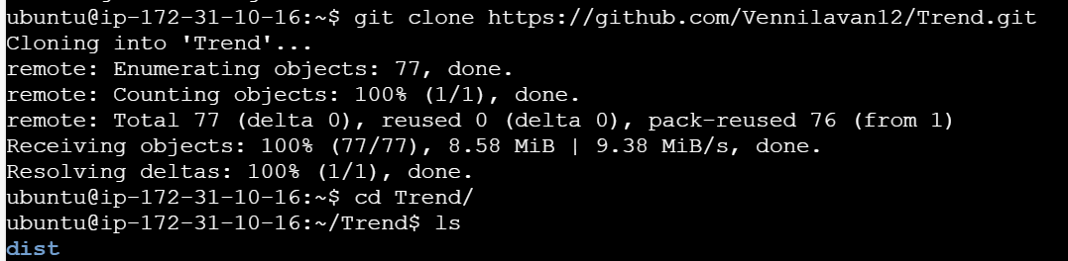

And build the Docker image and pushing the image into the Docker hub

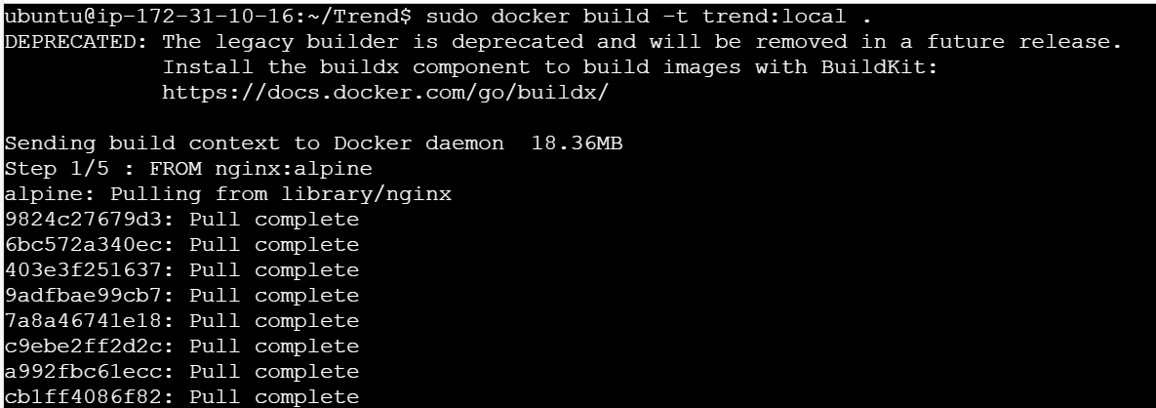



A

After if we hit the IP using public we will able to see access the website



Step2:

Provisioning the Terraform using the main.tf file and installed the terraform in Local machine

Mentioned the link Below

<https://github.com/karthicmariappan/Code_pipeline/blob/main/main.tf>

C:\My folder\Final Project\Mini_Project2\Screenshot 2025-08-29 090409.png

C:\My folder\Final Project\Mini_Project2\Screenshot 2025-08-29 090435.png

Using terraform init plan and apply command executed and created the Ec2 successfully

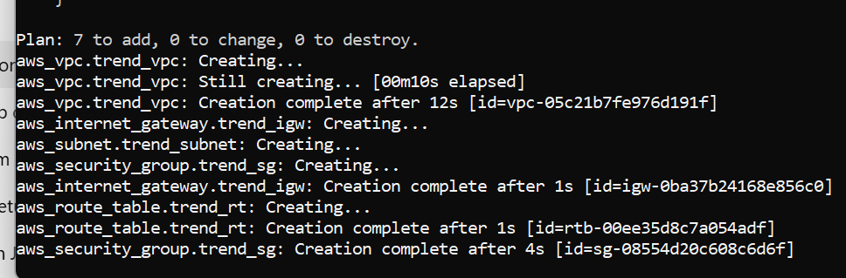

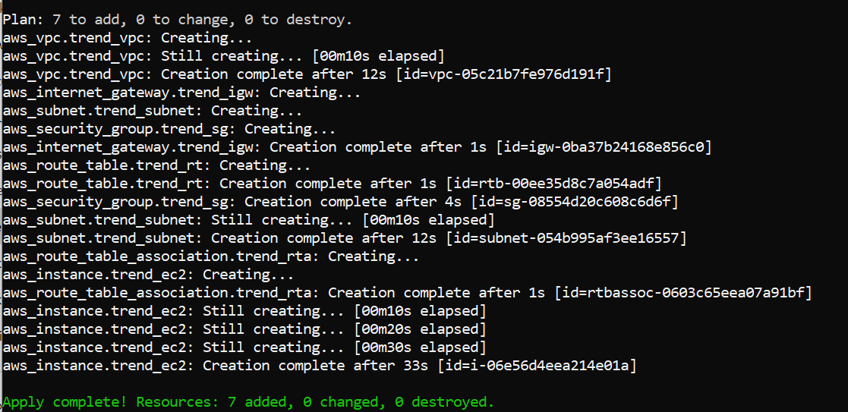

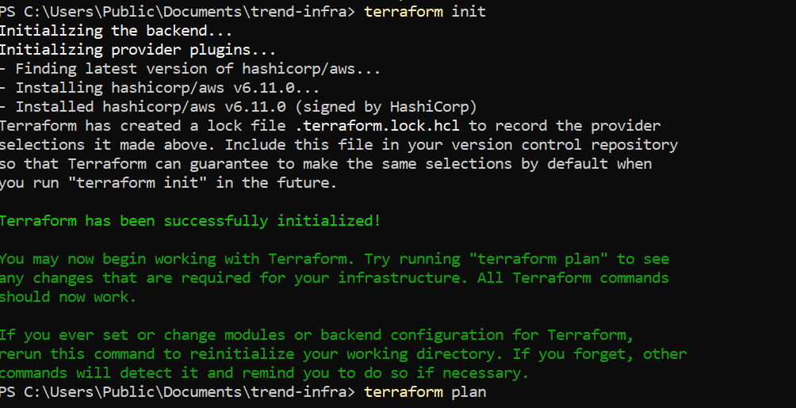



Step 3:

Created the Repository in Dcokerhub and puash image into the HUB using commands

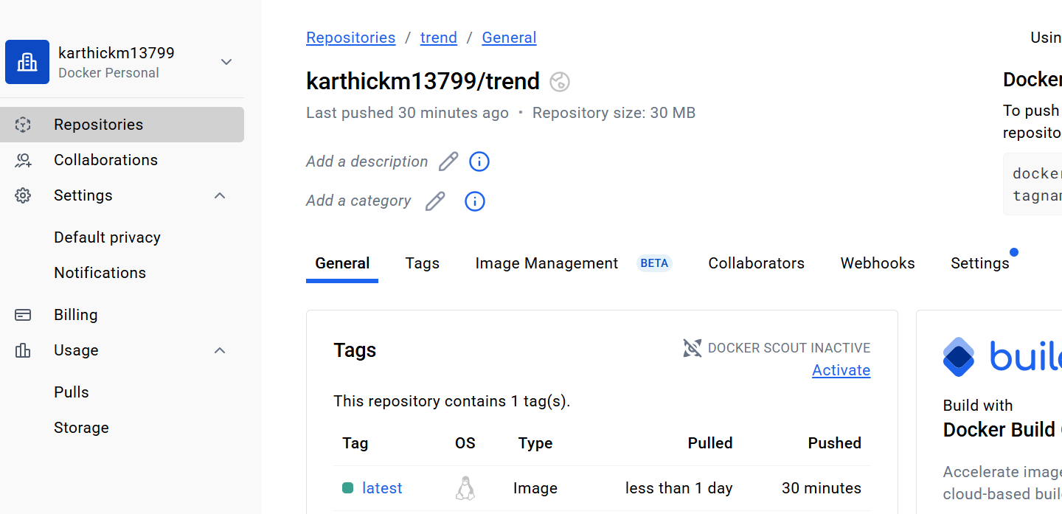

Step4:

Kubernetes setup is executed and nodes is running inside the cluster using eksctl command to create the cluster

After that cluster is running successfully and nodes are created

eksctl create cluster --name trend-app --region ap-south-1 --nodegroup-name trend\_EC2 --node-type t3.medium --nodes 1

Then Created the Deployment.yaml and Service.Yaml then someother file also mentioned in the link

<https://github.com/karthicmariappan/New>

And Deploy the image with kubernetes using Jenkins that also mentioned in the link

And all the file pushed into the Git Hub using command help of VS code

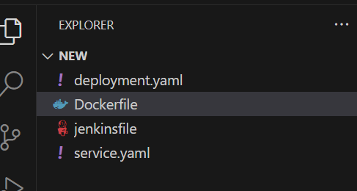

Step5:

We pushed those files inot the github with vscode with commands

<https://github.com/karthicmariappan/New>

Step6:

Jenkins setup we did and github wehook enabled by use of this whenever any changes we made the build will trigger automatically in the Jenkins

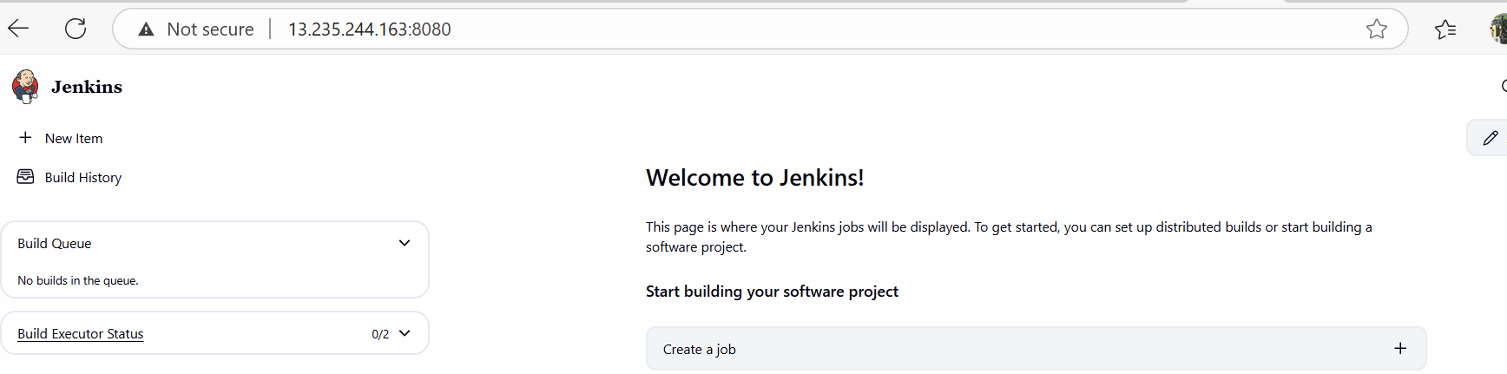

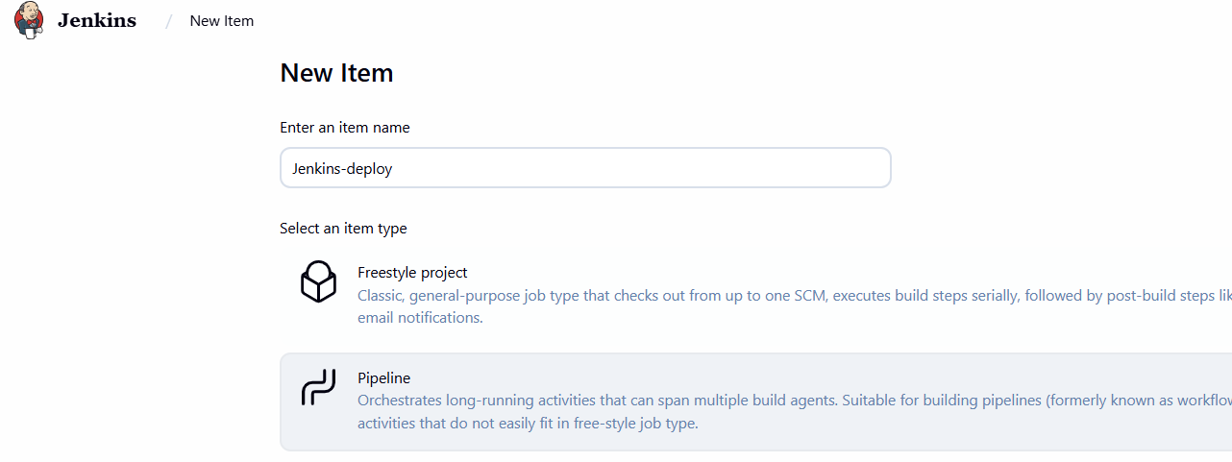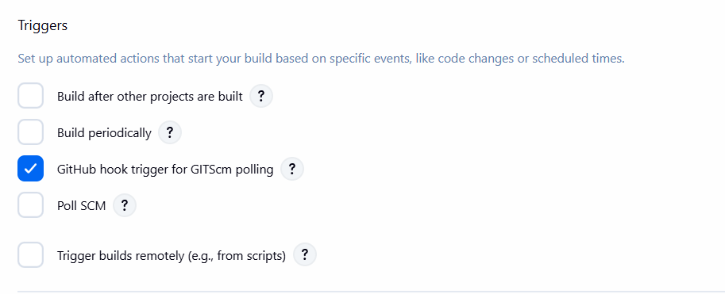

Step 7:

Monitoring the cluster throughout the metrices

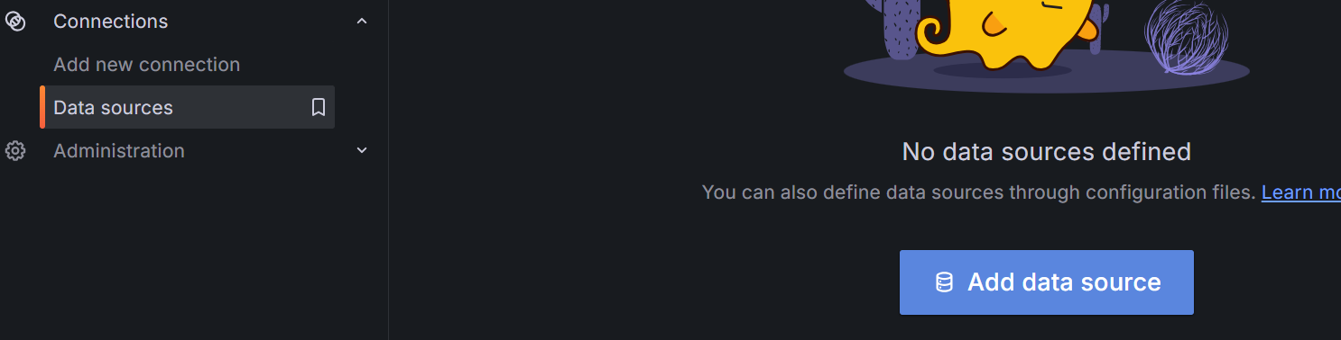

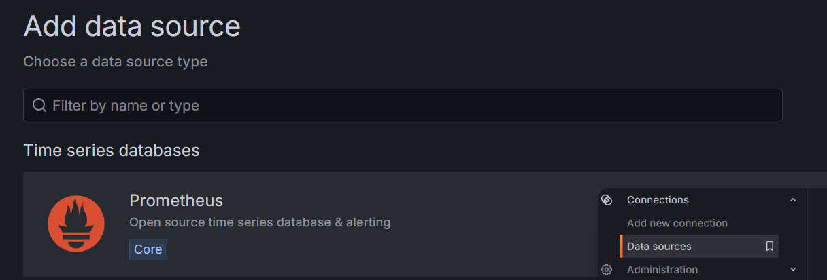

s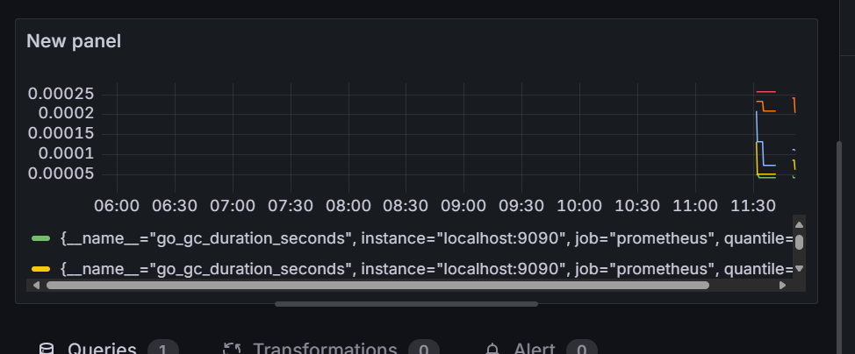

**Missing things into the Project :**

Step1:

Jenkins part is successfully executed

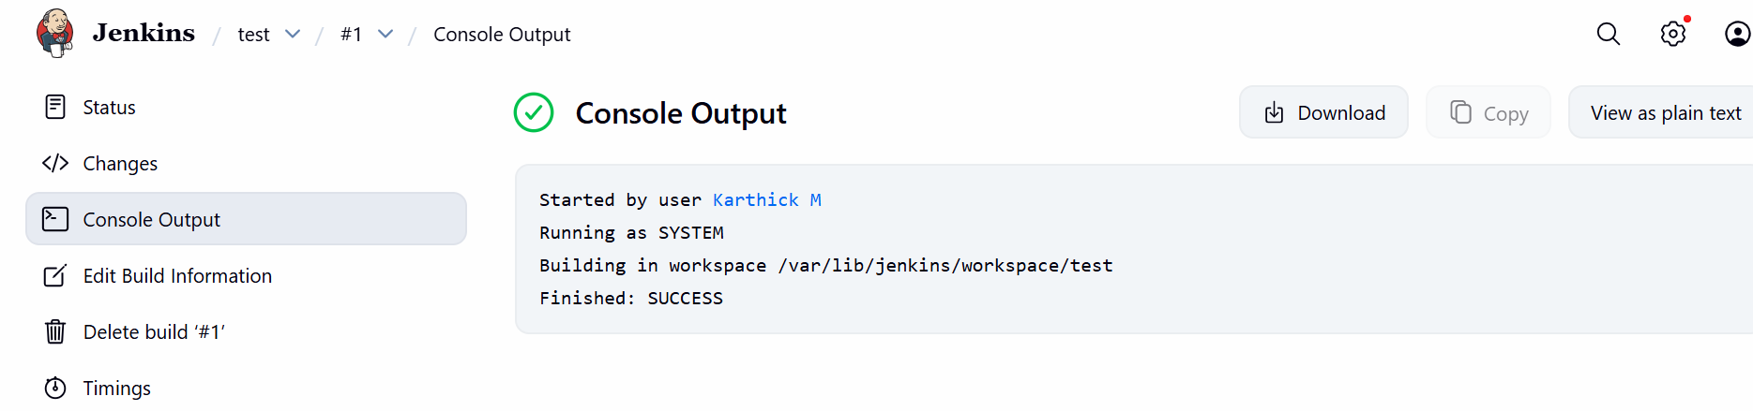

Step 2:

Eks Part

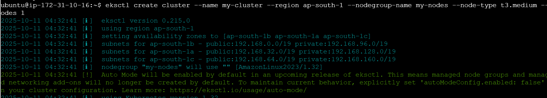

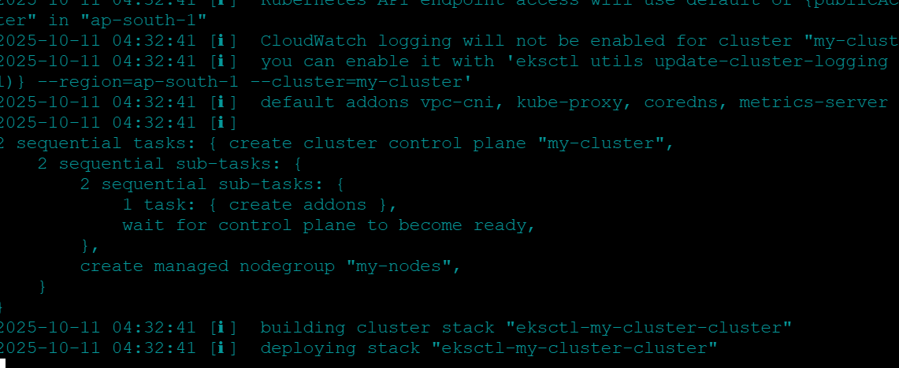

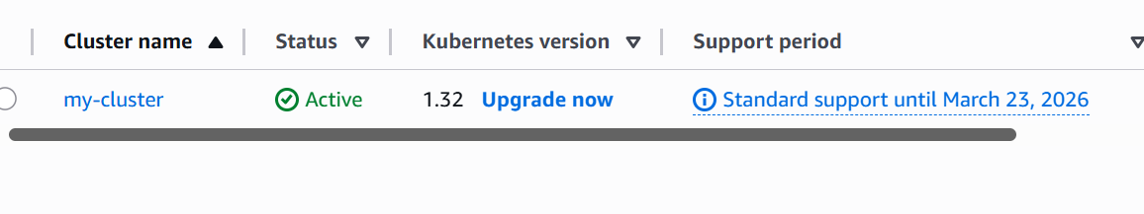

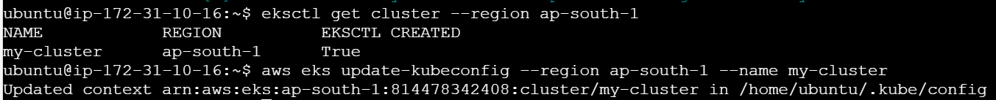

Deployment & Service.Yaml

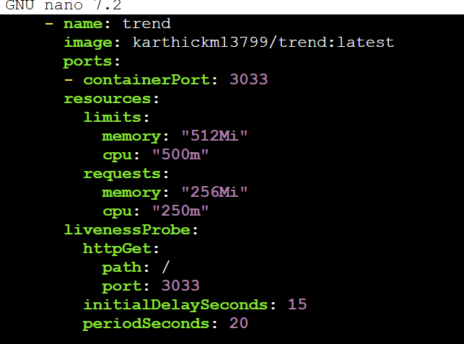

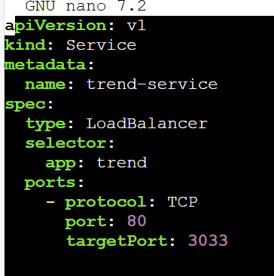

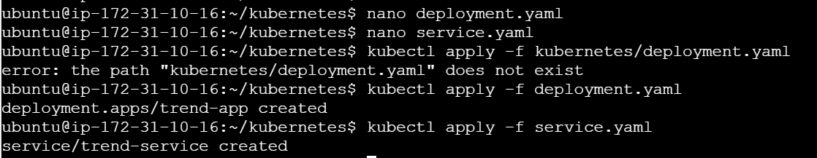

USING Loadbalancer Ip able to see the trendstore page

[abc6e79cd58034217b8b501e4675c3f7-1200105939.ap-south-1.elb.amazonaws.com](http://abc6e79cd58034217b8b501e4675c3f7-1200105939.ap-south-1.elb.amazonaws.com/)



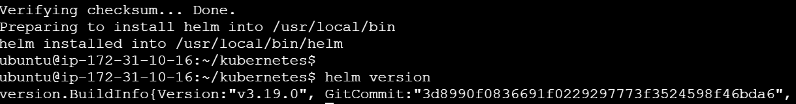

Grafana is Running:

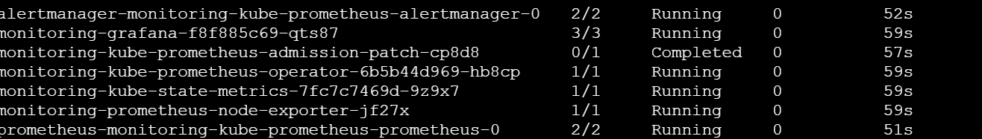

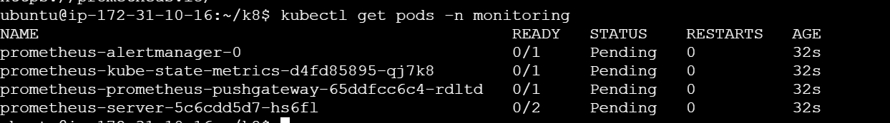

Grafana Dashboard

