Mini Project -3

Application Deployment

Step1:

Using git clone command we copyed the necessary file into the server

git clone <https://github.com/sriram-R-krishnan/devops-build>

cd devops-build

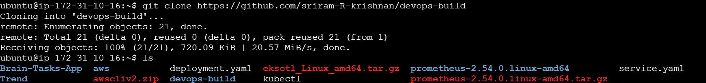

Step2:

Created 2 .sh file build and deploy file

<https://github.com/karthicmariappan/devops-build/tree/main/devops-build>

whatever the file present inside this link

Step3:

Creating the Dockerfile and dockercompose file into then build that using the.sh file and RUN

Build and Push the file into docker hub using test.sh

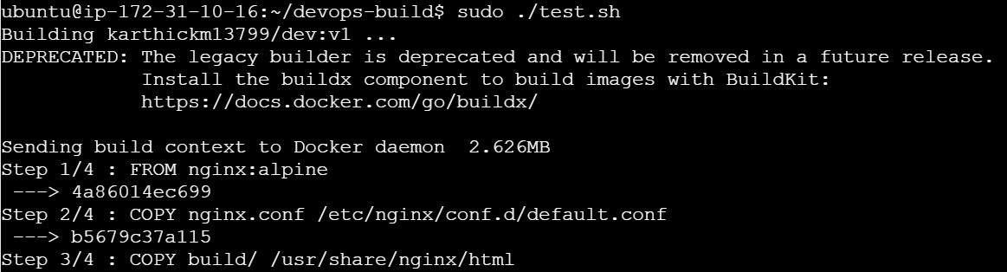

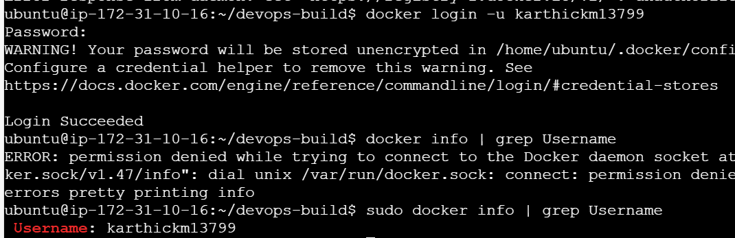

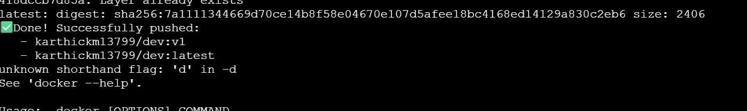

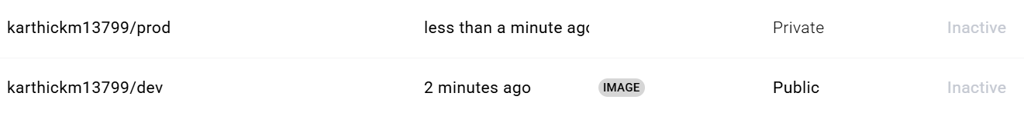

Step4:

Pushed code into the github using commands

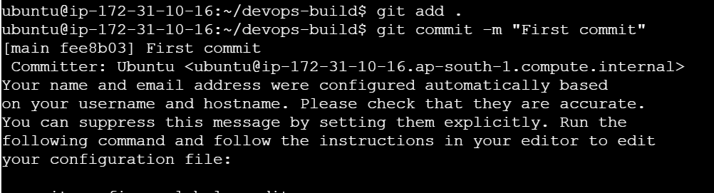

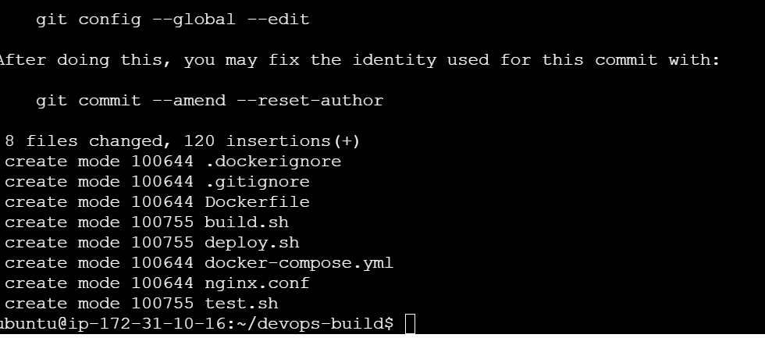

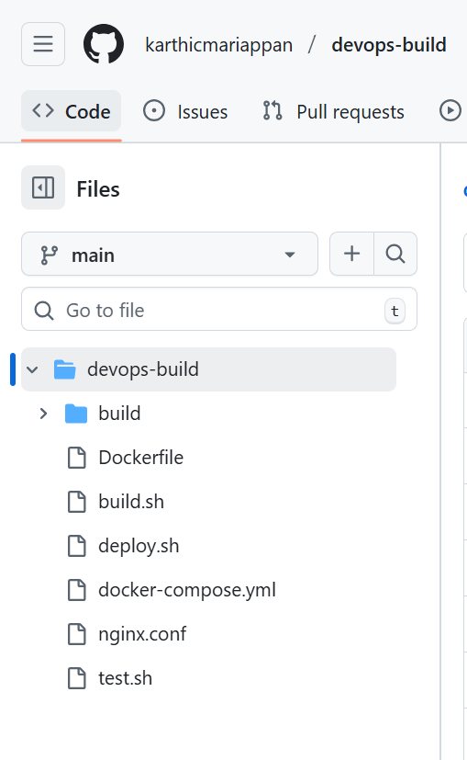

Build is Done After that My AWS account has been Suspended due to incomplete payment

So I will do that later