Jenkins Task

Step 1:

Set up the Jenkins in the Ec2 server and installation

Screenshot mentioned below:



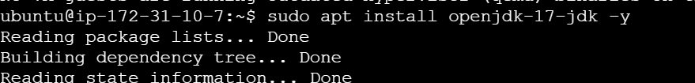



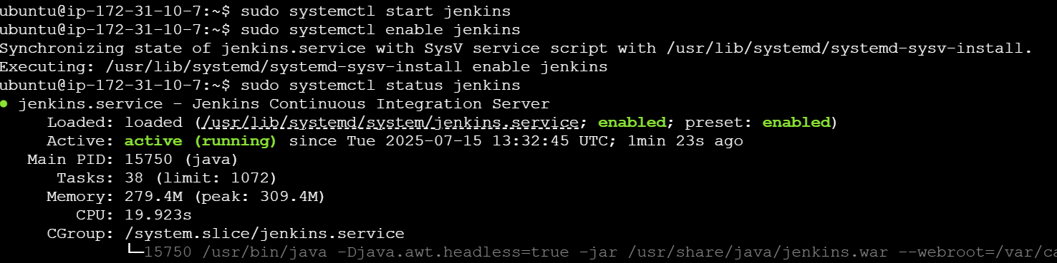

Copy the Password in the respective folder and paste into the Jenkins



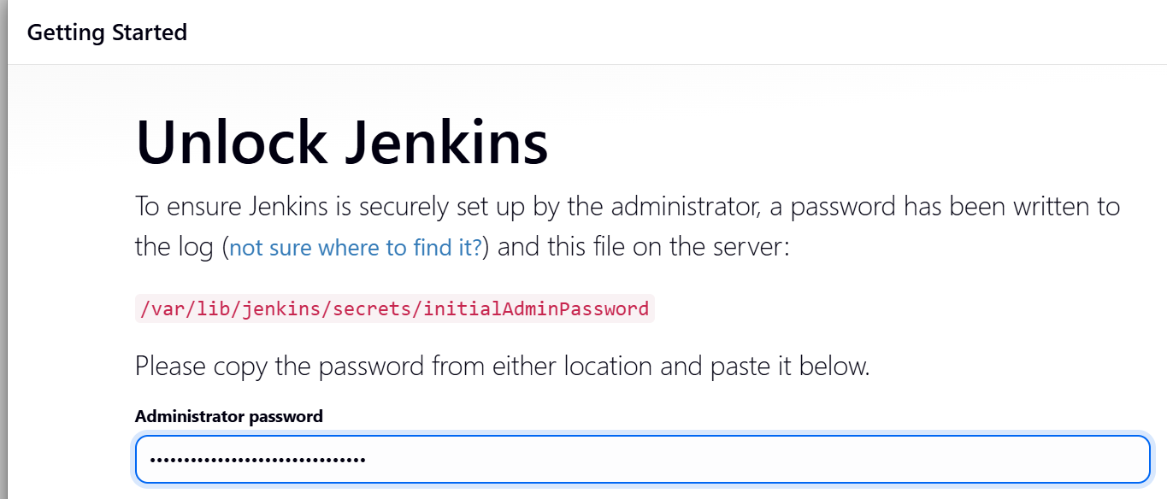

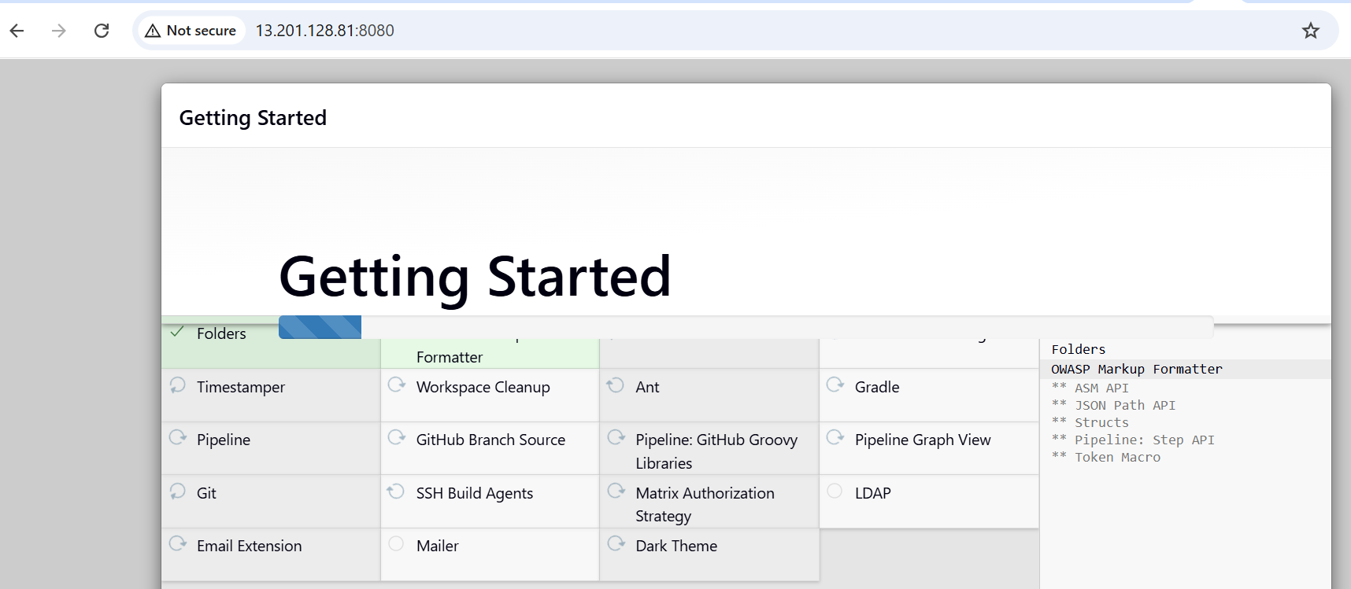

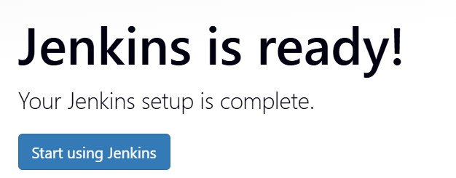

Step 2:

Creation of project using freestyle just running using the github

