Jenkins Task-2

Step1:

Created the simple.sh file and Jenkins file that I moved into the github Repo

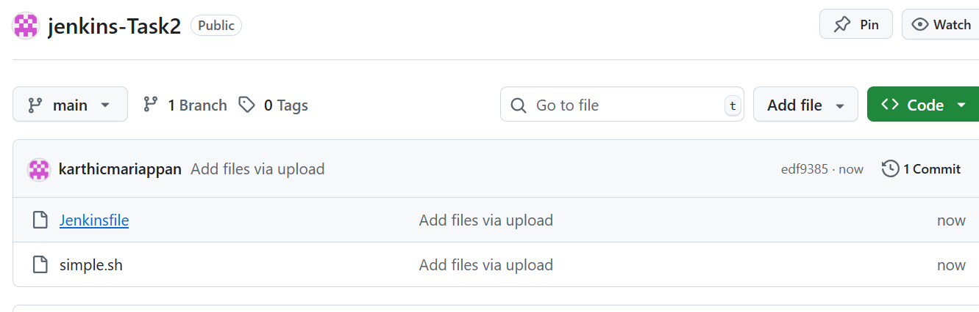

Installed Jenkins in EC2 server

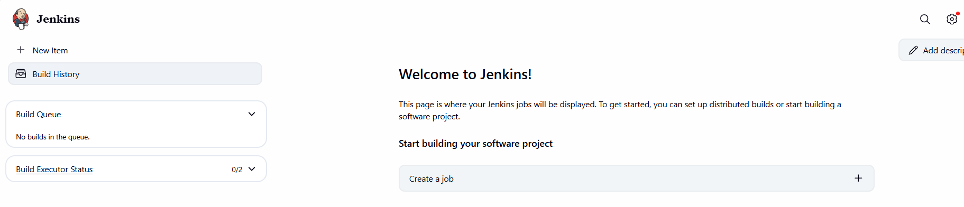

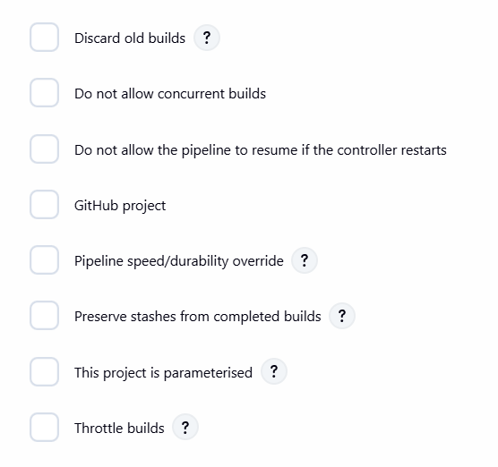

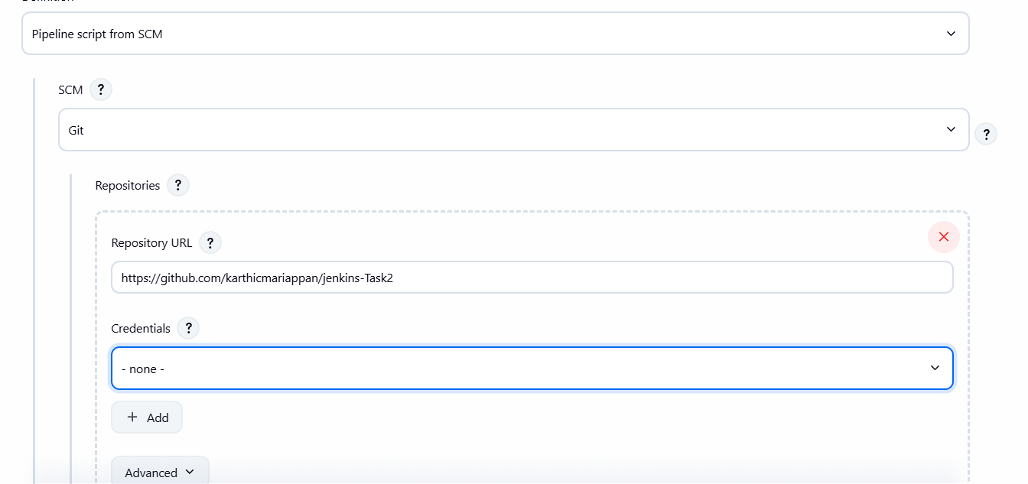

If we Made any changes Automatically will trigger the Build

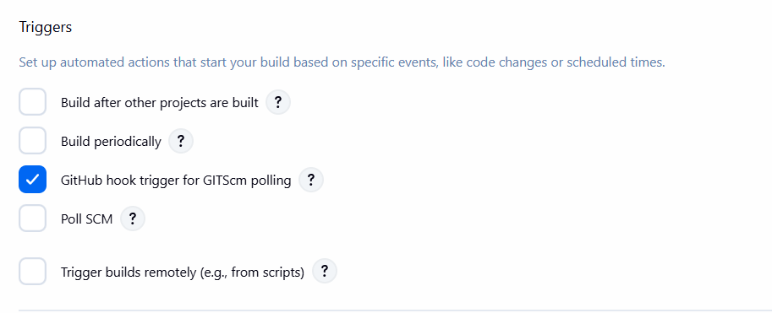

And the Output will Send via mail the Build will get success

