Git-Task

Step1:

Creating the Configuartion for Git in bash terminal

Attached in Below:

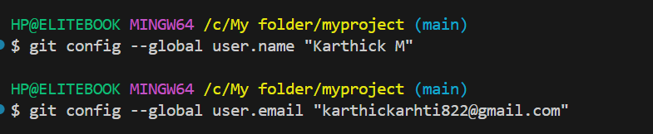

Step2:

And creating the Directory in local and navigate into that  
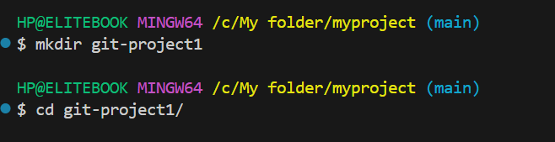

Step3:

So creating the Script file using echo command in bash terminal

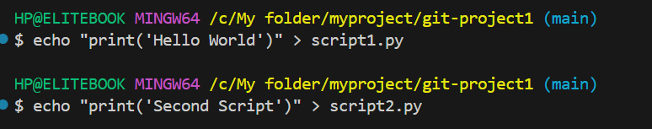

And init a git using git init command

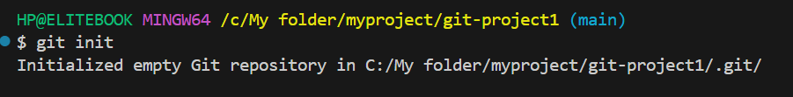

Step4:

Created the repo in github and clone into my Local repo using clone commands

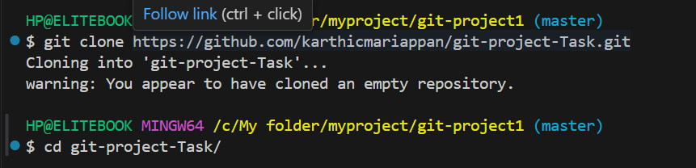

Step5:

So Both the Script file creating in the remote repo also

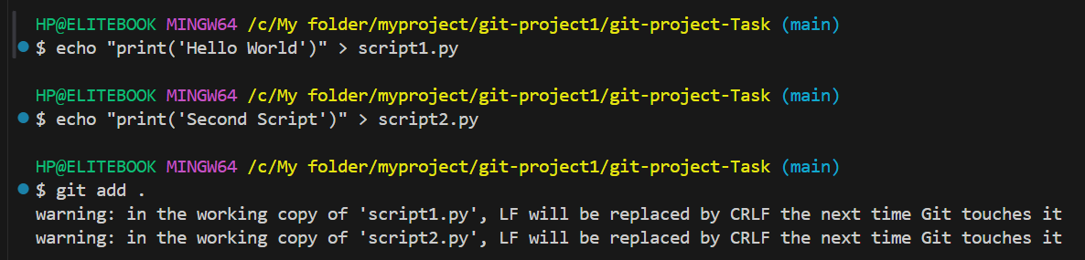

And add, commit and all we need to

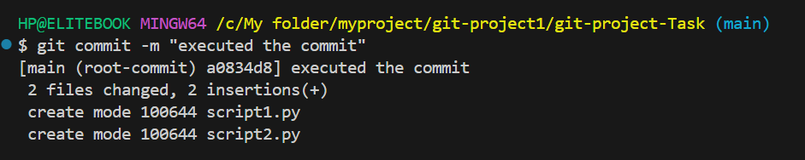

And push into the repo using git push commands

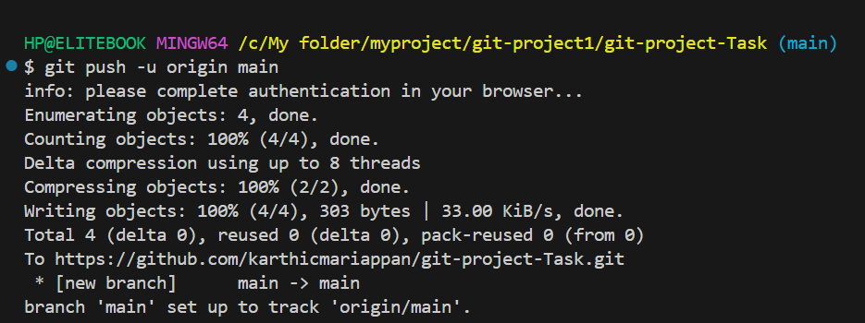

Step6:

After all these merge commands we follow using adding some content in .py file

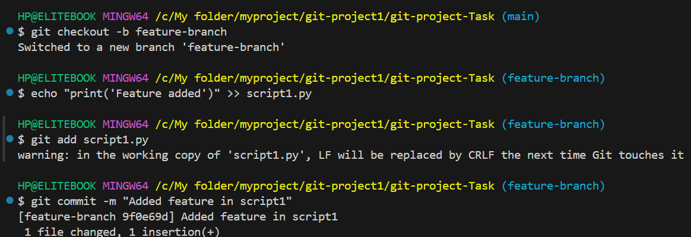

Then checkout into main and merging as taken care

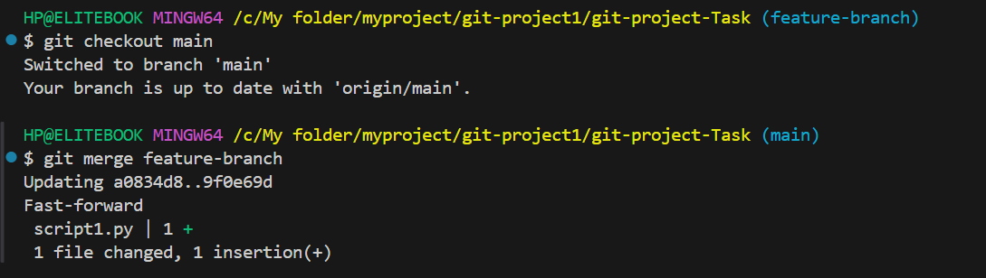

Step7:

And rebase stash and using then push into remote

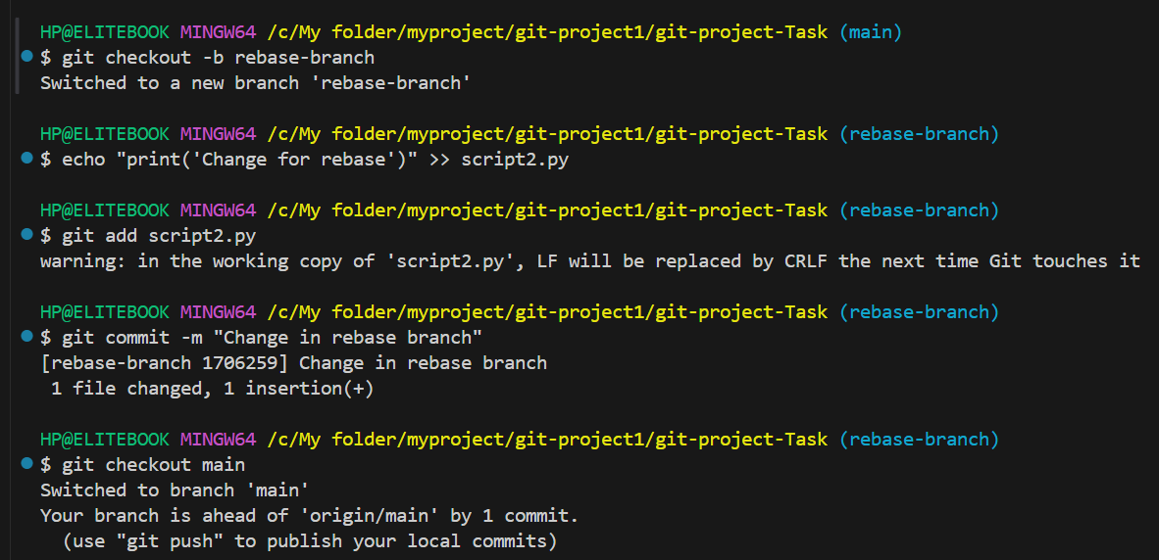

Then Added Readme file in rebase part

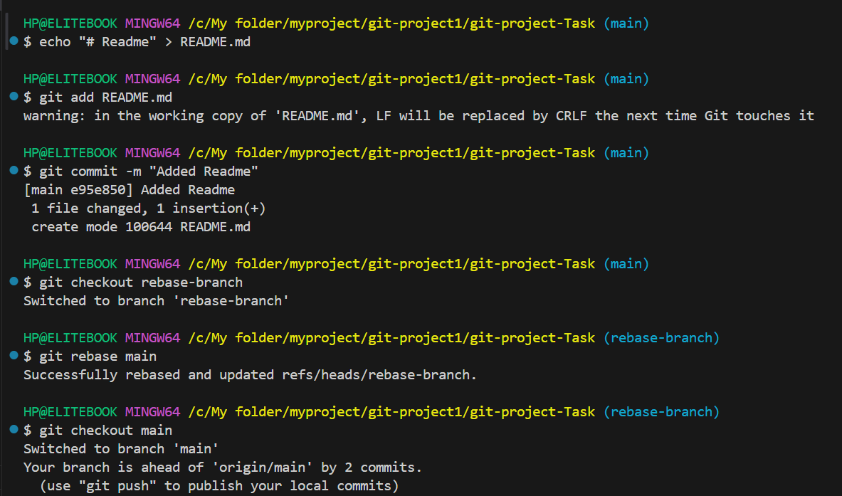

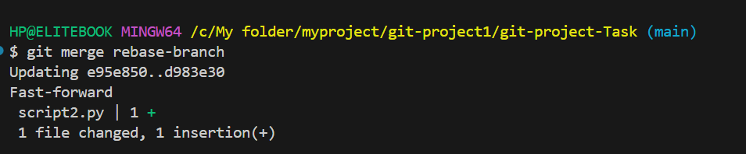

Using Stash Commands

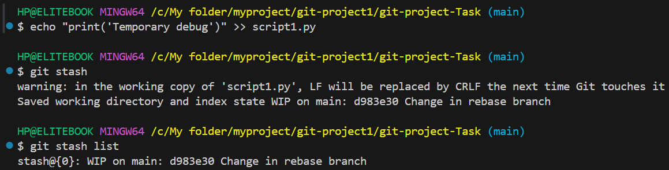 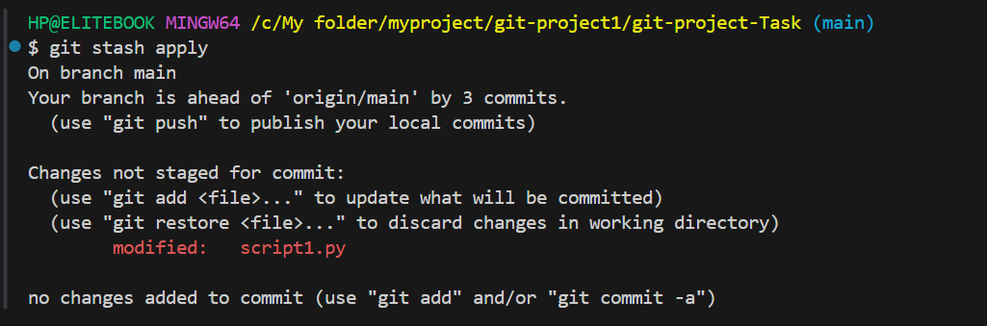Then pushing into github

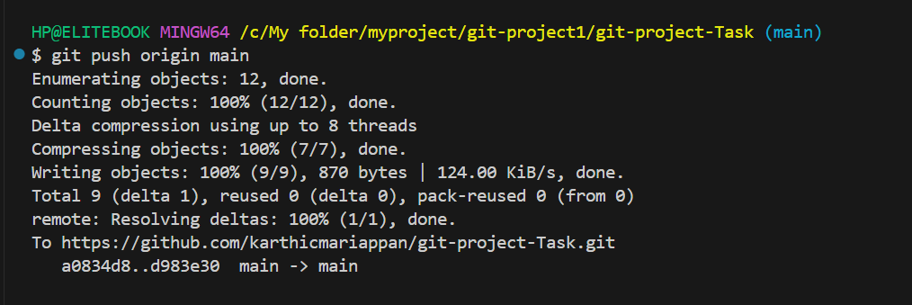

This is my remote ie. Git hub

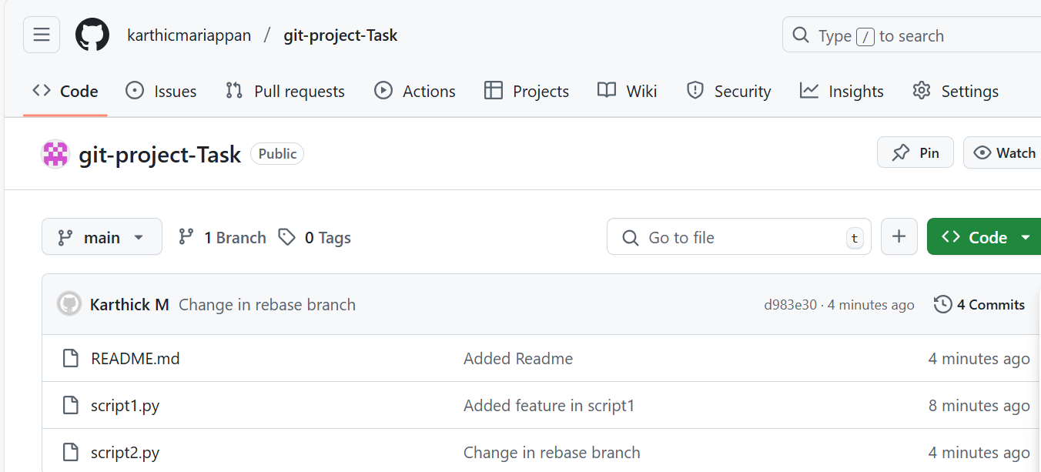

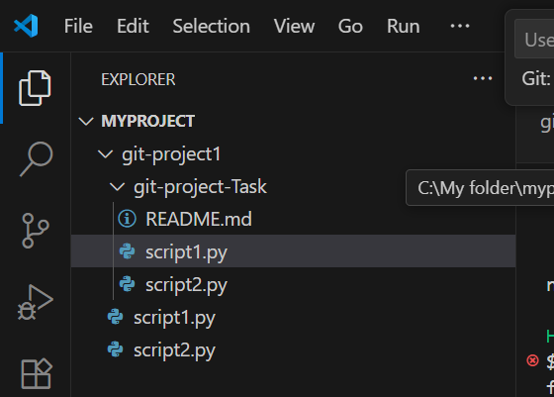

This is my local machine