1.Write a Python program to take a user's name as input and print a welcome message.
name = input("Enter your name: ")
print(f"Welcome, {name}!")
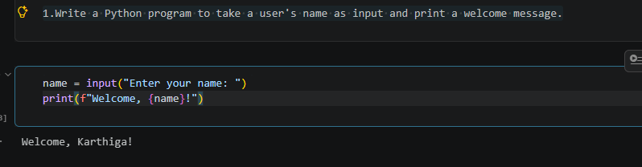

2.Write a Python program to find the sum of two numbers entered by the user.
FLOAT NUMBER:
num1 = float(input("Enter the first number: "))
num2 = float(input("Enter the second number: "))
total_sum = num1 + num2
print(f"The sum of {num1} and {num2} is {total_sum}")
WHOLE NUMBER:
num1 = int(input("Enter the 1st Number:"))
num2 = int(input("Enter the 2nd Number:"))
total_sum = num1+num2
print(f"The Sum of {num1} and {num2} is {total_sum}")
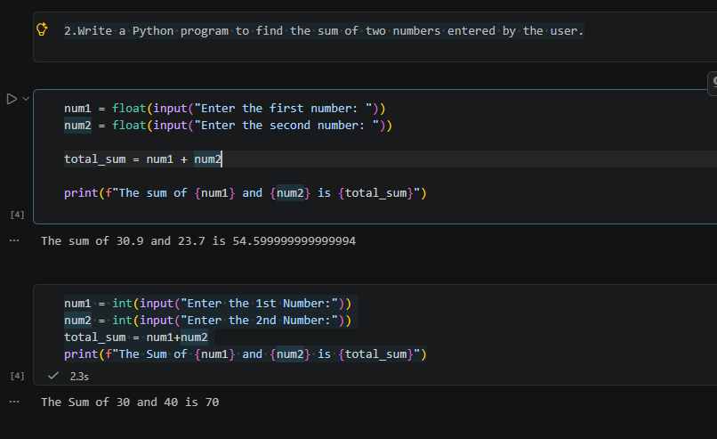
3. .Write a Python program to check whether a number is even or odd.
num = int(input("Enter a number: "))
if num % 2 == 0:
print(f"{num} is an Even number")
else:
print(f"{num} is an Odd number")

EXCUTE THE ODD NUMBER:
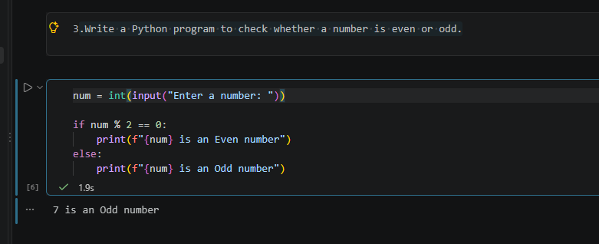

EXCUTE THE EVEN NUMBER:
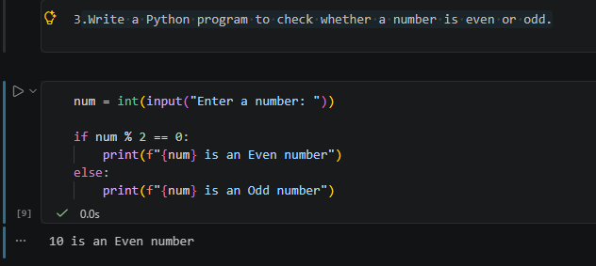
4. .Write a Python program to print numbers from 1 to 10 using a loop.
for num in range(1, 11):
print(num)
