1.Write a Python program to calculate the area of a rectangle using user input for length and width.
length = float(input("Enter the length: "))
width = float(input("Enter the width: "))
area = length * width
print(f"The area of the rectangle is {area}")
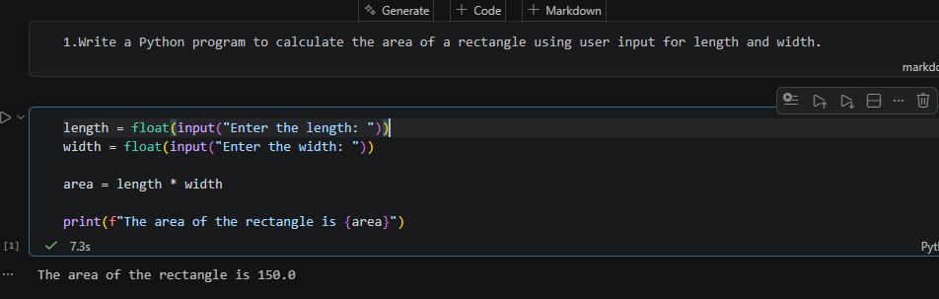
2.Write a Python program to check whether a given number is positive, negative, or zero.
num = float(input("Enter a number: "))
if num > 0:
print(f"{num} is Positive")
elif num < 0:
print(f"{num} is Negative")
else:
print(f"{num} is Zero")
POSITIVE VALUE:
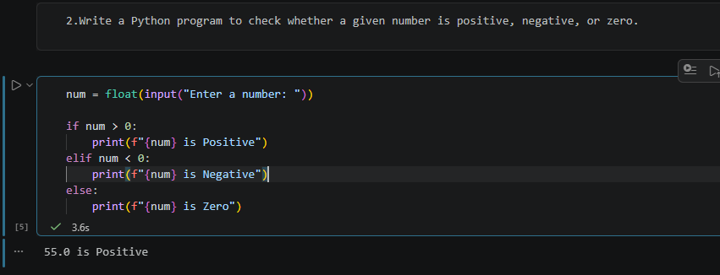
NEGATIVE VALUE:
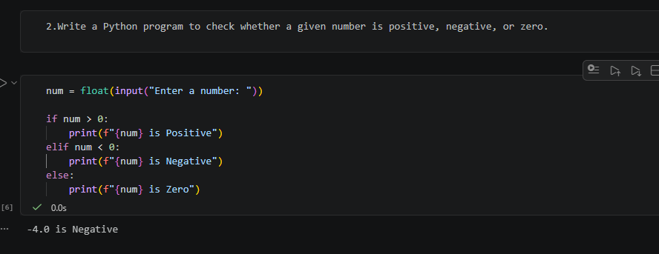
ELSE ZERO VALUE:
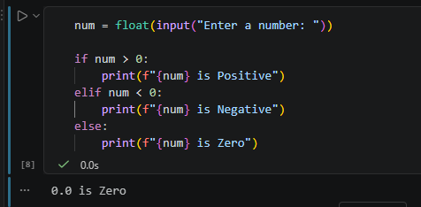

3.Write a Python program to find the largest number among three numbers entered by the user.
num1 = float(input("Enter the first number: "))
num2 = float(input("Enter the second number: "))
num3 = float(input("Enter the third number: "))
largest = max(num1, num2, num3)
print(f"The largest number is {largest}")

PRINT THE DECIMAL VALUE:
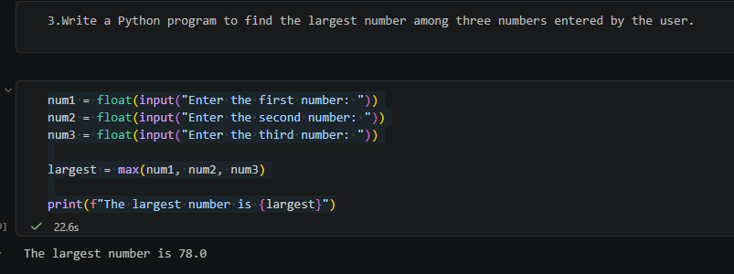
PRINT THE INTIGER VALUE:
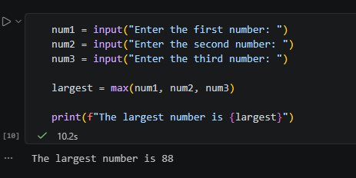

4.Write a Python program to count the number of vowels in a given string.
text = input("Enter a string: ")
count = 0
for char in text:
if char.lower() in "aeiou":
count += 1
print(f"The number of vowels is {count}")
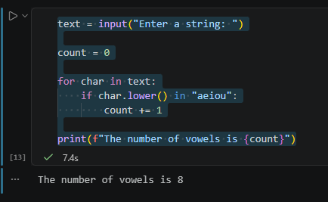

5.Write a Python program to generate the multiplication table of a given number (up to 10).
num = int(input("Enter a number: "))
for i in range(1, 11):
result = num * i
print(f"{num} x {i} = {result}")
