1.Write a Python program to find the factorial of a number using a loop.
num = int(input("Enter a number: "))
factorial = 1
for i in range(1, num + 1):
factorial = factorial * i
print("Factorial =", factorial)
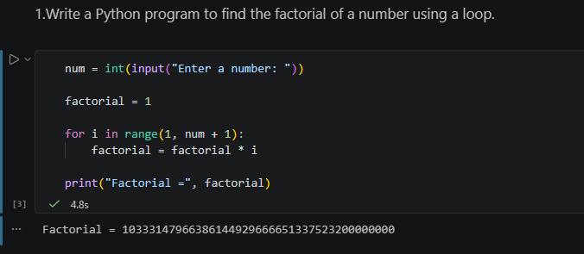
2.Write a Python program to check whether a number is a palindrome.
num = input("Enter a number: ")
if num == num[::-1]:
print("Palindrome")
else:
print("Not a Palindrome")

PALINDROME:
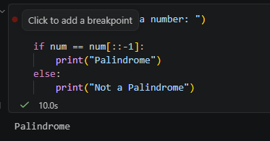
NOT PALINDROME:
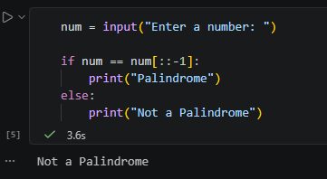
3.Write a Python program to reverse a string entered by the user.
text = input("Enter a string: ")
reverse = text[::-1]
print("Reversed string =", reverse)
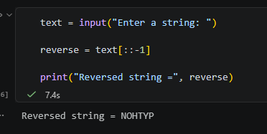
4.Write a Python program to find the sum of digits of a number.
num = int(input("Enter a number: "))
sum = 0
while num > 0:
digit = num % 10
sum = sum + digit
num = num // 10
print("Sum of digits =", sum)
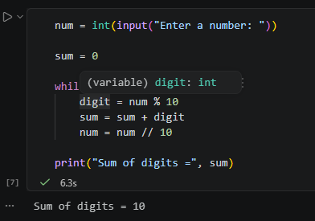
5.Write a Python program to find the largest number in a list
numbers = [10, 25, 7, 45, 18]
largest = numbers[0]
for num in numbers:
if num > largest:
largest = num
print("Largest number =", largest)
