1.String Data Analysis - text = "Data analytics is powerful and data driven"
Count total words
Count frequency of each word
Find most repeated word

COUNT TOTAL WORDS:
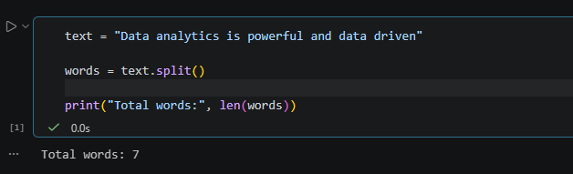

COUNT FREQUENCY OF EACH WORD:
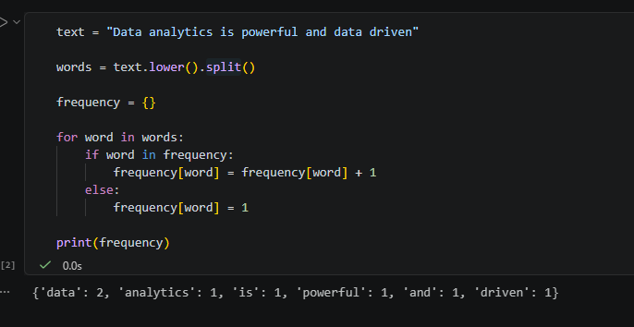

FIND MOST REPEATED WORD:
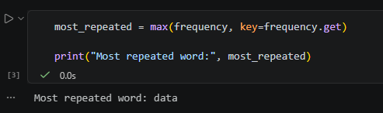

FULL PROGRAM:
