Dictionary-Based Dataset
students = { "A": 80, "B": 65, "C": 90, "D": 50 }
Find student with highest marks
Find average marks
Categorize students as Pass/Fail

FIND STUDENT WITH HIGHEST MARKS:
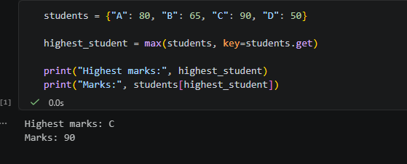
FIND AVERAGE MARKS:
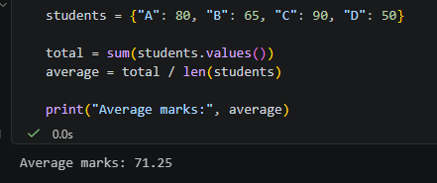
CATEGORIZE STUDENTS AS PASS/FAIL:
